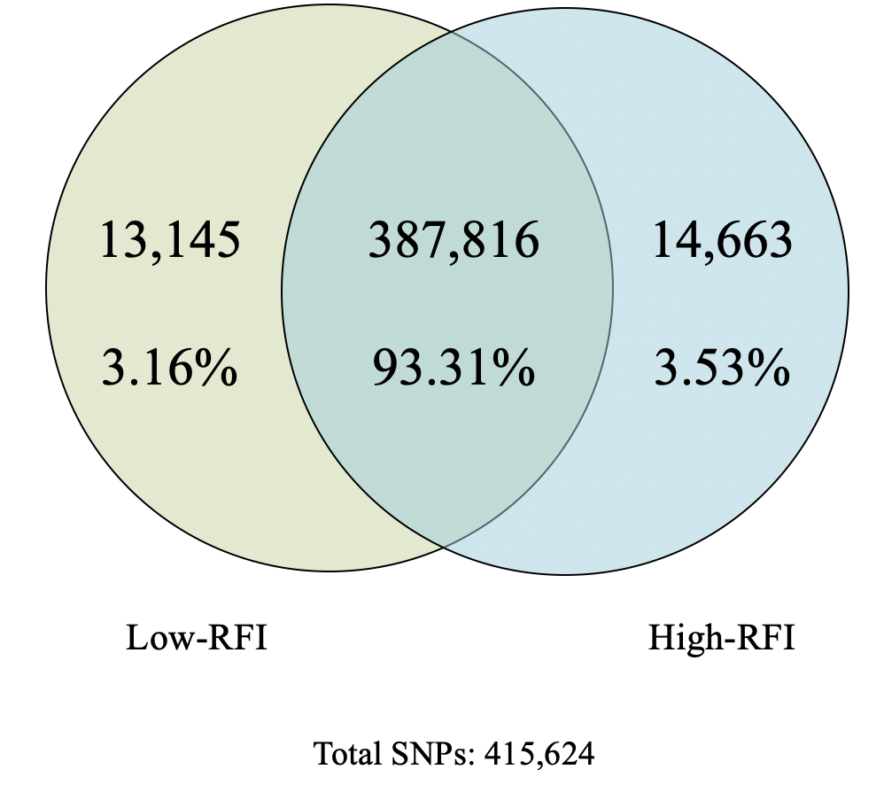
Additional file 5. Unique or common SNPs between low- and high-RFI groups using the most optimized RNA-Seq pipeline*.
*Approach iii) merged samples for low- and high-RFI for both tissues.

