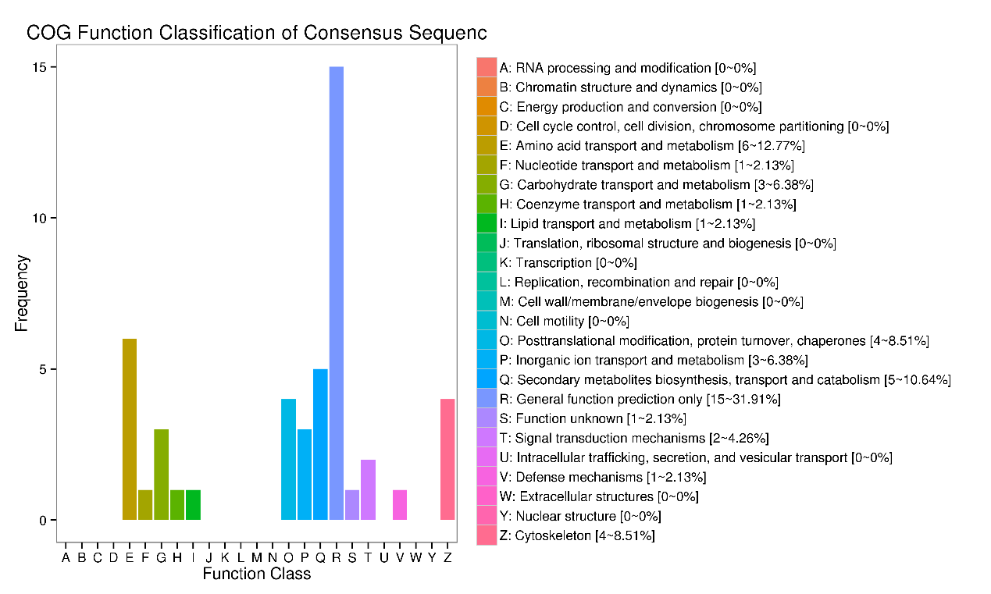
Additional file 3 Cluster of Orthologous Genes (COG) classification of differentially expressed genes of uterus in aged hen group (72 wk of age) relative to young hen group (42 wk of age).

