Supplementary tables

Table S1: List of accessions from the Senegalese pearl millet core collection
Entry | Sample | Morphotype | Phenotypic traits subgroup
1 | PgSL1 | Sanio | Subset_1
4 | PgSL4 | Sanio | Subset_1
9 | PgSL9 | Sanio | Subset_1
21 | PgSL21 | Sanio | Subset_1
23 | PgSL23 | Sanio | Subset_1
24 | PgSL24 | Sanio | Subset_1
25 | PgSL25 | Sanio | Subset_1
26 | PgSL26 | Sanio | Subset_1
27 | PgSL27 | Sanio | Subset_1
29 | PgSL29 | Sanio | Subset_1
31 | PgSL31 | Sanio | Subset_1
2 | PgSL2 | Sanio | Subset_2
3 | PgSL3 | Sanio | Subset_2
7 | PgSL7 | Sanio | Subset_2
11 | PgSL11 | Sanio | Subset_2
12 | PgSL12 | Sanio | Subset_2
15 | PgSL15 | Sanio | Subset_2
16 | PgSL16 | Sanio | Subset_2
20 | PgSL20 | Sanio | Subset_2
22 | PgSL22 | Sanio | Subset_2
28 | PgSL28 | Sanio | Subset_2
30 | PgSL30 | Sanio | Subset_2
5 | PgSL5 | Sanio | Subset _3
6 | PgSL6 | Sanio | Subset _3
8 | PgSL8 | Sanio | Subset _3
10 | PgSL10 | Sanio | Subset _3
13 | PgSL13 | Sanio | Subset _3
14 | PgSL14 | Sanio | Subset _3
17 | PgSL17 | Sanio | Subset _3
18 | PgSL18 | Sanio | Subset _3
19 | PgSL19 | Sanio | Subset _3
69 | PgSL69 | Souna | Subset _1
71 | PgSL71 | Souna | Subset _1
72 | PgSL72 | Souna | Subset _1
73 | PgSL73 | Souna | Subset _1
77 | PgSL77 | Souna | Subset _1
35 | PgSL35 | Souna | Subset _1
38 | PgSL38 | Souna | Subset _1
39 | PgSL39 | Souna | Subset _1
44 | PgSL44 | Souna | Subset _1
48 | PgSL48 | Souna | Subset _1
53 | PgSL53 | Souna | Subset _1
55 | PgSL55 | Souna | Subset _1
59 | PgSL59 | Souna | Subset _1
63 | PgSL63 | Souna | Subset _1
65 | PgSL65 | Souna | Subset _2
66 | PgSL66 | Souna | Subset _2
67 | PgSL67 | Souna | Subset _2
68 | PgSL68 | Souna | Subset _2
82 | PgSL82 | Souna | Subset _2
83 | PgSL83 | Souna | Subset _2
85 | PgSL85 | Souna | Subset _2
87 | PgSL87 | Souna | Subset _2
88 | PgSL88 | Souna | Subset _2
90 | PgSL90 | Souna | Subset _2
91 | PgSL91 | Souna | Subset _2
70 | PgSL70 | Souna | Subset _2
79 | PgSL79 | Souna | Subset _2
81 | PgSL81 | Souna | Subset _2
32 | PgSL32 | Souna | Subset _2
33 | PgSL33 | Souna | Subset _2
34 | PgSL34 | Souna | Subset _2
36 | PgSL36 | Souna | Subset _2
42 | PgSL42 | Souna | Subset _2
45 | PgSL45 | Souna | Subset _2
46 | PgSL46 | Souna | Subset _2
49 | PgSL49 | Souna | Subset _2
50 | PgSL50 | Souna | Subset _2
51 | PgSL51 | Souna | Subset _2
52 | PgSL52 | Souna | Subset _2
54 | PgSL54 | Souna | Subset _2
56 | PgSL56 | Souna | Subset _2
57 | PgSL57 | Souna | Subset _2
58 | PgSL58 | Souna | Subset _2
61 | PgSL61 | Souna | Subset _2
62 | PgSL62 | Souna | Subset _2
64 | PgSL64 | Souna | Subset _2
84 | PgSL84 | Souna | Subset _3
86 | PgSL86 | Souna | Subset _3
89 | PgSL89 | Souna | Subset _3
74 | PgSL74 | Souna | Subset _3
75 | PgSL75 | Souna | Subset _3
76 | PgSL76 | Souna | Subset _3
78 | PgSL78 | Souna | Subset _3
80 | PgSL80 | Souna | Subset _3
37 | PgSL37 | Souna | Subset _3
40 | PgSL40 | Souna | Subset _3
41 | PgSL41 | Souna | Subset _3
43 | PgSL43 | Souna | Subset _3
47 | PgSL47 | Souna | Subset _3
60 | PgSL60 | Souna | Subset _3

Table S2: Representativeness statistics of early-flowering Souna morphotype and late-flowering Sanio morphotypes within the core collection. %MD = Percentage of mean difference, %VD = Percentage of variance difference, % CR = Coincidence rate, and %VR = Variable rate

 | %CR |  | %VR |  | %VD |  | %MD
Souna | 96.97 |  | 131.8 |  | 40.49 |  | 1.7
Sanio | 92.54 |  | 104.58 |  | 14.47 |  | 0.99

Table S3: Means, P-values and correlation with axis from the discriminant analysis (DA) of early- and late- flowering millets

Trait | Early-flowering | Late-flowering | p-value | Correlation
DM | 0.043 (± 0.039) | 0.004 (± 0.008) | < 0.0001 | -0.5167
HT | 48.378 (± 3.094) | 71.796 (± 5.634) | < 0.0001 | 0.9588
FLO | 52.317 (± 2.897) | 76.801 (± 5.823) | < 0.0001 | 0.9639
NPT | 5.534 (± 0.933) | 7.928 (± 1.012) | < 0.0001 | 0.7835
NTN | 8.207 (± 0.433) | 11.479 (± 1) | < 0.0001 | 0.9375
IL | 20.622 (± 1.046) | 22.025 (± 0.975) | < 0.0001 | 0.5612
FLL | 44.93 (± 3.472) | 48.354 (± 3.229) | < 0.0001 | 0.4448
FLW | 4.641 (± 0.405) | 4.491 (± 0.358) | 0.0858 | -0.185
MSD | 4.232 (± 0.319) | 4.131 (± 0.289) | 0.1413 | -0.1588
PH | 220.266 (± 18.434) | 282.191 (± 18.293) | < 0.0001 | 0.8684
SL | 51.559 (± 7.02) | 43.754 (± 5.702) | < 0.0001 | -0.5034
ST | 8.13 (± 0.714) | 8.993 (± 0.905) | < 0.0001 | 0.4768
PE | 3.956 (± 1.734) | 1.583 (± 1.191) | < 0.0001 | -0.5988
SW | 5.863 (± 0.555) | 5.762 (± 0.478) | 0.3915 | -0.0929
Biomass | 1156.411 (± 318.566) | 2228.964 (± 376.957) | < 0.0001 | 0.8525
GY | 1341.09 (± 418.2) | 2195.8 (± 743.151) | < 0.0001 | 0.6105
Table S4: Significantly associated SNPs from GWAS, mapped in the pearl millet genome and associated with phenotypic traits

Marker | Chromosome | Associated phenotypic trait | Pvalues | FDR | Region | Distance to the nearest gene (bp) | Gene ID | Gene name | Definition | Number of proteins | Specific fonctions | General fonctions
S2_1673638 | 2 | Biomass | 4.52E-49 | 2.94E-45 | Intergenic | 400 | Pgl_GLEAN_10023350 | LTA3 | Dihydrolipoyllysine-residue acetyltransferase component 1 of pyruvate dehydrogenase complex | 3 | Metabolic process, transferase activity, transferring acyl groups | Biological process and molecular function
S2_182434549 | 2 | Biomass | 2.01E-34 | 7.25E-31 | Intergenic | 15131 | Pgl_GLEAN_10013800 | MFDR | NADPH:adrenodoxin oxidoreductase | Unknown | Unknown
S2_222890810 | 2 | Biomass | 2.63E-07 | 0.000437794 | Genic | 0 | Pgl_GLEAN_10027846 | ALDH5F1 | Succinate-semialdehyde dehydrogenase, mitochondrial | 2 | Metabolic process, oxidoreductase activity; oxidation-reduction process | Biological process and molecular function
S2_222920292 | 2 | Biomass | 7.61E-14 | 2.06E-10 | Intergenic | -169 | Pgl_GLEAN_10027850 | CCT1 | Choline-phosphate cytidylyltransferase 1 | 1 | Biosynthetic process, nucleotidyltransferase activity | Biological process and molecular function
S3_202496771 | 3 | Biomass | 2.22E-21 | 6.86E-18 | Genic | 0 | Pgl_GLEAN_10033123 | Os04g0379900 | Stearoyl-[acyl-carrier-protein] 9-desaturase 5 | 2 | Fatty acid metabolic process, fatty acid biosynthetic process, oxidoreductase activity, acyl-[acyl-carrier-protein] desaturase activity, oxidation-reduction process | Biological process and molecular function
S3_286185314 | 3 | Biomass | 3.77E-35 | 1.63E-31 | Intergenic | -657 | Pgl_GLEAN_10023831 | SCAMP6 | Secretory carrier-associated membrane protein 6 | 1 | Protein transport, integral to membrane | Biological process and molecular function
S3_58698346 | 3 | Biomass | 2.03E-07 | 0.000366077 | Intergenic | 333 | Pgl_GLEAN_10012689 | PHYLLO | Protein PHYLLO | 4 | Catalytic activity; cellular amino acid catabolic process; thiamine pyrophosphate binding | Biological process and molecular function
S3_61879906 | 3 | Biomass | 3.98E-07 | 0.000615194 | Genic | 0 | Pgl_GLEAN_10014062 |  |  | Unknown | Unknown
S3_97334843 | 3 | Biomass | 1.58E-06 | 0.002279413 | Intergenic | -10696 | Pgl_GLEAN_10000315 | UGT91C1 | UDP-glycosyltransferase 91C1 | 1 | Metabolic process; transferase activity, transferring hexosyl groups | Biological process and molecular function
S4_183522008 | 4 | Biomass | 3.45E-08 | 8.30E-05 | Intergenic | 12181 | Pgl_GLEAN_10004825 |  |  | 1 | Unknown
S4_32445778 | 4 | Biomass | 1.22E-07 | 0.000240007 | Genic | 0 | Pgl_GLEAN_10002428 | ABCF1 | ABC transporter F family member 1 | 3 | Nucleotide binding; ATP binding, ATPase activity, nucleoside-triphosphatase activity | Molecular function
S4_45574746 | 4 | Biomass | 5.44E-49 | 2.94E-45 | Genic | 0 | Pgl_GLEAN_10027450 | CPLC4 | Chaperone protein ClpC4 | 7 | Nucleotide binding, DNA binding; nuclease activity, ATP binding Nucleotide-excision repair, Nucleoside-triphosphatase activity | Molecular function and biological process
S5_78613055 | 5 | Biomass | 5.56E-08 | 0.000120318 | Intergenic | 17163 | Pgl_GLEAN_10038431 |  | Unknown | Unknown | Unknown
S7_128335177 | 7 | Biomass | 1.97E-49 | 2.13E-45 | Intergenic | -14 | Pgl_GLEAN_10007334 |  | Unknown | Unknown | Unknown
S7_88324424 | 7 | Biomass | 9.29E-50 | 2.01E-45 | Genic | 0 | Pgl_GLEAN_10028316 | DDB1B | DNA damage-binding protein 1b | 1 | Nucleic acid binding, Nucleus | Molecular function and cellular component
S5_143317884 | 5 | Flowering time | 1.94E-06 | 0.0419816 | Genic | 0 | Pgl_GLEAN_10013349 | PPR | Pentatricopeptide repeat | 1 | Unknown
S2_16892168 | 2 | Nodal tiller number | 4.91E-07 | 0.01062524 | Genic | 0 | Pgl_GLEAN_10013465 | HK4 | Histidine kinase 4 | 6 | Two-component sensor activity; two-component response regulator activity, two-component signal transduction system (phosphorelay); protein histidine kinase activity, ATP binding, regulation of transcription, DNA-dependent, signal transduction, membrane; phosphorylation, transferase activity, transferring phosphorus-containing groups, peptidyl-histidine phosphorylation | Molecular function, biological process and cellular component
S7_66044005 | 7 | Plant height | 1.04E-06 | 0.020333247 | Genic | 0 | Pgl_GLEAN_10031969 | AAO1 | Indole-3-acetaldehyde oxidase | 8 | Catalytic activity; electron carrier activity, oxidoreductase activity, acting on CH-OH group of donors, metal ion binding, flavin adenine dinucleotide binding, iron-sulfur cluster binding, 2 iron, 2 sulfur cluster binding, oxidation-reduction process | Molecular function and biological process

Supplementary figures

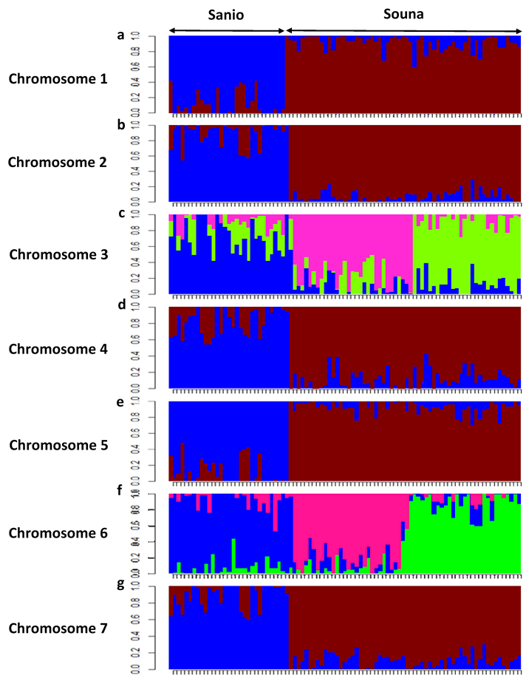

Figure S1: Genetic structure of Senegalese pearl millet landraces core collection at chromosome level (a-g) from chromosome 1 to chromosome 7, respectively

Figure S2: Discriminant analysis of (a) early-flowering (Axis1= 98.49, Axis2= 1.51) and (b) late-flowering morphotypes (Axis1=95.59, Axis2=4.41), from phenotypic traits of landraces from the core collection. Boxplots of (c) grain yield, (d) panicle yield, (e) spike thickness, (f) nodal tillering and (g) flag leaf length according to different subsets of early-flowering morphotype. Boxplots of (h) panicle yield, (i) grain yield and (j) nodal tillering according to different subsets of late-flowering morphotype

