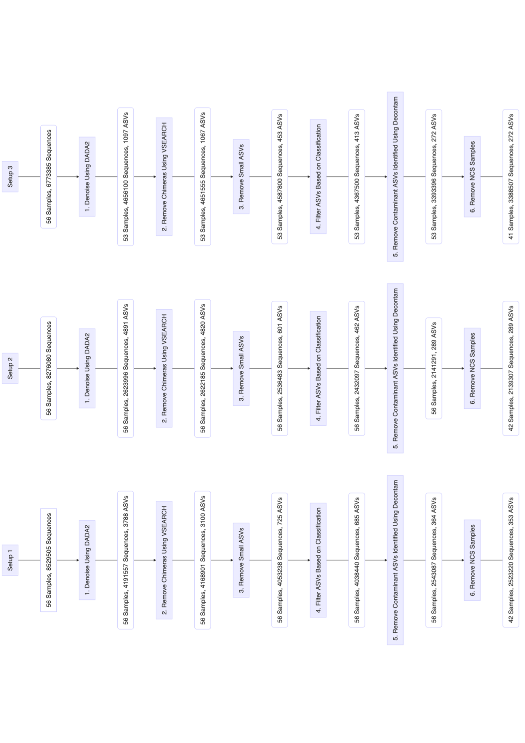
Additional File 1: Figure S.1.

Figure S.1. Comparison of the number of sequences and amplicon sequence variants (ASVs), retained at each bioinformatic filtering step for procedural samples (PSB, PBAL, OW, NCS) collected from 14 participants (n=56). Setup 1 (2-step PCR; V3 V4 region), Setup 2 (2-step PCR; V4 region), Setup 3 (1-step PCR; V4 region).

