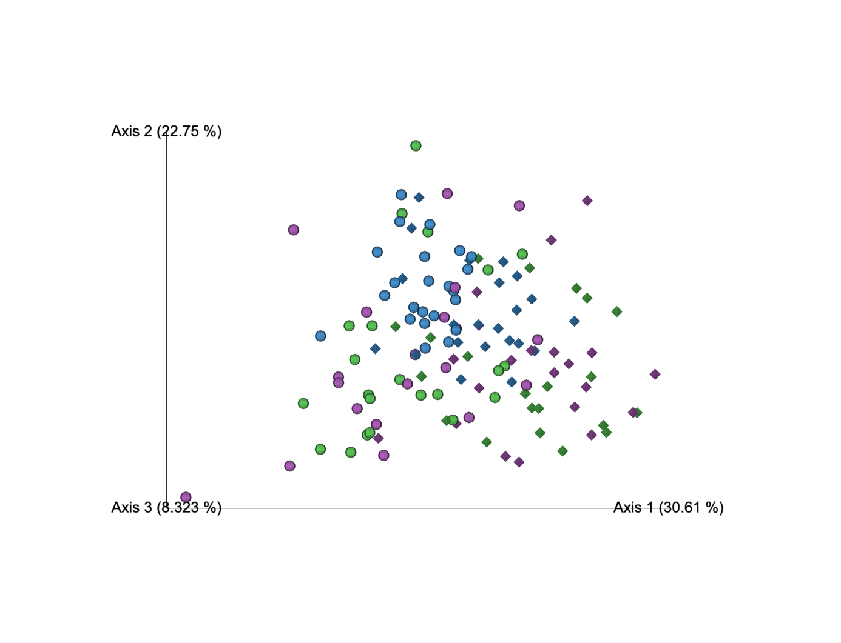

Supplementary Figure 4. Principal coordinates anaysis on weighted UniFrac distances for procedural samples sequenced following setup 2 (sphere) and 3 (diamond) after the removal of Decontam contaminants. Rarefaction depth: 1139 sequences. Setup 2 samples include OW: n=23; PBAL: n=22; PSB: n=20 and setup 3 samples include OW: n=23; PBAL: n=21; PSB: n=21. Oral wash (OW): blue; Protected bronchoalveolar lavage (PBAL): green; Protected specimen brushes (PSB): purple. Setup 2 (2-step PCR; V4 region), Setup 3 (1-step PCR; V4 region).

