Additional File 2: Manhattan plots using the PTA as phenotype for hypocalcemia (CALC), displaced abomasum (DSAB), ketosis (KETO), mastitis (MAST), metritis (METR), retained placenta (RETP) and cow livability. The genome-wide threshold (red line) corresponds to the Bonferroni correction for a nominal P-value = 0.05.
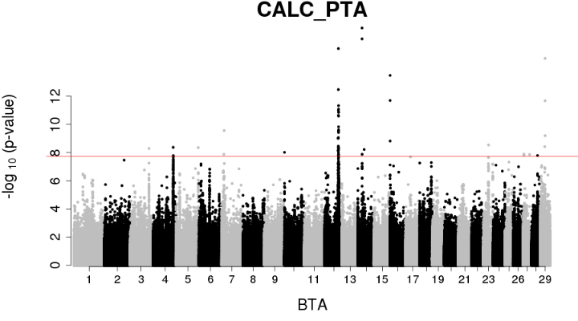 | 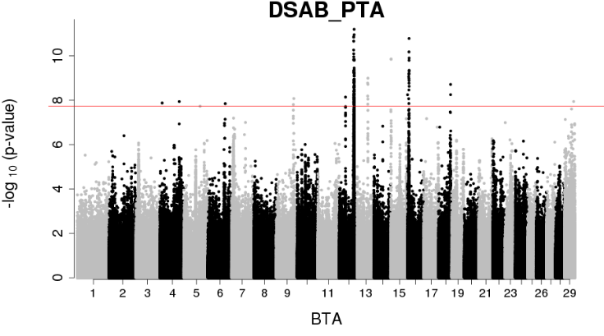
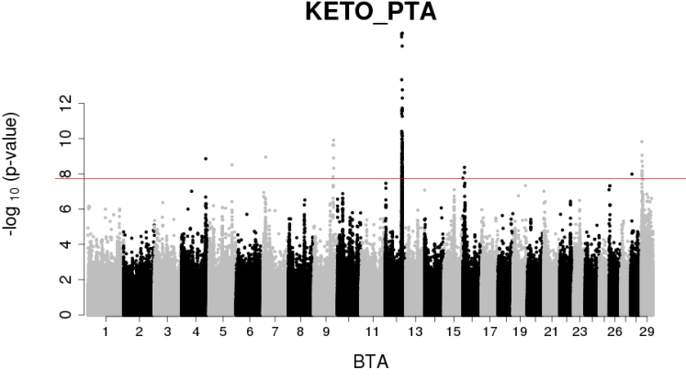 | 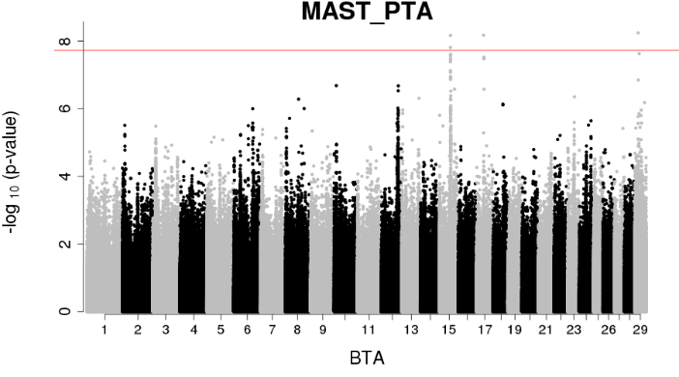
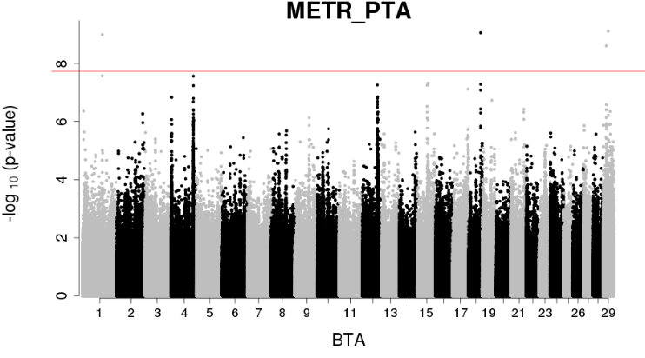 | 