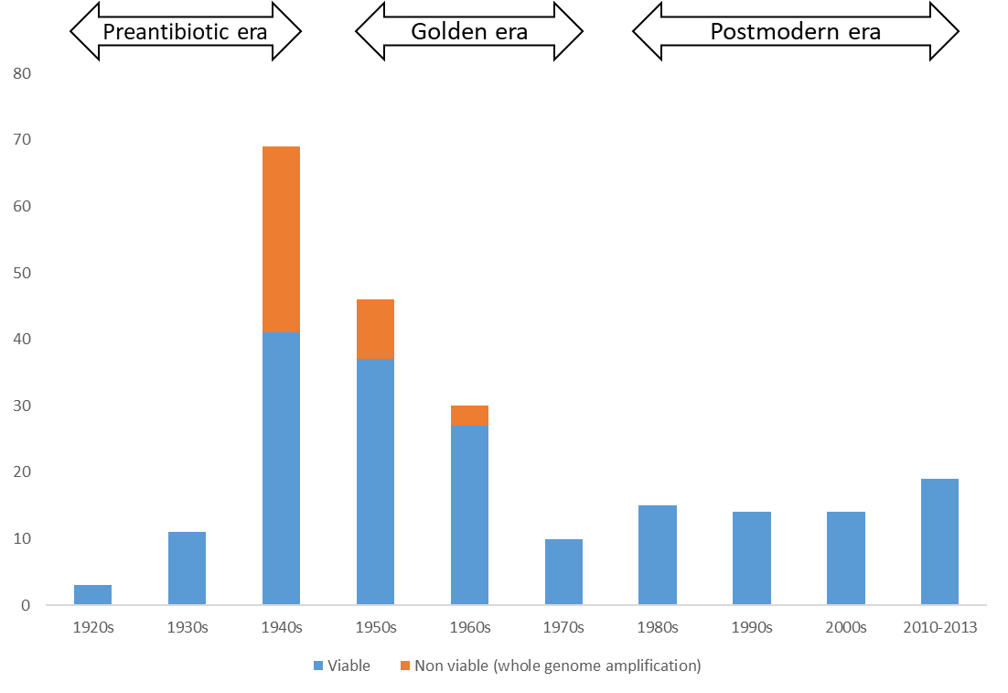
Figure S1. Number of whole genome sequenced Neisseria gonorrhoeae specimens per decade.

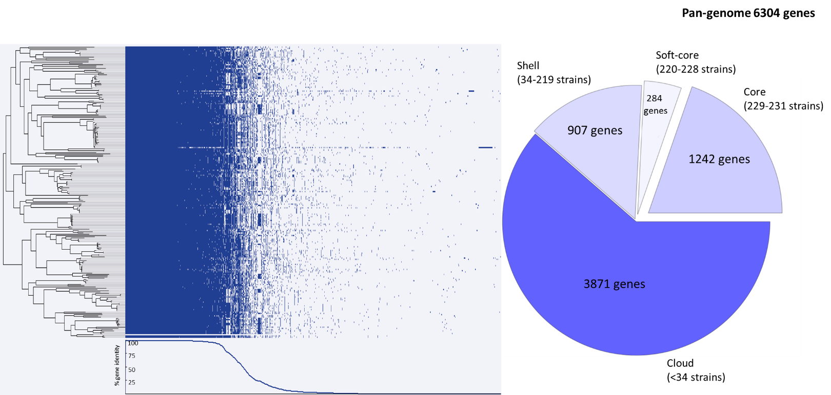
Figure S2. Pan-genome of all Neisseria gonorrhoeae specimens (n=231) showing the core genome of 1242 genes that were conserved over nine decades. Core= ≥99-100% of isolates share genes. Soft-core= ≥95-<99% of isolates share genes. Shell= ≥15-<95% of isolates share genes. Cloud= ≥0-<15% of isolates share genes.

