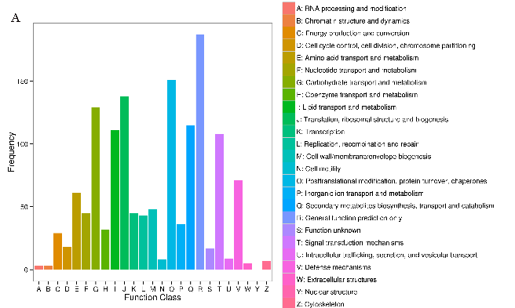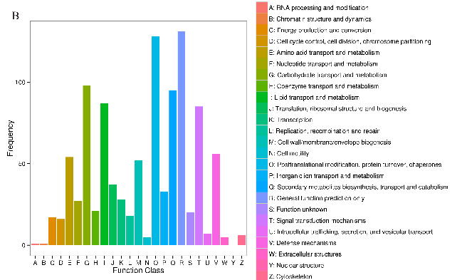

Additional file 12 Functional classification of DEGs according to COG database
Note: A represented the DEGs and all genes after the exposure of LC₃₀ fluralaner, B represented the DEGs and all genes after the exposure of LC₅₀ fluralaner, respectively.

