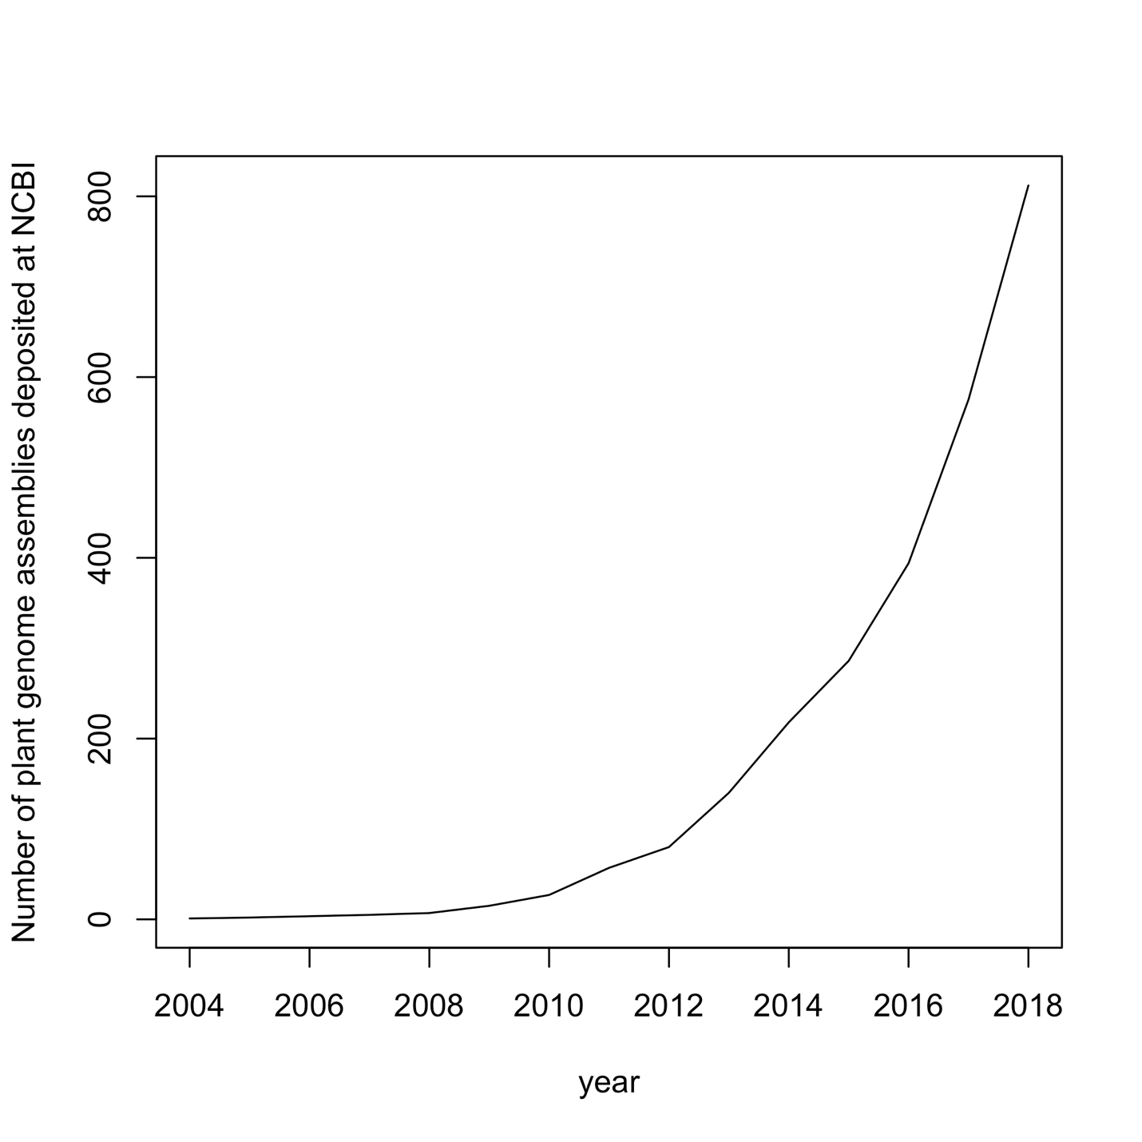
Figure S1: Exponential growth in the number of plant genome assemblies deposited in the NCBI Assembly database from November 2004 through December 2018.

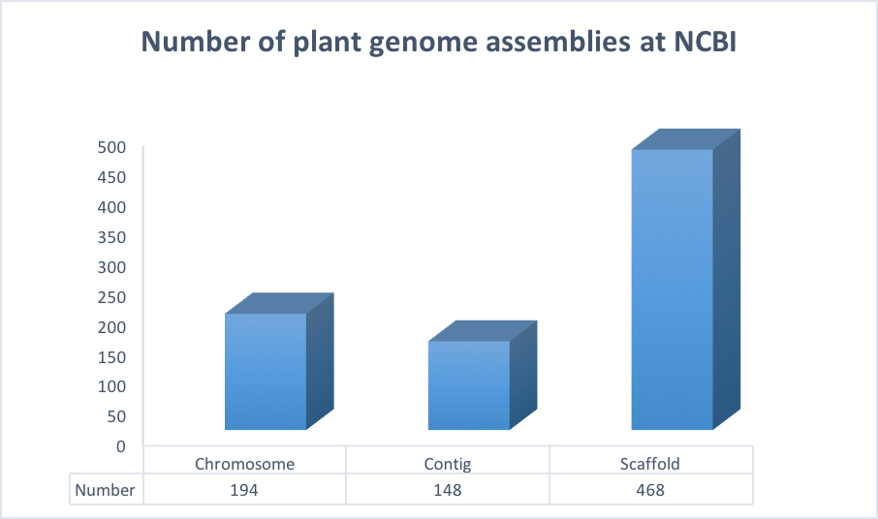

Figure S2. Number of plant genome assemblies in the NCBI Assembly Database at each level of assembly contiguity.

