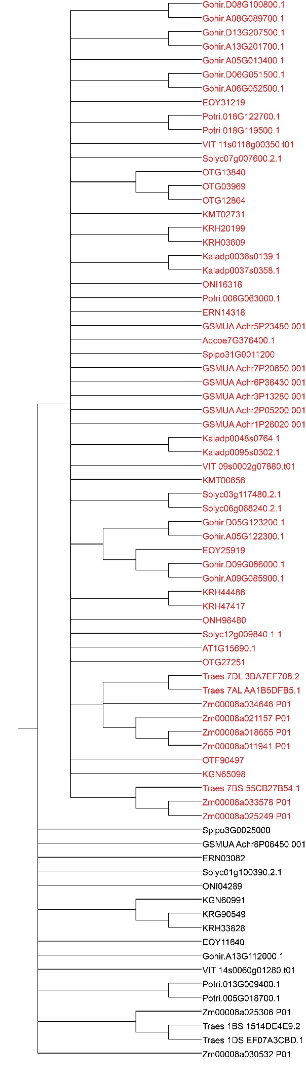
Additional file 10, phylogenetic trees used in positive selection analysis of type Ia.

