Additional file 4, genetic positions of 124 members in the background of family's seed alignment tree.

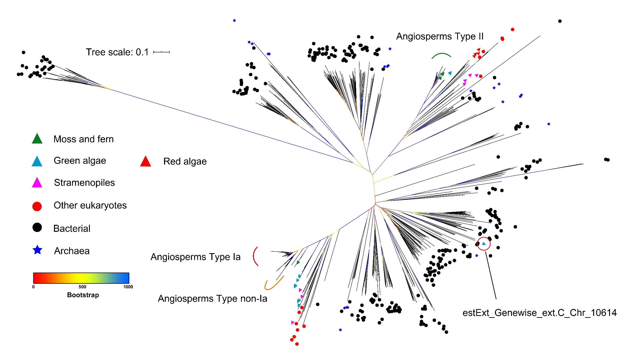
The legend shows the proteins from different species groups. The curves of different colors show the position of subtypes of gene family members in angiosperms. Bootstrap supports are indicated by the color of the branches.

