Fig. S1 Motif distribution in CsATG8s subfamily members of the tea plant, Arabidorpsis, Oryza sativa, Malus domestica Saccharomyces cerevisiae and Humans. Different motifs are represented by various colors.

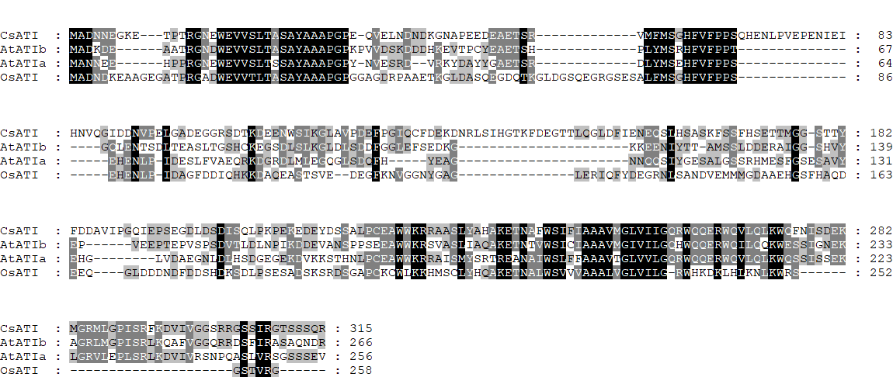

Fig. S2 Alignment analysis of CsATI with AtATIs and OsATI. The TM-HMM-predicted transmembrane helix of CsATI1 (242-259) are highlighted with a yellow box. The putative N-terminal and C-terminal AIMs are highlighted with red boxes.

