Supplementary Information

SARS-CoV-2 early infection signature identified potential key infection mechanisms and drug targets

Yue Li¹, Ashley Duche¹, Michael R. Sayer¹, Don Roosan², Farid G. Khalafalla³, Rennolds S. Ostrom¹, Jennifer Totonchy¹, Moom R. Roosan¹

¹Chapman University School of Pharmacy, Irvine, CA 92618
² Western University of Health Sciences, College of Pharmacy, Pomona, CA 91766
³California Health Sciences University, College of Pharmacy, Clovis, CA 93612

Table of Contents

Fig. S1. Leave-one-out-cross-validation scatter plot showing SARS-CoV-2 infection activity in the training cell line samples………………………………………………………...................3

Fig. S2. The key (top-scoring) 16 bio-functions in four series of data infected with SARS-CoV-2 were obtained through Ingenuity Pathway Analysis (IPA). ……………………………...........4

Fig. S3. Uniform Manifold Approximation and Projection (UMAP) plot of cells from bronchoalveolar lavage fluid cells (n=12) show distinct clusters predominantly determined by cell type. ………………………………………………………………………………………..5

Fig. S4. Expression of signature genes in basal cells from patient groups………………..........6

Fig. S5. Expression of signature genes in dendritic cells from patient groups…………………7

Fig. S6. Expression of signature genes in macrophages from patient groups………..................8

Fig. S7. Expression of signature genes in naïve CD4+ T cells from patient groups…………....9

Fig. S8. Expression of signature genes in natural killer cells from patient groups………………………………………………………………………………………….10

Fig. S9. Expression of signature genes in plasma cells from patient groups. …………...........11

Fig. S10. Expression of signature genes in T cells from patient groups. ………………..........12

Fig. S11. Connectivity Scores (CSs) for Genetic perturbations with the 25-gene SARS-CoV-2 Infection Signature…………………………………………………………………….............13

Fig. S12. Data processing steps used in SARS-CoV-2 gene expression signature generation, testing and validation in various datasets……………………………………….......................14

Table S1: Cell markers used to identify cell types in single-cell RNA-Sequencing dataset GSE145926…………………………………………………………………………………….15

Table S2. Selected Connectivity Score (CS) with the 25-gene SARS-CoV-2 infection signature from the ConnectivityMap (CMAP) database…………………………………………………16

Table S3: Description of the samples from GSE147507 used for SARS-CoV-2 signature generation and internal validation………………………………………………………………34

Table S4: Description of the external validation human datasets used for SARS-CoV-2 signature…………………………………………………………………………………………35

References ………………………………………………………………………………………36

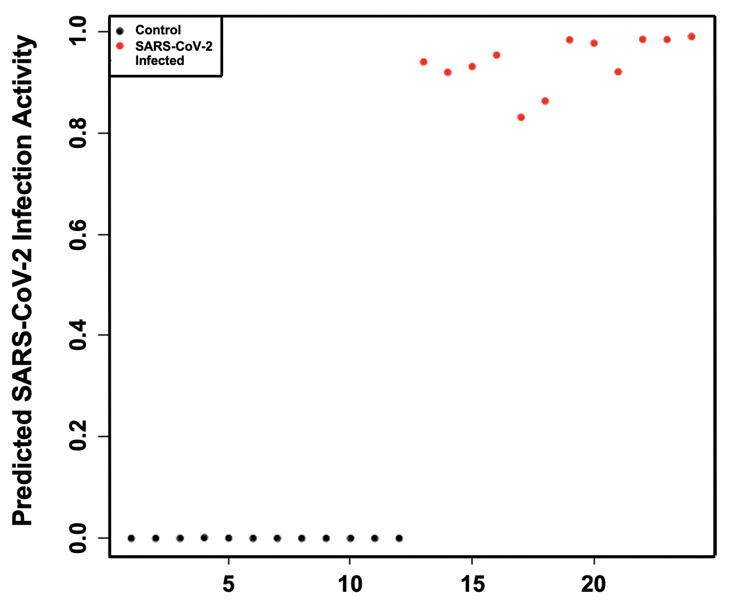

Fig. S1. Leave-one-out-cross-validation scatter plot showing SARS-CoV-2 infection activity in the training cell line samples. Values of zero represent no infection activity and one represents high infection activity.

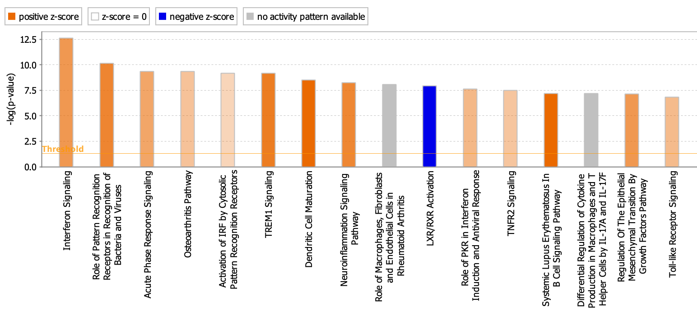

Fig. S2. The key (top-scoring) 16 bio-functions in four series of data infected with SARS-CoV-2 were obtained through Ingenuity Pathway Analysis (IPA). The most statistically significant bio-functions that were identified in the IPA infected analysis are listed here according to their P-value (-log). The threshold line corresponds to a P-value of 0.05.

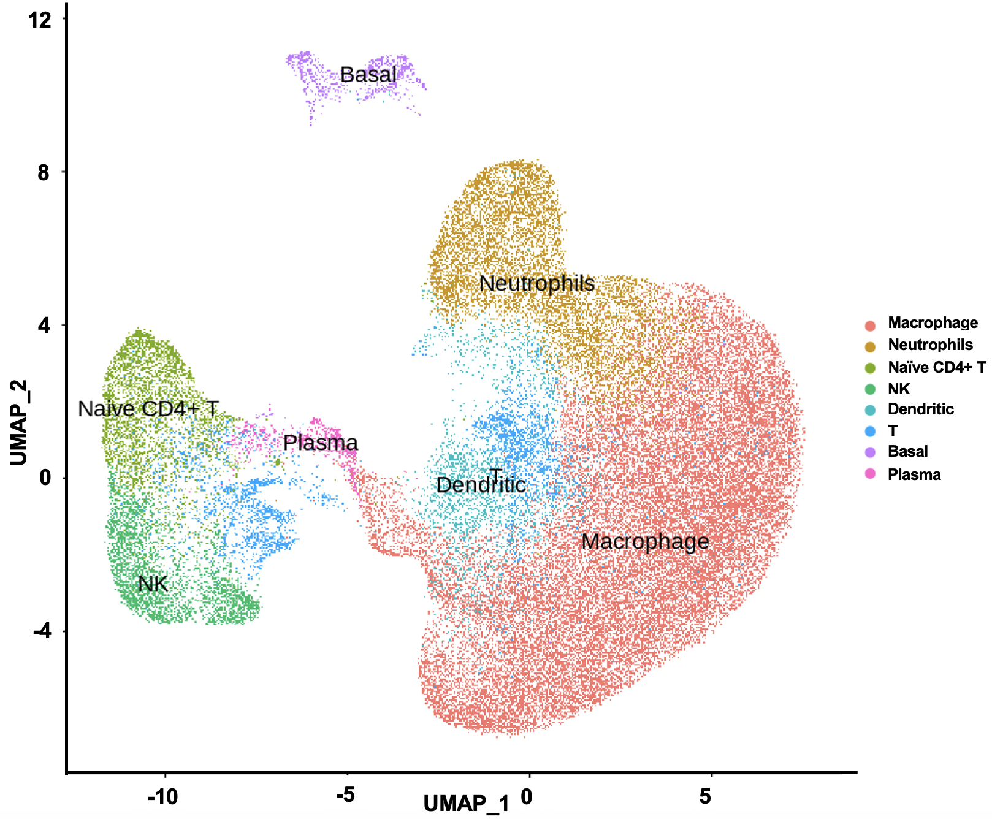

Fig. S3. Uniform Manifold Approximation and Projection (UMAP) plot of cells from bronchoalveolar lavage fluid cells (n=12) show distinct clusters predominantly determined by cell type. Each dot corresponds to a single cell and is colored according to cell type.

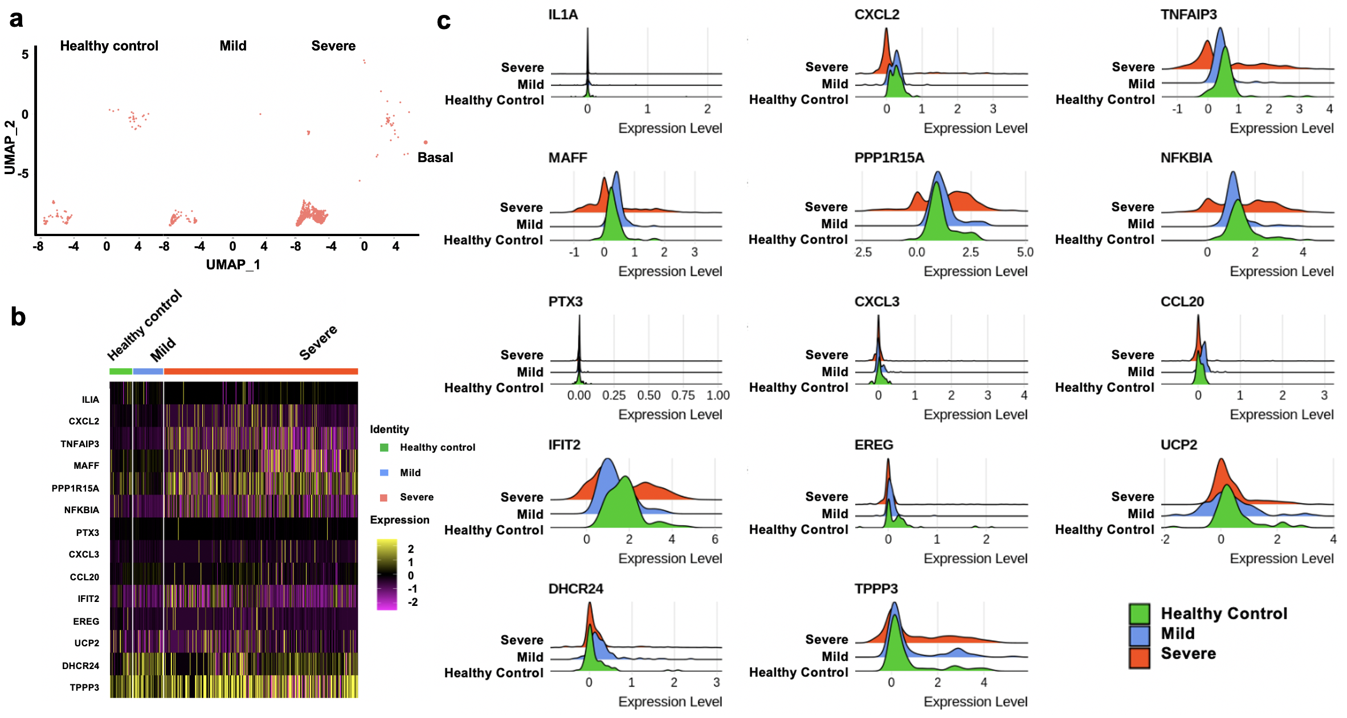

Fig. S4. Expression of signature genes in basal cells from patient groups. a, UMAP plots of the basal cells. Each dot corresponds to one single cell. b, Heatmap of fourteen signature genes in three groups. Each vertical bar represents a single cell. Column (cell identity) width is proportional to the number of cells present in that cluster. c, Distributions of signature gene expression shown in ridge plots. Red, blue and green colors represent gene expression values in severe, mild patients and healthy controls.

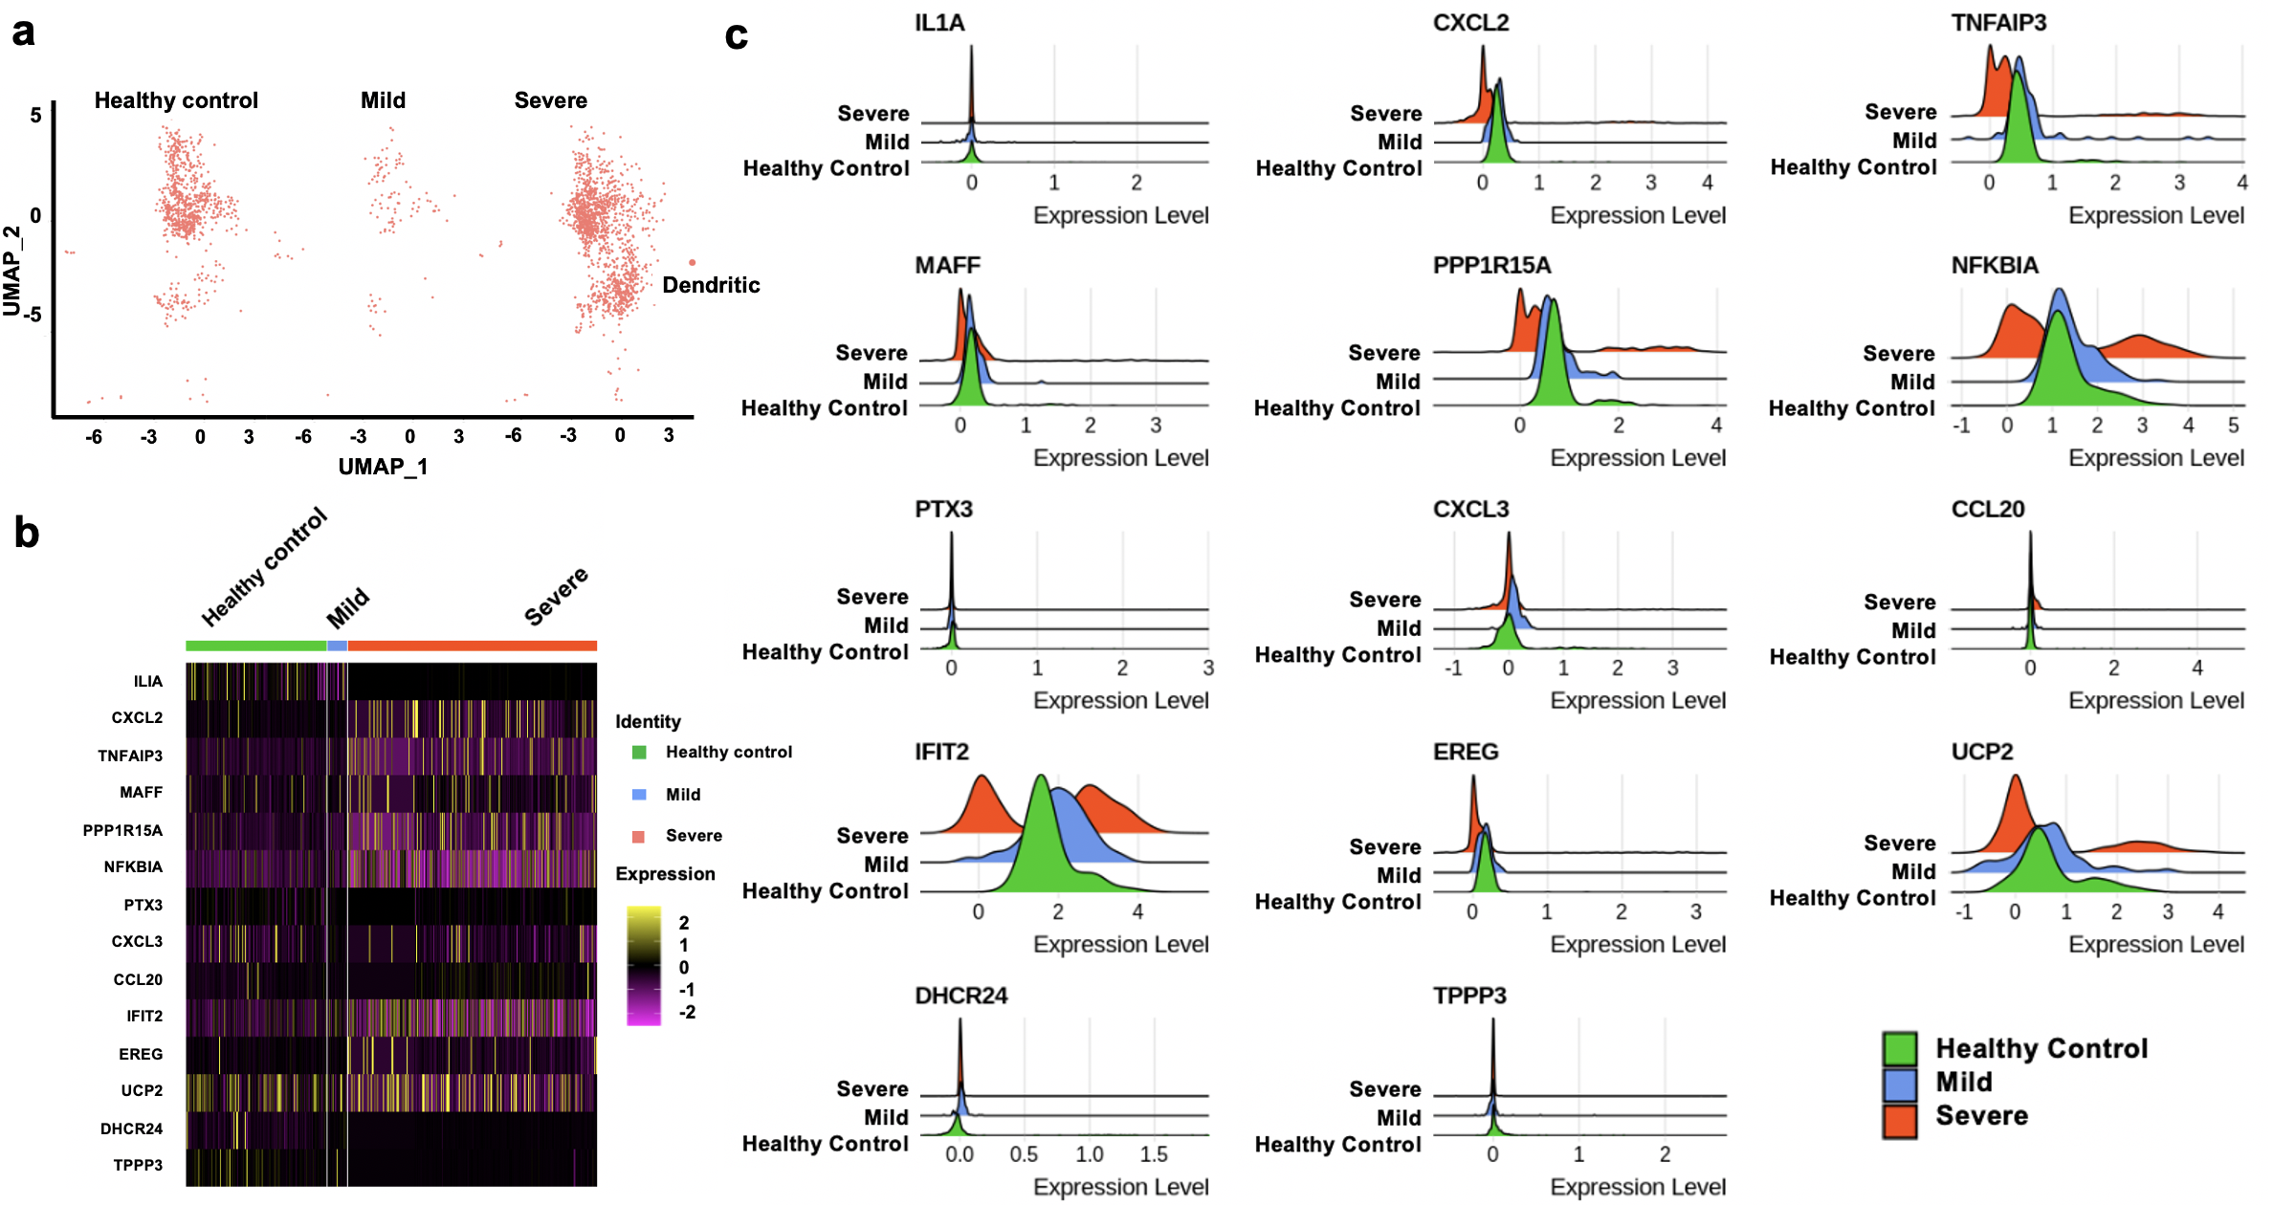

Fig. S5. Expression of signature genes in dendritic cells from patient groups. a, UMAP plots of the dendritic cells. Each dot corresponds to one single cell. b, Heatmap of fourteen signature genes in three groups. Each vertical bar represents a single cell. Column (cell identity) width is proportional to the number of cells present in that cluster. c, Distributions of signature gene expression shown in ridge plots. Red, blue and green colors represent gene expression values in severe, mild patients and healthy controls.

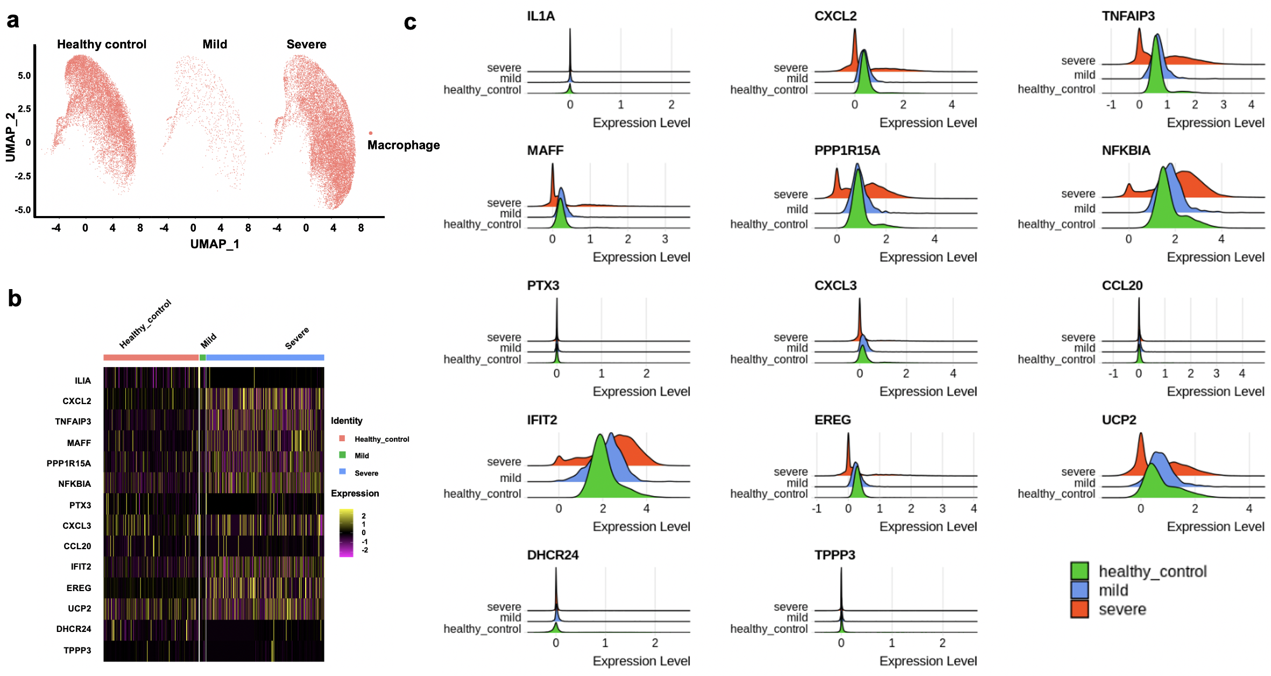

Fig. S6. Expression of signature genes in macrophages from patient groups. a, UMAP plots of the macrophage cells. Each dot corresponds to one single cell. b, Heatmap of fourteen signature genes in three groups. Each vertical bar represents a single cell. Column (cell identity) width is proportional to the number of cells present in that cluster. c, Distributions of signature gene expression shown in ridge plots. Red, blue and green colors represent gene expression values in severe, mild patients and healthy controls.

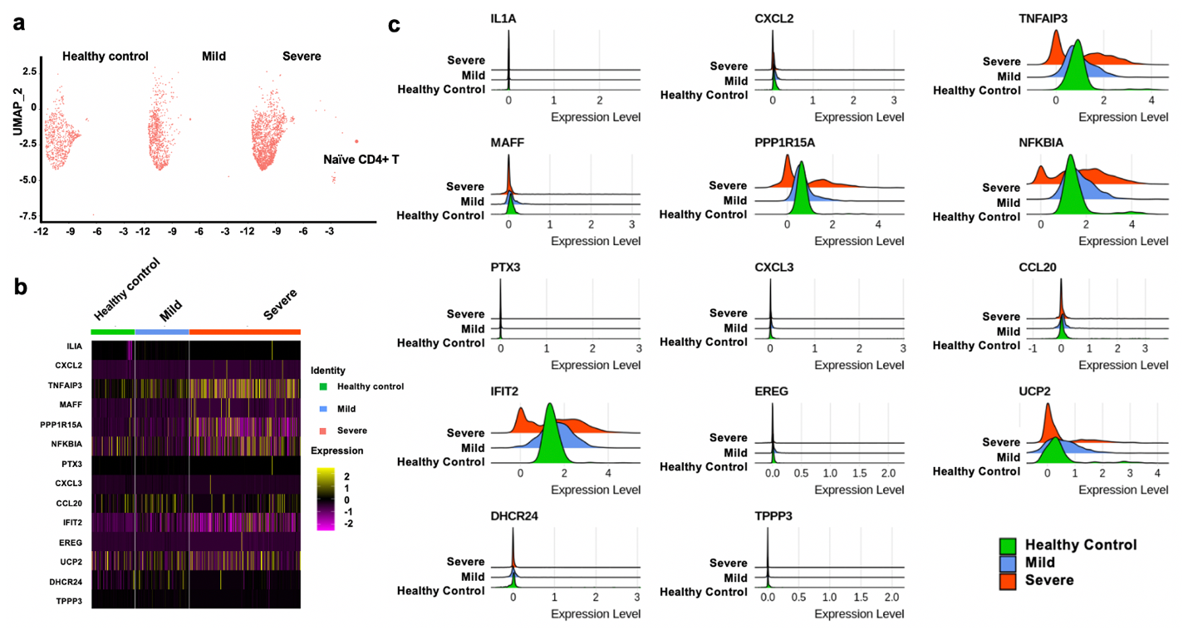

Fig. S7. Expression of signature genes in naïve CD4+ T cells from patient groups. a, UMAP plots of the naïve CD4+ T cells. Each dot corresponds to one single cell. b, Heatmap of fourteen signature genes in three groups. Each vertical bar represents a single cell. Column (cell identity) width is proportional to the number of cells present in that cluster. c, Distributions of signature gene expression shown in ridge plots. Red, blue and green colors represent gene expression values in severe, mild patients and healthy controls.

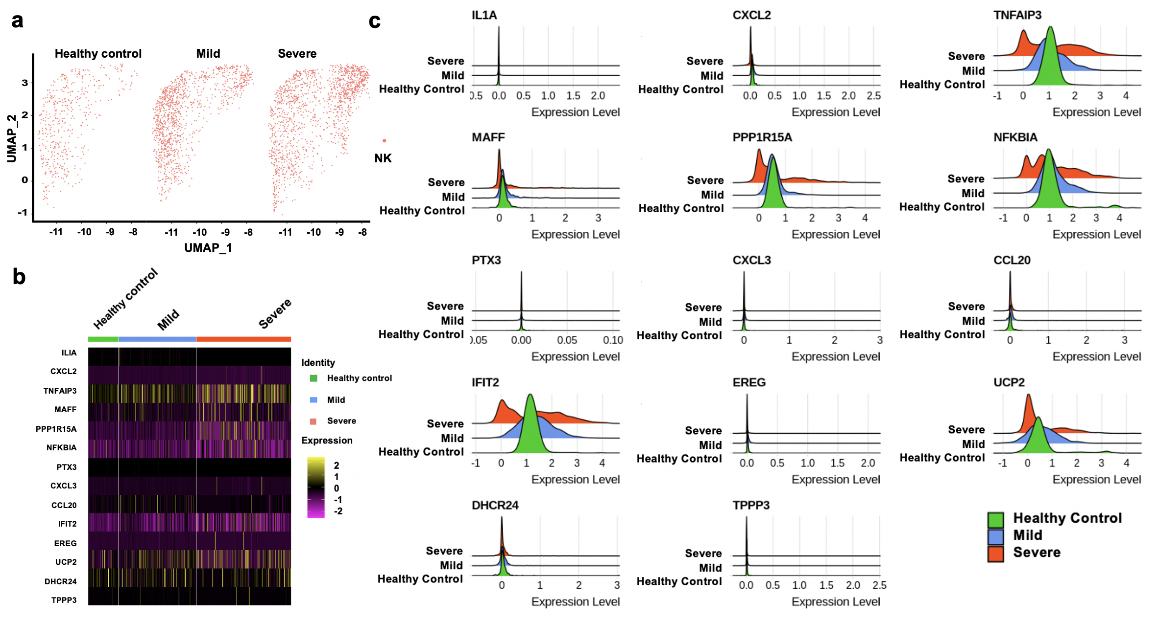

Fig. S8. Expression of signature genes in natural killer (NK) cells from patient groups. a, UMAP plots of the natural killer cells. Each dot corresponds to one single cell. b, Heatmap of fourteen signature genes in three groups. Each vertical bar represents a single cell. Column (cell identity) width is proportional to the number of cells present in that cluster. c, Distributions of signature gene expression shown in ridge plots. Red, blue and green colors represent gene expression values in severe, mild patients and healthy controls.

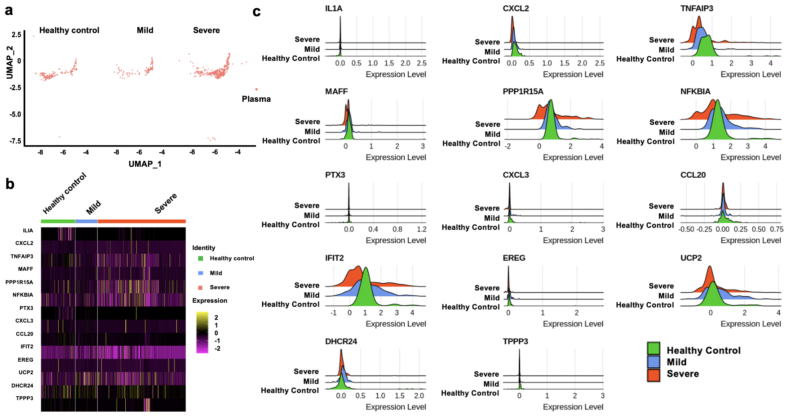

Figure S9. Expression of signature genes in plasma cells from patient groups. a, UMAP plots of the plasma cells. Each dot corresponds to one single cell. b, Heatmap of fourteen signature genes in three groups. Each vertical bar represents a single cell. Column (cell identity) width is proportional to the number of cells present in that cluster. c, Distributions of signature gene expression shown in ridge plots. Red, blue and green colors represent gene expression values in severe, mild patients and healthy controls.

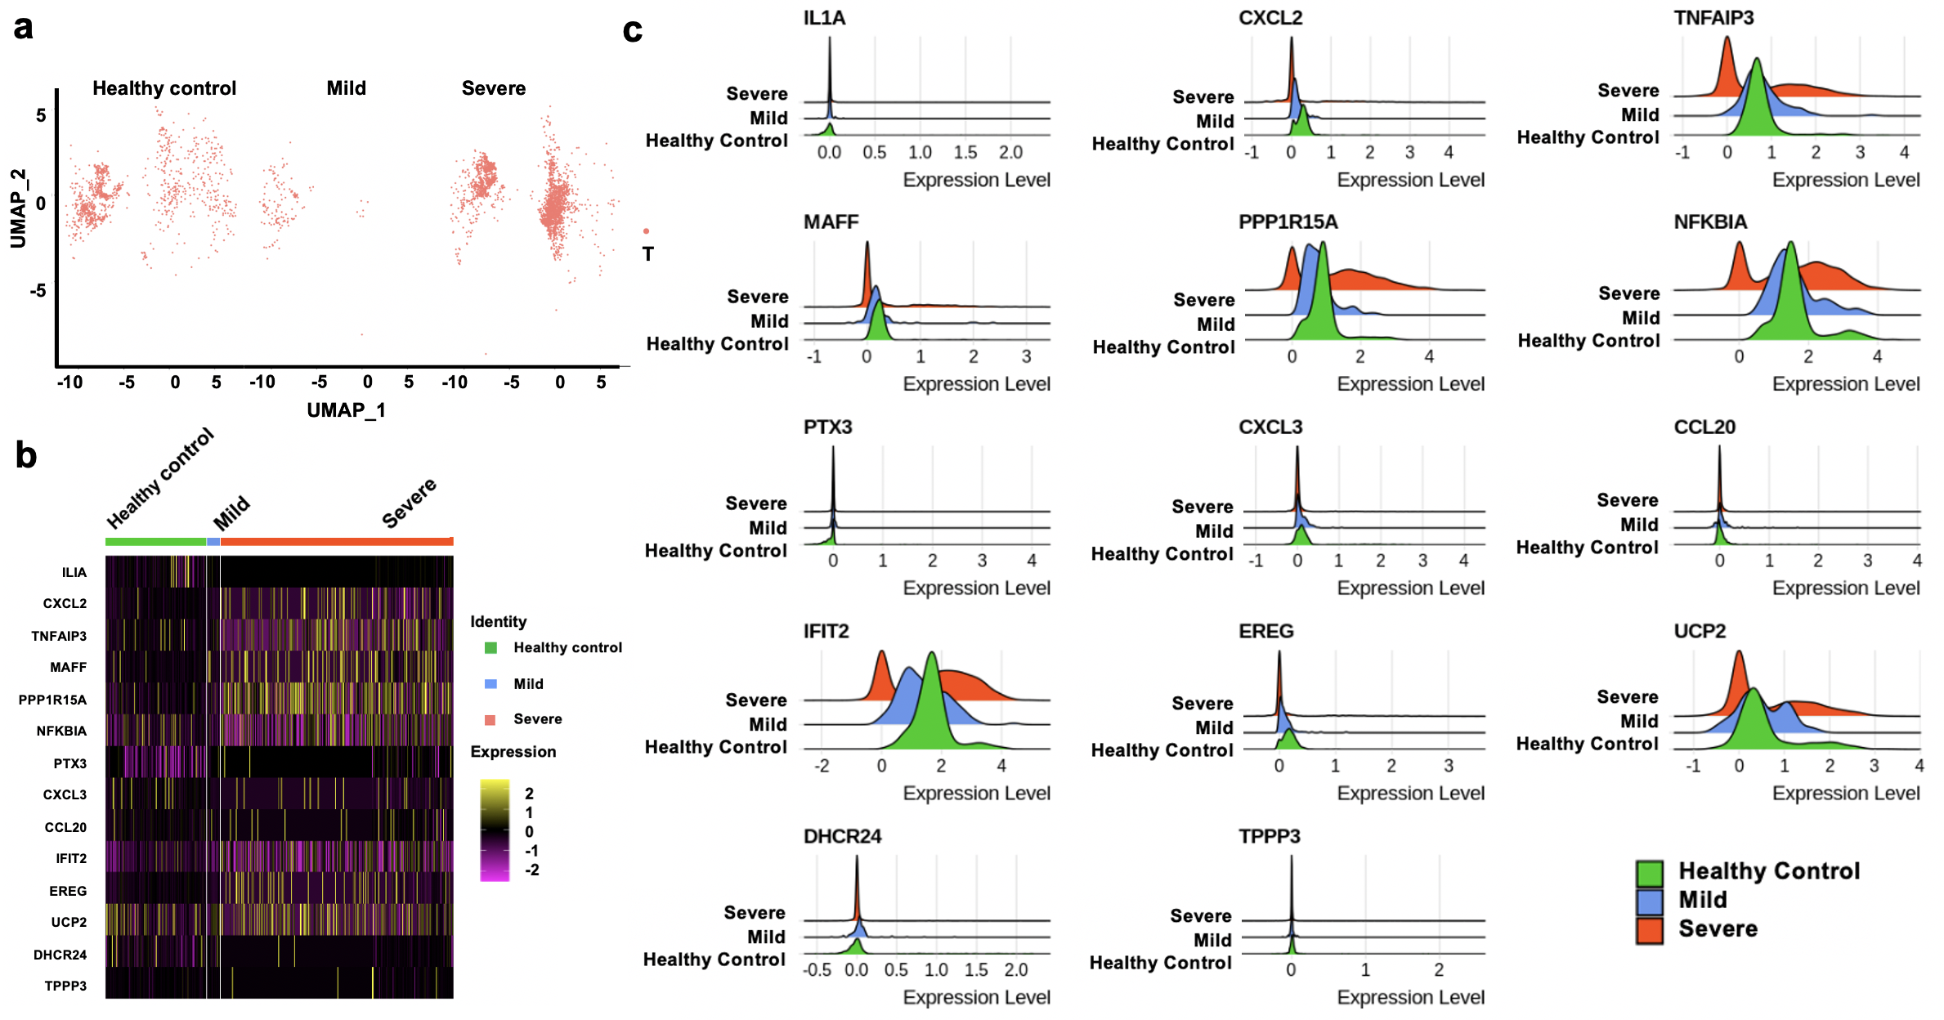

Fig. S10. Expression of signature genes in T cells from patient groups. a, UMAP plots of the T cells. b, Heatmap of signature genes in three groups. Each vertical bar represents a single cell. Column (cell identity) width is proportional to the number of cells present in that cluster. c, Distributions of gene expression signature were shown in ridge plots. Red, blue and green colors represent gene expression values in severe, mild patients and healthy controls.

Fig. S11. Connectivity Scores (CSs) for Genetic perturbations with the 25-gene SARS-CoV-2 Infection Signature. Red color bars represent CS > 95 and blue color bar represent CS < -95 for gene overexpression and knockdown signatures, respectively.

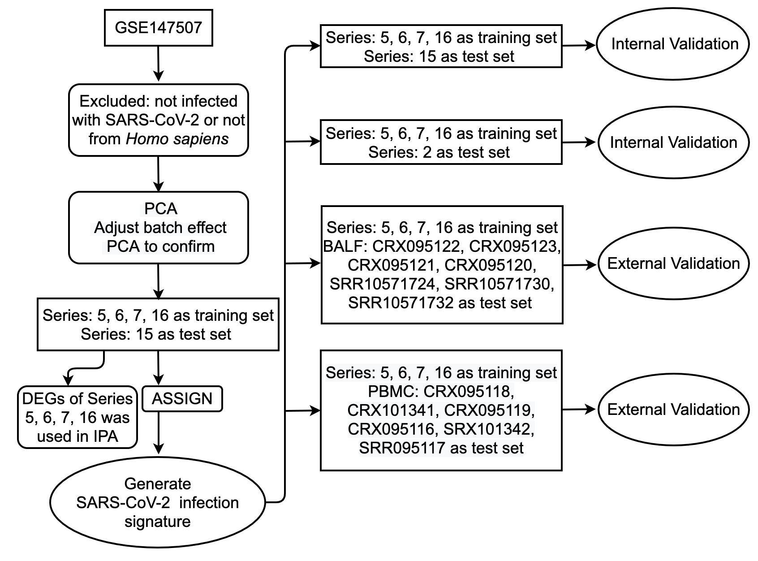

Fig. S12. Data processing steps used in SARS-CoV-2 gene expression signature generation, testing and validation in various datasets. PCA: principal component analysis, DEGs: differentially expressed genes, IPA: Ingenuity Pathway Analysis, BALF: bronchoalveolar lavage fluid, PBMC: peripheral blood mononuclear cell.
Supplementary Tables:

Table S1: Cell markers used to identify cell types in single-cell RNA-Sequencing dataset GSE145926.

Cell Type | Cell Marker
Macrophages  Basal cells | CD68 [1]  S1000A14 [2], KRT6A [3]
Dendritic cells  Naive CD4 T cells  Neutrophils  Natural killer cells | IRF7 [4]  IL7R [5]  FCGR3B [6]  CCL5 [7], CD7 [8]
Plasma cells | JCHAIN [9]
T cells | CD3D [10]

Table S2: Selected Connectivity Score (CS) with the 25-gene SARS-CoV-2 infection signature from the ConnectivityMap (CMAP) database.

 | CMAP Rank | Score | Type | ID | Name | Description
1 | 8559 | -99.37 | kd | CGS001-6856 | SYPL1 | -
2 | 8558 | -99.34 | kd | CGS001-4712 | NDUFB6 | Mitochondrial respiratory chain complex / Complex I
3 | 8557 | -99.12 | cp | BRD-K49865102 | PD-0325901 | MEK inhibitor
4 | 8556 | -99.08 | kd | CGS001-23429 | RYBP | -
5 | 8555 | -99.01 | cp | BRD-K74236984 | UNC-0321 | Histone lysine methyltransferase inhibitor
6 | 8554 | -98.95 | kd | CGS001-56834 | GPR137 | GPCR / Unclassified: 7TM orphan receptors
7 | 8553 | -98.92 | kd | CGS001-9128 | PRPF4 | WD repeat domain containing
8 | 8552 | -98.7 | cp | BRD-K62810658 | PD-98059 | MEK inhibitor
9 | 8550 | -98.69 | cc |  | MEK inhibitor | -
10 | 8551 | -98.69 | kd | CGS001-930 | CD19 | CD molecules
11 | 8549 | -98.66 | kd | CGS001-8477 | GPR65 | GPCR / Class A: Orphans
12 | 8548 | -98.63 | cp | BRD-K12244279 | MEK1-2-inhibitor | MEK inhibitor
13 | 8547 | -98.53 | kd | CGS001-3576 | IL8 | -
14 | 8546 | -98.45 | cp | BRD-K48722833 | iloperidone | Dopamine receptor antagonist
15 | 8545 | -98.37 | kd | CGS001-22934 | RPIA | -
16 | 8544 | -98.31 | cp | BRD-U73238814 | QL-XI-92 | DDR1 inhibitor
17 | 8543 | -98.21 | kd | CGS001-8148 | TAF15 | RNA binding motif (RRM) containing
18 | 8542 | -98.13 | cp | BRD-A11702965 | chromomycin-a3 | DNA binding agent
19 | 8541 | -98 | cp | BRD-U88459701 | atorvastatin | HMGCR inhibitor
20 | 8540 | -97.98 | kd | CGS001-10336 | PCGF3 | Polycomb group ring fingers
21 | 8539 | -97.97 | kd | CGS001-4047 | LSS | Lanosterol biosynthesis pathway
22 | 8538 | -97.87 | kd | CGS001-2920 | CXCL2 | Endogenous ligands
23 | 8537 | -97.63 | kd | CGS001-894 | CCND2 | -
24 | 8536 | -97.59 | cp | BRD-K41895714 | AS-605240 | PI3K inhibitor
25 | 8535 | -97.57 | kd | CGS001-3654 | IRAK1 | Interleukin-1 receptor-associated kinase (IRAK) family
26 | 8534 | -97.53 | kd | CGS001-9170 | LPAR2 | GPCR / Class A: Lysophospholipid receptors: Lysophosphatidic acid
27 | 8533 | -97.37 | kd | CGS001-23039 | XPO7 | Exportins
28 | 8532 | -97.36 | kd | CGS001-27102 | EIF2AK1 | Other PEK family kinases
29 | 8531 | -97.3 | kd | CGS001-5029 | P2RY2 | GPCR / Class A: Purinergic receptors, P2Y
30 | 8530 | -97.29 | kd | CGS001-8864 | PER2 | -
31 | 8529 | -97.18 | kd | CGS001-10447 | FAM3C | -
32 | 8528 | -97.13 | cp | BRD-A13122391 | triptolide | RNA polymerase inhibitor
33 | 8527 | -97.03 | kd | CGS001-23636 | NUP62 | -
34 | 8526 | -96.89 | kd | CGS001-10892 | MALT1 | Immunoglobulin superfamily / Immunoglobulin-like domain containing
35 | 8525 | -96.63 | kd | CGS001-688 | KLF5 | Kruppel-like transcription factors
36 | 8524 | -96.62 | cp | BRD-U51951544 | ZG-10 | JNK inhibitor
37 | 8522 | -96.6 | kd | CGS001-1457 | CSNK2A1 | Casein kinase 2 (CK2) family
38 | 8523 | -96.6 | kd | CGS001-468 | ATF4 | basic leucine zipper proteins
39 | 8521 | -96.48 | cp | BRD-M16762496 | PIK-75 | DNA protein kinase inhibitor
40 | 8520 | -96.43 | cp | BRD-K21680192 | mitoxantrone | Topoisomerase inhibitor
41 | 8519 | -96.36 | kd | CGS001-3373 | HYAL1 | -
42 | 8518 | -96.35 | oe | ccsbBroad304_01061 | NAB2 | -
43 | 8517 | -96.22 | cp | BRD-K53414658 | tivozanib | VEGFR inhibitor
44 | 8516 | -96.02 | kd | CGS001-3597 | IL13RA1 | IL-2 receptor family
45 | 8515 | -95.88 | cp | BRD-K57080016 | selumetinib | MEK inhibitor
46 | 8514 | -95.87 | cp | BRD-K29113274 | ketoconazole | Sterol demethylase inhibitor
47 | 8513 | -95.81 | cp | BRD-K55127134 | fluphenazine | Dopamine receptor antagonist
48 | 8512 | -95.59 | kd | CGS001-23013 | SPEN | RNA binding motif (RRM) containing
49 | 8511 | -95.58 | kd | CGS001-10342 | TFG | -
50 | 8510 | -95.52 | oe | ccsbBroad304_06198 | FCGR2A | CD molecules
51 | 8509 | -95.45 | cp | BRD-K19540840 | saracatinib | SRC inhibitor
52 | 8508 | -95.4 | cp | BRD-K68202742 | trichostatin-a | HDAC inhibitor
53 | 8507 | -95.26 | cp | BRD-K74761218 | WT-171 | HDAC inhibitor
54 | 8506 | -95.17 | cp | BRD-U44618005 | WH-4023 | SRC inhibitor
55 | 8505 | -95.11 | cc |  | SRC inhibitor | -
56 | 8504 | -95.06 | cp | BRD-K14965640 | ibuprofen | Cyclooxygenase inhibitor
57 | 8503 | -94.87 | cp | BRD-K59184148 | SB-216763 | Glycogen synthase kinase inhibitor
58 | 8502 | -94.86 | kd | CGS001-25805 | BAMBI | -
59 | 8501 | -94.8 | kd | CGS001-9124 | PDLIM1 | -
60 | 8500 | -94.72 | kd | CGS001-8835 | SOCS2 | SH2 domain containing
61 | 8499 | -94.44 | kd | CGS001-5526 | PPP2R5B | Serine/threonine phosphatases / Protein phosphatase 2, regulatory subunits
62 | 8498 | -94.27 | kd | CGS001-51135 | IRAK4 | Interleukin-1 receptor-associated kinase (IRAK) family
63 | 8497 | -94.13 | kd | CGS001-5867 | RAB4A | RAB, member RAS oncogene
64 | 8496 | -94.11 | kd | CGS001-9231 | DLG5 | -
65 | 8495 | -93.94 | kd | CGS001-85377 | MICALL1 | -
66 | 8494 | -93.92 | kd | CGS001-22841 | RAB11FIP2 | -
67 | 8493 | -93.72 | kd | CGS001-4352 | MPL | Prolactin receptor family
68 | 8492 | -93.66 | cp | BRD-K15791587 | L-733060 | Tachykinin antagonist
69 | 8491 | -93.59 | kd | CGS001-29775 | CARD10 | -
70 | 8490 | -93.34 | oe | ccsbBroad304_07272 | PPAP2B | Lipid phosphate phosphatases
71 | 8489 | -93.15 | cp | BRD-K81418486 | vorinostat | HDAC inhibitor
72 | 8488 | -93.13 | cp | BRD-K69840642 | ISOX | HDAC inhibitor
73 | 8487 | -93.07 | cp | BRD-A39646320 | HC-toxin | HDAC inhibitor
74 | 8486 | -93.01 | oe | ccsbBroad304_01579 | SOX2 | SRY (sex determining region Y)-boxes
75 | 8485 | -92.96 | cp | BRD-K68756823 | FR-180204 | -666
76 | 8483 | -92.93 | oe | ccsbBroad304_06847 | RBBP4 | WD repeat domain containing
77 | 8484 | -92.93 | kd | CGS001-80025 | PANK2 | -
78 | 8482 | -92.91 | oe | ccsbBroad304_01540 | SLC2A1 | Solute carriers
79 | 8481 | -92.88 | kd | CGS001-639 | PRDM1 | Zinc fingers, C2H2-type
80 | 8480 | -92.67 | kd | CGS001-3459 | IFNGR1 | Interferon receptor family
81 | 8479 | -92.61 | cc |  | NADH ubiquinone oxidoreductase supernumerary subunits LOF | -
82 | 8478 | -92.58 | kd | CGS001-200734 | SPRED2 | -
83 | 8477 | -92.57 | cp | BRD-K94176593 | TWS-119 | Glycogen synthase kinase inhibitor
84 | 8476 | -92.52 | cp | BRD-A81795050 | U-18666A | Oxidosqualene cyclase inhibitor
85 | 8474 | -92.45 | kd | CGS001-55033 | FKBP14 | EF-hand domain containing
86 | 8475 | -92.45 | kd | CGS001-159 | ADSS | -
87 | 8473 | -92.39 | kd | CGS001-51478 | HSD17B7 | Short chain dehydrogenase/reductase superfamily / Classical SDR fold cluster 2
88 | 8472 | -92.36 | cp | BRD-K23875128 | RHO-kinase-inhibitor-III [rockout] | Rho associated kinase inhibitor
89 | 8471 | -92.35 | cp | BRD-K52522949 | NCH-51 | HDAC inhibitor
90 | 8470 | -92.34 | cp | BRD-K03319035 | maprotiline | Norepinephrine reuptake inhibitor
91 | 8469 | -92.3 | kd | CGS001-10919 | EHMT2 | Histone methyltransferases
92 | 8468 | -92.24 | cp | BRD-K99964838 | bosutinib | ABL inhibitor
93 | 8467 | -92.15 | kd | CGS001-7625 | ZNF74 | Zinc fingers, C2H2-type
94 | 8466 | -92.02 | kd | CGS001-91137 | SLC25A46 | Miscellaneous SLC25 mitochondrial transporters
95 | 8465 | -92.01 | cc |  | Tricyclic antidepressant | -
96 | 8464 | -92 | kd | CGS001-2589 | GALNT1 | Glycosyltransferase family 2 domain containing
97 | 8463 | -91.97 | cp | BRD-K33583600 | isoliquiritigenin | Guanylate cyclase activator
98 | 8462 | -91.95 | cp | BRD-K89732114 | trifluoperazine | Dopamine receptor antagonist
99 | 8461 | -91.87 | kd | CGS001-2130 | EWSR1 | RNA binding motif (RRM) containing
100 | 8460 | -91.81 | cp | BRD-K61314889 | IWR-1-ENDO | PARP inhibitor
101 | 8459 | -91.73 | cp | BRD-K11558771 | droxinostat | HDAC inhibitor
102 | 8458 | -91.69 | cp | BRD-K85503079 | perospirone | Dopamine receptor antagonist
103 | 8457 | -91.67 | kd | CGS001-7433 | VIPR1 | GPCR / Class B: VIP and PACAP (ADCYAP1) receptors
104 | 8456 | -91.56 | kd | CGS001-6453 | ITSN1 | Rho guanine nucleotide exchange factors
105 | 8455 | -91.43 | cp | BRD-K22503835 | scriptaid | HDAC inhibitor
106 | 8454 | -91.42 | cp | BRD-K80527266 | triacsin-c | Adrenergic receptor antagonist
107 | 8453 | -91.41 | kd | CGS001-65057 | ACD | -
108 | 8452 | -91.39 | oe | ccsbBroad304_00529 | F3 | CD molecules
109 | 8451 | -91.22 | kd | CGS001-8859 | STK19 | G11 family
110 | 8450 | -91.21 | cp | BRD-K50720187 | flupirtine | Glutamate receptor antagonist
111 | 8449 | -91.13 | kd | CGS001-1806 | DPYD | -
112 | 8448 | -91.05 | kd | CGS001-6397 | SEC14L1 | -
113 | 8447 | -91 | kd | CGS001-9918 | NCAPD2 | -
114 | 8446 | -90.75 | kd | CGS001-6794 | STK11 | LKB subfamily
115 | 8445 | -90.56 | cp | BRD-K41160163 | fenobam | Glutamate receptor antagonist
116 | 8444 | -90.44 | cp | BRD-A18579359 | wiskostatin | Neural Wiskott-Aldrich syndrome protein inhibitor
117 | 8443 | -90.41 | kd | CGS001-6767 | ST13 | Tetratricopeptide (TTC) repeat domain containing
118 | 8442 | -90.2 | oe | ccsbBroad304_02138 | TRIP10 | -
119 | 8440 | -90.18 | kd | CGS001-2959 | GTF2B | General transcription factors
120 | 8441 | -90.18 | cp | BRD-A16311756 | profenamine | Butyrylcholinesterase inhibitor
121 | 8439 | -90.05 | kd | CGS001-3030 | HADHA | -
122 | 370 | 90.23 | kd | CGS001-38 | ACAT1 | Lanosterol biosynthesis pathway
123 | 369 | 90.25 | kd | CGS001-51375 | SNX7 | Sorting nexins
124 | 368 | 90.29 | kd | CGS001-9019 | MPZL1 | Immunoglobulin superfamily / V-set domain containing
125 | 367 | 90.31 | kd | CGS001-9296 | ATP6V1F | ATPases / V-type
126 | 366 | 90.33 | kd | CGS001-1955 | MEGF9 | -
127 | 364 | 90.47 | kd | CGS001-10014 | HDAC5 | Histone deacetylases
128 | 362 | 90.68 | kd | CGS001-7511 | XPNPEP1 | Methionyl aminopeptidase
129 | 360 | 90.79 | oe | ccsbBroad304_06681 | P2RY2 | GPCR / Class A: Purinergic receptors, P2Y
130 | 359 | 90.86 | kd | CGS001-5373 | PMM2 | -
131 | 358 | 90.92 | kd | CGS001-29911 | HOOK2 | -
132 | 357 | 90.96 | kd | CGS001-6723 | SRM | -
133 | 356 | 90.97 | oe | ccsbBroad304_07079 | TSPAN4 | Tetraspanins
134 | 353 | 91.13 | oe | ccsbBroad304_06539 | LSS | Lanosterol biosynthesis pathway
135 | 351 | 91.19 | kd | CGS001-6203 | RPS9 | S ribosomal proteins
136 | 350 | 91.21 | kd | CGS001-1019 | CDK4 | Cyclin-dependent kinases, CDK4 subfamily
137 | 348 | 91.23 | kd | CGS001-10482 | NXF1 | -
138 | 349 | 91.23 | kd | CGS001-2936 | GSR | Oxidoreductases
139 | 347 | 91.24 | oe | ccsbBroad304_06648 | CNOT3 | -
140 | 344 | 91.29 | kd | CGS001-51586 | MED15 | -
141 | 342 | 91.34 | kd | CGS001-8894 | EIF2S2 | Serine/threonine phosphatases / Protein phosphatase 1, regulatory subunits
142 | 343 | 91.34 | kd | CGS001-100 | ADA | Adenosine turnover
143 | 340 | 91.37 | kd | CGS001-10681 | GNB5 | WD repeat domain containing
144 | 338 | 91.47 | oe | ccsbBroad304_06753 | POU5F1 | Homeoboxes / POU class
145 | 337 | 91.49 | kd | CGS001-440387 | CTRB2 | -
146 | 335 | 91.53 | oe | ccsbBroad304_04616 | ORMDL3 | -
147 | 336 | 91.53 | kd | CGS001-6584 | SLC22A5 | Organic zwitterions/cation transporters (OCTN)
148 | 333 | 91.69 | kd | CGS001-83743 | GRWD1 | WD repeat domain containing
149 | 332 | 91.75 | oe | ccsbBroad304_01150 | PCCB | Carboxylases
150 | 328 | 91.84 | kd | CGS001-6632 | SNRPD1 | -
151 | 329 | 91.84 | kd | CGS001-4245 | MGAT1 | -
152 | 327 | 91.86 | oe | ccsbBroad304_00272 | CDC25A | Protein tyrosine phosphatases / Class III Cys-based PTPs
153 | 326 | 91.97 | kd | CGS001-2063 | NR2F6 | COUP-TF-like receptors
154 | 325 | 91.98 | kd | CGS001-80351 | TNKS2 | Ankyrin repeat domain containing
155 | 319 | 92.23 | kd | CGS001-5019 | OXCT1 | -
156 | 318 | 92.27 | kd | CGS001-6657 | SOX2 | SRY (sex determining region Y)-boxes
157 | 317 | 92.33 | kd | CGS001-23658 | LSM5 | -
158 | 313 | 92.46 | kd | CGS001-10112 | KIF20A | Kinesins
159 | 312 | 92.49 | kd | CGS001-51727 | CMPK1 | -
160 | 309 | 92.64 | kd | CGS001-6646 | SOAT1 | -
161 | 306 | 92.69 | oe | ccsbBroad304_00477 | LPAR1 | GPCR / Class A: Lysophospholipid receptors: Lysophosphatidic acid
162 | 302 | 92.76 | kd | CGS001-9275 | BCL7B | -
163 | 301 | 92.85 | kd | CGS001-7157 | TP53 | -
164 | 300 | 92.86 | kd | CGS001-10868 | USP20 | Ubiquitin-specific peptidases
165 | 295 | 93.09 | kd | CGS001-7267 | TTC3 | RING-type (C3HC4) zinc fingers
166 | 293 | 93.1 | kd | CGS001-10285 | SMNDC1 | Tudor domain containing
167 | 294 | 93.1 | oe | ccsbBroad304_00602 | SLC37A4 | SLC37 family of phosphosugar/phosphate exchangers
168 | 290 | 93.27 | kd | CGS001-8986 | RPS6KA4 | MSK subfamily
169 | 289 | 93.28 | kd | CGS001-513 | ATP5D | ATPases / F-type
170 | 287 | 93.34 | oe | ccsbBroad304_00088 | FASLG | Tumour necrosis factor (TNF) receptor family
171 | 286 | 93.38 | kd | CGS001-308 | ANXA5 | Annexins
172 | 283 | 93.49 | kd | CGS001-8649 | LAMTOR3 | -
173 | 281 | 93.51 | oe | ccsbBroad304_01186 | PHB | -
174 | 276 | 93.73 | kd | CGS001-8349 | HIST2H2BE | Histones / Replication-dependent
175 | 272 | 93.89 | kd | CGS001-5257 | PHKB | -
176 | 271 | 93.94 | kd | CGS001-8607 | RUVBL1 | ATPases / AAA-type
177 | 270 | 93.96 | kd | CGS001-50814 | NSDHL | Short chain dehydrogenase/reductase superfamily / Extended SDR fold
178 | 269 | 93.98 | kd | CGS001-9308 | CD83 | CD molecules
179 | 267 | 94.03 | kd | CGS001-4191 | MDH2 | -
180 | 264 | 94.12 | oe | ccsbBroad304_03232 | VPS28 | -
181 | 263 | 94.13 | kd | CGS001-64746 | ACBD3 | A-kinase anchor proteins
182 | 260 | 94.27 | kd | CGS001-7272 | TTK | TTK family
183 | 259 | 94.45 | kd | CGS001-8878 | SQSTM1 | -
184 | 258 | 94.46 | oe | ccsbBroad304_00771 | HOXA5 | Homeoboxes / ANTP class: HOXL subclass
185 | 253 | 94.61 | kd | CGS001-2067 | ERCC1 | -
186 | 254 | 94.61 | oe | ccsbBroad304_05390 | DUSP28 | Protein tyrosine phosphatases / Class I Cys-based PTPs: Atypical dual specificity phosphatases
187 | 249 | 94.7 | kd | CGS001-5910 | RAP1GDS1 | Armadillo repeat containing
188 | 246 | 94.82 | kd | CGS001-6772 | STAT1 | SH2 domain containing
189 | 247 | 94.82 | kd | CGS001-9031 | BAZ1B | Zinc fingers, PHD-type
190 | 244 | 94.91 | oe | ccsbBroad304_00879 | IRAK2 | Interleukin-1 receptor-associated kinase (IRAK) family
191 | 243 | 94.93 | kd | CGS001-23161 | SNX13 | Sorting nexins
192 | 242 | 94.99 | kd | CGS001-3326 | HSP90AB1 | Heat shock proteins / HSPC
193 | 241 | 95.02 | kd | CGS001-10298 | PAK4 | PAKB subfamily
194 | 239 | 95.06 | kd | CGS001-501 | ALDH7A1 | Aldehyde dehydrogenases
195 | 238 | 95.08 | kd | CGS001-5981 | RFC1 | ATPases / AAA-type
196 | 235 | 95.18 | kd | CGS001-2853 | GPR31 | GPCR / Class A : Orphans
197 | 233 | 95.2 | kd | CGS001-54472 | TOLLIP | -
198 | 232 | 95.21 | oe | ccsbBroad304_07117 | UGCG | Glycosyltransferase family 2 domain containing
199 | 224 | 95.38 | kd | CGS001-1528 | CYB5A | Cytochrome b genes
200 | 222 | 95.4 | kd | CGS001-2673 | GFPT1 | -
201 | 220 | 95.43 | kd | CGS001-6196 | RPS6KA2 | RSK subfamily
202 | 218 | 95.46 | kd | CGS001-4771 | NF2 | A-kinase anchor proteins
203 | 216 | 95.47 | kd | CGS001-1314 | COPA | Endogenous ligands
204 | 215 | 95.5 | kd | CGS001-283455 | KSR2 | RAF family
205 | 211 | 95.63 | kd | CGS001-11157 | LSM6 | -
206 | 207 | 95.71 | kd | CGS001-29110 | TBK1 | IKK family
207 | 206 | 95.72 | kd | CGS001-79094 | CHAC1 | -
208 | 204 | 95.75 | oe | ccsbBroad304_01203 | PIM1 | PIM family
209 | 200 | 95.82 | kd | CGS001-6938 | TCF12 | Basic helix-loop-helix proteins
210 | 198 | 95.86 | kd | CGS001-2184 | FAH | -
211 | 196 | 95.91 | kd | CGS001-6428 | SRSF3 | RNA binding motif (RRM) containing
212 | 192 | 95.98 | kd | CGS001-10525 | HYOU1 | Heat shock proteins / HSP70
213 | 191 | 95.99 | kd | CGS001-4726 | NDUFS6 | Mitochondrial respiratory chain complex / Complex I
214 | 187 | 96.11 | kd | CGS001-4323 | MMP14 | Matrix metallopeptidase
215 | 184 | 96.14 | kd | CGS001-1643 | DDB2 | WD repeat domain containing
216 | 183 | 96.16 | oe | ccsbBroad304_01291 | MAP2K6 | MAPKK: STE7 family
217 | 181 | 96.18 | kd | CGS001-9016 | SLC25A14 | Mitochondrial uncoupling proteins
218 | 182 | 96.18 | kd | CGS001-5531 | PPP4C | Serine/threonine phosphatases / Protein phosphatase, catalytic subunits
219 | 179 | 96.24 | kd | CGS001-81550 | TDRD3 | Tudor domain containing
220 | 178 | 96.26 | kd | CGS001-4048 | LTA4H | Hydrolases
221 | 177 | 96.36 | kd | CGS001-204 | AK2 | Adenylate kinases
222 | 173 | 96.42 | kd | CGS001-23200 | ATP11B | Phospholipid-transporting ATPases
223 | 172 | 96.43 | kd | CGS001-4782 | NFIC | -
224 | 169 | 96.49 | kd | CGS001-64170 | CARD9 | -
225 | 164 | 96.6 | kd | CGS001-23012 | STK38L | NDR family
226 | 163 | 96.61 | kd | CGS001-6233 | RPS27A | S ribosomal proteins
227 | 162 | 96.63 | kd | CGS001-79006 | METRN | -
228 | 161 | 96.71 | kd | CGS001-55031 | USP47 | Ubiquitin-specific peptidases
229 | 160 | 96.73 | kd | CGS001-29890 | RBM15B | RNA binding motif (RRM) containing
230 | 157 | 96.83 | kd | CGS001-1871 | E2F3 | -
231 | 156 | 96.89 | kd | CGS001-6259 | RYK | Type XV RTKs: RYK
232 | 154 | 96.93 | kd | CGS001-3125 | HLA-DRB3 | Immunoglobulin superfamily / C1-set domain containing
233 | 150 | 97 | kd | CGS001-8644 | AKR1C3 | Prostaglandin synthases
234 | 146 | 97.08 | kd | CGS001-19 | ABCA1 | ATP binding cassette transporters / subfamily A
235 | 145 | 97.14 | kd | CGS001-9276 | COPB2 | WD repeat domain containing
236 | 139 | 97.31 | oe | ccsbBroad304_01093 | NFKBIA | Ankyrin repeat domain containing
237 | 138 | 97.32 | kd | CGS001-55422 | ZNF331 | Zinc fingers, C2H2-type
238 | 137 | 97.36 | kd | CGS001-3482 | IGF2R | CD molecules
239 | 136 | 97.37 | kd | CGS001-7477 | WNT7B | Endogenous ligands
240 | 133 | 97.51 | kd | CGS001-10381 | TUBB3 | Tubulins
241 | 131 | 97.53 | kd | CGS001-51385 | ZNF589 | Zinc fingers, C2H2-type
242 | 129 | 97.55 | kd | CGS001-57616 | TSHZ3 | Teashirt zinc fingers
243 | 128 | 97.56 | kd | CGS001-5184 | PEPD | Methionyl aminopeptidase
244 | 127 | 97.57 | kd | CGS001-26472 | PPP1R14B | Serine/threonine phosphatases / Protein phosphatase 1, regulatory subunits
245 | 126 | 97.6 | kd | CGS001-7297 | TYK2 | Janus kinase (JakA) family
246 | 124 | 97.7 | oe | ccsbBroad304_02012 | FADD | -
247 | 123 | 97.81 | kd | CGS001-50604 | IL20 | Interleukins and interleukin receptors
248 | 121 | 97.9 | kd | CGS001-25803 | SPDEF | ETS Transcription Factors
249 | 120 | 97.92 | kd | CGS001-1611 | DAP | -
250 | 118 | 97.93 | oe | ccsbBroad304_00532 | F11 | Chymotrypsin
251 | 117 | 98.02 | kd | CGS001-6241 | RRM2 | Ribonucleoside-diphosphate reductases
252 | 114 | 98.08 | kd | CGS001-4267 | CD99 | CD molecules
253 | 111 | 98.11 | kd | CGS001-23224 | SYNE2 | -
254 | 110 | 98.16 | kd | CGS001-50810 | HDGFRP3 | -
255 | 107 | 98.21 | kd | CGS001-1874 | E2F4 | -
256 | 106 | 98.26 | kd | CGS001-5654 | HTRA1 | Serine peptidases / Serine peptidases
257 | 105 | 98.27 | kd | CGS001-10267 | RAMP1 | Receptor (G protein-coupled) activity modifying proteins
258 | 103 | 98.34 | kd | CGS001-22949 | PTGR1 | -
259 | 101 | 98.35 | kd | CGS001-55837 | EAPP | -
260 | 99 | 98.36 | kd | CGS001-55604 | LRRC16A | -
261 | 100 | 98.36 | kd | CGS001-1329 | COX5B | Mitochondrial respiratory chain complex
262 | 372 | 90.05 | cp | BRD-K82823804 | SA-792987 | PKC inhibitor
263 | 371 | 90.21 | cp | BRD-K47150025 | KI-8751 | VEGFR inhibitor
264 | 365 | 90.38 | cp | BRD-K51816706 | oxindole-I | VEGFR inhibitor
265 | 363 | 90.63 | cp | BRD-A38030642 | cyclosporin-a | Calcineurin inhibitor
266 | 361 | 90.68 | cp | BRD-K62353524 | DY-131 | Estrogen receptor agonist
267 | 355 | 91.09 | cp | BRD-K68336408 | tyrphostin-AG-1478 | EGFR inhibitor
268 | 354 | 91.12 | cp | BRD-K78599730 | manumycin-a | Farnesyltransferase inhibitor
269 | 352 | 91.17 | cp | BRD-K16406336 | methylene-blue | Guanylyl cyclase inhibitor
270 | 346 | 91.26 | cp | BRD-K15616905 | CCCP | Mitochondrial oxidative phosphorylation uncoupler
271 | 345 | 91.29 | cp | BRD-K37456065 | VU-0365114-2 | M5 modulator
272 | 341 | 91.36 | cp | BRD-K17075857 | chloroxine | Opioid receptor antagonist
273 | 339 | 91.39 | cp | BRD-A22713669 | BVT-948 | Tyrosine phosphatase inhibitor
274 | 334 | 91.61 | cp | BRD-K60230970 | MG-132 | Proteasome inhibitor
275 | 331 | 91.79 | cp | BRD-K38477985 | malonoben | Protein tyrosine kinase inhibitor
276 | 330 | 91.83 | cp | BRD-K62012036 | acitretin | Retinoid receptor agonist
277 | 324 | 92 | cp | BRD-K66896231 | BRD-K66896231 | Acetylcholinesterase inhibitor
278 | 323 | 92.05 | cp | BRD-K73395020 | SA-1478088 | -666
279 | 322 | 92.06 | cp | BRD-A11007541 | BCI-hydrochloride | Protein phosphatase inhibitor
280 | 321 | 92.09 | cc |  | PKC inhibitor | -
281 | 320 | 92.14 | cp | BRD-A75517195 | thiazolopyrimidine | CDC inhibitor
282 | 316 | 92.36 | cp | BRD-K28907958 | CD-437 | Retinoid receptor agonist
283 | 315 | 92.37 | cp | BRD-K15600710 | obatoclax | BCL inhibitor
284 | 314 | 92.43 | cp | BRD-K82135108 | elesclomol | Oxidative stress inducer
285 | 311 | 92.53 | cp | BRD-K88677950 | PD-198306 | MAP kinase inhibitor
286 | 310 | 92.55 | cp | BRD-K12184916 | dactolisib | MTOR inhibitor
287 | 308 | 92.64 | cp | BRD-K54233340 | dorsomorphin | AMPK inhibitor
288 | 307 | 92.67 | cp | BRD-K21806131 | tegaserod | Serotonin receptor partial agonist
289 | 304 | 92.71 | cp | BRD-K49810818 | sorafenib | FLT3 inhibitor
290 | 305 | 92.71 | cp | BRD-K77987382 | mebendazole | Tubulin inhibitor
291 | 303 | 92.74 | cp | BRD-A34205397 | suloctidil | Adrenergic receptor antagonist
292 | 299 | 92.87 | cp | BRD-K54095730 | CMPD-1 | p38 MAPK inhibitor
293 | 298 | 92.88 | cc |  | FLT3 inhibitor | -
294 | 297 | 92.92 | cp | BRD-A55484088 | BNTX | Opioid receptor antagonist
295 | 296 | 92.94 | cp | BRD-K39120595 | bithionol | Autotaxin inhibitor
296 | 292 | 93.1 | cp | BRD-A50737080 | CGK-733 | ATR kinase inhibitor
297 | 291 | 93.13 | cp | BRD-A08003242 | rhodomyrtoxin-b | sodium fluorescein uptake inhibitor
298 | 288 | 93.29 | cp | BRD-K03816923 | rottlerin | MAP kinase inhibitor
299 | 285 | 93.48 | cp | BRD-K03109492 | NSC-663284 | CDC inhibitor
300 | 284 | 93.49 | cp | BRD-K35687265 | ON-01910 | PLK inhibitor
301 | 282 | 93.51 | cp | BRD-K26863634 | BIX-01338 | Histone lysine methyltransferase inhibitor
302 | 280 | 93.57 | cp | BRD-K41903098 | diphenoxylate | Opioid receptor agonist
303 | 279 | 93.67 | cp | BRD-K26669427 | WR-216174 | PFMRK inhibitor
304 | 278 | 93.69 | cp | BRD-K13646352 | midostaurin | FLT3 inhibitor
305 | 277 | 93.71 | cp | BRD-K13514097 | everolimus | MTOR inhibitor
306 | 275 | 93.75 | cp | BRD-A80775386 | hyperforin | Cyclooxygenase inhibitor
307 | 273 | 93.87 | cp | BRD-K15409150 | penfluridol | T-type calcium channel blocker
308 | 274 | 93.87 | cp | BRD-K14821540 | FCCP | Mitochondrial oxidative phosphorylation uncoupler
309 | 268 | 94.02 | cp | BRD-K59753975 | vindesine | Tubulin inhibitor
310 | 266 | 94.06 | cp | BRD-K83988098 | alvespimycin | HSP inhibitor
311 | 265 | 94.12 | cp | BRD-K10573841 | tunicamycin | GLCNAC phosphotransferase inhibitor
312 | 262 | 94.2 | cp | BRD-A28105619 | cucurbitacin-i | JAK inhibitor
313 | 261 | 94.22 | cp | BRD-U08759356 | EI-346-erlotinib-analog | EGFR inhibitor
314 | 257 | 94.48 | cp | BRD-K78659596 | MLN-2238 | Proteasome inhibitor
315 | 256 | 94.5 | cp | BRD-K08547377 | irinotecan | Topoisomerase inhibitor
316 | 255 | 94.57 | cp | BRD-K84595254 | strophanthidin | ATPase inhibitor
317 | 252 | 94.67 | cp | BRD-K43405658 | tyrphostin-AG-527 | Protein tyrosine kinase inhibitor
318 | 251 | 94.68 | cp | BRD-A96799240 | 4-hydroxyretinoic-acid | Retinoid receptor binder
319 | 250 | 94.69 | cp | BRD-K15935639 | z-leu3-VS | Proteasome inhibitor
320 | 248 | 94.71 | cp | BRD-K74305673 | IKK-2-inhibitor-V | IKK inhibitor
321 | 245 | 94.89 | cp | BRD-K64517075 | heliomycin | ATP synthase inhibitor
322 | 240 | 95.04 | cp | BRD-K81528515 | nilotinib | ABL inhibitor
323 | 237 | 95.1 | cp | BRD-K26818574 | BIX-01294 | Histone lysine methyltransferase inhibitor
324 | 236 | 95.16 | cp | BRD-K76907295 | VU-0418947-2 | HIF modulator
325 | 234 | 95.18 | cp | BRD-K51318897 | fenbendazole | Tubulin inhibitor
326 | 231 | 95.22 | cp | BRD-A98283014 | calmidazolium | Calcium channel blocker
327 | 230 | 95.24 | cp | BRD-K44432556 | VU-0418946-1 | HIF modulator
328 | 229 | 95.27 | cp | BRD-A82371568 | clofarabine | Ribonucleoside reductase inhibitor
329 | 228 | 95.32 | cc |  | BCL inhibitor | -
330 | 226 | 95.35 | cp | BRD-A45498368 | WYE-125132 | MTOR inhibitor
331 | 227 | 95.35 | cp | BRD-K19295594 | gossypol | BCL inhibitor
332 | 225 | 95.37 | cp | BRD-K89930444 | AG-592 | Tyrosine kinase inhibitor
333 | 223 | 95.38 | cp | BRD-K18518344 | digitoxigenin | ATPase inhibitor
334 | 221 | 95.41 | cp | BRD-K35960502 | niclosamide | DNA replication inhibitor
335 | 219 | 95.44 | cp | BRD-K40255344 | tyrphostin-A9 | Protein tyrosine kinase inhibitor
336 | 217 | 95.46 | cp | BRD-K18619710 | digoxigenin | Steroid
337 | 214 | 95.55 | cp | BRD-K32744045 | disulfiram | Aldehyde dehydrogenase inhibitor
338 | 213 | 95.57 | cp | BRD-A35588707 | teniposide | Topoisomerase inhibitor
339 | 212 | 95.62 | cp | BRD-K95901403 | XL-147 | PI3K inhibitor
340 | 209 | 95.67 | cp | BRD-K17705806 | JTC-801 | Opioid receptor antagonist
341 | 210 | 95.67 | cp | BRD-A55594068 | vinblastine | Microtubule inhibitor
342 | 208 | 95.71 | cp | BRD-K25504083 | cytochalasin-d | Actin polymerization inhibitor
343 | 205 | 95.74 | cp | BRD-K17140735 | SCH-79797 | Proteasome inhibitor
344 | 203 | 95.75 | cp | BRD-K60623809 | SU-11652 | Tyrosine kinase inhibitor
345 | 202 | 95.76 | cp | BRD-K95655893 | MAZ-51 | VEGFR inhibitor
346 | 201 | 95.81 | cp | BRD-K93331255 | lypressin | Vasopressin receptor agonist
347 | 199 | 95.84 | cp | BRD-K78126613 | menadione | Mitochondrial DNA polymerase inhibitor
348 | 197 | 95.88 | cp | BRD-A89434049 | sarmentogenin | ATPase inhibitor
349 | 195 | 95.91 | cp | BRD-A28970875 | puromycin | Protein synthesis inhibitor
350 | 194 | 95.95 | cp | BRD-A02481876 | importazole | Importin-beta transport receptor inhibitor
351 | 193 | 95.96 | cp | BRD-K59469039 | AG-879 | Angiogenesis inhibitor
352 | 190 | 96 | cc |  | Vesicular Transport LOF | -
353 | 189 | 96.04 | cp | BRD-U68942961 | JW-7-24-1 | LCK Inhibitor
354 | 188 | 96.05 | cp | BRD-A34806832 | proscillaridin | ATPase inhibitor
355 | 185 | 96.12 | cp | BRD-A06352508 | SB-218078 | CHK inhibitor
356 | 186 | 96.12 | cp | BRD-A93236127 | digitoxin | ATPase inhibitor
357 | 180 | 96.22 | cp | BRD-K63265447 | docetaxel | Tubulin inhibitor
358 | 175 | 96.37 | cp | BRD-U33728988 | QL-X-138 | MTOR inhibitor
359 | 176 | 96.37 | cp | BRD-A94756469 | digoxin | ATPase inhibitor
360 | 174 | 96.41 | cp | BRD-K21672174 | RO-28-1675 | Glucokinase activator
361 | 171 | 96.44 | cp | BRD-K63606607 | bufalin | ATPase inhibitor
362 | 170 | 96.46 | cp | BRD-K28296557 | AKT-inhibitor-IV | AKT inhibitor
363 | 168 | 96.49 | cp | BRD-A62809825 | thapsigargin | ATPase inhibitor
364 | 167 | 96.55 | cp | BRD-K02526760 | QS-11 | ARFGAP inhibitor
365 | 166 | 96.58 | cp | BRD-A68930007 | ouabain | ATPase inhibitor
366 | 165 | 96.59 | cc |  | IKK inhibitor | -
367 | 158 | 96.82 | cp | BRD-K19894101 | MST-312 | Telomerase inhibitor
368 | 159 | 96.82 | cp | BRD-K04546108 | JAK3-inhibitor-VI | JAK inhibitor
369 | 155 | 96.91 | cc |  | Proteasome inhibitor | -
370 | 152 | 96.93 | cp | BRD-K09638361 | SA-63133 | -666
371 | 153 | 96.93 | cp | BRD-K65814004 | diphenyleneiodonium | Nitric oxide synthase inhibitor
372 | 151 | 96.98 | cp | BRD-K66792149 | quinoclamine | Algicide
373 | 149 | 97.03 | cp | BRD-A45333398 | periplocymarin | Apoptosis stimulant
374 | 148 | 97.04 | cp | BRD-K26997899 | SA-792574 | Microtubule inhibitor
375 | 147 | 97.07 | cp | BRD-A58564983 | selamectin | Nematocide
376 | 144 | 97.15 | cp | BRD-A80502530 | cinobufagin | ATPase inhibitor
377 | 143 | 97.21 | cp | BRD-M86331534 | pyrvinium-pamoate | AKT inhibitor
378 | 141 | 97.22 | cp | BRD-K12539581 | nocodazole | Tubulin inhibitor
379 | 142 | 97.22 | cp | BRD-K03406345 | azacitidine | DNA methyltransferase inhibitor
380 | 140 | 97.29 | cp | BRD-A47829399 | artesunate | DNA synthesis inhibitor
381 | 135 | 97.39 | cp | BRD-K67506692 | tyrphostin-AG-126 | ERK1 and ERK2 phosphorylation inhibitor
382 | 134 | 97.43 | cp | BRD-K68174511 | torin-2 | MTOR inhibitor
383 | 130 | 97.53 | cp | BRD-K76805682 | SB-415286 | Glycogen synthase kinase inhibitor
384 | 132 | 97.53 | cp | BRD-K47869605 | podophyllotoxin | Microtubule inhibitor
385 | 125 | 97.69 | cc |  | Heat shock 70kDa proteins LOF | -
386 | 122 | 97.88 | cp | BRD-K86003836 | flubendazole | Tubulin inhibitor
387 | 119 | 97.92 | cp | BRD-K24681473 | YM-155 | Survivin inhibitor
388 | 116 | 98.05 | cp | BRD-A63998256 | helveticoside | ATPase inhibitor
389 | 115 | 98.06 | cp | BRD-K91370081 | anisomycin | DNA synthesis inhibitor
390 | 112 | 98.1 | cp | BRD-K99498722 | NPI-2358 | Tubulin inhibitor
391 | 113 | 98.1 | cp | BRD-A54927599 | KF-38789 | P-selectin inhibitor
392 | 109 | 98.17 | cp | BRD-K47983010 | BX-795 | IKK inhibitor
393 | 108 | 98.2 | cp | BRD-A47513740 | calyculin | Protein phosphatase inhibitor
394 | 104 | 98.31 | cp | BRD-A26002865 | verrucarin-a | Protein synthesis inhibitor
395 | 102 | 98.34 | cc |  | HIF activator | -
396 | 98 | 98.41 | cp | BRD-K56334280 | amonafide | Topoisomerase inhibitor
397 | 97 | 98.45 | cp | BRD-K82109576 | vincristine | Tubulin inhibitor
398 | 96 | 98.47 | cp | BRD-K98490050 | amsacrine | Topoisomerase inhibitor
399 | 95 | 98.49 | kd | CGS001-11331 | PHB2 | -
400 | 93 | 98.52 | cc |  | ATPase inhibitor | -
401 | 94 | 98.52 | cp | BRD-A62184259 | cycloheximide | Protein synthesis inhibitor
402 | 92 | 98.53 | kd | CGS001-11057 | ABHD2 | Abhydrolase domain containing
403 | 91 | 98.56 | cp | BRD-K53972329 | ruxolitinib | JAK inhibitor
404 | 90 | 98.61 | kd | CGS001-6461 | SHB | SH2 domain containing
405 | 89 | 98.63 | kd | CGS001-6909 | TBX2 | T-boxes
406 | 88 | 98.65 | kd | CGS001-7311 | UBA52 | L ribosomal proteins
407 | 87 | 98.66 | kd | CGS001-3309 | HSPA5 | Heat shock proteins / HSP70
408 | 86 | 98.68 | kd | CGS001-4723 | NDUFV1 | Mitochondrial respiratory chain complex / Complex I
409 | 85 | 98.69 | kd | CGS001-332 | BIRC5 | Inhibitors of apoptosis (IAP) protein family
410 | 83 | 98.7 | cp | BRD-U86922168 | QL-XII-47 | BTK inhibitor
411 | 84 | 98.7 | cp | BRD-K06792661 | narciclasine | Coflilin signaling pathway activator
412 | 82 | 98.71 | kd | CGS001-2879 | GPX4 | -
413 | 81 | 98.73 | cp | BRD-K80348542 | cephaeline | Protein synthesis inhibitor
414 | 80 | 98.77 | cp | BRD-K92138166 | mammea-a | another antibiotic
415 | 79 | 98.8 | cp | BRD-K76674262 | homoharringtonine | Protein synthesis inhibitor
416 | 77 | 98.82 | kd | CGS001-6129 | RPL7 | L ribosomal proteins
417 | 78 | 98.82 | kd | CGS001-9020 | MAP3K14 | MAPKKK: STE-unique family
418 | 76 | 98.83 | kd | CGS001-4713 | NDUFB7 | Mitochondrial respiratory chain complex / Complex I
419 | 75 | 98.84 | kd | CGS001-5050 | PAFAH1B3 | -
420 | 74 | 98.87 | cp | BRD-A15010982 | HU-211 | Glutamate receptor antagonist
421 | 72 | 98.89 | oe | ccsbBroad304_00606 | GABPB1 | Ankyrin repeat domain containing
422 | 73 | 98.89 | oe | ccsbBroad304_11405 | UBE3C | -
423 | 68 | 98.91 | cc |  | Tubulin inhibitor | -
424 | 69 | 98.91 | cp | BRD-A36707673 | hydroxycholesterol | LXR agonist
425 | 70 | 98.91 | cp | BRD-K80431395 | triciribine | AKT inhibitor
426 | 71 | 98.91 | cp | BRD-A25687296 | emetine | Protein synthesis inhibitor
427 | 67 | 98.92 | kd | CGS001-64764 | CREB3L2 | basic leucine zipper proteins
428 | 66 | 98.94 | oe | ccsbBroad304_02691 | PUF60 | RNA binding motif (RRM) containing
429 | 65 | 98.95 | kd | CGS001-79080 | CCDC86 | -
430 | 64 | 99.01 | cp | BRD-K28143534 | cyproheptadine | Histamine receptor antagonist
431 | 62 | 99.03 | kd | CGS001-51160 | VPS28 | -
432 | 63 | 99.03 | kd | CGS001-100133941 | CD24 | CD molecules
433 | 61 | 99.05 | oe | ccsbBroad304_05981 | CDO1 | -
434 | 59 | 99.11 | kd | CGS001-79170 | PRR15L | -
435 | 60 | 99.11 | kd | CGS001-51053 | GMNN | -
436 | 57 | 99.13 | kd | CGS001-79724 | ZNF768 | Zinc fingers, C2H2-type
437 | 58 | 99.13 | cp | BRD-K49669041 | BX-912 | Pyruvate dehydrogenase kinase inhibitor
438 | 55 | 99.17 | kd | CGS001-9326 | ZNHIT3 | Zinc fingers, HIT-type
439 | 56 | 99.17 | kd | CGS001-11004 | KIF2C | Kinesins
440 | 54 | 99.18 | kd | CGS001-11065 | UBE2C | Ubiquitin-conjugating enzymes E2
441 | 53 | 99.19 | cp | BRD-A15079084 | phorbol-12-myristate-13-acetate | PKC activator
442 | 52 | 99.22 | cp | BRD-K94325918 | kinetin-riboside | Apoptosis stimulant
443 | 51 | 99.26 | oe | ccsbBroad304_07097 | TRAF1 | -
444 | 50 | 99.3 | cp | BRD-K04853698 | LDN-193189 | Serine/threonine kinase inhibitor
445 | 49 | 99.32 | kd | CGS001-1212 | CLTB | -
446 | 48 | 99.35 | oe | ccsbBroad304_01090 | NFE2L2 | basic leucine zipper proteins
447 | 47 | 99.39 | kd | CGS001-8767 | RIPK2 | Receptor interacting protein kinase (RIPK) family
448 | 46 | 99.41 | kd | CGS001-11284 | PNKP | -
449 | 45 | 99.44 | oe | ccsbBroad304_01388 | RELB | NFkappaB transcription factor family
450 | 44 | 99.45 | kd | CGS001-221692 | PHACTR1 | Phosphatase and actin regulators
451 | 43 | 99.46 | kd | CGS001-2021 | ENDOG | -
452 | 39 | 99.47 | kd | CGS001-291 | SLC25A4 | Mitochondrial nucleotide transporter subfamily
453 | 40 | 99.47 | kd | CGS001-51116 | MRPS2 | Mitochondrial ribosomal proteins / small subunits
454 | 41 | 99.47 | kd | CGS001-1182 | CLCN3 | Ion channels / Chloride channels : Voltage-sensitive
455 | 42 | 99.47 | kd | CGS001-978 | CDA | -
456 | 37 | 99.49 | oe | ccsbBroad304_07304 | TNFRSF10B | Tumour necrosis factor (TNF) receptor family
457 | 38 | 99.49 | oe | ccsbBroad304_05098 | MAGEB6 | -
458 | 36 | 99.5 | kd | CGS001-7480 | WNT10B | Wingless-type MMTV integration sites
459 | 35 | 99.51 | kd | CGS001-7187 | TRAF3 | -
460 | 33 | 99.53 | kd | CGS001-4795 | NFKBIL1 | -
461 | 34 | 99.53 | kd | CGS001-54566 | EPB41L4B | -
462 | 31 | 99.54 | cp | BRD-K91145395 | prostratin | PKC activator
463 | 32 | 99.54 | cp | BRD-A52650764 | ingenol | PKC activator
464 | 30 | 99.55 | cc |  | Protein synthesis inhibitor | -
465 | 28 | 99.58 | oe | ccsbBroad304_00832 | IFNB1 | Interferons
466 | 29 | 99.58 | kd | CGS001-1677 | DFFB | -
467 | 26 | 99.61 | kd | CGS001-58477 | SRPRB | -
468 | 27 | 99.61 | kd | CGS001-51071 | DERA | -
469 | 23 | 99.63 | oe | ccsbBroad304_00259 | CD40 | Tumour necrosis factor (TNF) receptor family
470 | 24 | 99.63 | kd | CGS001-7494 | XBP1 | basic leucine zipper proteins
471 | 25 | 99.63 | kd | CGS001-8738 | CRADD | -
472 | 22 | 99.68 | oe | ccsbBroad304_07531 | TANK | -
473 | 21 | 99.71 | kd | CGS001-59286 | UBL5 | -
474 | 17 | 99.72 | cc |  | PKC activator | -
475 | 18 | 99.72 | oe | ccsbBroad304_01710 | TRAF2 | RING-type (C3HC4) zinc fingers
476 | 19 | 99.72 | oe | ccsbBroad304_01688 | TNFRSF1A | Tumour necrosis factor (TNF) receptor family
477 | 20 | 99.72 | oe | ccsbBroad304_09396 | TIRAP | -
478 | 16 | 99.74 | kd | CGS001-7184 | HSP90B1 | Heat shock proteins / HSPC
479 | 13 | 99.77 | oe | ccsbBroad304_00833 | IFNG | Interferons
480 | 14 | 99.77 | oe | ccsbBroad304_02048 | BCL10 | -
481 | 15 | 99.77 | oe | ccsbBroad304_06542 | LTBR | Tumor necrosis factor receptor superfamily
482 | 11 | 99.79 | kd | CGS001-4907 | NT5E | Adenosine turnover
483 | 12 | 99.79 | kd | CGS001-1054 | CEBPG | basic leucine zipper proteins
484 | 10 | 99.81 | oe | ccsbBroad304_00954 | LYN | Src family
485 | 9 | 99.82 | kd | CGS001-3516 | RBPJ | -
486 | 7 | 99.84 | kd | CGS001-4151 | MB | -
487 | 8 | 99.84 | kd | CGS001-383 | ARG1 | Arginase
488 | 6 | 99.86 | oe | ccsbBroad304_07306 | TNFRSF10A | Tumour necrosis factor (TNF) receptor family
489 | 4 | 99.89 | kd | CGS001-22937 | SCAP | WD repeat domain containing
490 | 5 | 99.89 | kd | CGS001-83694 | RPS6KL1 | RSKL family
491 | 3 | 99.91 | cc |  | NFKB Activation GOF | -
492 | 2 | 99.92 | kd | CGS001-694 | BTG1 | -
493 | 1 | 99.95 | kd | CGS001-10113 | PREB | WD repeat domain containing
494 | 8373 | -82.94 | cp | BRD-K51485625 | ritonavir | HIV protease inhibitor
495 | 8264 | -72.2 | cp | BRD-K04210847 | tamoxifen | Estrogen receptor antagonist
496 | 7248 | -13.59 | cp | BRD-A96255180 | ribavirin | Antiviral
497 | 7209 | -12.76 | cp | BRD-K92731339 | perindopril | ACE inhibitor
498 | 6910 | -7.41 | cp | BRD-K60038276 | irbesartan | Angiotensin receptor antagonist
499 | 6829 | -6.34 | cp | BRD-K14791739 | fluticasone | Glucocorticoid receptor agonist
500 | 6621 | -3.99 | cp | BRD-K99451608 | lopinavir | HIV protease inhibitor
501 | 6436 | -2.71 | cp | BRD-K78485176 | olmesartan | Angiotensin receptor antagonist
502 | 6362 | -2.36 | cp | BRD-K76205745 | losartan | Angiotensin receptor antagonist
503 | 6135 | -1.34 | cp | BRD-A91699651 | chloroquine | Antimalarial
504 | 5870 | -0.19 | cp | BRD-K89348303 | ramipril | ACE inhibitor
505 | 4633 | 0.42 | cp | BRD-K62310379 | fluticasone | Glucocorticoid receptor agonist
506 | 4515 | 0.88 | cp | BRD-K83144676 | olmesartan | Angiotensin antagonist
507 | 3914 | 2.88 | cp | BRD-A93424738 | dexamethasone | Glucocorticoid receptor agonist
508 | 2889 | 10.36 | cp | BRD-A35108200 | dexamethasone | Glucocorticoid receptor agonist
509 | 2761 | 12.12 | cp | BRD-A17655518 | ibuprofen | Cyclooxygenase inhibitor
510 | 565 | 81.09 | cp | BRD-A48570745 | ivermectin | GABA receptor agonist
List of all strong connectivity scores (CS) from CMAP with SARS-CoV-2 signature. CS <= -90 or CS >= 90 were considered strong connections. All strong connections and many proposed small molecules for COVID-19 treatment are listed. kd, cp, cc, and oe indicate gene knockdown, CMAP class, CMAP compound and gene overexpression, respectively.

Table S3: Description of the samples from GSE147507 used for SARS-CoV-2 signature generation and internal validation [11].
Cell Type  (number of samples) | Cell Line | Series | Not infected with SARS-CoV-2 | SARS-CoV-2 Infection  Multiplicity of infection (MOI)  Time point | Training/Testing set
Lung Adenocarcinoma (6) | A549 | 5 | A549 Mock | A549 SARS-CoV-2 (MOI 2)  24 hours post-treatment | Training
Lung Adenocarcinoma (6) | A549 overexpressing human ACE2 | 6 | A549-ACE2 Mock | A549-ACE2 SARS-CoV-2 (MOI 0.2)  24 hours post-treatment | Training
Lung Adenocarcinoma (6) | Calu-3 | 7 | Calu-3 Mock | Calu-3 SARS-CoV-2 (MOI 2)  24 hours post-treatment | Training
Lung Adenocarcinoma (6) | A549 overexpressing human ACE2 | 16 | A549-ACE2 Mock | A549-ACE2 SARS-CoV-2 (MOI 2)  24shours post-treatment | Training
Lung adenocarcinoma (6) | A549 | 2 | A549 Mock | A549 SARS-CoV-2 (MOI 0.2)  24 hours post-treatment | Testing
COVID19 Lung Patient Sample (4) | Lung Biopsy | 15 | Healthy Lung Biopsy | Postmortem COVID-19 patients | Testing

Table S4: Description of the external validation human datasets used for SARS-CoV-2 signature [11].

Datasets | Cell Type (Number of Samples) | Accession Number
Datasets | Cell Type (Number of Samples) | Healthy Control | COVID-19 Patients
CRA002390, SRR10571724, SRR10571730, SRR10571732 | Bronchoalveolar lavage fluid cells (7) | SRR10571724, SRR10571730, SRR10571732 | CRX095120, CRX095121, CRX095122, CRX095123
CRA002390 | Peripheral blood mononuclear cells (6) | CRX101341, CRX101342, CRX095116 | CRX095117, CRX095118, CRX095119

References
1. Liao, M. et al. Single-cell landscape of bronchoalveolar immune cells in patients with COVID-19. Nat. Med. 26, 842–844 (2020).
2. He, H. et al. 12-O-tetradecanoylphorbol-13-acetate promotes breast cancer cell motility by increasing S100A14 Level in a Kruppel-like transcription factor 4 (KLF4)-dependent manner. J. Biol. Chem. 289, 9089–9099 (2014).
3. Biton, A. et al. Independent Component Analysis Uncovers the Landscape of the Bladder Tumor Transcriptome and Reveals Insights into Luminal and Basal Subtypes. Cell Rep. 9, 1235–1245 (2014).
4. Jang, J. S. et al. Rsad2 is necessary for mouse dendritic cell maturation via the IRF7-mediated signaling pathway. Cell Death Dis. 9, (2018).
5. Heron, M. et al. Variation in IL7R predisposes to sarcoid inflammation. Genes Immun. 10, 647–653 (2009).
6. Thomas, H. B., Moots, R. J., Edwards, S. W. & Wright, H. L. Whose gene is it anyway? the effect of preparation purity on neutrophil transcriptome studies. PLoS One 10, 1–15 (2015).
7. Ottaviani, C. et al. CD56brightCD16- NK cells accumulate in psoriatic skin in response to CXCL10 and CCL5 and exacerbate skin inflammation. Eur. J. Immunol. 36, 118–128 (2006).
8. Cupedo, T. et al. Human fetal lymphoid tissue-inducer cells are interleukin 17-producing precursors to RORC+ CD127+ natural killer-like cells. Nat. Immunol. 10, 66–74 (2009).
9. Harper, S. J. et al. Expression of J chain mRNA in duodenal IgA plasma cells in IgA nephropathy. Kidney Int. 45, 836–844 (1994).
10. Noutsias, M. et al. Expression of functional T-cell markers and T-cell receptor Vbeta repertoire in endomyocardial biopsies from patients presenting with acute myocarditis and dilated cardiomyopathy. Eur. J. Heart Fail. 13, 611–618 (2011).
11. Cavalli, E. et al. Transcriptomic analysis of COVID‑19 lungs and bronchoalveolar lavage fluid samples reveals predominant B cell activation responses to infection. Int. J. Mol. Med. 1266–1273 (2020) doi:10.3892/ijmm.2020.4702.

