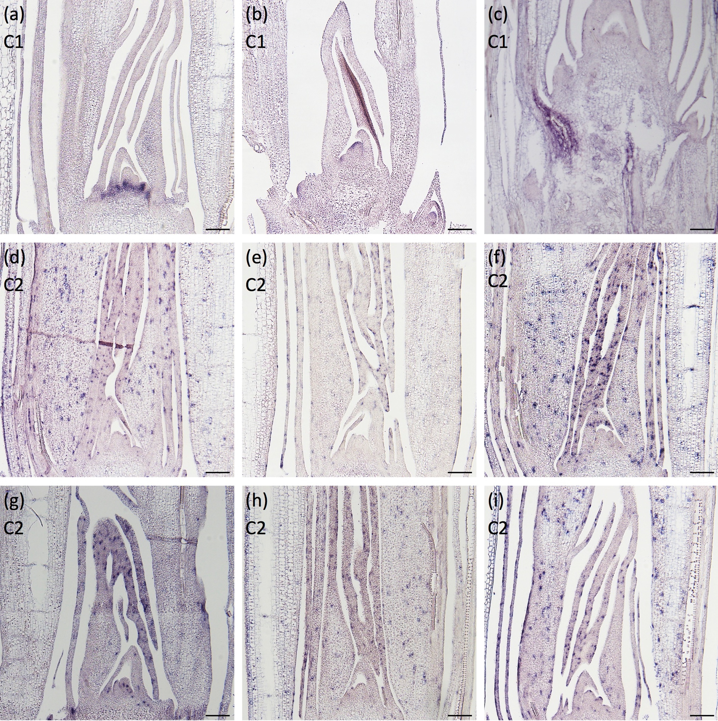
Supplemental Fig. 8. In situ hybridization of genes showing localized expression during leaf development.
The expression patterns of (a) Os05g0223200, (b) Os05g0153200, (c) Os10g0579400, (d) Os01g0176500, (e) Os01g0765500, (f) Os02g0258200, (g) Os03g0184500, (h) Os04g0228100, and (i) Os09g0556800 around the shoot apex in longitudinal sections.
The cluster number to which each gene belongs is indicated in the upper left.
See Supplemental Table 2 for annotation of the genes.
Scale bars: 100 μm.
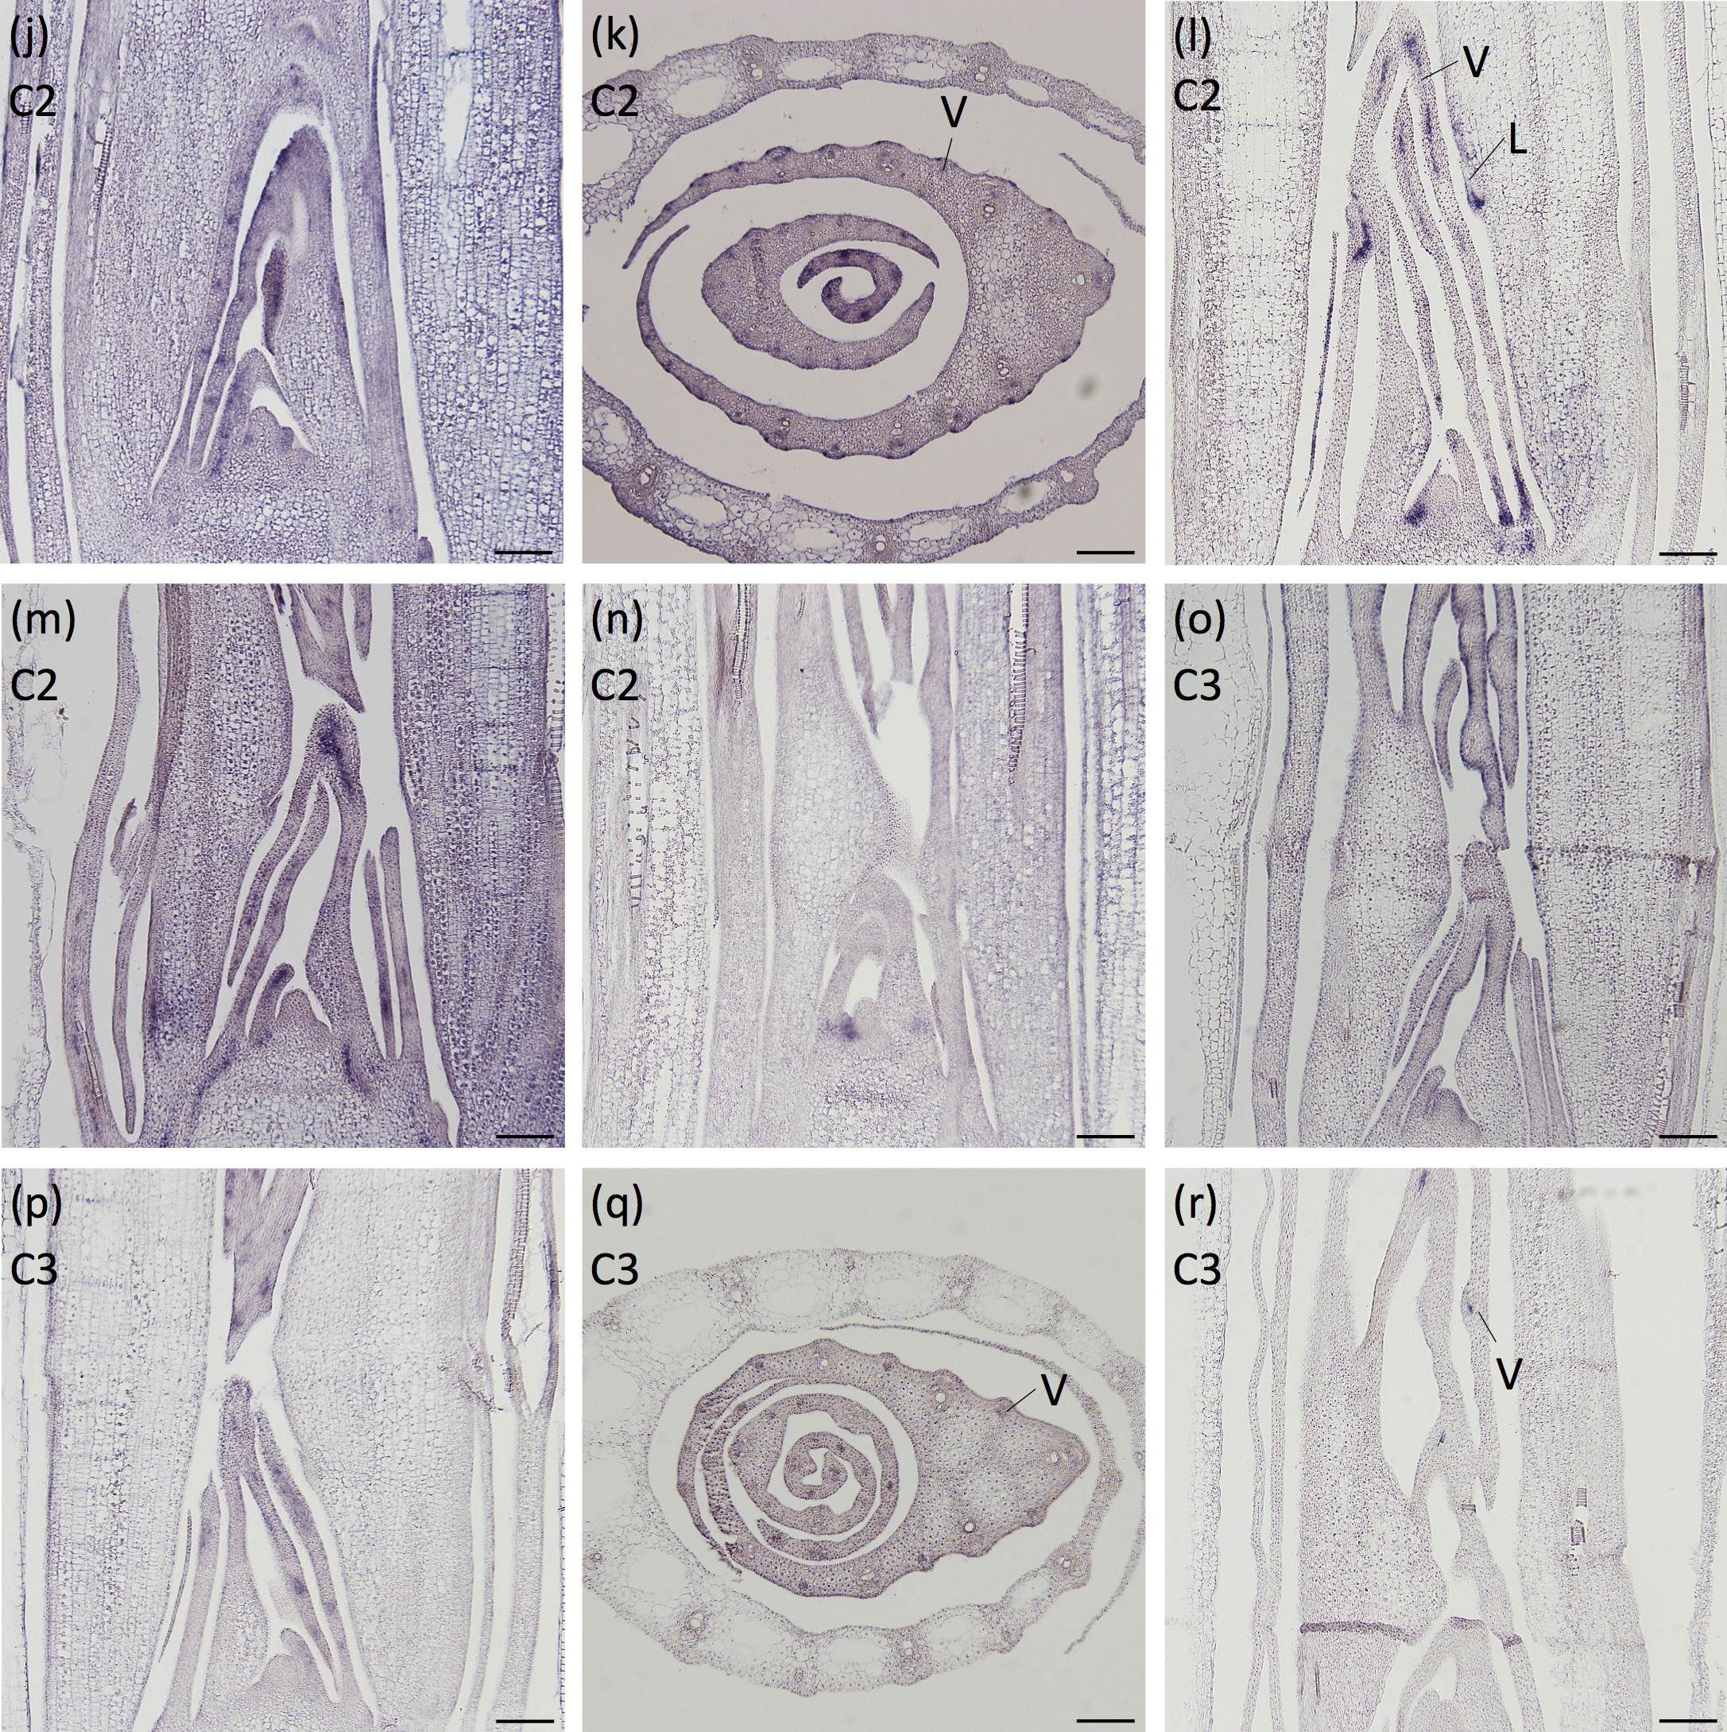
Supplemental Fig. 8. (Continued)
The expression patterns of (j, k) Os11g0149100, (l) Os04g0664400, (m) Os03g0244600, (n) Os03g0680700, (o) Os03g0164300, (p, q) Os06g0474500, and (r) Os02g0528100 around the shoot apex.
(j), (l) to (p), and (r) are longitudinal sections of the shoot apices, while (k) and (q) are transverse sections of the shoot apices.
The cluster number to which each gene belongs is indicated in the upper left.
See Supplemental Table 2 for annotation of the genes.
Scale bars: 100 μm.

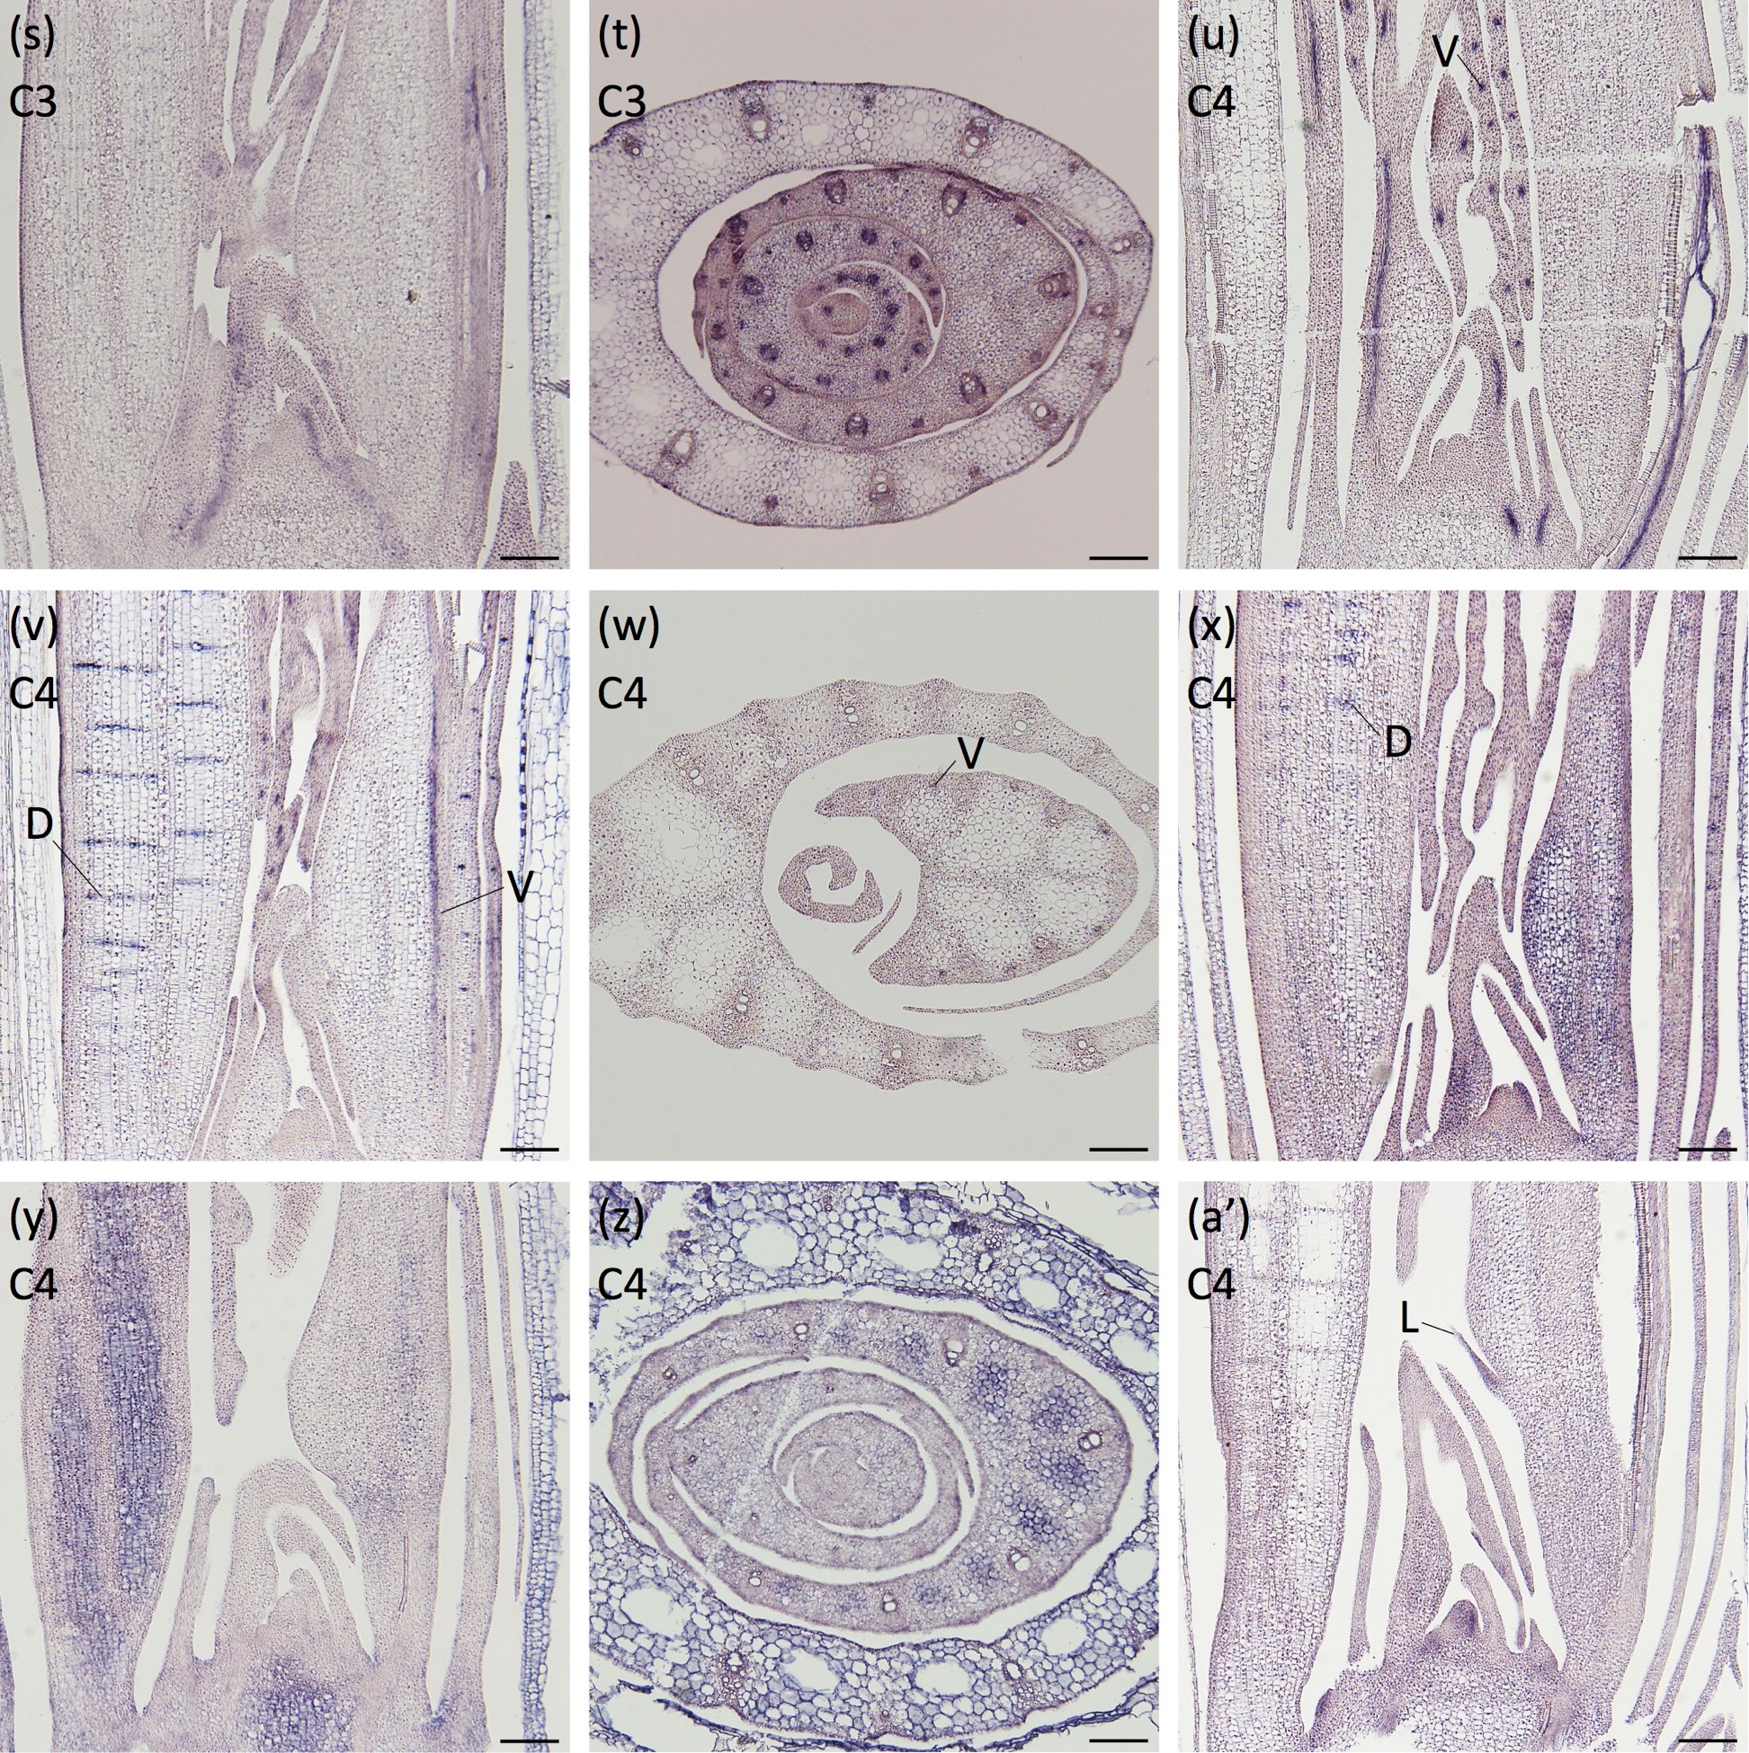
Supplemental Fig. 8. (Continued)
(s, t) Os04g0690100, (u) Os05g0112200, (v, w) Os03g0762100, (x) Os08g0483900, (y, z) Os02g0669900, and (a’) Os03g0728900 around the shoot apex.
(s), (u), (v), (x), (y), and (a’) are longitudinal sections of the shoot apices, while (t), (w), and (z) are transverse sections of the shoot apices.
The cluster number to which each gene belongs is indicated in the upper left.
See Supplemental Table 2 for annotation of the genes.
Scale bars: 100 μm.

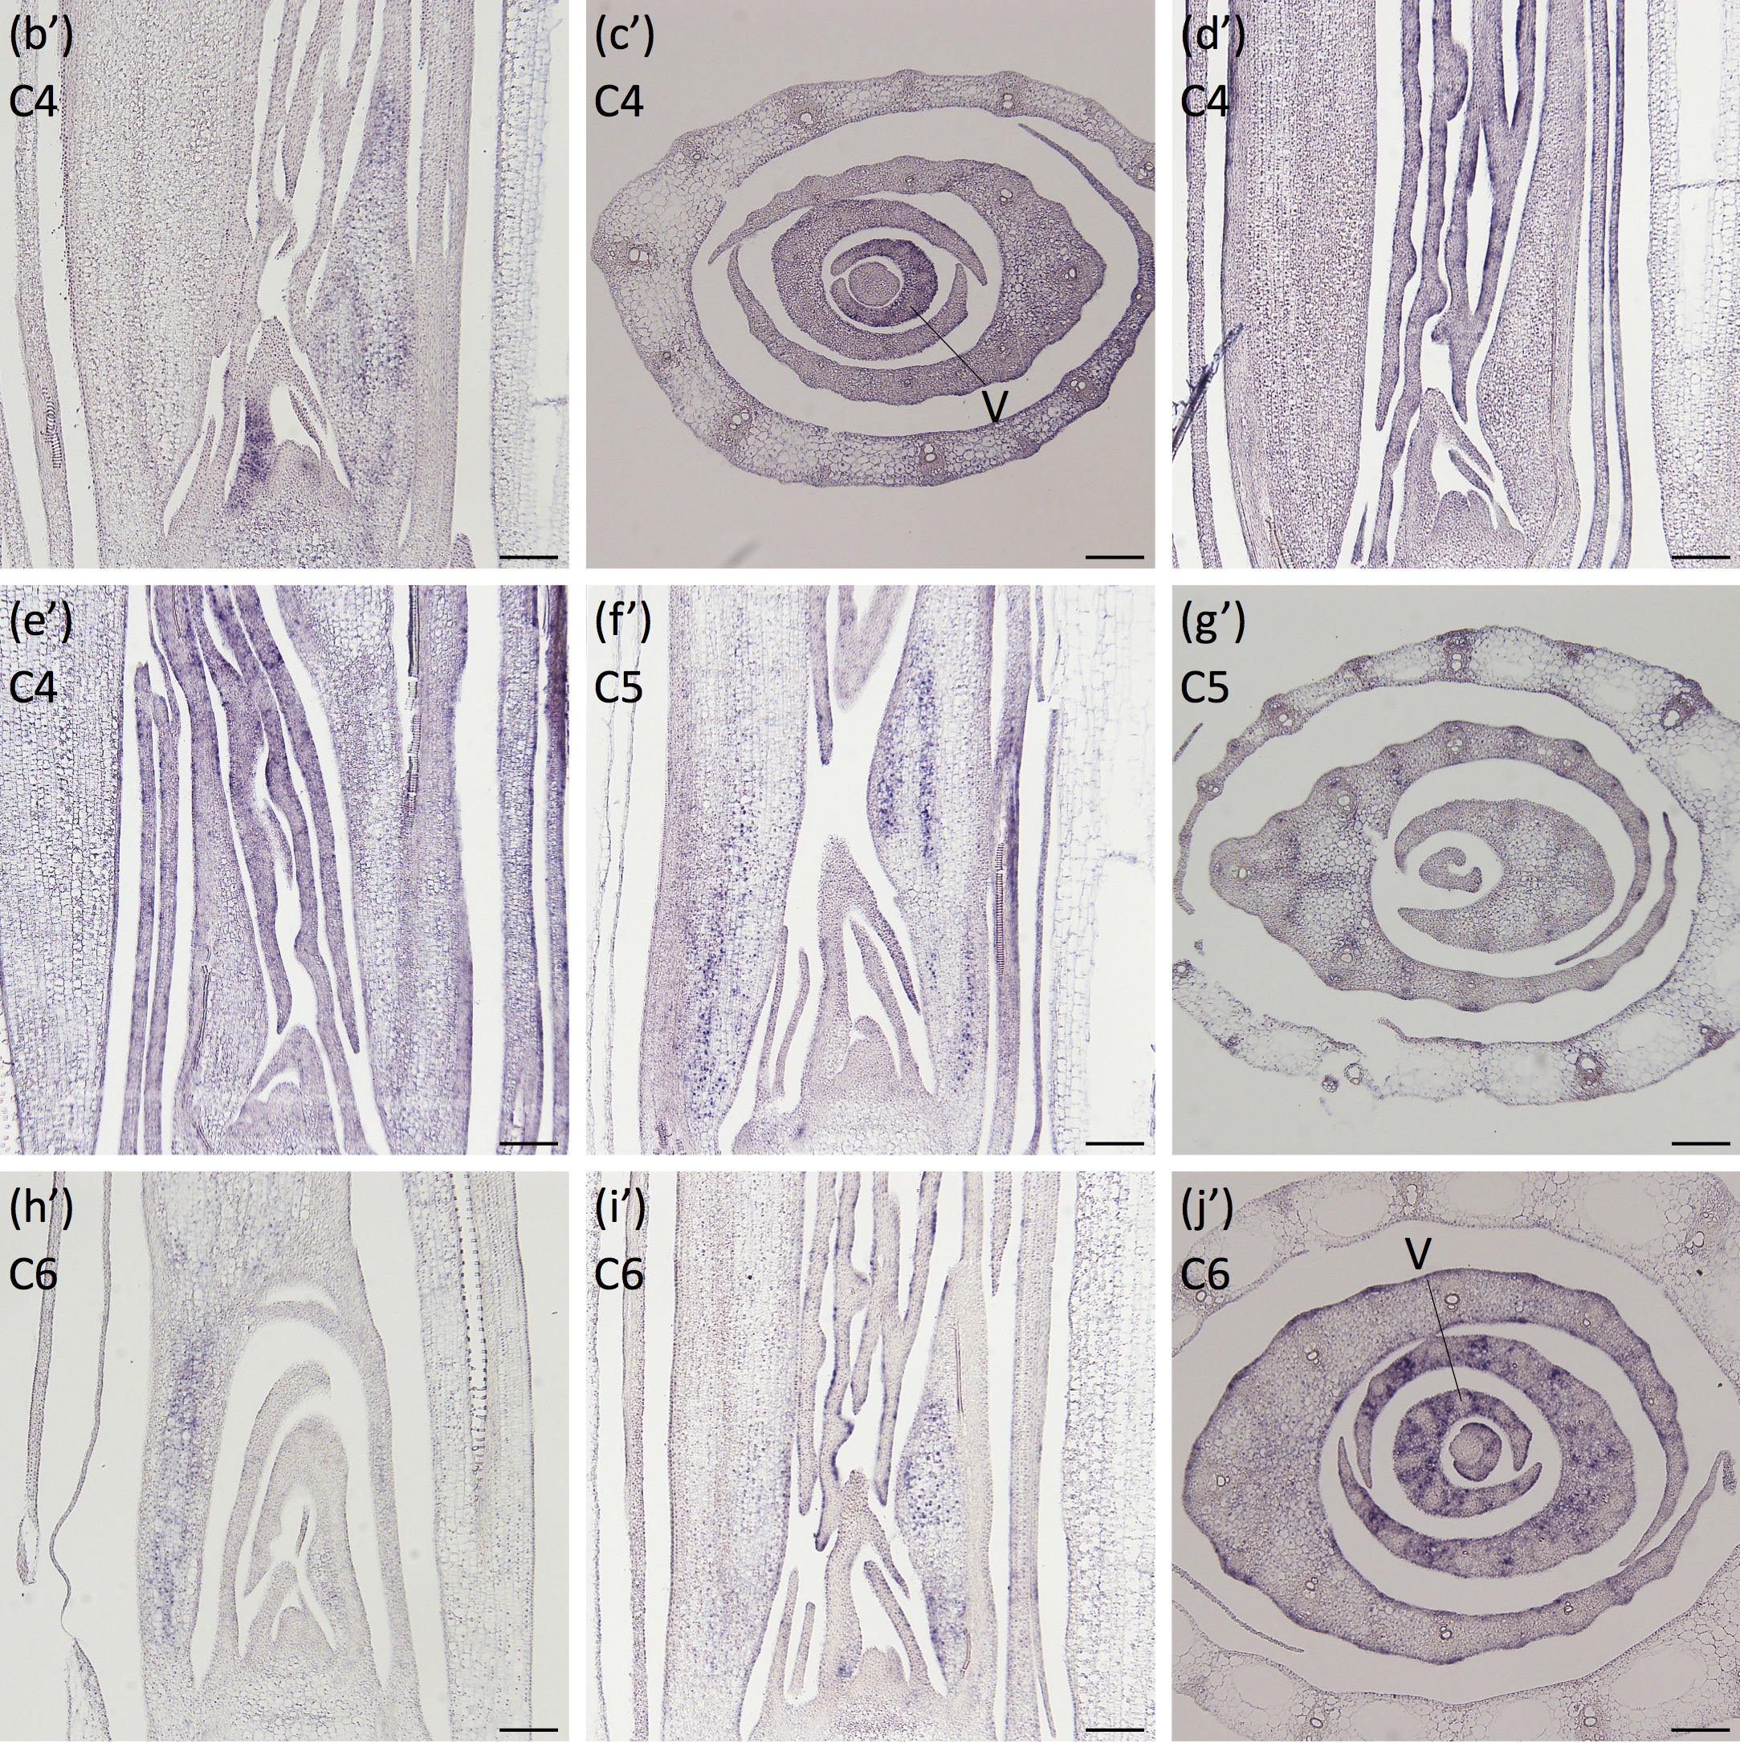
Supplemental Fig. 8. (Continued)
(b’, c’) Os05g0103000, (d’) Os09g0542500, (e’) Os03g0127600, (f’, g’) Os09g0474100, (h’) Os09g0282300, and (i’, j’) Os09g0510500 around the shoot apex.
(b’), (d’), (e’), (f’), (h’), and (i’) are longitudinal sections of the shoot apices, while (c’), (g’), and (j’) are transverse sections of the shoot apices.
The cluster number to which each gene belongs is indicated in the upper left.
See Supplemental Table 2 for annotation of the genes.
Scale bars: 100 μm.

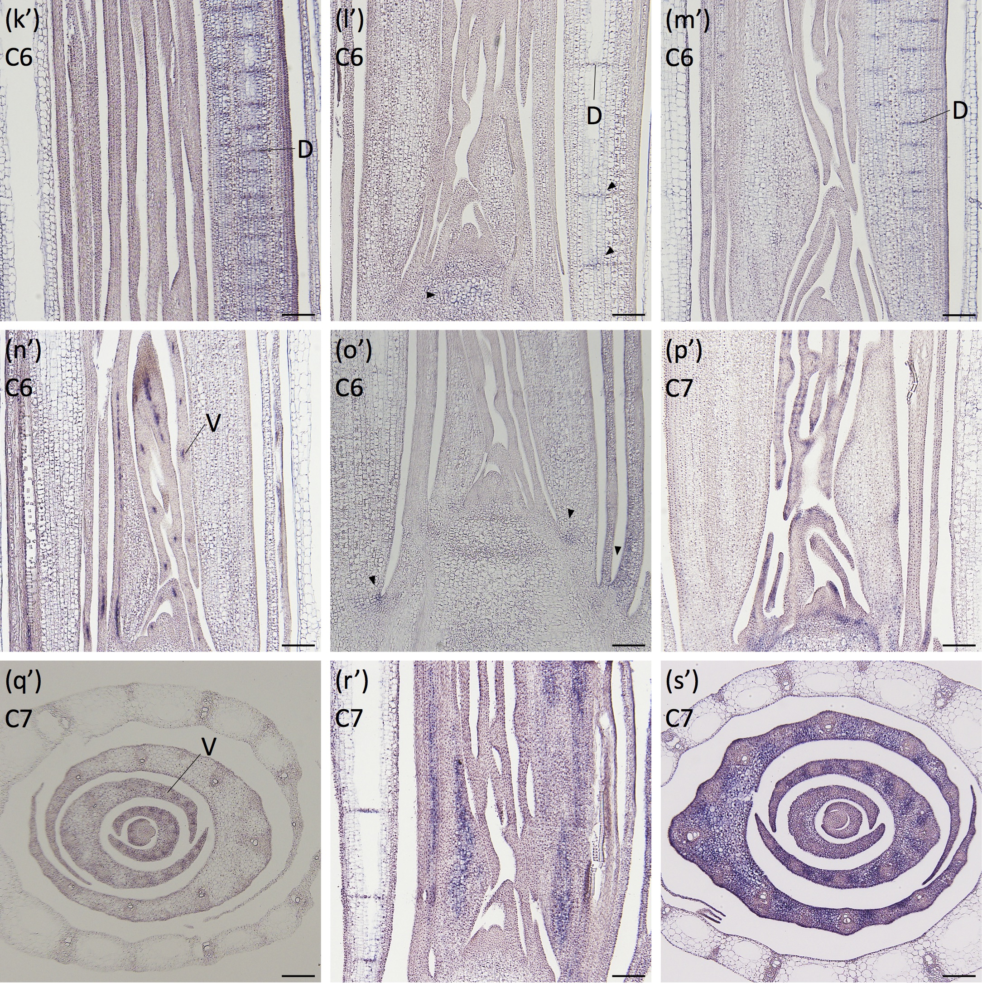
Supplemental Fig. 8. (Continued)
(k’) Os10g0404900, (l’) Os03g0188400, (m’) Os08g0260400, (n’) Os03g0591300, (o’) Os02g0791300, (p’, q’) Os06g0724800, and (r’, s’) Os03g0135700 around the shoot apex.
(k’) to (p’), and (r’) are longitudinal sections of the shoot apices, while (q’) and (s’) are transverse sections of the shoot apices.
The cluster number to which each gene belongs is indicated in the upper left.
See Supplemental Table 2 for annotation of the genes.
Scale bars: 100 μm.

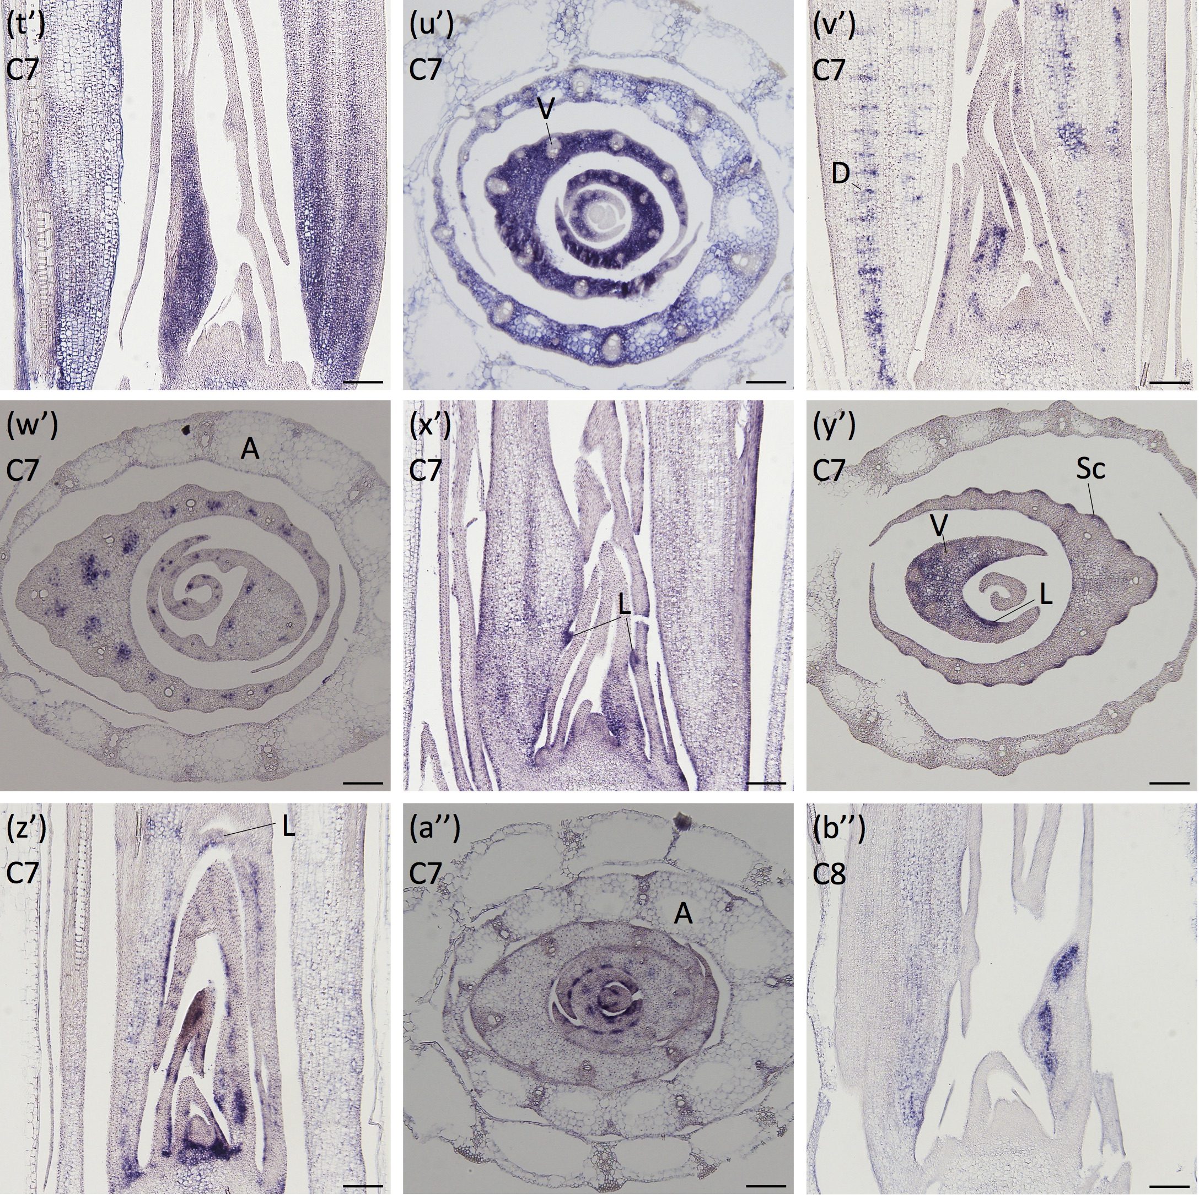
Supplemental Fig. 8. (Continued)
(t’, u’) Os09g0484200, (v’, w’) Os07g0676600, (x’, y’) Os01g0848400, (z’, a’’) Os08g0444500, and (b’’) Os10g0544200 around the shoot apex.
(t’), (v’), (x’), (z’), and (b’’) are longitudinal sections of the shoot apices, while (u’), (w’), (y’), and (a’’) are transverse sections of the shoot apices.
The cluster number to which each gene belongs is indicated in the upper left.
See Supplemental Table 2 for annotation of the genes.
Scale bars: 100 μm.

Supplemental Table 2. Annotation of genes in Fig. 4, 5, Supplemental Fig. 8.
Figure | RAP ID | RAP Description | Gene Symbol
Fig. 4 (a, b) | Os02g0172800 | Similar to Zinc-binding protein.
Fig. 4 (c) | Os08g0536800 | Similar to TA1 protein (Fragment). | OsbHLH080
Fig. 4 (d, e) | Os03g0338400 | Basic helix-loop-helix dimerisation region bHLH domain containing protein. | OsbHLH166
Fig. 4 (f) | Os05g0363500 | Hypothetical conserved gene.
Fig. 4 (g, h) | Os05g0500900 | Similar to Indole-3-acetic acid-amido synthetase GH3.5 (EC 6.3.2.-) (Auxin- responsive GH3-like protein 5) (AtGH3-5). | OsGH3-4
Fig. 5 (a) | Os02g0164900 | Similar to Auxin response factor 3. | OsARF6
Fig. 5 (b) | Os04g0671900 | Transcription factor, Regulator for phosphate homeostasis | OsARF12
Fig. 5 (c) | Os06g0677800 | ARF transcription factor, Defense against different types of plant viruses | OsARF17
Fig. 5 (d) | Os12g0613700 | Transcriptional factor B3 family protein. | OsARF25
Fig. S8 (a) | Os05g0223200 | Similar to Glycine-rich RNA-binding protein GRP2A.
Fig. S8 (b) | Os05g0153200 | Uncharacterised domain XH domain containing protein. | OsFDML4
Fig. S8 (c) | Os10g0579400 | Conserved hypothetical protein. | OsWRKY2
Fig. S8 (d) | Os01g0176500 | Conserved hypothetical protein.
Fig. S8 (e) | Os01g0765500 | Conserved hypothetical protein.
Fig. S8 (f) | Os02g0258200 | Similar to high mobility group family.
Fig. S8 (g) | Os03g0184500 | Transcriptional factor B3 family protein.
Fig. S8 (h) | Os04g0228100 | Similar to H0209A05.2 protein.
Fig. S8 (i) | Os09g0556800 | Conserved hypothetical protein.
Fig. S8 (j, k) | Os11g0149100 | AT-hook motif and PPC domain containing protein, Drought tolerance, Regulation of root development under drought condition, Oxidative stress response, Regulation of the content of chlorophyll | OsAHL1
Fig. S8 (l) | Os04g0664400 | Auxin response factor, Transcriptional factor, Transcriptional regulation of plant height and leaf angle | OsMP
Fig. S8 (m) | Os03g0244600 | Similar to AUX1-like protein. | OsLAX2
Fig. S8 (n) | Os03g0680700 | Similar to Knotted1-interacting protein.
Fig. S8 (o) | Os03g0164300 | Conserved hypothetical protein.
Fig. S8 (p,q) | Os06g0474500 | Protein of unknown function DUF239, plant domain containing protein.
Fig. S8 (r) | Os02g0528100 | Protein of unknown function DUF662 family protein.
Fig. S8 (s, t) | Os04g0690100 | Zinc finger, C2H2-type domain containing protein.
Fig. S8 (u) | Os05g0112200 | Similar to Zn finger protein (Fragment). | OsDof19
Fig. S8 (v, w) | Os03g0762100 | Conserved hypothetical protein.
Fig. S8 (x) | Os08g0483900 | Helix-loop-helix DNA-binding domain containing protein. | OsbHLH047
Fig. S8 (y, z) | Os02g0669900 | Similar to H0211B05.8 protein.
Fig. S8 (a’) | Os03g0728900 | Helix-loop-helix DNA-binding domain containing protein. | OsbHLH084
Fig. S8 (b’, c’) | Os05g0103000 | Similar to MYC1. | OsbHLH083
Fig. S8 (d’) | Os09g0542500 | Domain of unknown function DUF632 domain containing protein.
Fig. S8 (e’) | Os03g0127600 | Forkhead-associated domain containing protein. | OsDLN74
Fig. S8 (f’, g’) | Os09g0474100 | Similar to TA1 protein (Fragment). | OsbHLH085
Fig. S8 (h’) | Os09g0282300 | Zinc finger, C2H2-type/integrase, DNA-binding domain containing protein.
Fig. S8 (i’, j’) | Os09g0510500 | Basic helix-loop-helix (bHLH) transcriptional activator, Control of leaf angle and grain size | OsBC1
Fig. S8 (k’) | Os10g0404900 | Similar to HAHB-5 (Fragment). | OsHox23
Fig. S8 (l’) | Os03g0188400 | Helix-loop-helix DNA-binding domain containing protein. | OsbHLH044
Fig. S8 (m’) | Os08g0260400 | Conserved hypothetical protein. | OsbHLH171
Fig. S8 (n’) | Os03g0591300 | Helix-loop-helix DNA-binding domain containing protein. | OsbHLH140
Fig. S8 (o’) | Os02g0791300 | Hypothetical conserved gene. | OsbHLH168
Fig. S8 (p’, q’) | Os06g0724800 | Basic helix-loop-helix dimerisation region bHLH domain containing protein. | OsbHLH155
Fig. S8 (r’, s’) | Os03g0135700 | Basic helix-loop-helix transcription factor, Nucleotide-binding site leucine-rich repeat (NLR) protein-mediated resistance to rice blast disease | OsRAI1
Fig. S8 (t’, u’) | Os09g0484200 | Hypothetical protein.
Fig. S8 (v’, w’) | Os07g0676600 | HLH (helix-loop-helix) protein, Mediation of defense to brown planthopper (BPH) | OsbHLH163
Fig. S8 (x’, y’) | Os01g0848400 | BEL1-type homeobox family, Paralog of RI, Seed shattering, Initiation and maintenance of the shoot apical meristem during embryogenesis, Construction of inflorescence architecture | qSH1
Fig. S8 (z’, a’’) | Os08g0444500 | Conserved hypothetical protein.
Fig. S8 (b’’) | Os10g0544200 | Basic helix-loop-helix dimerisation region bHLH domain containing protein. | OsbHLH004

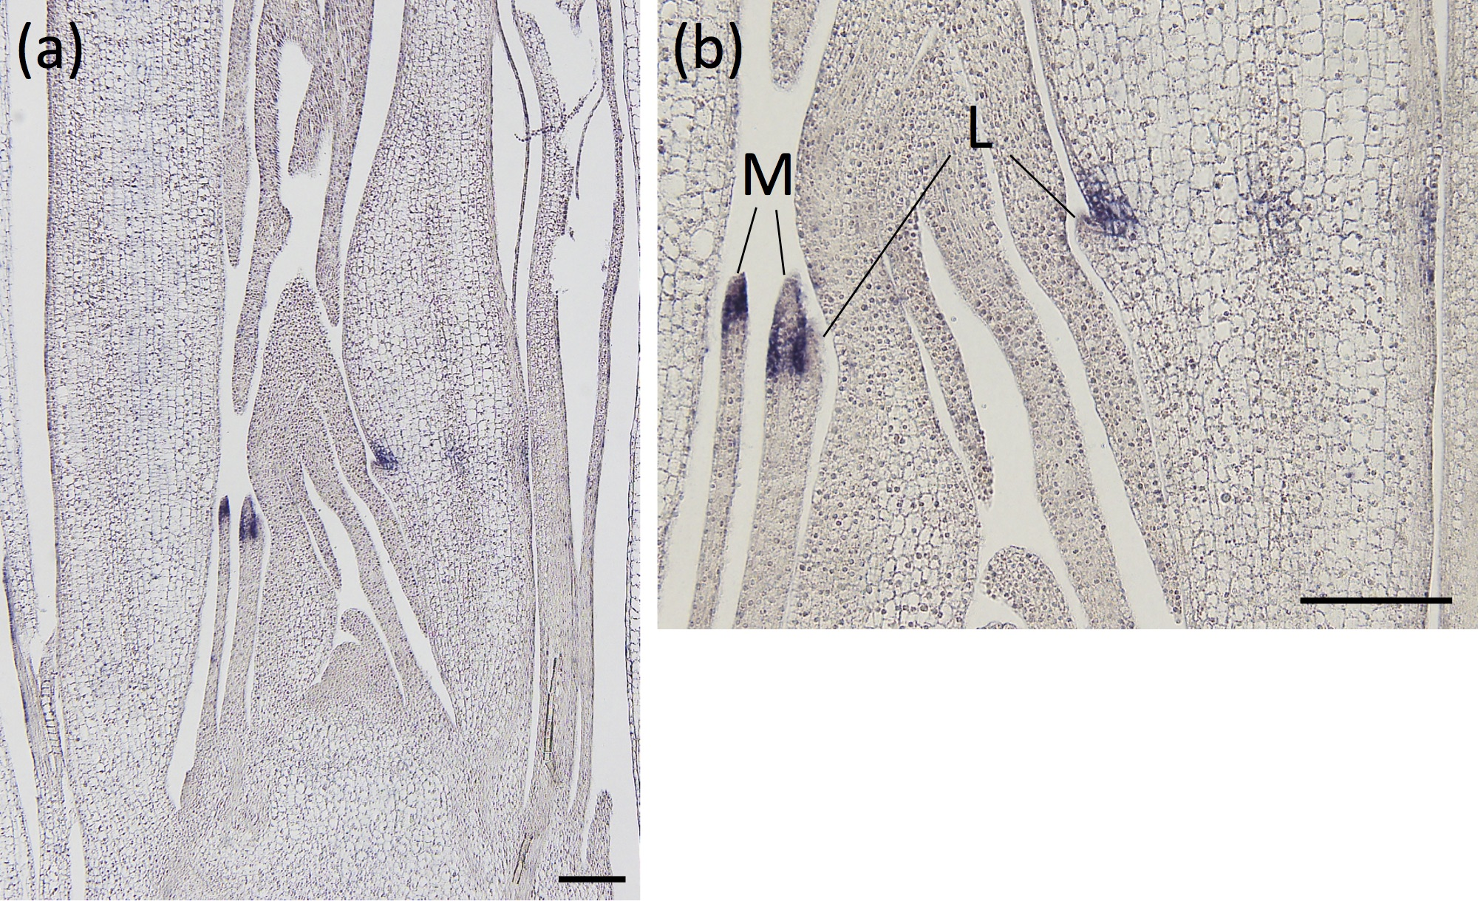
Supplemental Fig. 9. Spatial expression pattern of LIGULELESS1.
(a) Expression around the shoot apex in a longitudinal section. (b) Magnified view of (a) at the blade-sheath boundary.
L, ligule; M, marginal part of the blade-sheath boundary. Scale bars: 100 μm.

