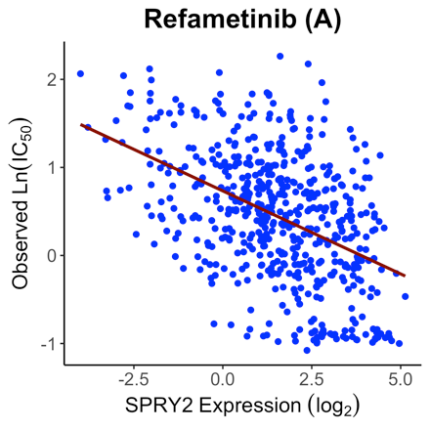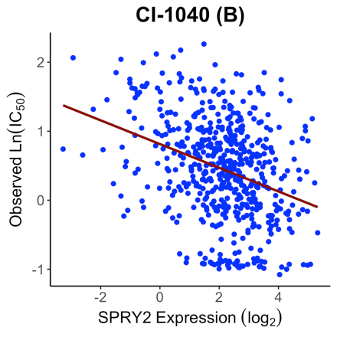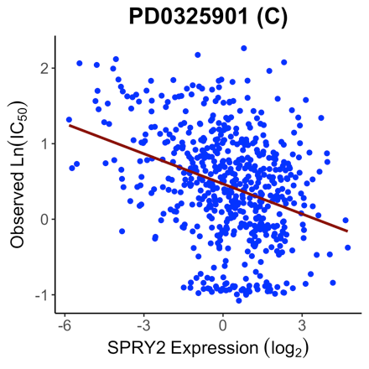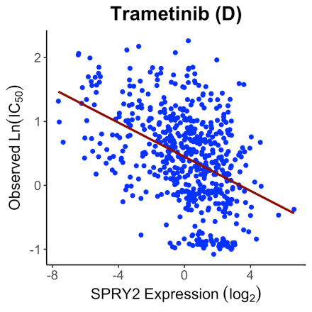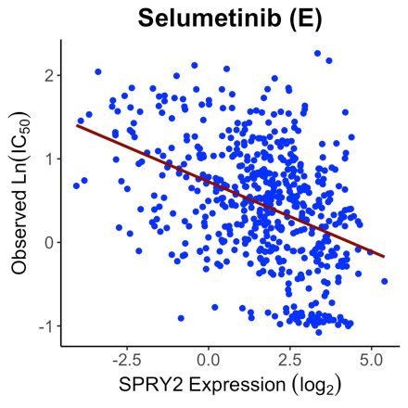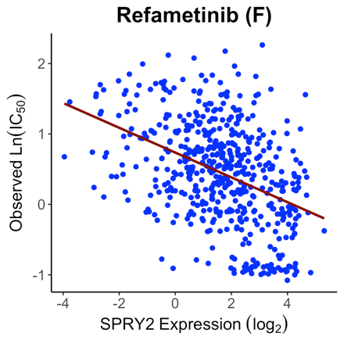
Figure S1. Inverse correlation between SPRY2 expression (Z score) in cancer cell lines and the observed ln(IC₅₀) of the six MEK inhibitors for those cell lines. Higher SPRY2 expression was associated with lower ln(IC₅₀) value (more sensitive to these drugs).

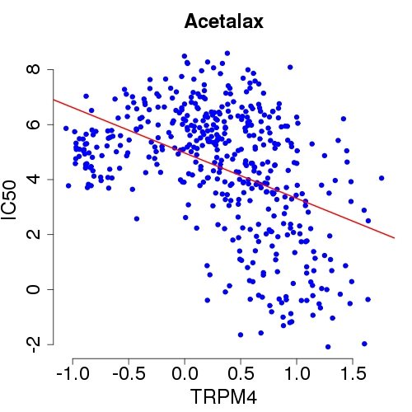
Figure S2. TRPM4 expression (Z score) in cancer cell lines is inversely correlated with observed ln(IC₅₀) values of acetalax for the cell lines, indicating high TRPM4 expression is associated with high sensitivity (low IC₅₀) to acetalax.
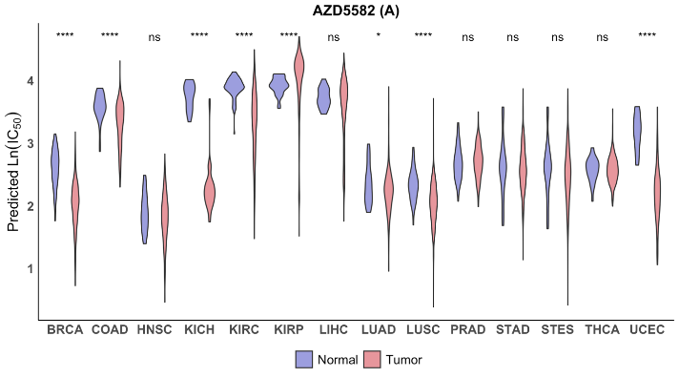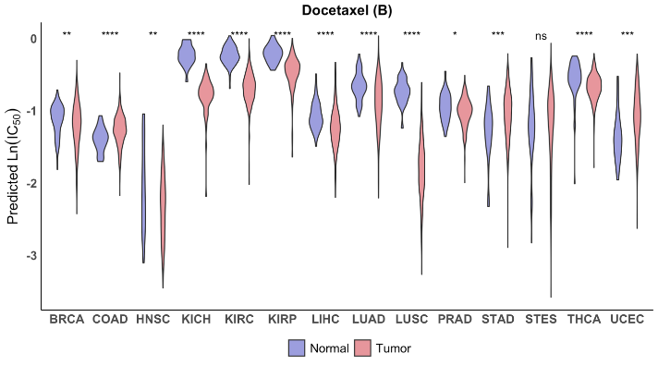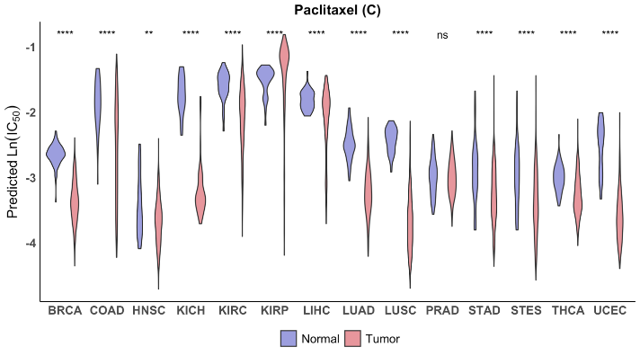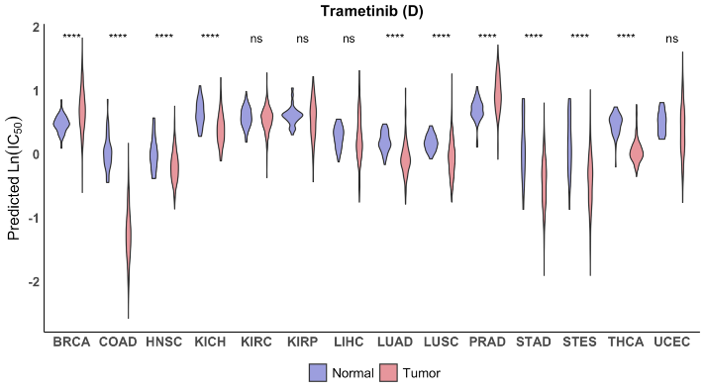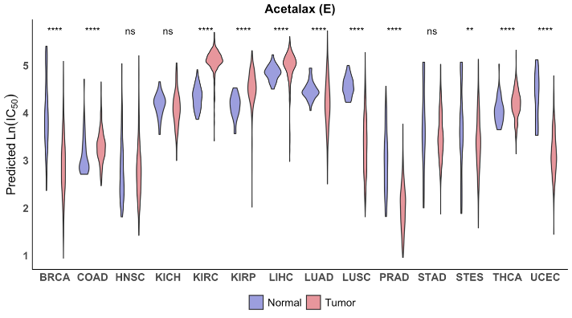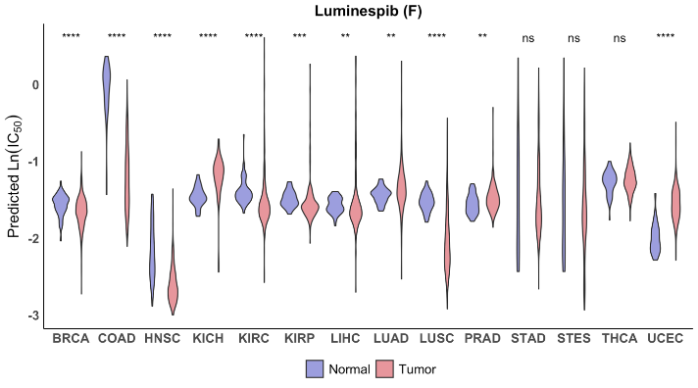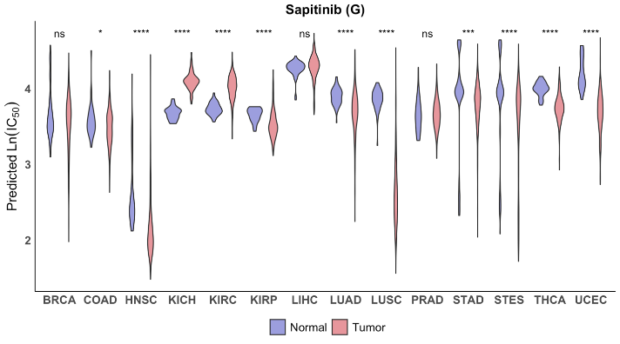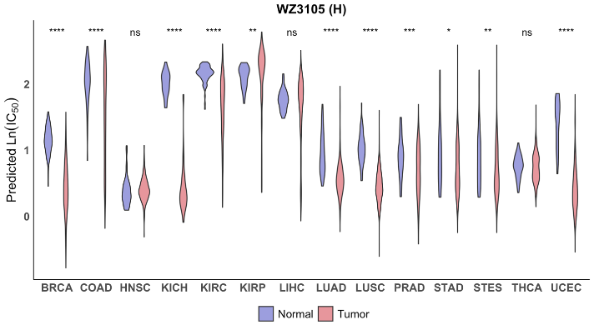
Figure S3. Drugs that are predicted to have high tumor-to-normal sensitivity for some tumor types. Violin plots of predicted ln(IC₅₀) values in tumor (pink) and normal (blue) tissue for the eight drugs that showed the ratio of tumor-to-normal sensitivity exceeding 2.7 (1 logarithmic unit) for at least one of 14 tissue types. The ln(IC₅₀ ) values of the drugs were predicted based on the RNA-seq data of the tumor and normal tissue samples from TCGA. Violin plots for normal and tumor samples from the same tissue type are shown as side-by-side pairs with their TCGA type on the x-axis. See Figure 4 legend for additional description of the violin plots. Statistical significance based on a two-tailed Mann-Whitney-Wilcoxon rank sum test is shown above each pair with ns: p > 0.05, *: p <= 0.05, **: p <= 0.01, ***: p <= 0.001, ****: p <= 0.0001.

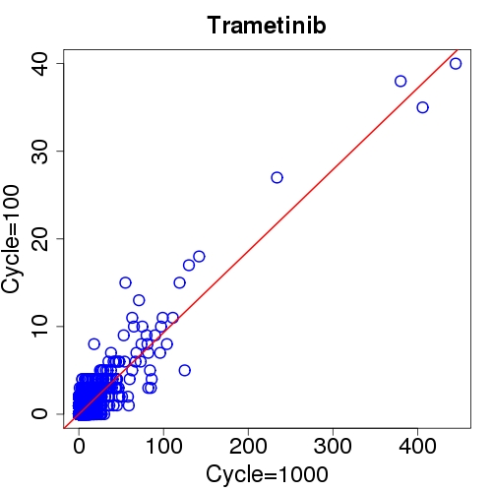
Figure S4. Scatter plot of the counts of genes selected into the sets of 30 chromosomes from two independent runs with 100 runs and 1,000 runs, respectively.

