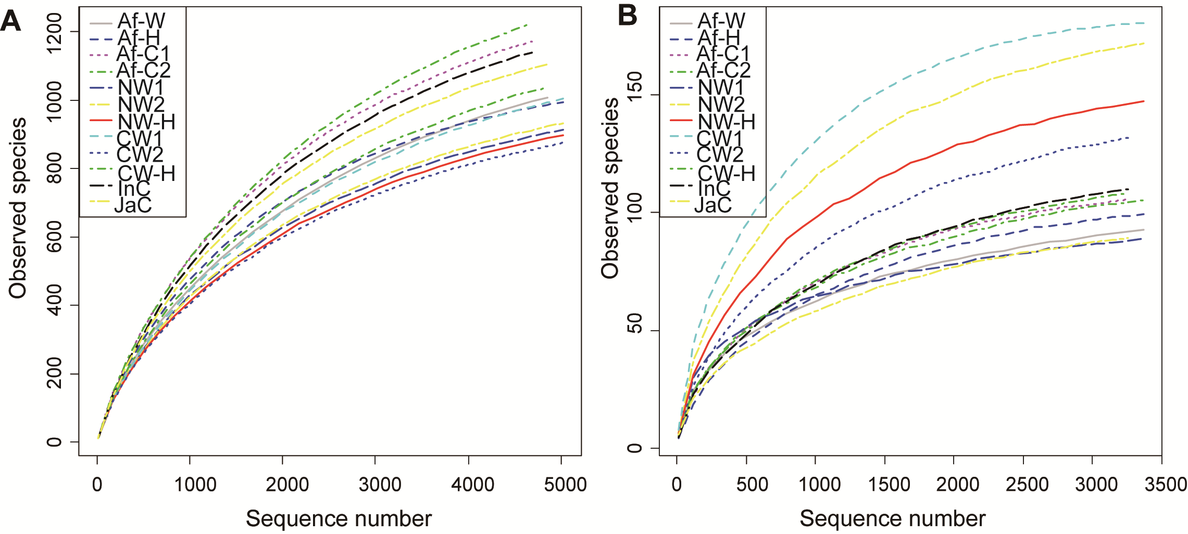

Additional file 2: Figure S1 Rarefication curves for the bacterial (A) and fungal (B) OTUs in each group. Each group was comprised of 4 replicates (n = 4). Af-W, African wild rice; Af-H, F1 generation of a cross between African wild rice (Af-W) and African cultivated rice (AfC1); AfC1, African cultivated rice No. 2; AfC2, African cultivated rice No. 4; NW1, nivara wild rice No. 1; NW2, nivara wild rice No. 2; NW-H, F1 generation of a cross between nivara wild rice (NW1) and Asian cultivated rice (indica, InC); CW1, common wild rice No. 1; CW2, common wild rice No. 2; CW-H, F1 generation of a cross between common wild rice (CW1) and Asian cultivated rice (japonica, JaC); InC, Asian cultivated rice (Jiangxi indica); JaC, Asian cultivated rice (Jiangxi japonica).

