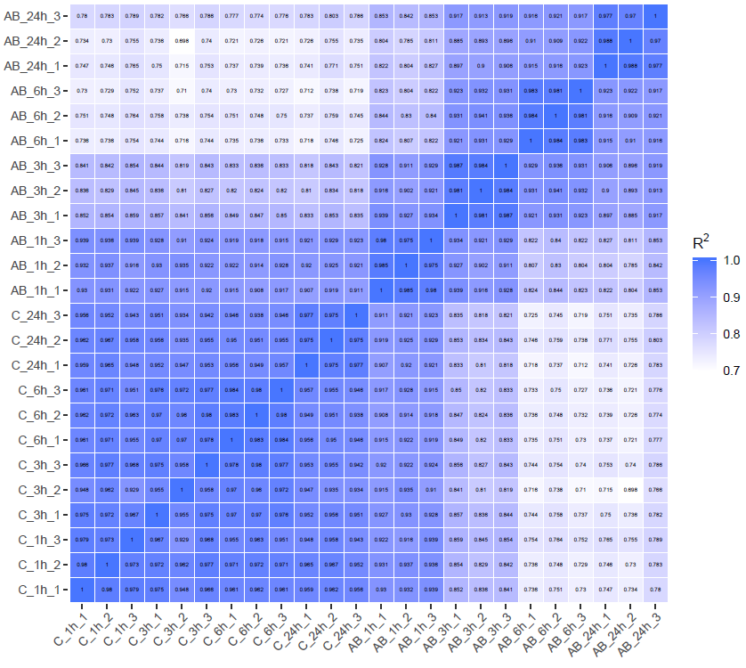
Figure S1. Spearman correlations of gene expressions among all samples

