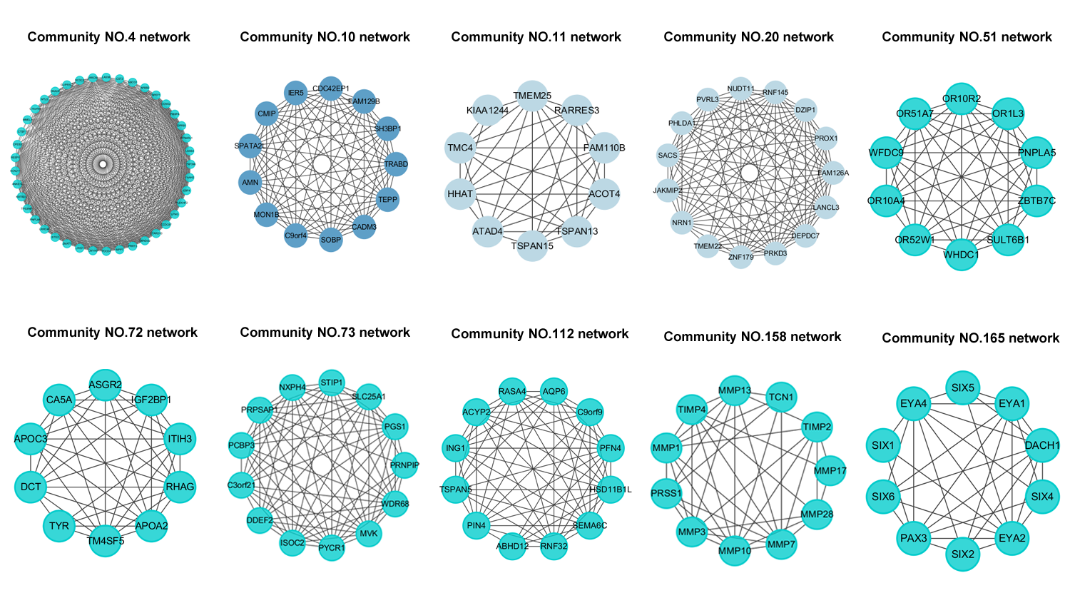
Fig. S1. The rest of Independent-Communities networks in community network, enriched with the known Gene Ontology(GO) terms. The node and edge represent genes and interaction in community.

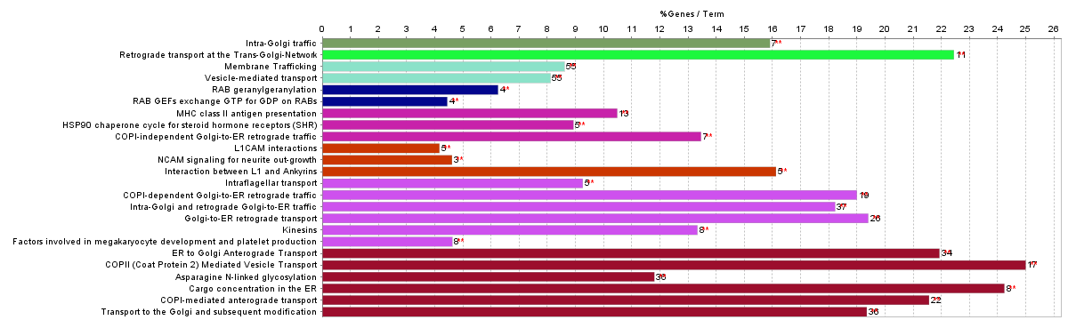
Fig. S2. Functional pathway in ClueGO. It presents the genes and information related to their associated genes. The bars represent the number of the genes from Community NO.121, 126, 172 found associated with the pathway. The different color of the bars denotes diverse pathway types.

Table S1. Number of mutated samples for each subtype for each community.

 | All | lumA(215) | lumB(122) | Basal(92) | Her2(55)
Community NO.4(LRIG1,PDCD4) | 330 | 120 | 97(***) | 68 | 45(***)
Community NO.10  (FAM129B,MON1B) | 340 | 166(***) | 87 | 55 | 32
Community NO.20  (PROX1,PRKD3,PHLDA1) | 376 | 152 | 106(***) | 76 | 42
Community NO.112  (ING1,HSD11B1) | 388 | 165 | 107(***) | 72 | 44
Community NO.141  (PKP2,KRT1) | 158 | 42 | 40 | 55(***) | 21
Community NO.165  (EYA1,EYA2,EYA4) | 364 | 136 | 104(***) | 73 | 47(***)
This table supplements the discussion of community identified in Independent-Community model. In Table 1 in S1 Text we show the number of mutated samples for each community for each subtype. Figure 3C in S1 Text shows the distribution for each gene. The total number of mutated samples for 4 subtypes are shown in the first row. For each community, we computed the number of samples with mutations in at least one gene in the community (followed by the number of mutated samples for each gene in the community). * indicates the significance of subtype enrichment relative to the overall mutations of a given community (or a gene) across all the subtypes. (*** for p < 0.01, ** for p < 0.05, and * for p < 0.1).

Table S2. The list of AUC, regulation score and module about top-10 driver genes in each cancer

Cancer Type | TCGA ID Data | Driver Genes | Module Number | Regulation Score | AUC
Kidney Chromophobe | KICH | MRAP2 | 145 | 18.209 | 0.985
Kidney Chromophobe | KICH | EDARADD | 275 | 24.692 | 0.954
Kidney Chromophobe | KICH | OXGR1 | 136 | 24.759 | 0.954
Kidney Chromophobe | KICH | USP51 | 23 | 67.044 | 0.908
Kidney Chromophobe | KICH | ZNF41 | 20 | 12.592 | 0.908
Kidney Chromophobe | KICH | LANCL3 | 237 | 22.200 | 0.877
Kidney Chromophobe | KICH | SLC25A19 | 16 | 26.795 | 0.815
Kidney Chromophobe | KICH | CYSLTR2 | 114 | 14.171 | 0.769
Kidney Chromophobe | KICH | IGSF1 | 104 | 38.579 | 0.754
Kidney Chromophobe | KICH | MTHFD1L | 277 | 12.817 | 0.754
Bladder Urothelial Carcinoma | BLCA | FGFR1 | 6 | 84.373 | 1
Bladder Urothelial Carcinoma | BLCA | ADCK5 | 32 | 67.474 | 0.975
Bladder Urothelial Carcinoma | BLCA | ATAD2 | 133 | 41.459 | 0.969
Bladder Urothelial Carcinoma | BLCA | RBPMS | 81 | 34.433 | 0.963
Bladder Urothelial Carcinoma | BLCA | RHPN1 | 28 | 67.836 | 0.941
Bladder Urothelial Carcinoma | BLCA | HIC1 | 174 | 37.393 | 0.923
Bladder Urothelial Carcinoma | BLCA | DPYSL2 | 6 | 33.827 | 0.920
Bladder Urothelial Carcinoma | BLCA | GLIPR2 | 231 | 51.288 | 0.892
Bladder Urothelial Carcinoma | BLCA | KCNK9 | 37 | 49.740 | 0.880
Bladder Urothelial Carcinoma | BLCA | LY6E | 90 | 32.282 | 0.855
Breast invasive carcinoma cancer | BRCA | PEX19 | 40 | 23.348 | 0.969
Breast invasive carcinoma cancer | BRCA | LCE2D | 15 | 113.855 | 0.959
Breast invasive carcinoma cancer | BRCA | PSMD4 | 6 | 26.168 | 0.943
Breast invasive carcinoma cancer | BRCA | TNNI1 | 133 | 27.894 | 0.892
Breast invasive carcinoma cancer | BRCA | SCAMP3 | 12 | 23.216 | 0.866
Breast invasive carcinoma cancer | BRCA | CNIH3 | 23 | 41.737 | 0.851
Breast invasive carcinoma cancer | BRCA | MUC1 | 195 | 30.408 | 0.835
Breast invasive carcinoma cancer | BRCA | CD48 | 70 | 62.065 | 0.789
Breast invasive carcinoma cancer | BRCA | LAD1 | 176 | 32.105 | 0.773
Breast invasive carcinoma cancer | BRCA | CDC73 | 131 | 59.787 | 0.768
Colon adenocarcinoma | COAD | ASXL1 | 396 | 48.993 | 0.929
Colon adenocarcinoma | COAD | PLCG1 | 275 | 22.100 | 0.903
Colon adenocarcinoma | COAD | DDX27 | 158 | 63.483 | 0.901
Colon adenocarcinoma | COAD | SNHG11 | 129 | 27.688 | 0.879
Colon adenocarcinoma | COAD | HCK | 228 | 160.939 | 0.877
Colon adenocarcinoma | COAD | PRPF6 | 129 | 30.836 | 0.875
Colon adenocarcinoma | COAD | STX16 | 159 | 21.182 | 0.862
Colon adenocarcinoma | COAD | SPG20 | 305 | 29.430 | 0.841
Colon adenocarcinoma | COAD | KIFC2 | 22 | 94.267 | 0.821
Colon adenocarcinoma | COAD | CDCA2 | 328 | 65.171 | 0.817
Esophageal carcinoma | ESCA | SLC4A4 | 23 | 52.020 | 0.932
Esophageal carcinoma | ESCA | GPR87 | 61 | 23.977 | 0.919
Esophageal carcinoma | ESCA | EREG | 124 | 55.667 | 0.919
Esophageal carcinoma | ESCA | DSC3 | 39 | 44.682 | 0.905
Esophageal carcinoma | ESCA | DSG3 | 95 | 84.003 | 0.878
Esophageal carcinoma | ESCA | CNTN4 | 7 | 20.290 | 0.865
Esophageal carcinoma | ESCA | TWIST1 | 123 | 35.348 | 0.837
Esophageal carcinoma | ESCA | MYL9 | 50 | 35.502 | 0.757
Esophageal carcinoma | ESCA | ADH1C | 56 | 18.956 | 0.730
Esophageal carcinoma | ESCA | RNF150 | 53 | 88.520 | 0.689
Head and Neck squamous cell carcinoma | HNSC | ATP6V0D2 | 141 | 38.139 | 0.958
Head and Neck squamous cell carcinoma | HNSC | MED30 | 69 | 24.713 | 0.957
Head and Neck squamous cell carcinoma | HNSC | TMEM40 | 37 | 136.603 | 0.955
Head and Neck squamous cell carcinoma | HNSC | SNAI2 | 94 | 80.236 | 0.935
Head and Neck squamous cell carcinoma | HNSC | ACTL6A | 91 | 30.896 | 0.933
Head and Neck squamous cell carcinoma | HNSC | SLURP1 | 39 | 153.772 | 0.904
Head and Neck squamous cell carcinoma | HNSC | TM4SF19 | 207 | 24.920 | 0.900
Head and Neck squamous cell carcinoma | HNSC | PRKAR2A | 95 | 84.628 | 0.893
Head and Neck squamous cell carcinoma | HNSC | SETMAR | 173 | 19.802 | 0.893
Head and Neck squamous cell carcinoma | HNSC | SATB1 | 229 | 31.989 | 0.872

Algorithm S1. The algorithm of overlapping community identification
