Title
Genome-wide association study reveals novel loci associated with feeding behavior in Pekin ducks

Guang-Sheng Li*, Feng Zhu*, Fan Zhang*, Fang-Xi Yang†, Jin-Ping Hao†,Zhuo-Cheng Hou^{*,1}

* National Engineering Laboratory for Animal Breeding and Key Laboratory of Animal Genetics, Breeding and Reproduction, MARA; College of Animal Science and Technology, China Agricultural University, Beijing, China 100193
†Beijing Golden Star Inc., Beijing, China 100076

¹Corresponding author: Zhuo-Cheng Hou
E-mail address: zchou@cau.edu.cn

Additional file 2:
Figure S1. Circus plot showing distribution of SNPs on the duck genome. The inner histogram plot presents the frequency of SNPs in 1Mb windows along the genome. The outer tracks display the candidate genes associated with significant SNPs.
Figure S2. Quantile-quantile (QQ) plot for feeding behavior traits. (A) daily feed intake; (B), number of meals per day; (C), meal feed intake; (D), meal duration per time; (E), total feeding time.
Figure S3. Principal component analysis of Pekin ducks.

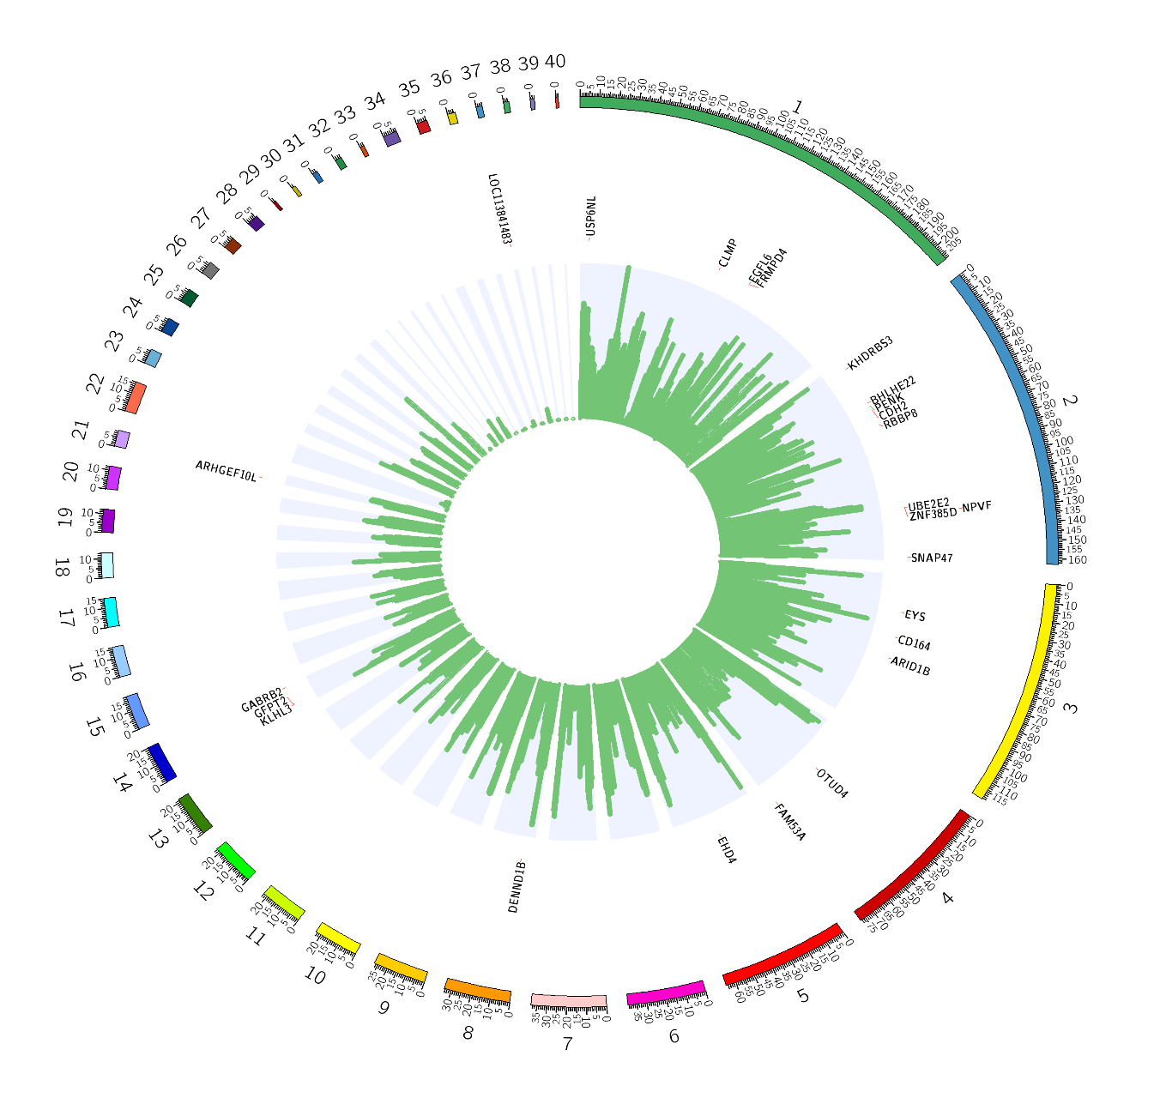
Figure S1

Figure S2

Figure S3

