Detection of copy number variants in African goats using whole genome sequence data
Wilson Nandolo^{1,2}, Gábor Mészáros¹, Maria Wurzinger¹, Liveness Jessica Banda², Timothy N. Gondwe², Henry Aaron Mulindwa³, Helen N. Nakimbugwe⁴, Emily L. Clark⁵, M. Jennifer Woodward-Greene⁶, Mei Liu⁶, George E. Liu⁶, Curtis P. Van Tassell⁶, Benjamin D. Rosen⁶, Johann Sölkner¹

1 University of Natural Resources and Life Sciences, Vienna, Austria
2 Lilongwe University of Agriculture and Natural Resources, Lilongwe, Malawi
3 National Livestock Resources Research Institute, Tororo, Uganda
4 Kyambogo University, Kyambogo, Uganda
5 The Roslin Institute, University of Edinburgh, Edinburgh, Scotland, United Kingdom
6 Animal Genomics and Improvement Laboratory, USDA-ARS, Beltsville, MD, USA

Corresponding author: Benjamin D. Rosen (Ben.Rosen@usda.gov)

List of figures
Supplementary Figure 1: CNV differentiation between Boer and East African goat populations. 3
Supplementary Figure 2: CNV differentiation between Boer and Madagascar goat populations. 3
Supplementary Figure 3: CNV differentiation between Boer and Southern African goat populations. 4
Supplementary Figure 4: CNV differentiation between Boer and West African goat populations. 5
Supplementary Figure 5: CNV differentiation between East African and Madagascar goat populations. 5
Supplementary Figure 6: CNV differentiation between East African and Southern African goat populations. 6
Supplementary Figure 7: CNV differentiation between East African and West African goat populations. 6
Supplementary Figure 8: CNV differentiation between Madagascar and Southern African goat populations. 7
Supplementary Figure 9: CNV differentiation between Madagascar and West African goat populations. 7
Supplementary Figure 10: CNV differentiation between Southern African and Western African goat populations. 8
Supplementary Figure 11: Proportions of CNV copy loss and gain for each set of filter parameter and CNV cut-off point. 8
Supplementary Figure 11: CNVR for the Abergelle breed 9
Supplementary Figure 12: CNVR for the Androy breed 9
Supplementary Figure 13: CNVR for the Balaka-Ulongwe breed 10
Supplementary Figure 14: CNVR for the Boer breed 10
Supplementary Figure 15: CNVR for the Dedza breed 11
Supplementary Figure 16: CNVR for the Diana breed 11
Supplementary Figure 17: CNVR for the Galla breed 12
Supplementary Figure 18: CNVR for the Gogo breed 12
Supplementary Figure 19: CNVR for the Guera breed 13
Supplementary Figure 20: CNVR for the Gumez breed 13
Supplementary Figure 21: CNVR for the Keffa breed 14
Supplementary Figure 22: CNVR for the Landin breed 14
Supplementary Figure 23: CNVR for the Maasai breed 15
Supplementary Figure 24: CNVR for the Malya breed 15
Supplementary Figure 25: CNVR for the Manica breed 16
Supplementary Figure 26: CNVR for the Mashona breed 16
Supplementary Figure 27: CNVR for the Matebele breed 17
Supplementary Figure 28: CNVR for the Menabe breed 17
Supplementary Figure 29: CNVR for the Naine breed 18
Supplementary Figure 30: CNVR for the Norwegian breed 18
Supplementary Figure 31: CNVR for the Nsanje breed 19
Supplementary Figure 32: CNVR for the Pare White breed 19
Supplementary Figure 33: CNVR for the Saanen breed 20
Supplementary Figure 34: CNVR for the Small East African breed 20
Supplementary Figure 35: CNVR for the Sofia breed 21
Supplementary Figure 36: CNVR for the Soudanaise breed 21
Supplementary Figure 37: CNVR for the SudOuest breed 22
Supplementary Figure 38: CNVR for the Thyolo breed 23
Supplementary Figure 39: CNVR for the Woyito Guji breed 23
Supplementary Figure 40: Global CNVR with variable SV calling parameters 24
Supplementary Figure 41: Global CNVR with variable SV calling parameters 25
Supplementary Figure 42: Global CNVR with variable SV calling parameters 26
Supplementary Figure 43: Global CNVR with variable SV calling parameters 27
Supplementary Figure 44: Global CNVR with variable SV calling parameters 28
Supplementary Figure 45: Global CNVR with variable SV calling parameters 29
Supplementary Figure 46: Global CNVR with variable SV calling parameters 30
Supplementary Figure 47: Global CNVR with variable SV calling parameters 31
Supplementary Figure 48: Global CNVR with variable SV calling parameters 32
Supplementary Figure 49: Global CNVR with variable SV calling parameters 33
Supplementary Figure 50: Global CNVR with variable SV calling parameters 34
Supplementary Figure 51: Global CNVR with variable SV calling parameters 35
Supplementary Figure 52: Global CNVR with variable SV calling parameters 36
Supplementary Figure 53: Global CNVR with variable SV calling parameters 37
Supplementary Figure 54: Global CNVR with variable SV calling parameters 38
Supplementary Figure 55: Global CNVR with variable SV calling parameters 39
Supplementary Figure 56: Global CNVR with variable SV calling parameters 40
Supplementary Figure 57: Global CNVR with variable SV calling parameters 41
Supplementary Figure 58: Global CNVR with variable SV calling parameters 42
Supplementary Figure 59: Global CNVR with variable SV calling parameters 43
Supplementary Figure 60: Global CNVR with variable SV calling parameters 44
Supplementary Figure 61: Global CNVR with variable SV calling parameters 45
Supplementary Figure 62: Global CNVR with variable SV calling parameters 46
Supplementary Figure 64: Global CNVR with variable SV calling parameters 47

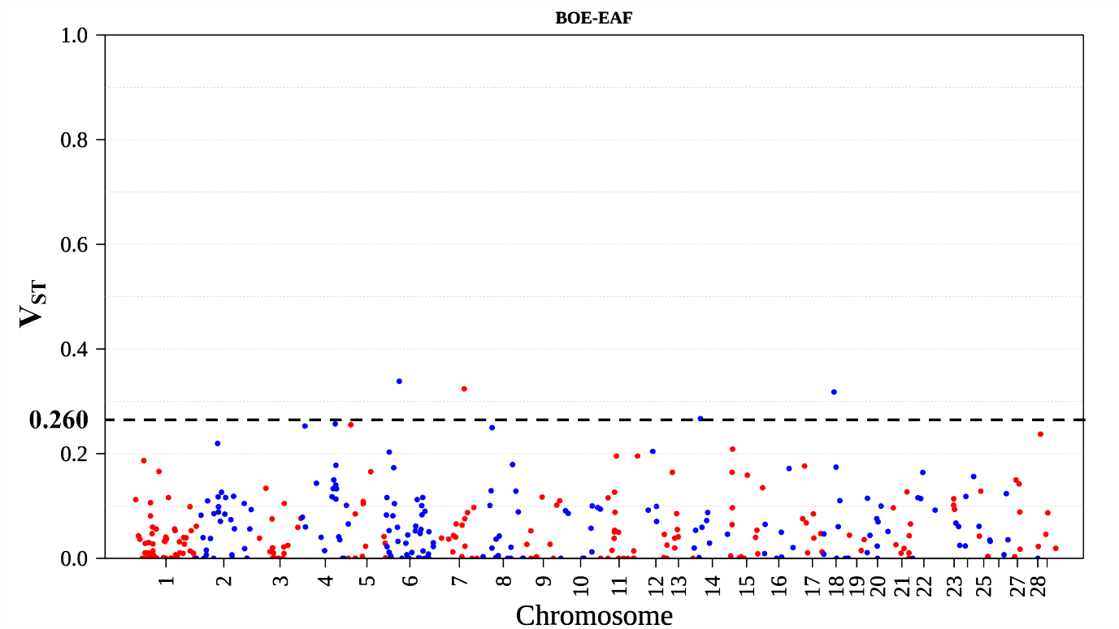
Supplementary Figure 1: CNV differentiation between Boer and East African goat populations.
The dotted line represents the V_{ST} threshold value for this test.

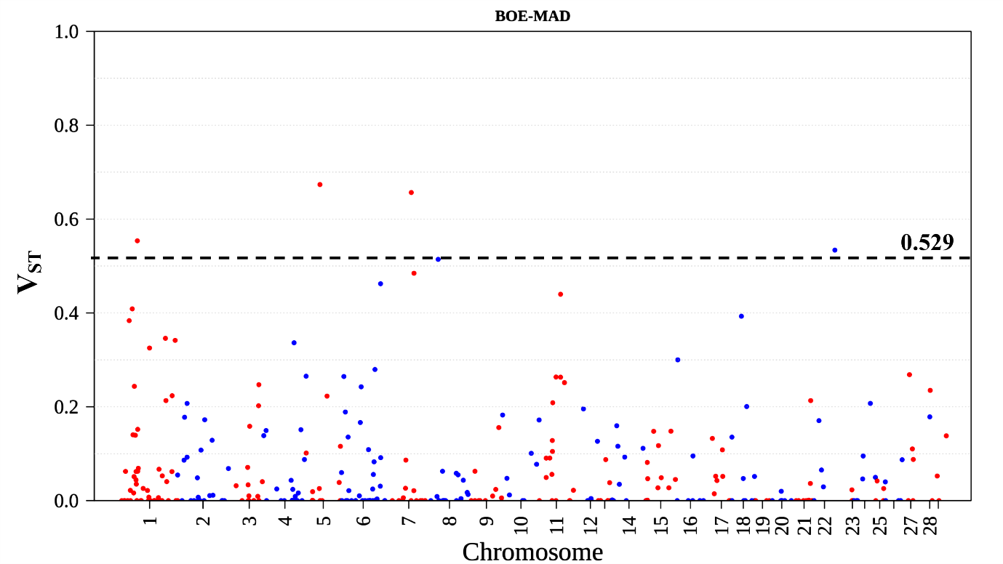
Supplementary Figure 2: CNV differentiation between Boer and Madagascar goat populations.
The dotted line represents the V_{ST} threshold value for this test.

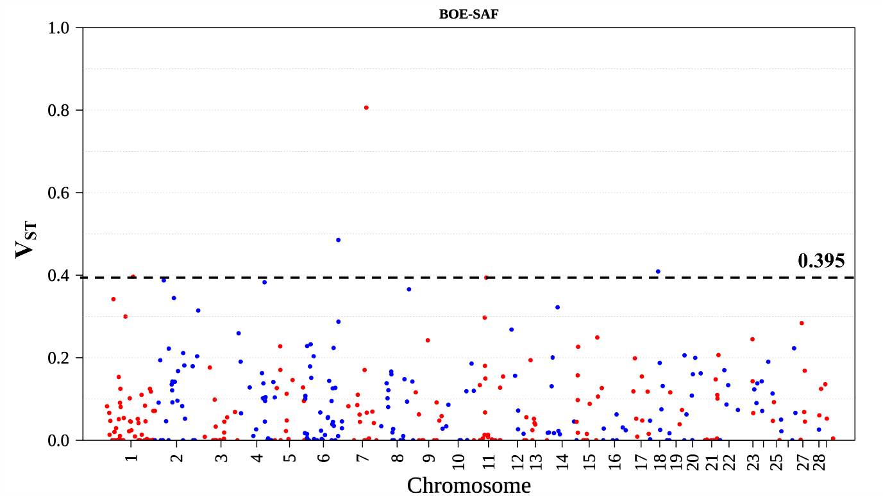
Supplementary Figure 3: CNV differentiation between Boer and Southern African goat populations.
The dotted line represents the V_{ST} threshold value for this test.

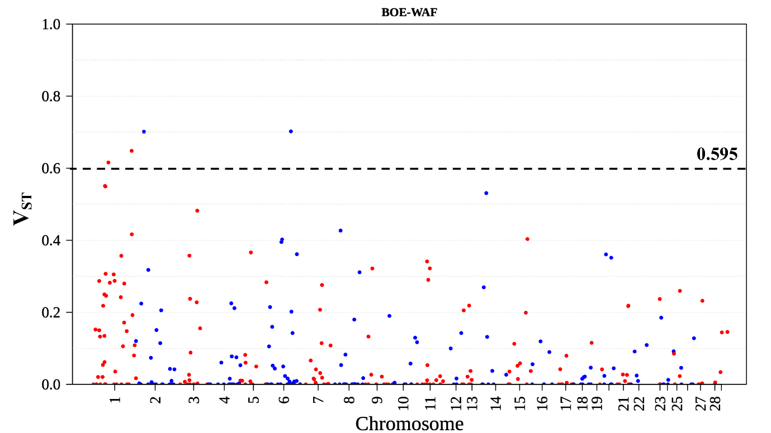
Supplementary Figure 4: CNV differentiation between Boer and West African goat populations.
The dotted line represents the V_{ST} threshold value for this test.

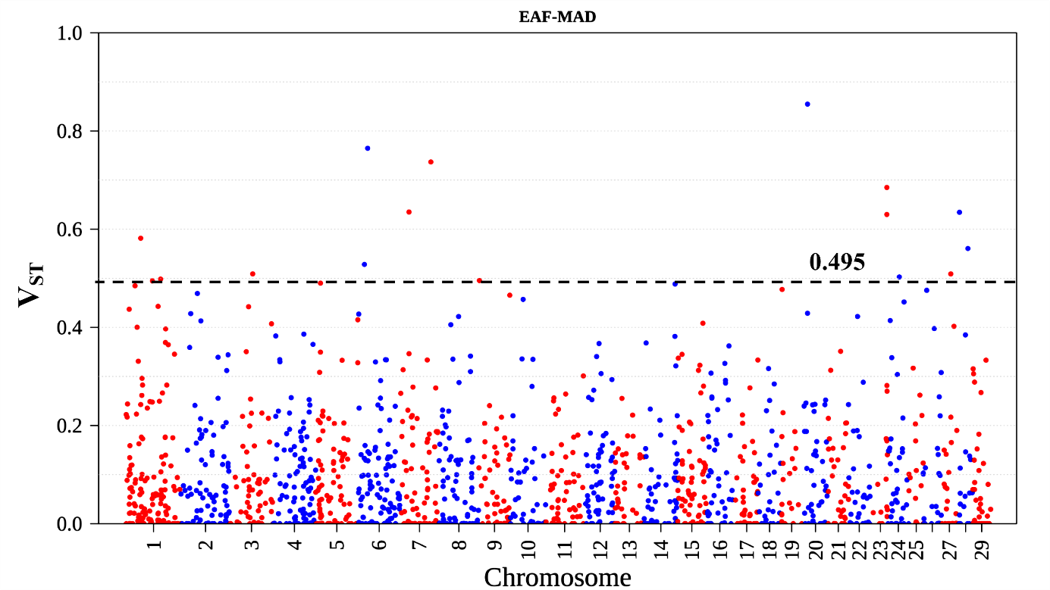
Supplementary Figure 5: CNV differentiation between East African and Madagascar goat populations.
The dotted line represents the V_{ST} threshold value for this test.

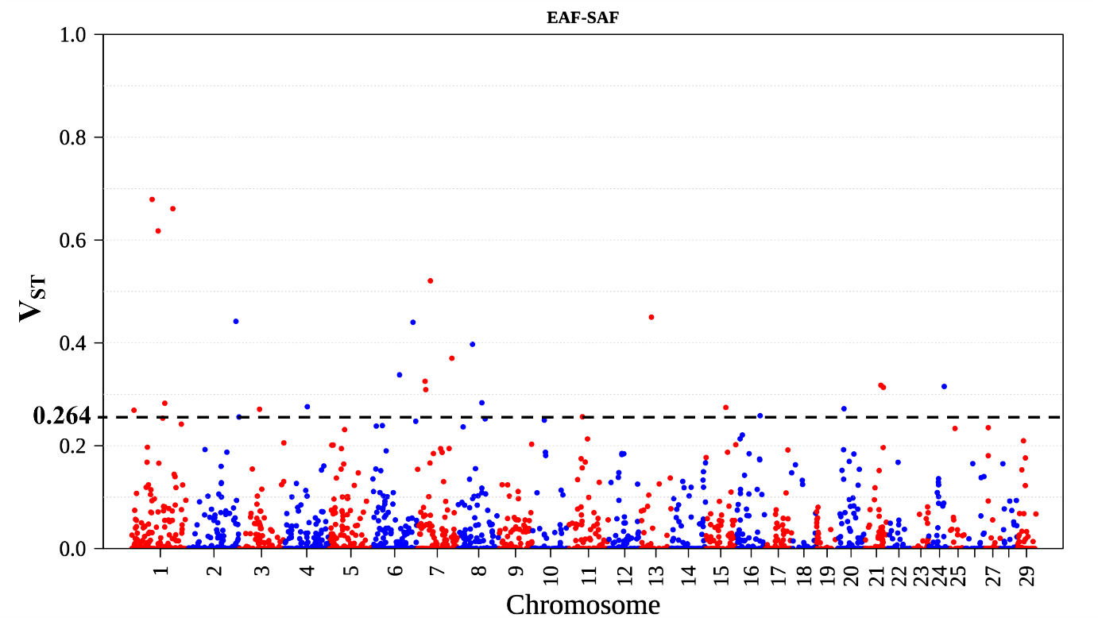
Supplementary Figure 6: CNV differentiation between East African and Southern African goat populations.
The dotted line represents the V_{ST} threshold value for this test.

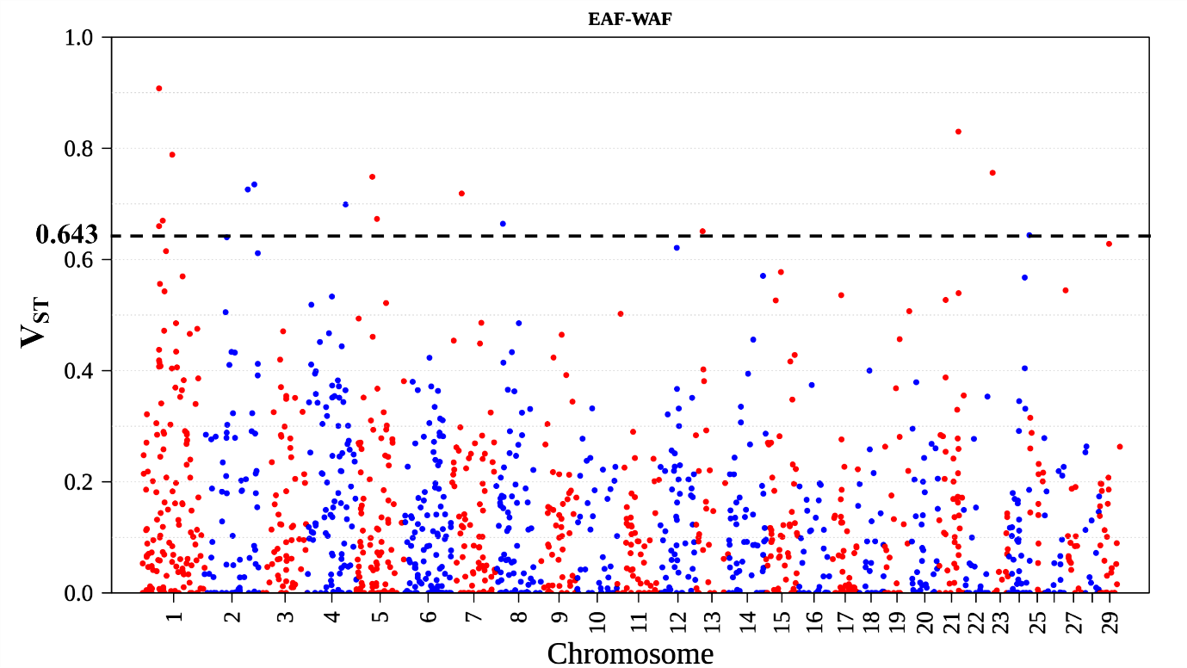
Supplementary Figure 7: CNV differentiation between East African and West African goat populations.
The dotted line represents the V_{ST} threshold value for this test.

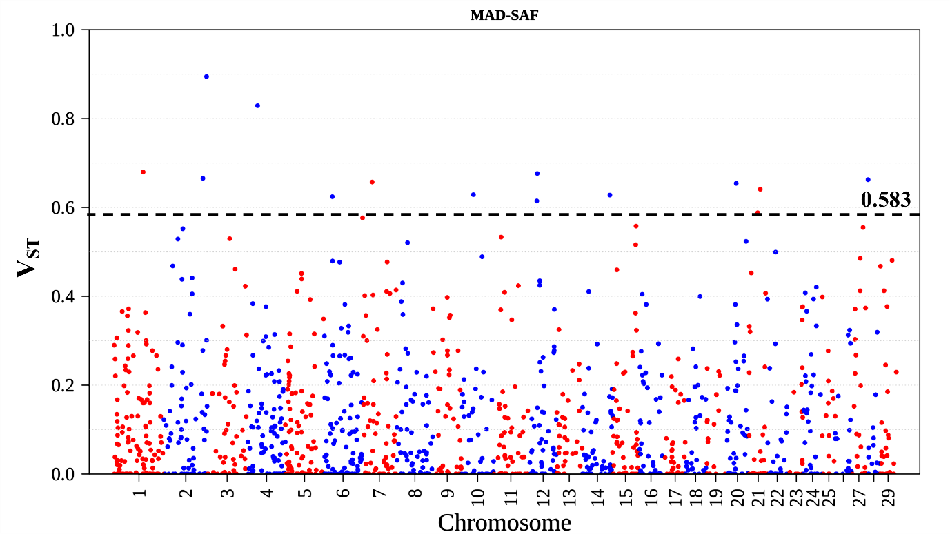
Supplementary Figure 8: CNV differentiation between Madagascar and Southern African goat populations.
The dotted line represents the V_{ST} threshold value for this test.

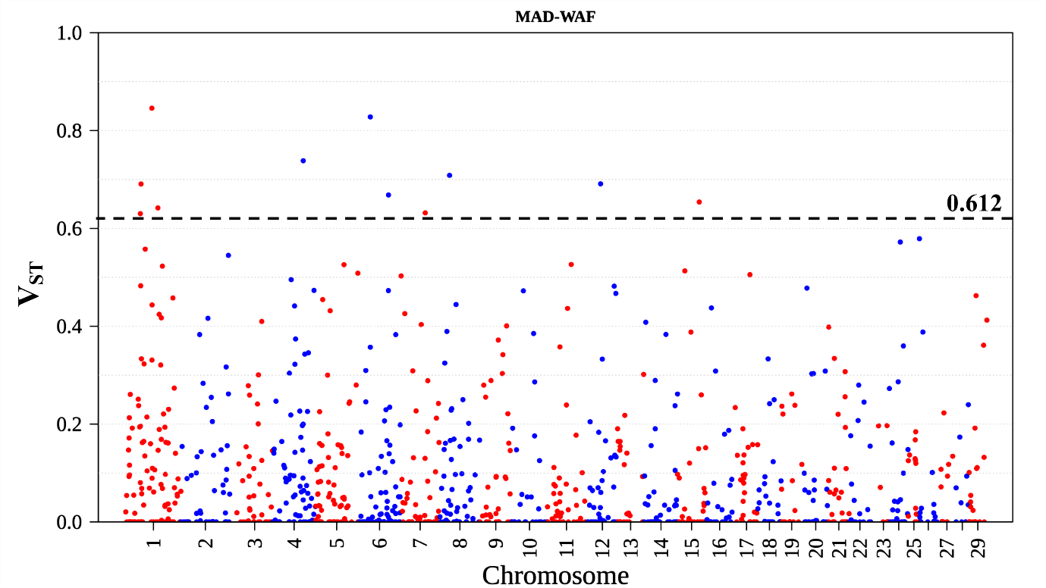
Supplementary Figure 9: CNV differentiation between Madagascar and West African goat populations.
The dotted line represents the V_{ST} threshold value for this test.

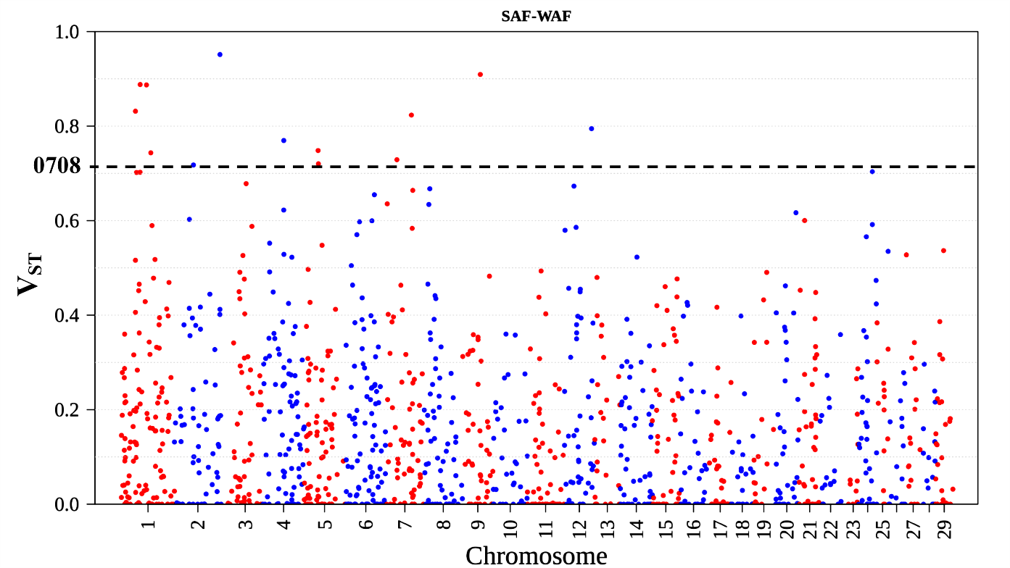
Supplementary Figure 10: CNV differentiation between Southern African and Western African goat populations.
The dotted line represents the V_{ST} threshold value for this test.

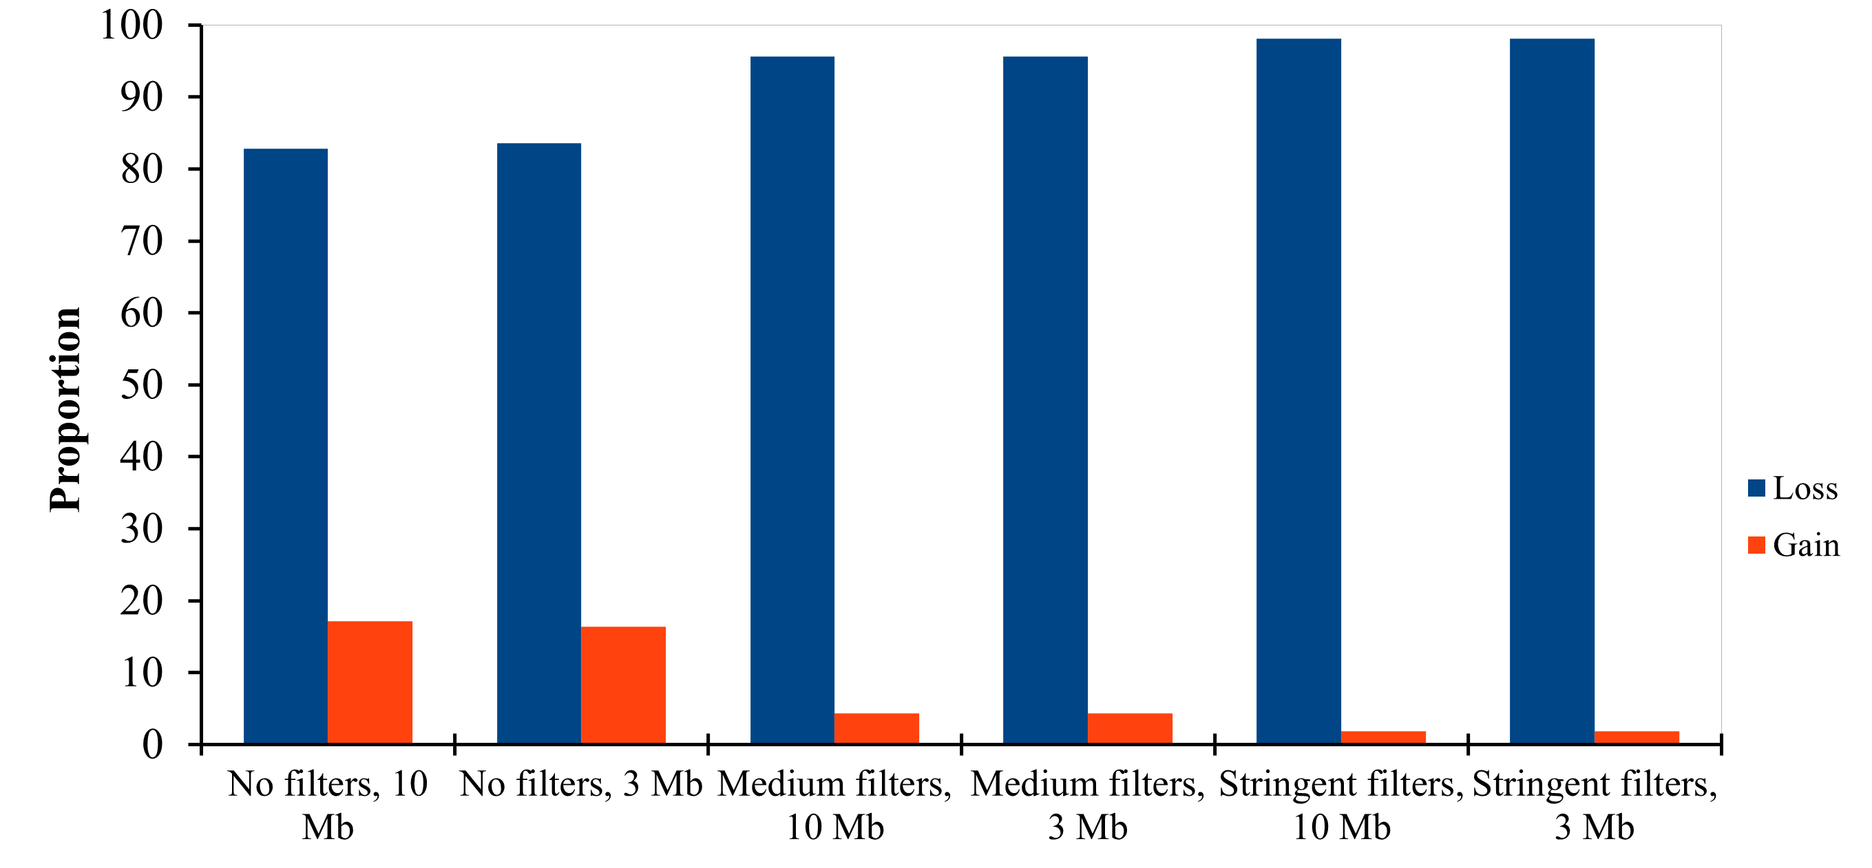
Supplementary Figure 11: Proportions of CNV copy loss and gain for each set of filter parameter and CNV cut-off point.
Medium filters: PE = SR = 3
Stringent filters: PE= SR = 5

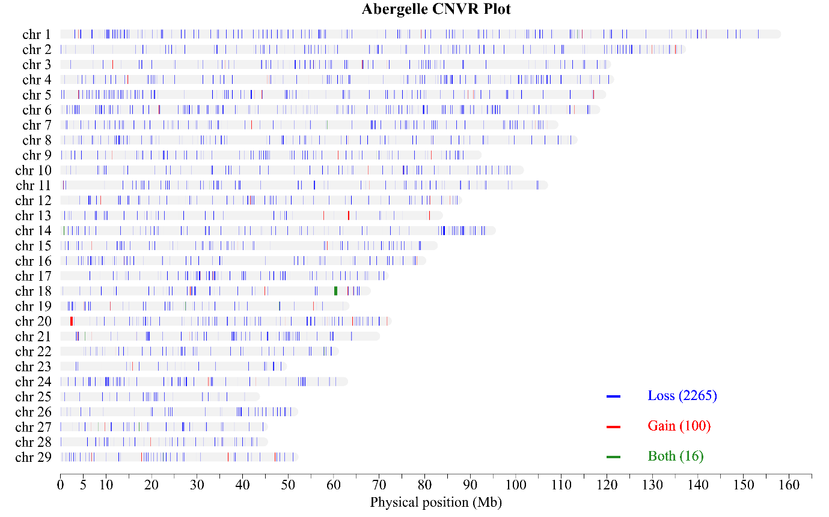
Supplementary Figure 12: CNVR for the Abergelle breed

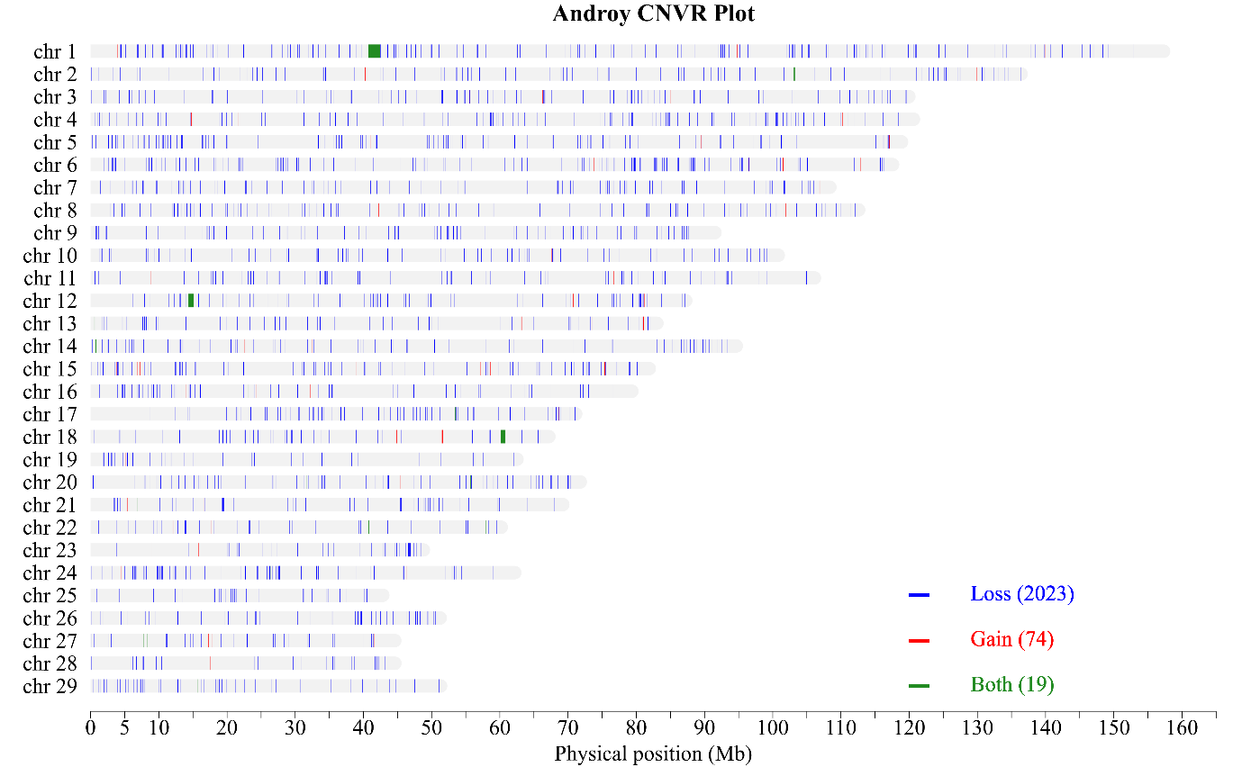
Supplementary Figure 13: CNVR for the Androy breed

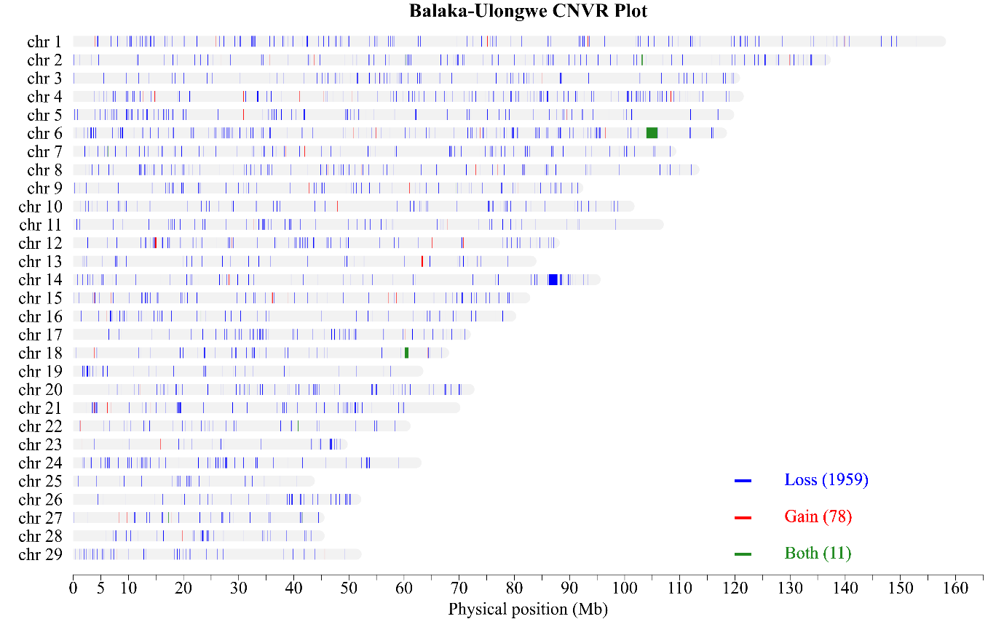
Supplementary Figure 14: CNVR for the Balaka-Ulongwe breed

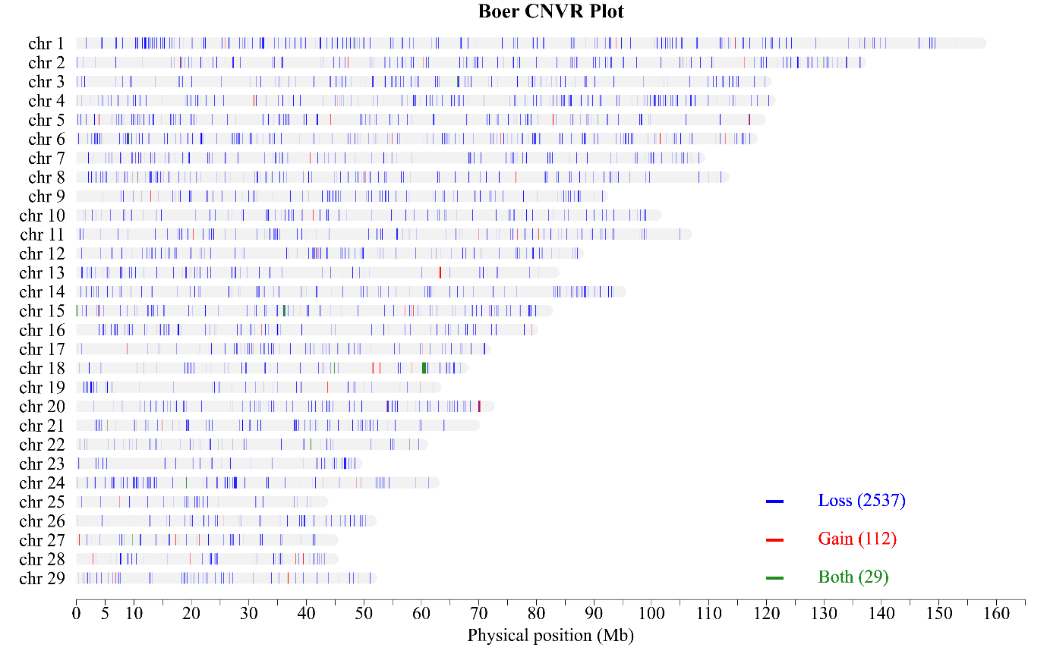
Supplementary Figure 15: CNVR for the Boer breed

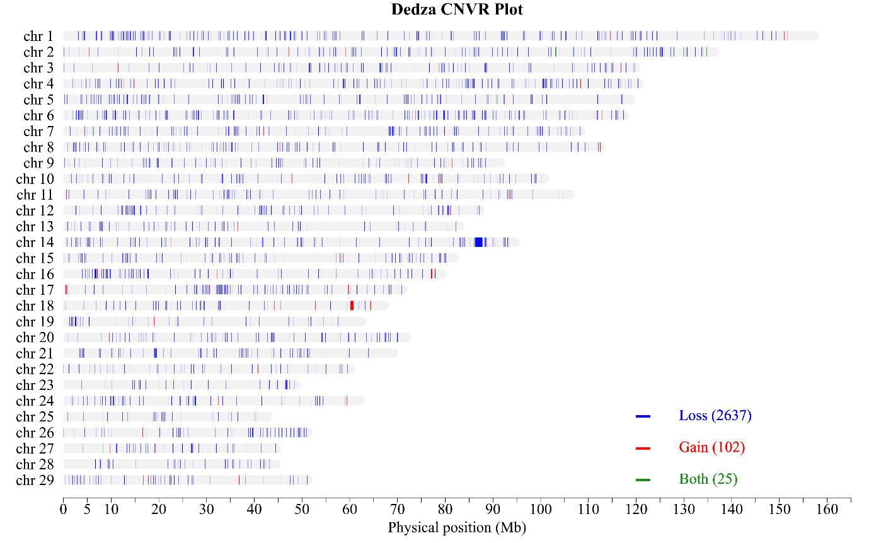
Supplementary Figure 16: CNVR for the Dedza breed

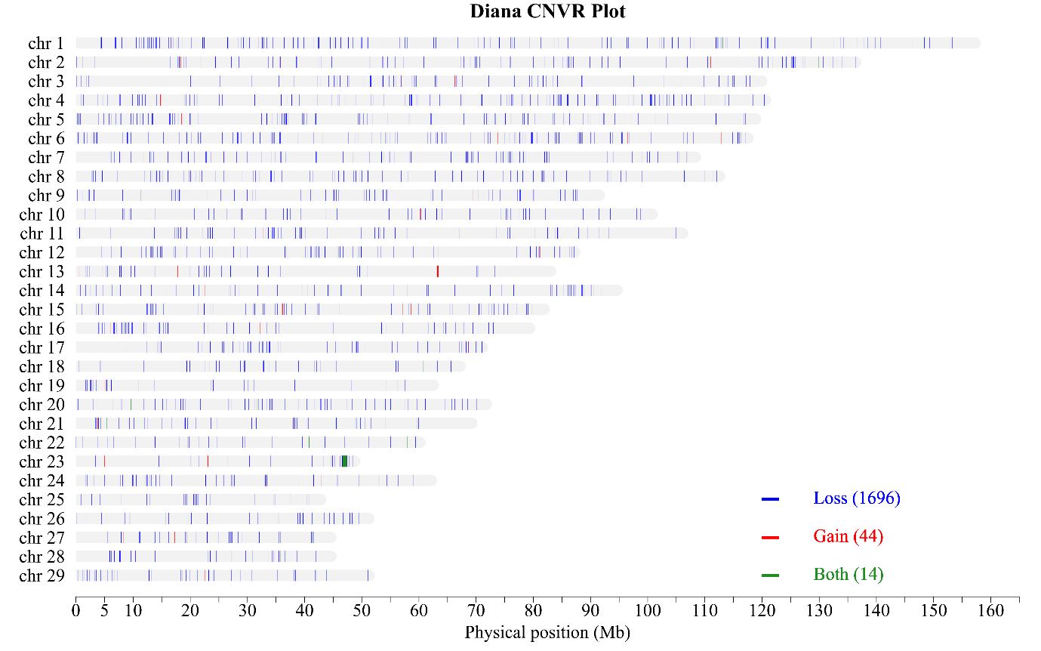
Supplementary Figure 17: CNVR for the Diana breed

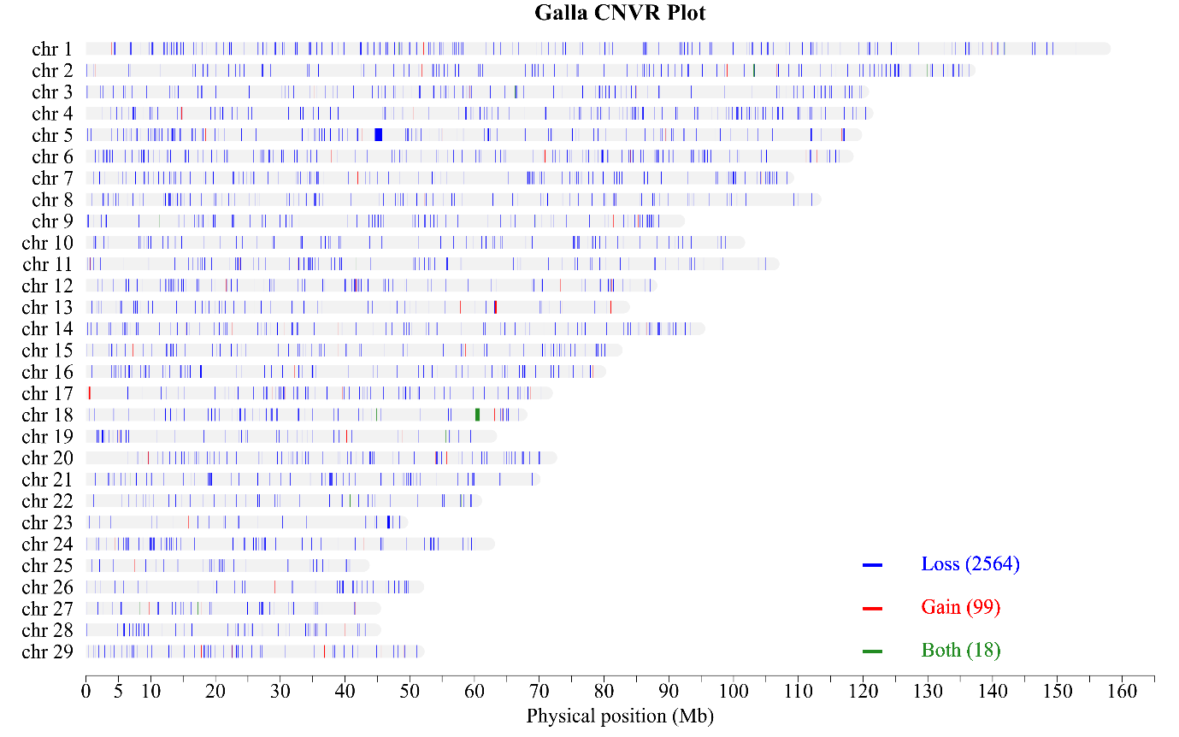
Supplementary Figure 18: CNVR for the Galla breed

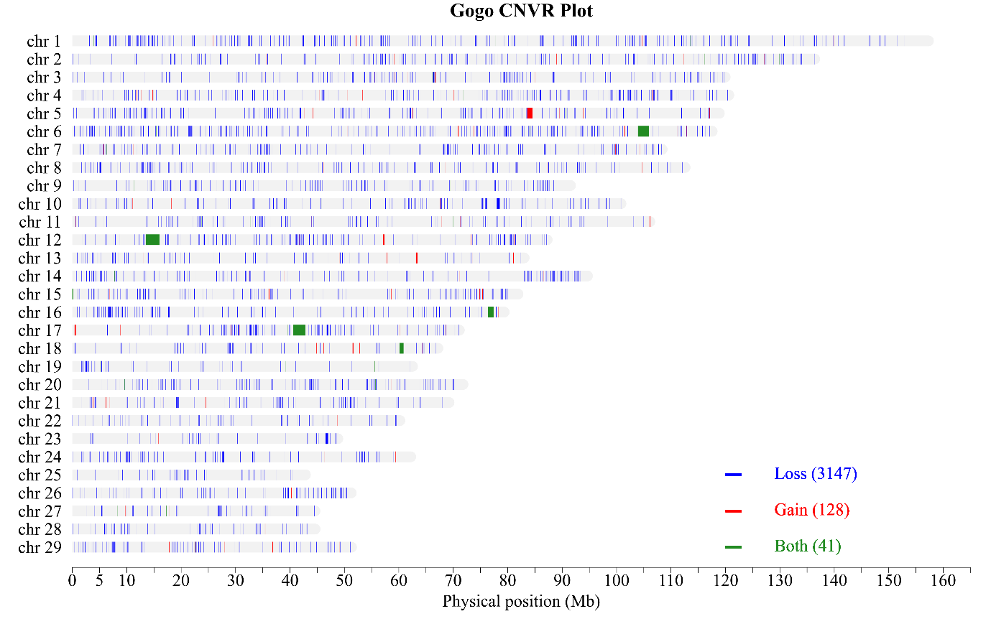
Supplementary Figure 19: CNVR for the Gogo breed

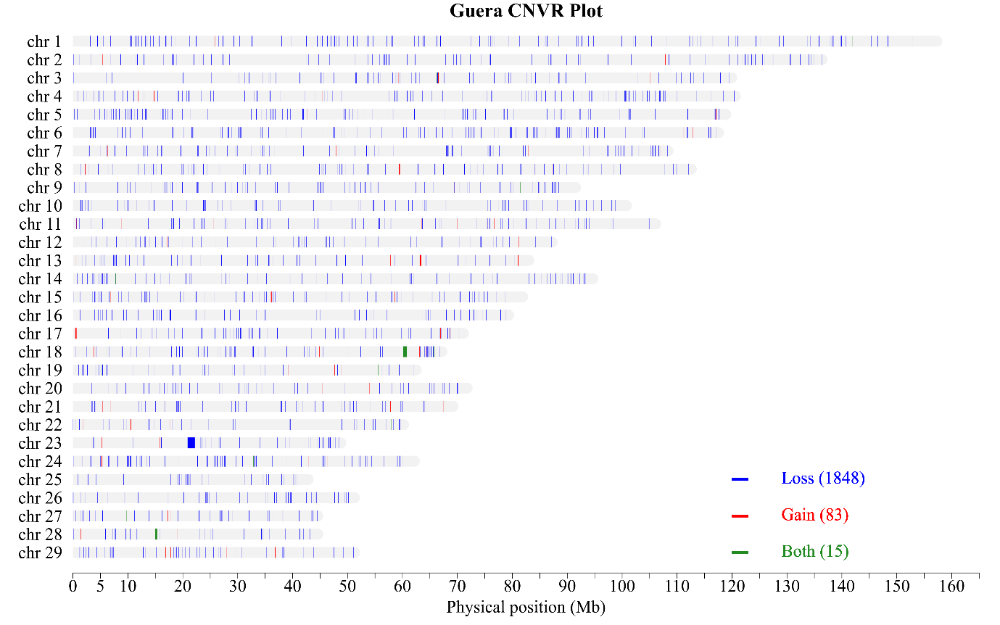
Supplementary Figure 20: CNVR for the Guera breed

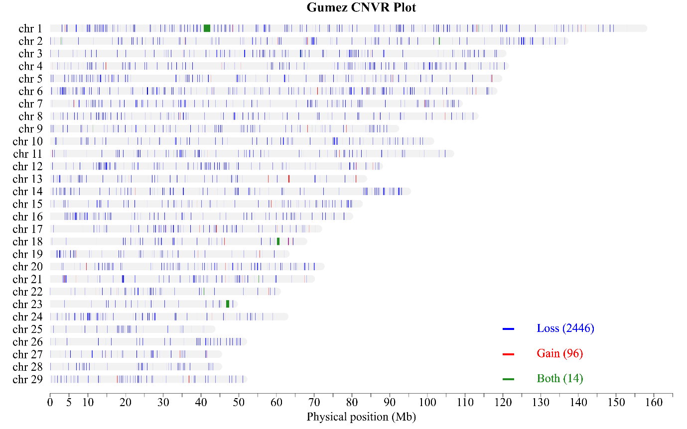
Supplementary Figure 21: CNVR for the Gumez breed

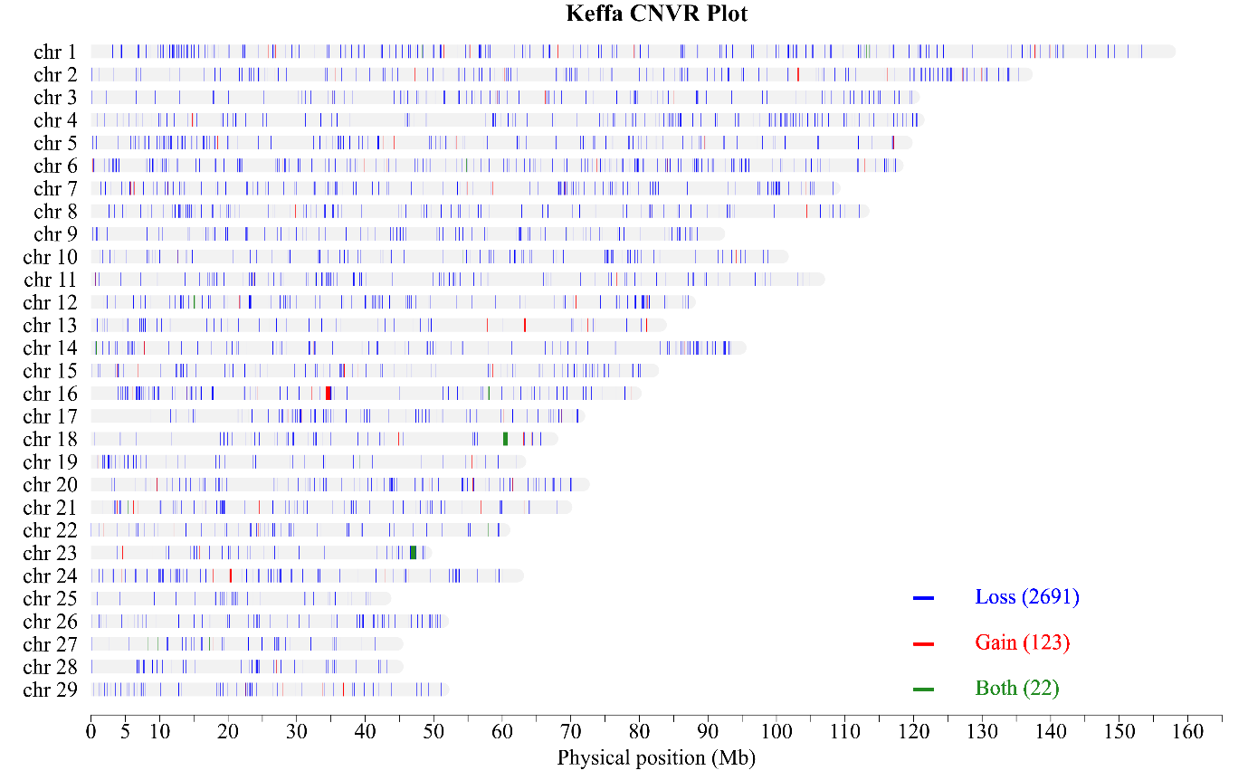
Supplementary Figure 22: CNVR for the Keffa breed

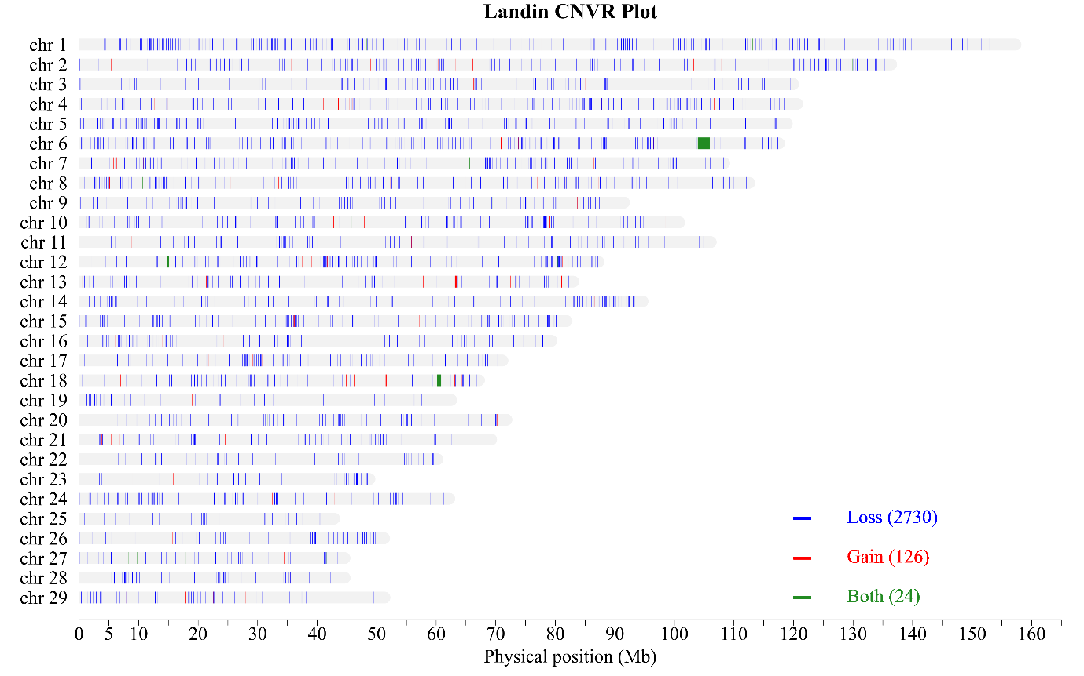
Supplementary Figure 23: CNVR for the Landin breed

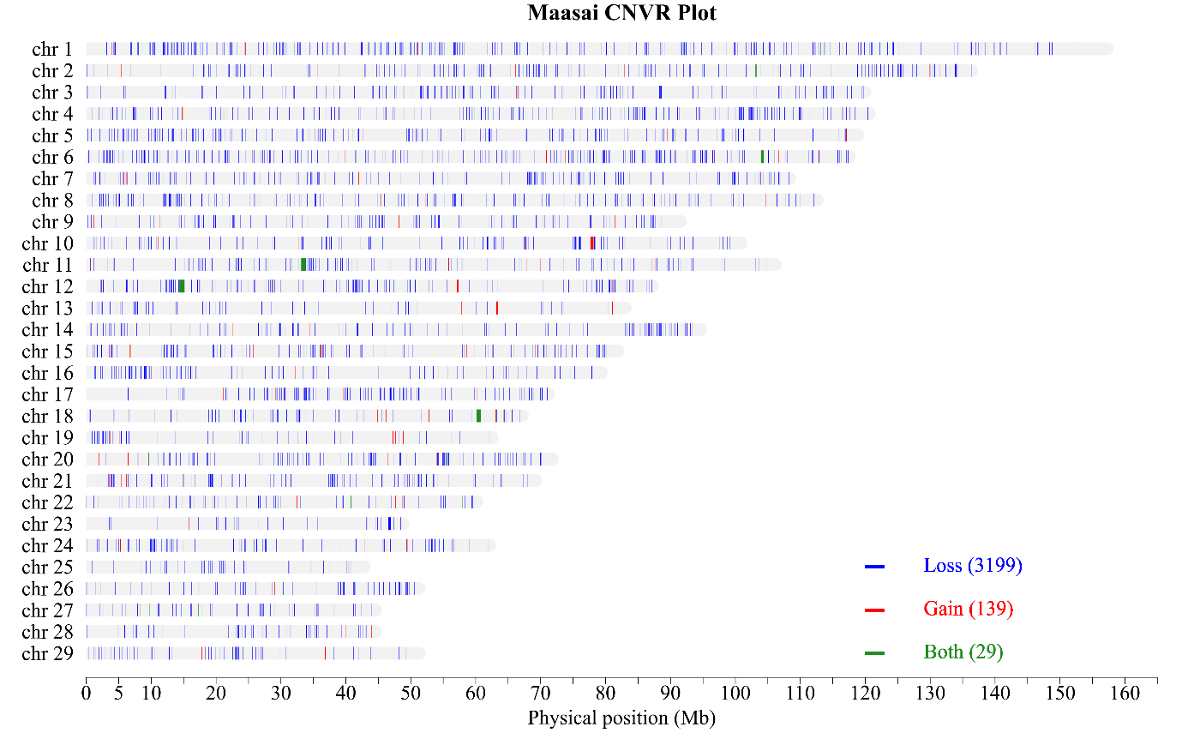
Supplementary Figure 24: CNVR for the Maasai breed

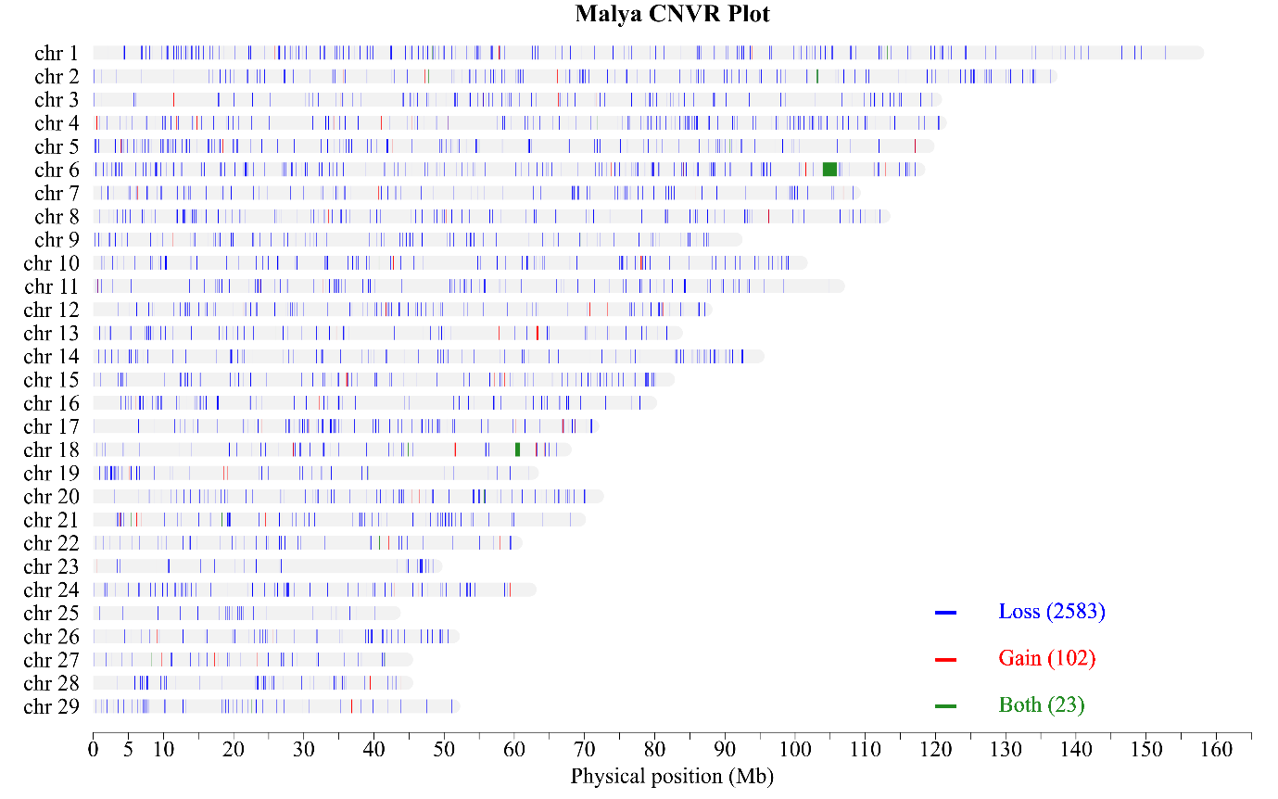
Supplementary Figure 25: CNVR for the Malya breed

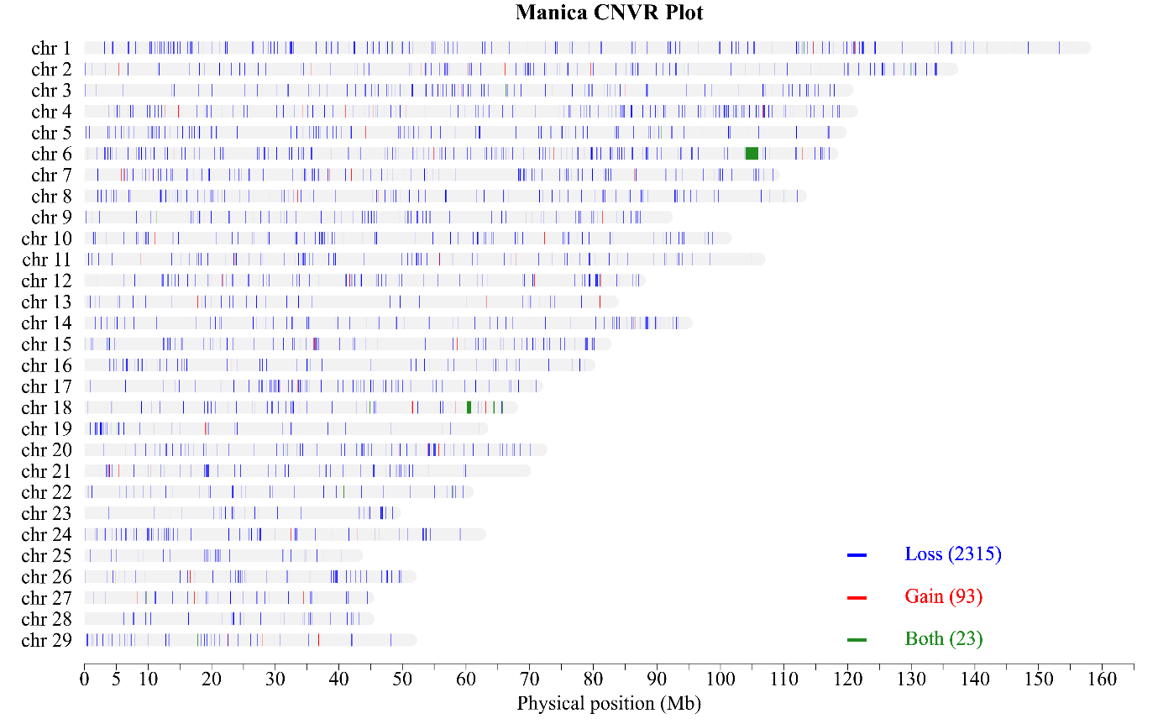
Supplementary Figure 26: CNVR for the Manica breed

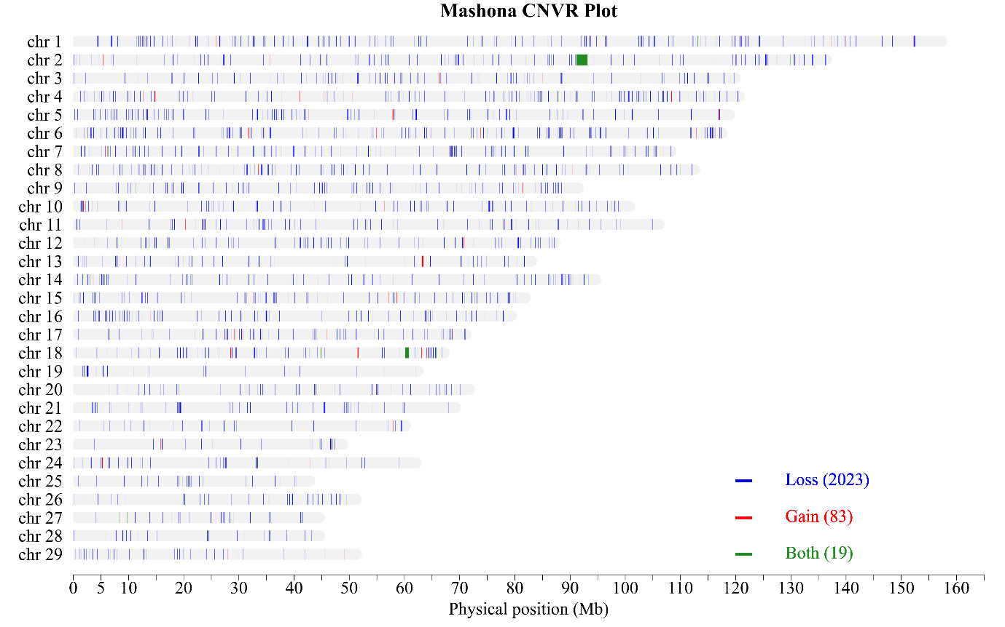
Supplementary Figure 27: CNVR for the Mashona breed

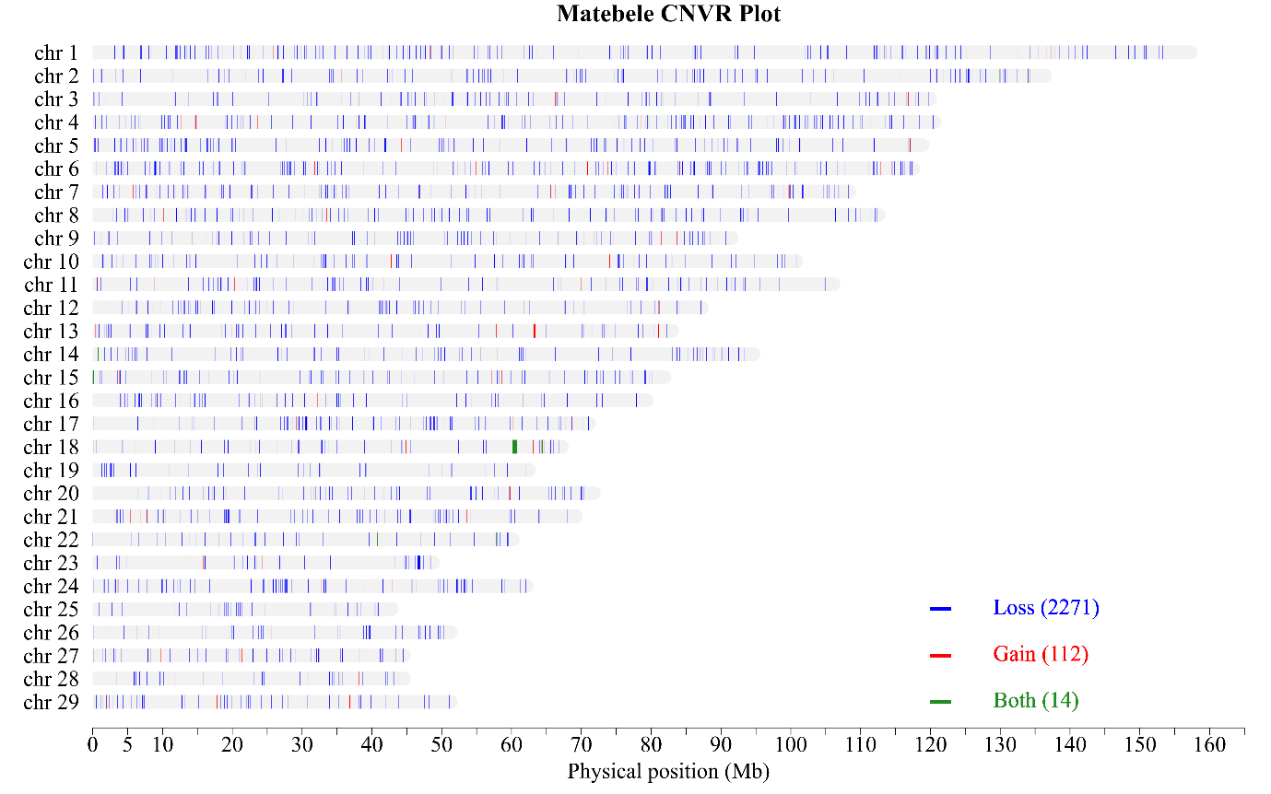
Supplementary Figure 28: CNVR for the Matebele breed

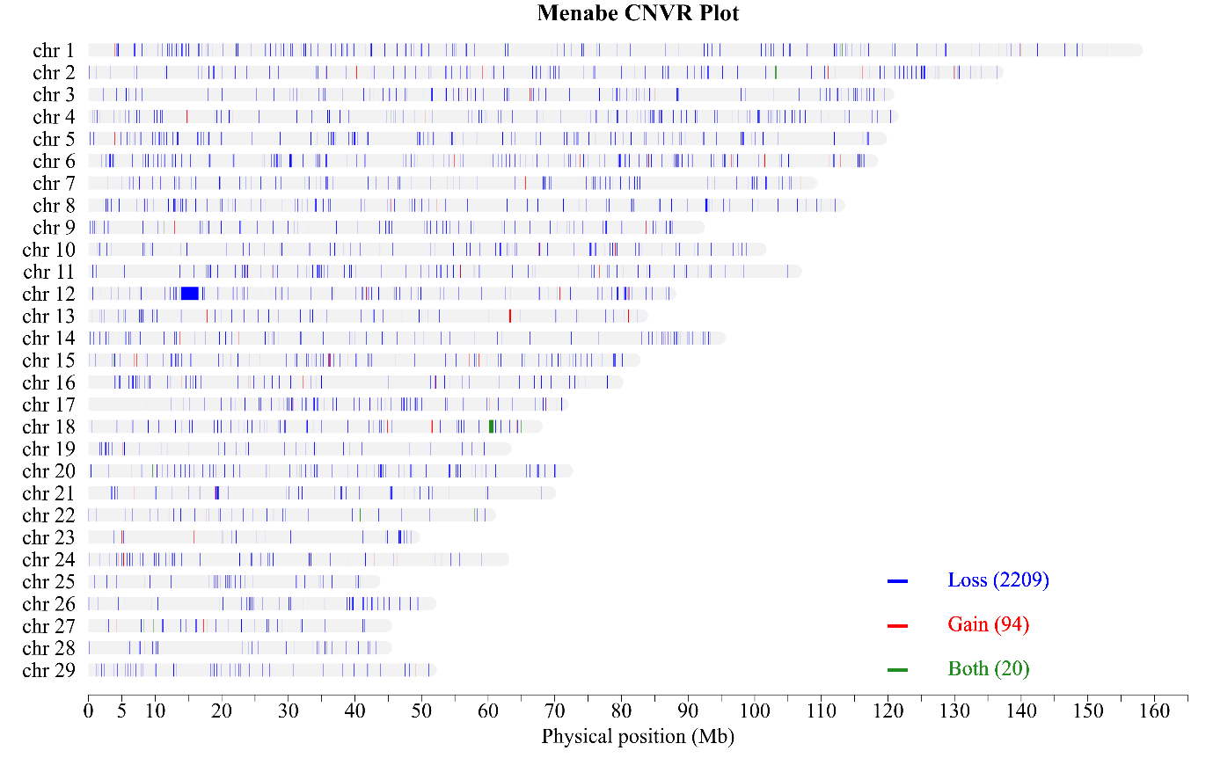
Supplementary Figure 29: CNVR for the Menabe breed

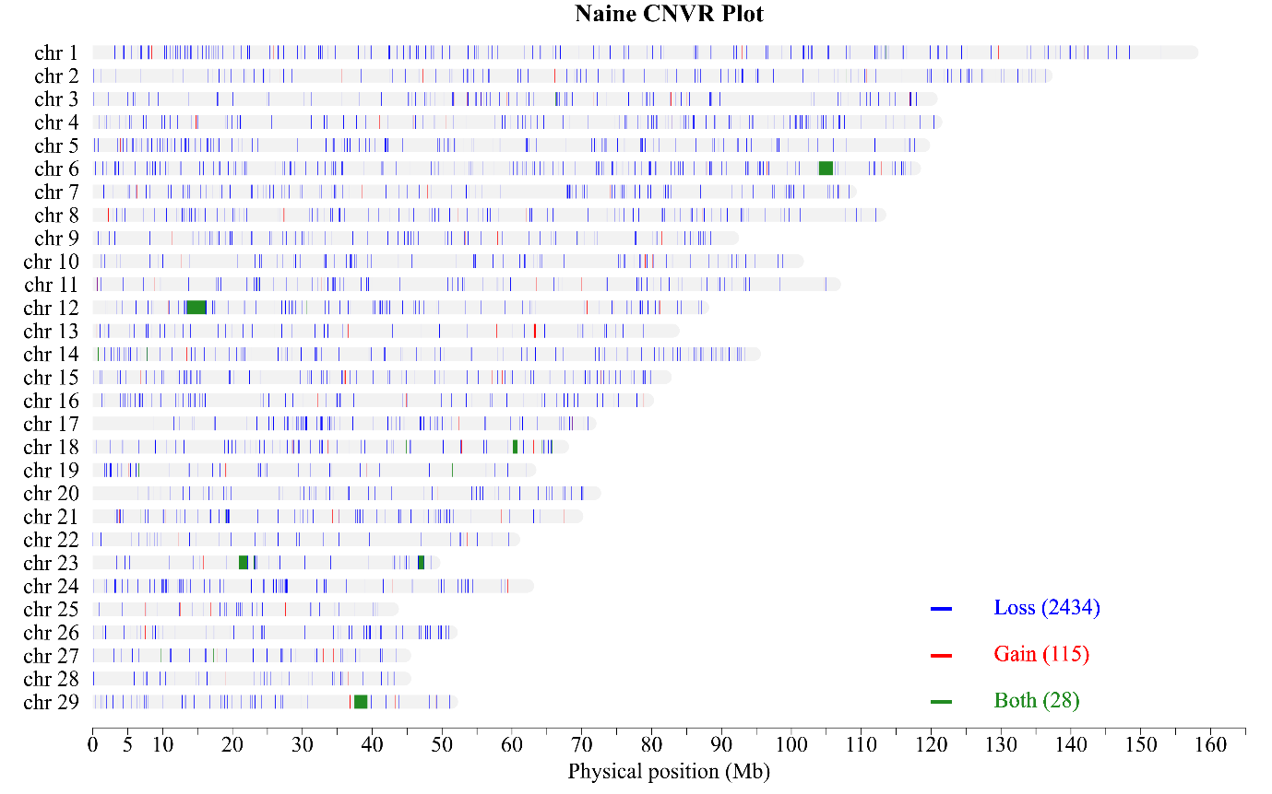
Supplementary Figure 30: CNVR for the Naine breed

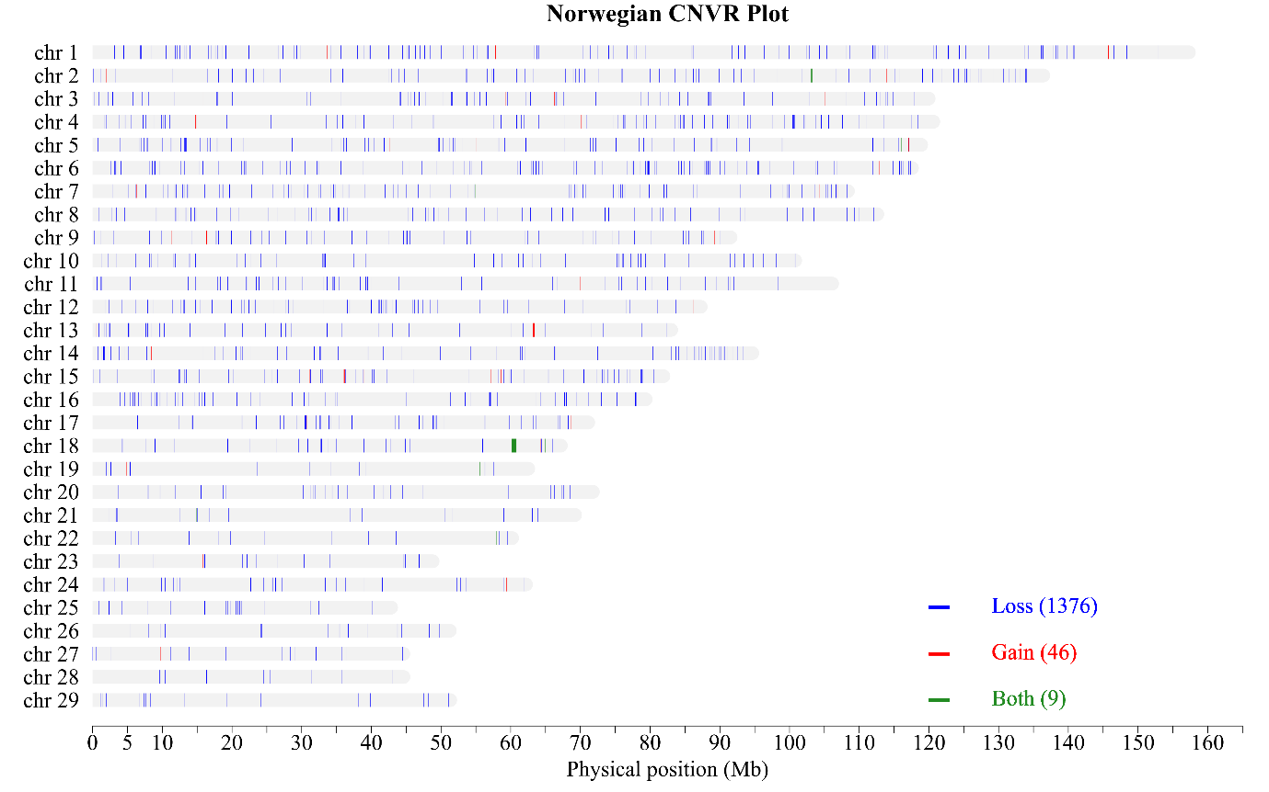
Supplementary Figure 31: CNVR for the Norwegian breed

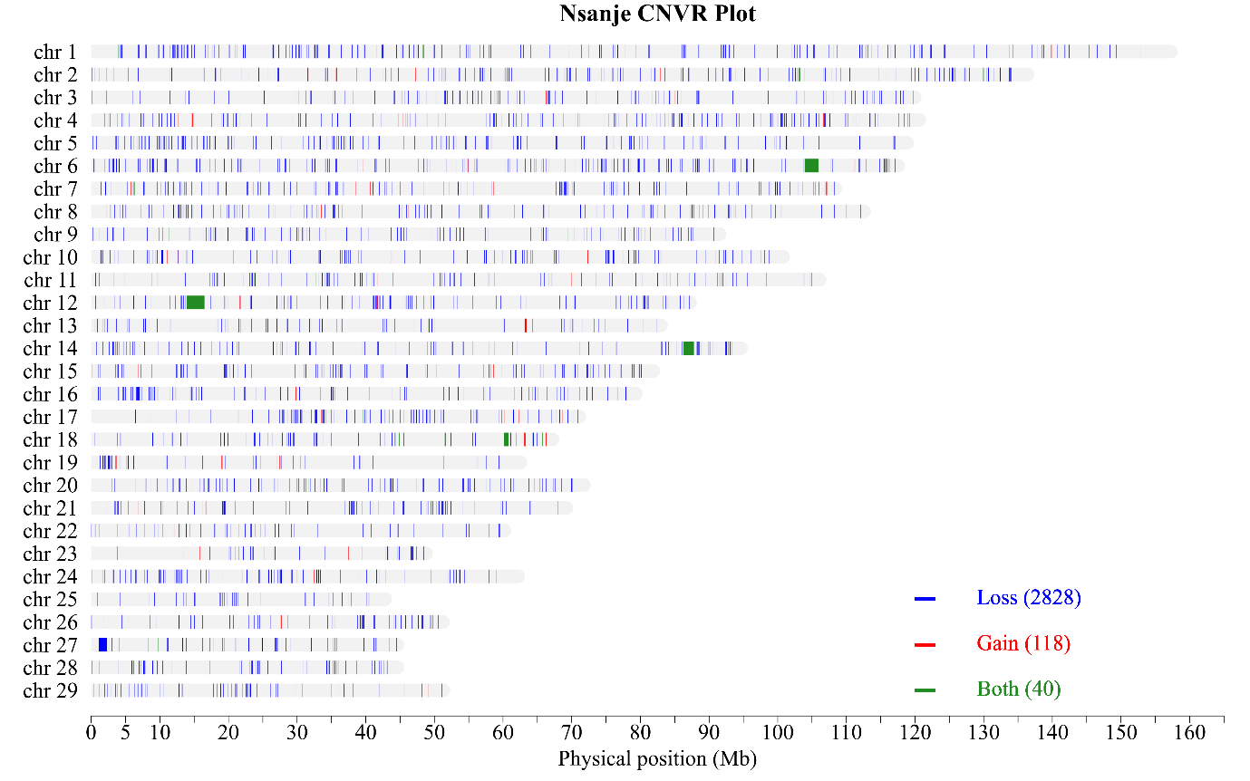
Supplementary Figure 32: CNVR for the Nsanje breed

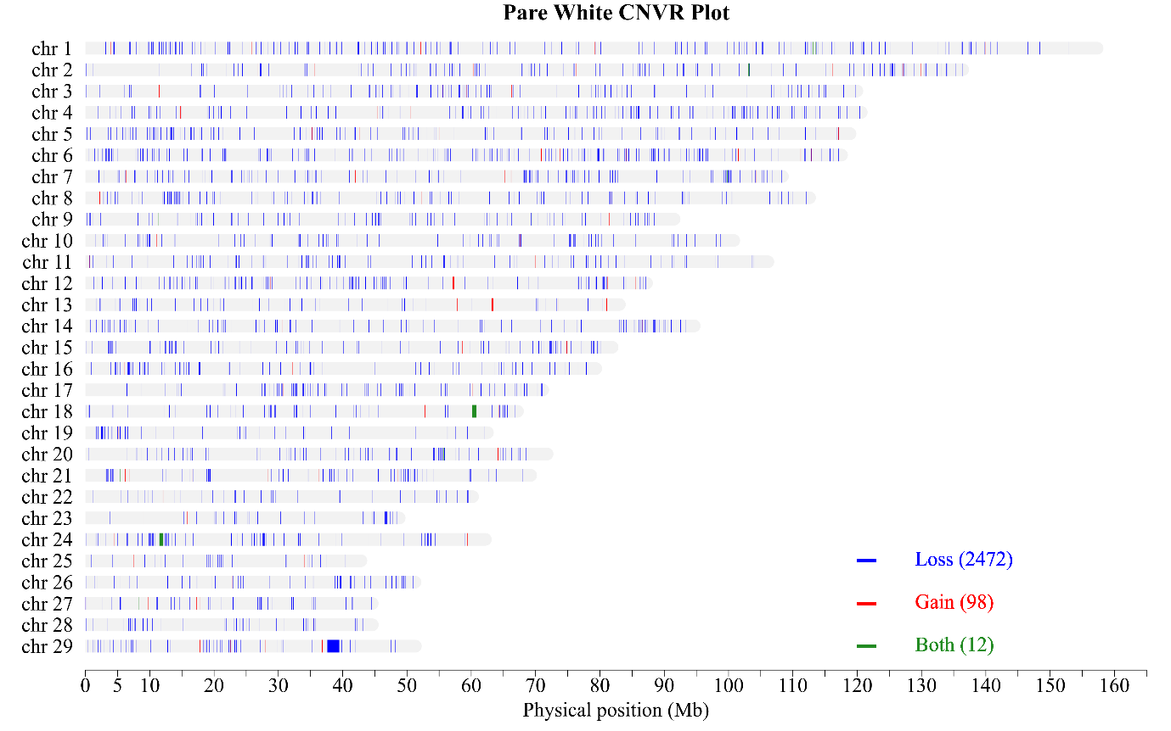
Supplementary Figure 33: CNVR for the Pare White breed

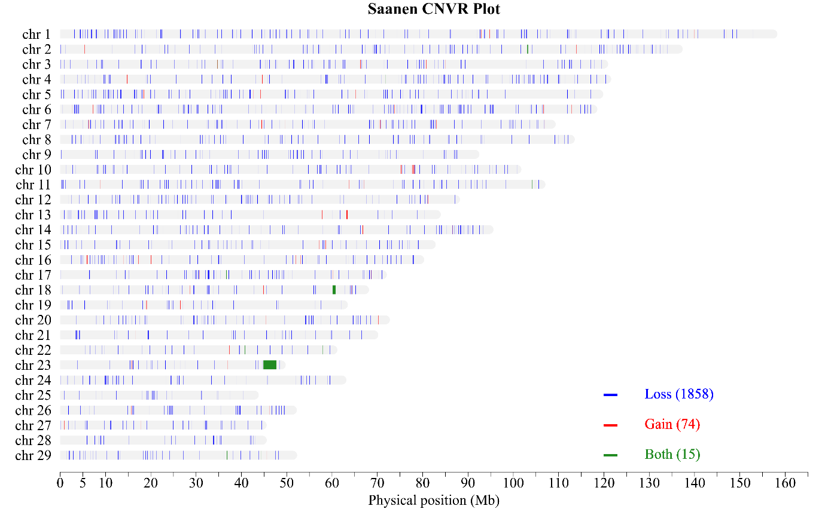
Supplementary Figure 34: CNVR for the Saanen breed

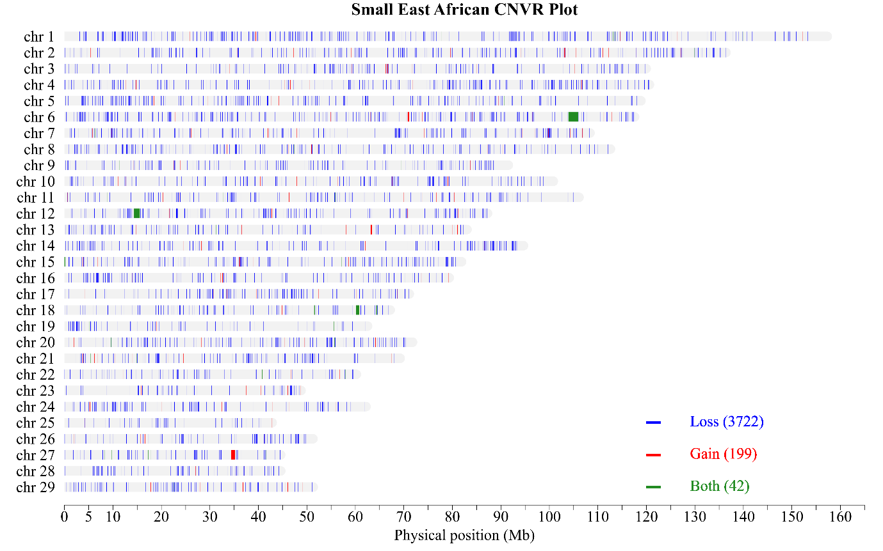
Supplementary Figure 35: CNVR for the Small East African breed

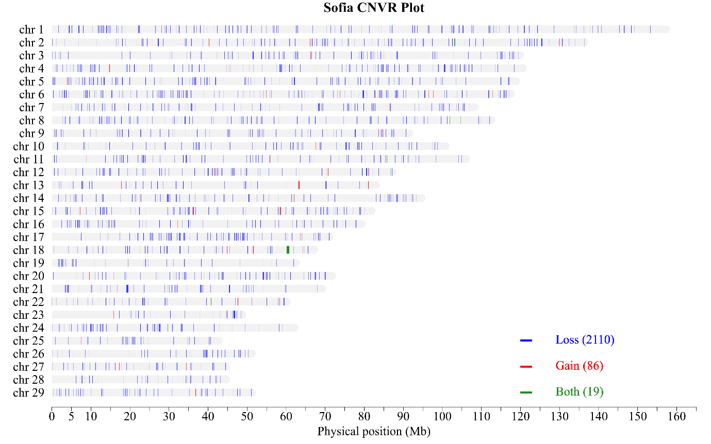
Supplementary Figure 36: CNVR for the Sofia breed

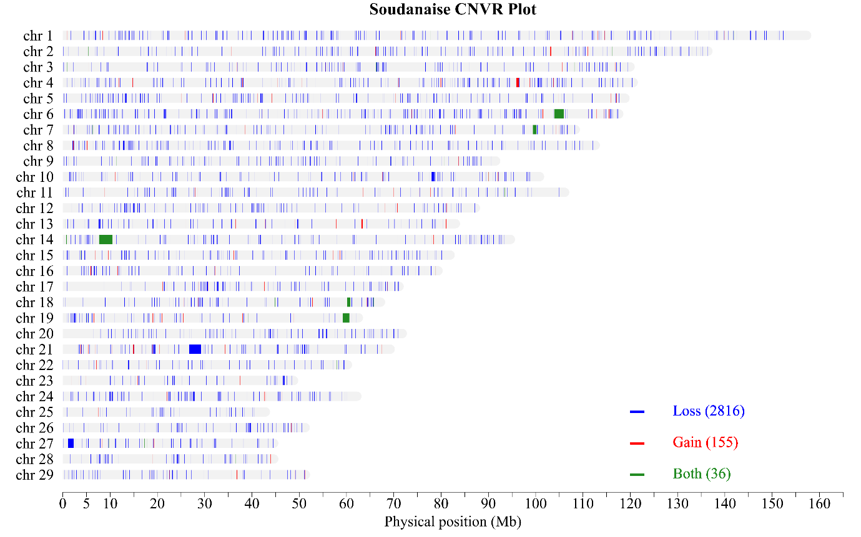
Supplementary Figure 37: CNVR for the Soudanaise breed

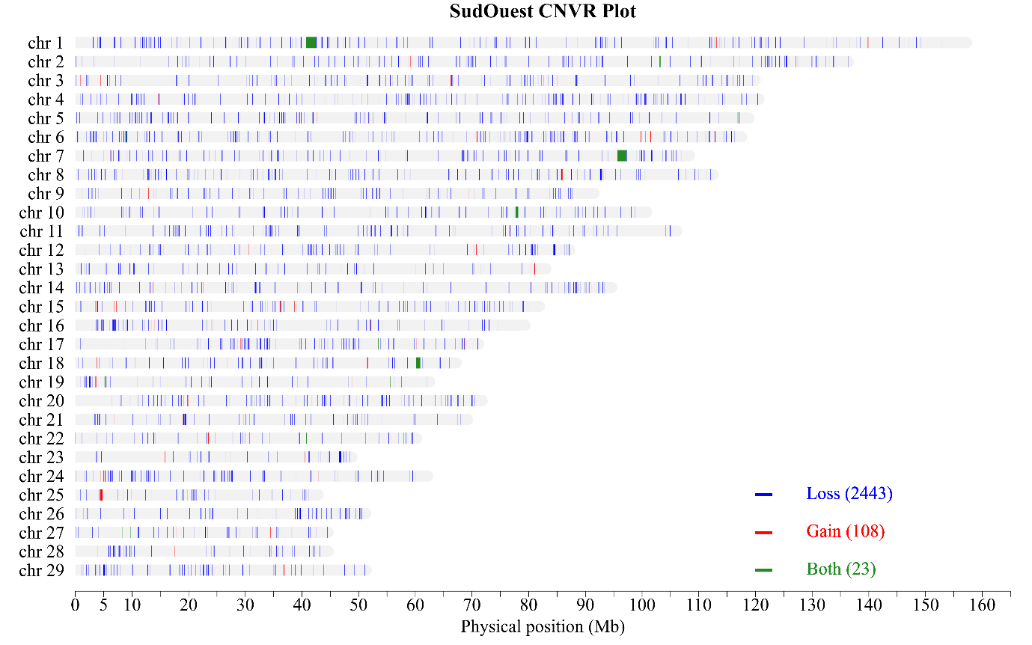
Supplementary Figure 38: CNVR for the SudOuest breed

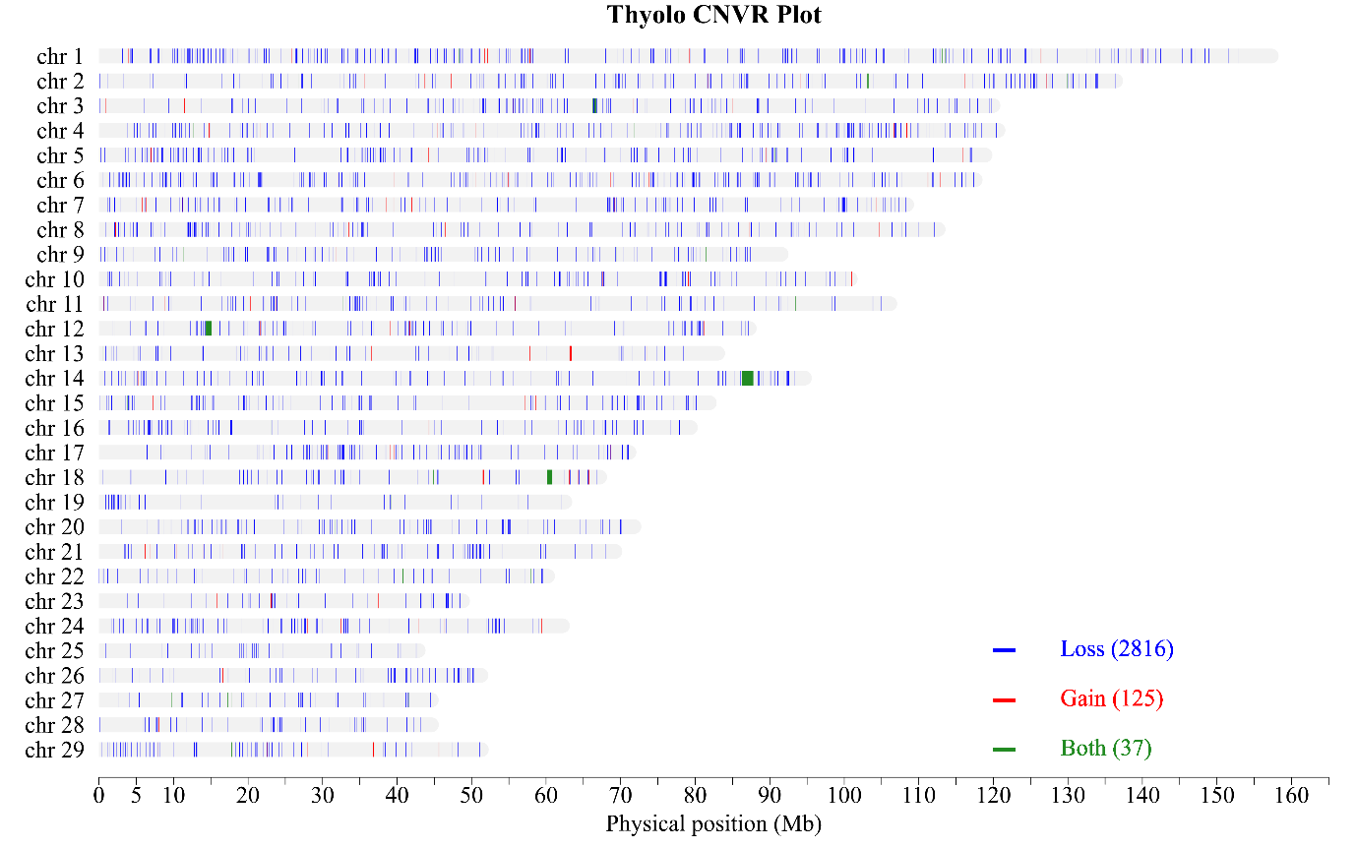
Supplementary Figure 39: CNVR for the Thyolo breed

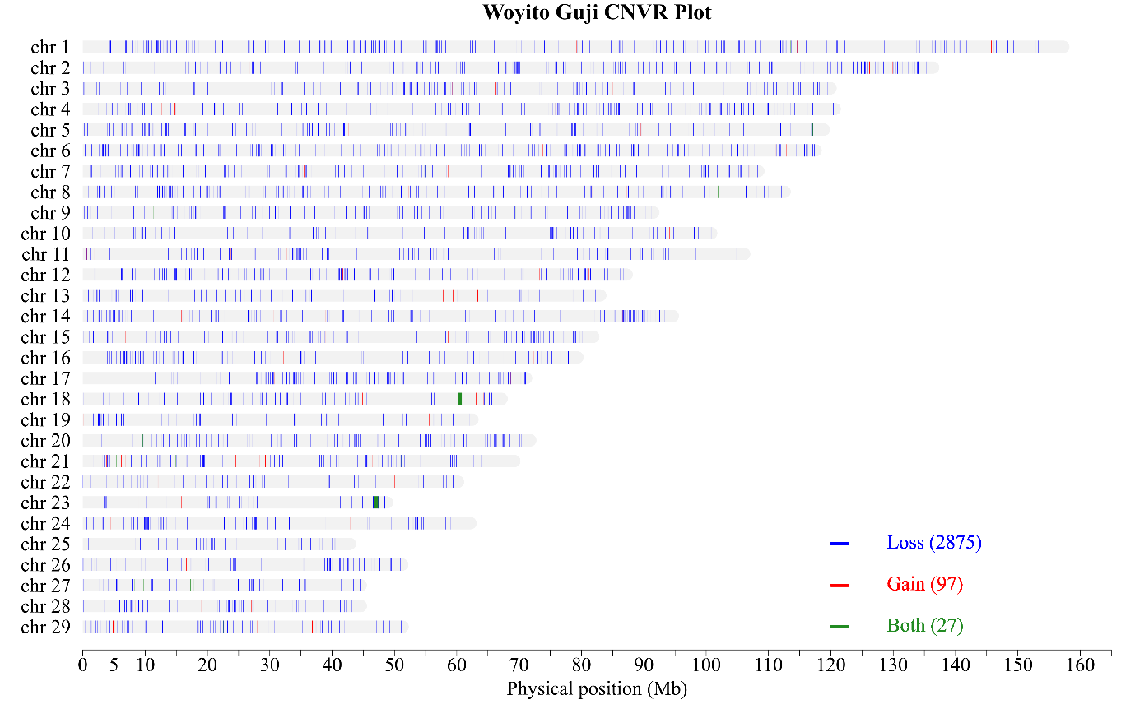
Supplementary Figure 40: CNVR for the Woyito Guji breed

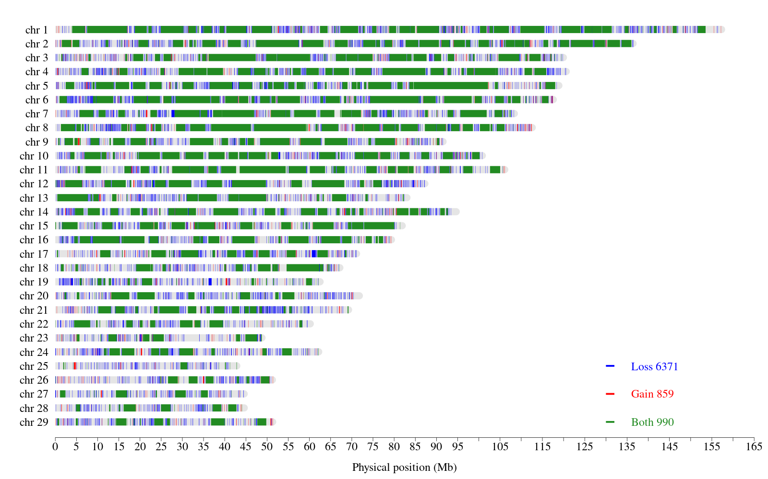
Supplementary Figure 41: Global CNVR with variable SV calling parameters
Imprecise SV included
Lower cut-off length of 50 bp applied before merging Manta and Lumpy SV
No SV filters (PE = SR = 0)
Upper cut-off length: 3 Mb
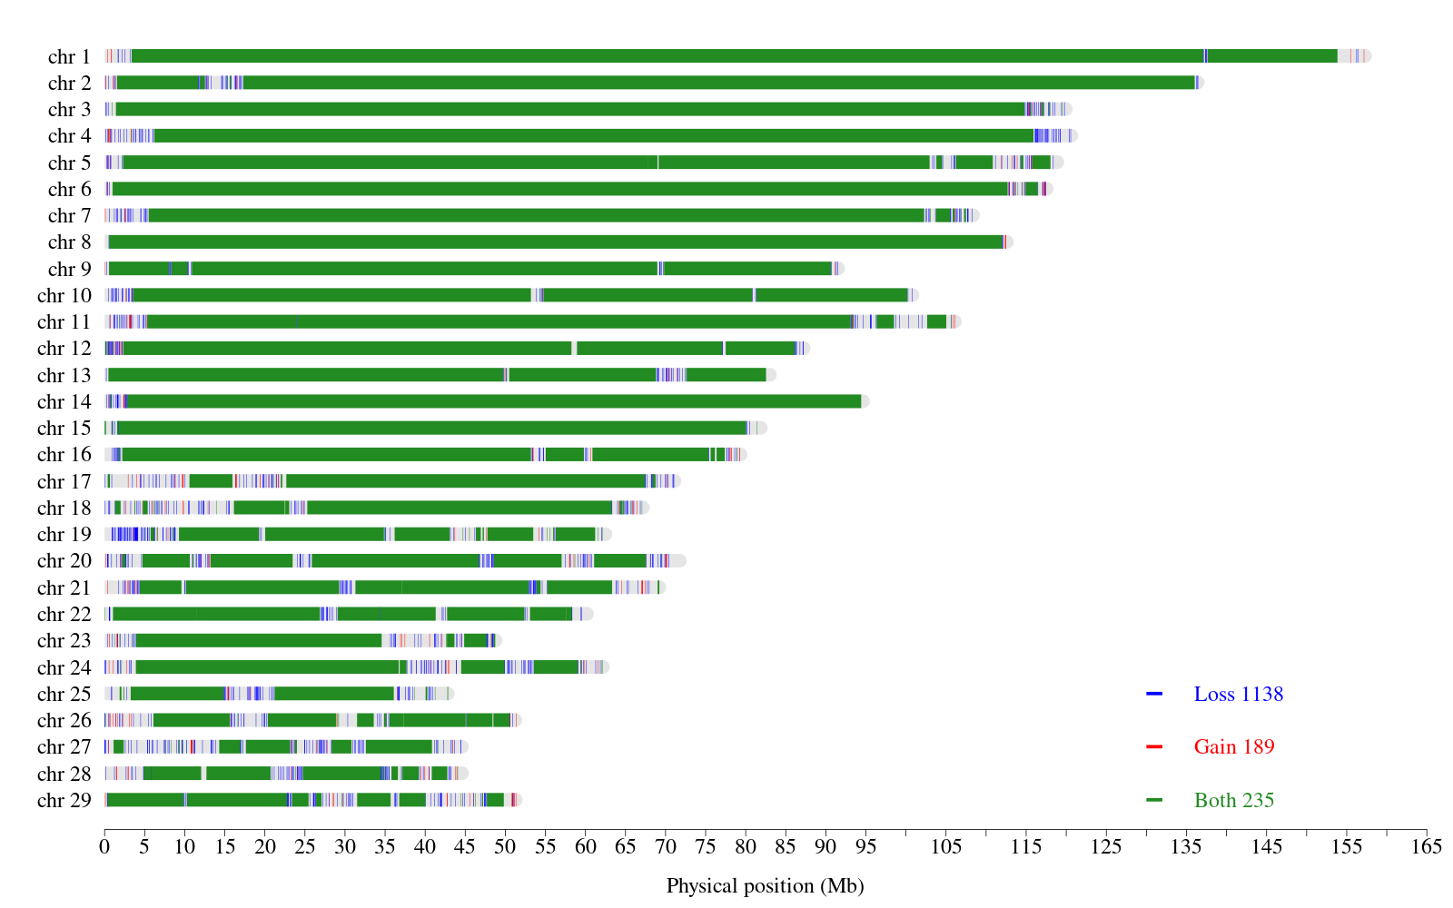
Supplementary Figure 42: Global CNVR with variable SV calling parameters
Imprecise SV included
Lower cut-off length of 50 bp applied before merging Manta and Lumpy SV
No SV filters (PE = SR = 0)
Upper cut-off length: 10 Mb

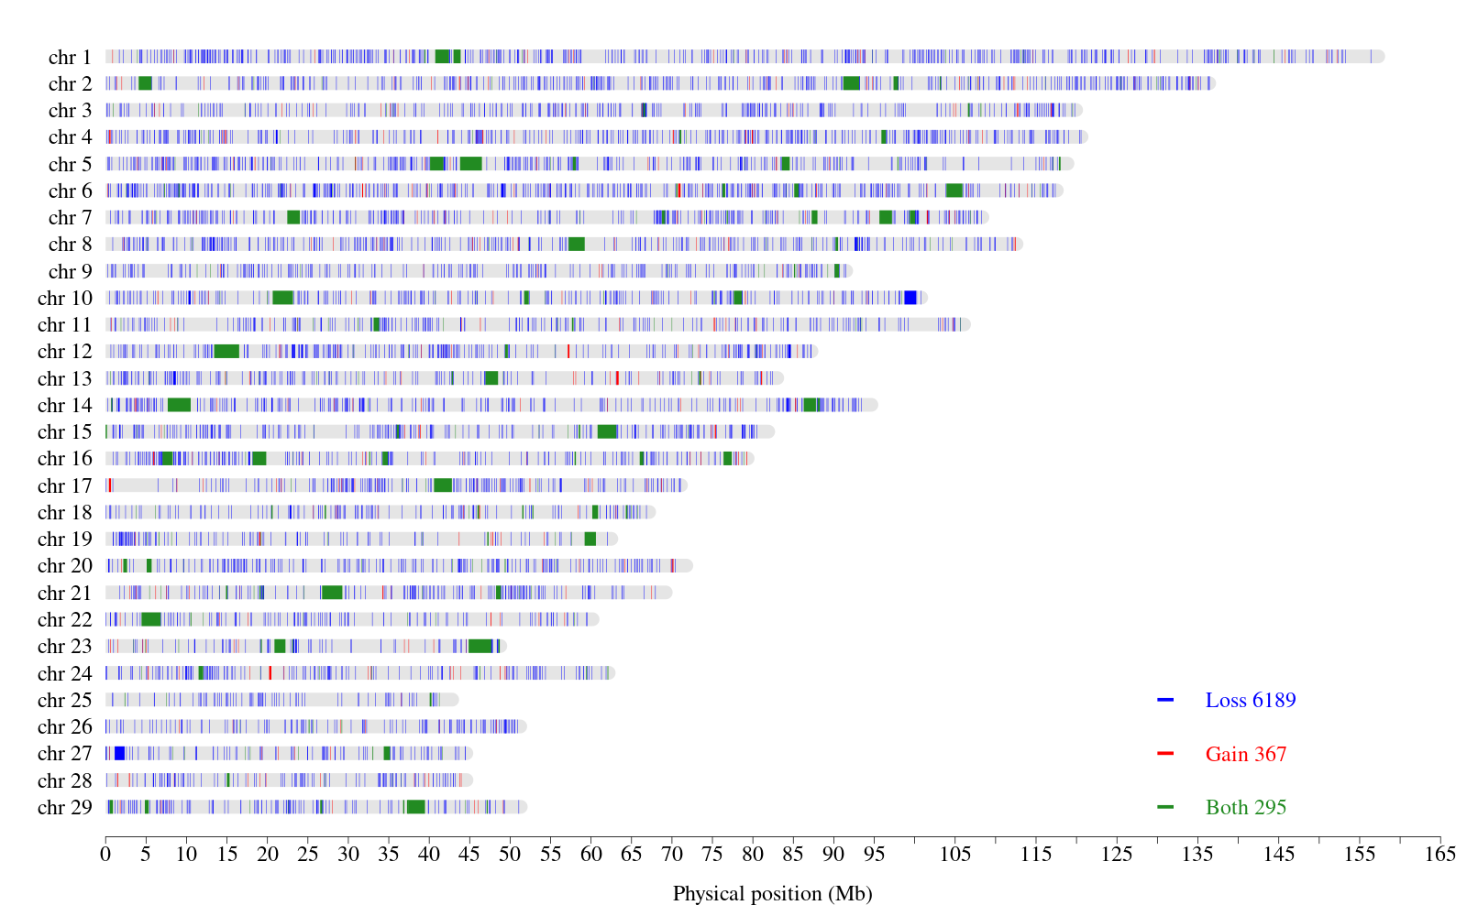
Supplementary Figure 43: Global CNVR with variable SV calling parameters
Imprecise SV included
Lower cut-off length of 50 bp applied before merging Manta and Lumpy SV
Medium SV filters (PE = SR = 3)
Upper cut-off length: 3 Mb
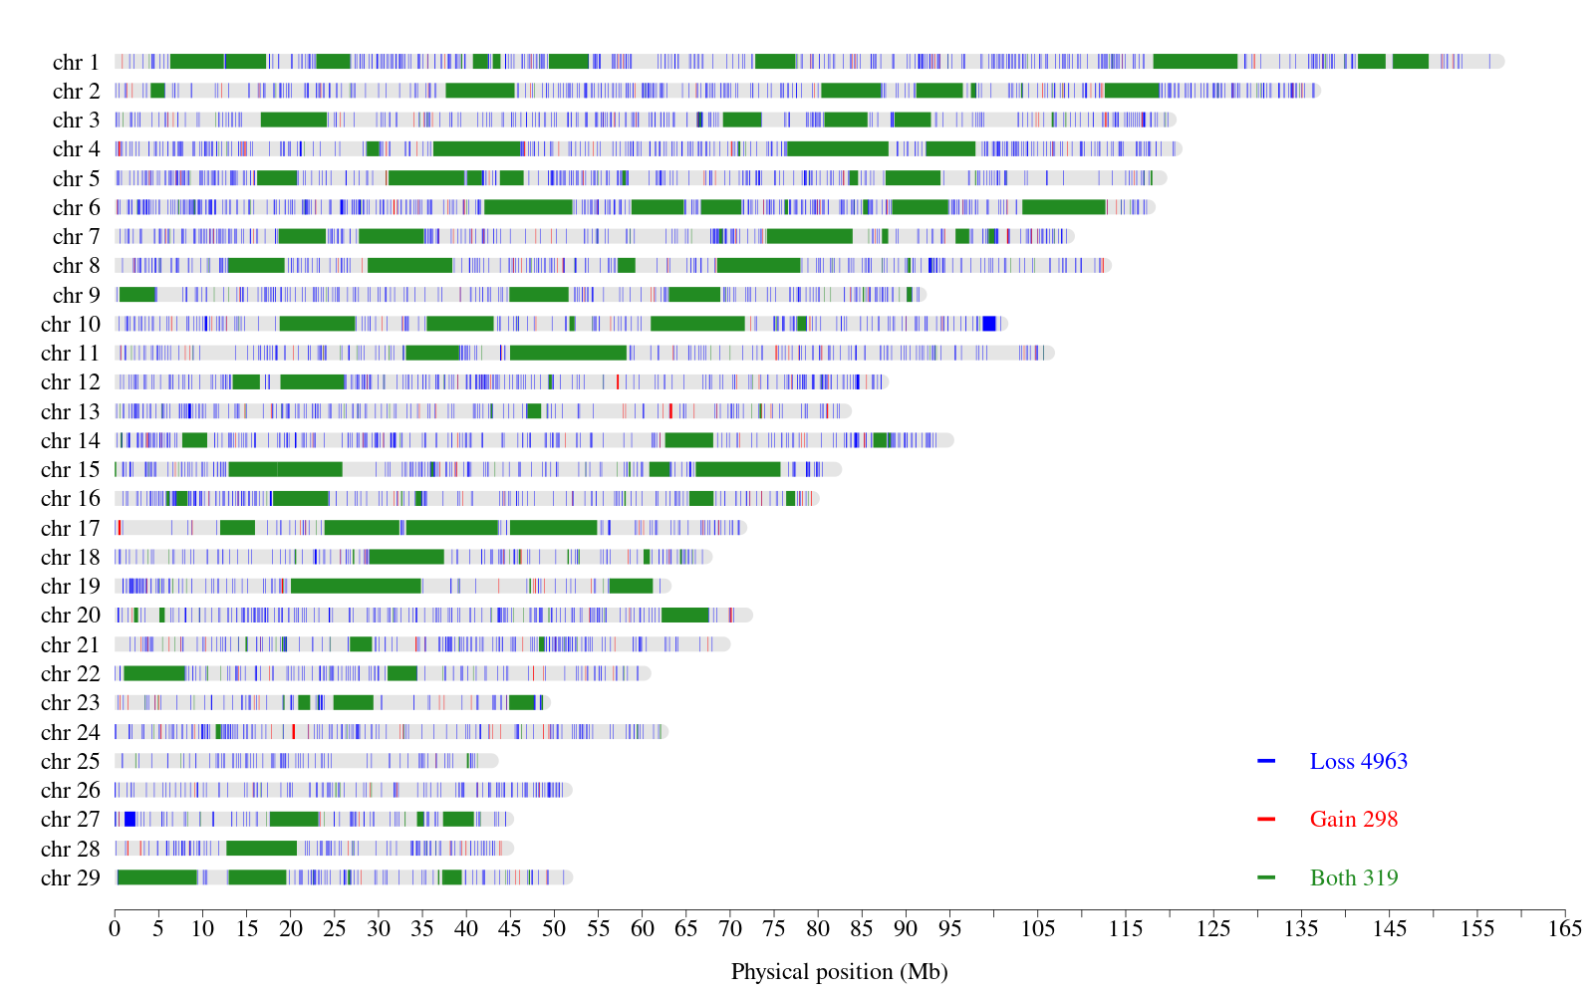
Supplementary Figure 44: Global CNVR with variable SV calling parameters
Imprecise SV included
Lower cut-off length of 50 bp applied before merging Manta and Lumpy SV
Medium SV filters (PE = SR = 3)
Upper cut-off length: 10 Mb
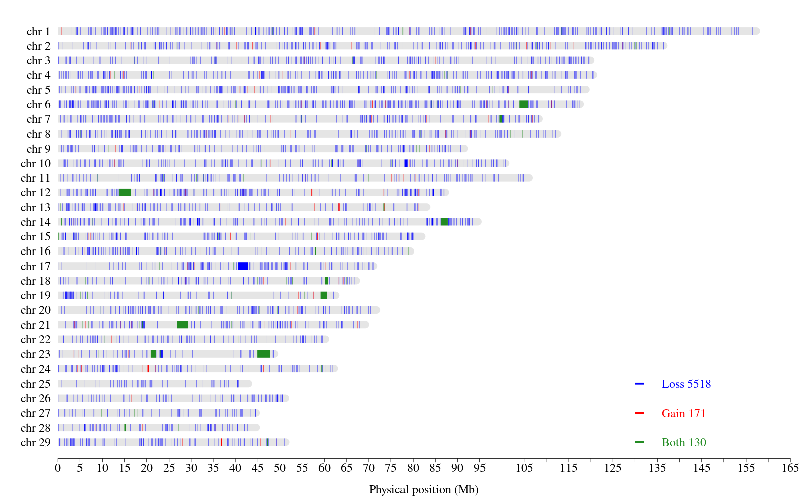
Supplementary Figure 45: Global CNVR with variable SV calling parameters
Imprecise SV included
Lower cut-off length of 50 bp applied before merging Manta and Lumpy SV
Stringent SV filters (PE = SR = 5)
Upper cut-off length: 3 Mb
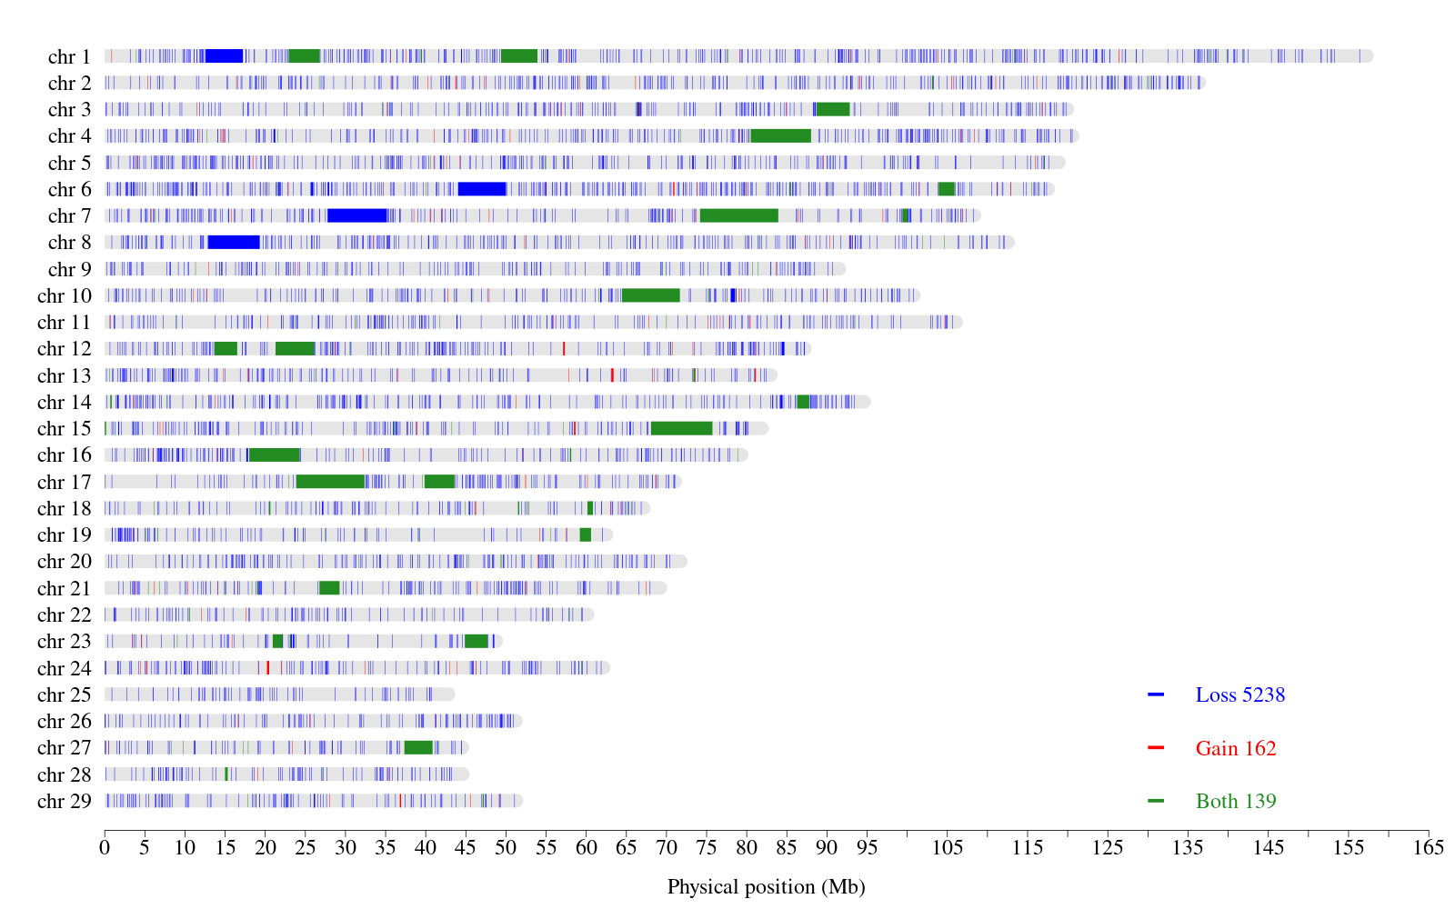
Supplementary Figure 46: Global CNVR with variable SV calling parameters
Imprecise SV included
Lower cut-off length of 50 bp applied before merging Manta and Lumpy SV
Stringent SV filters (PE = SR = 3)
Upper cut-off length: 10 Mb
Supplementary Figure 47: Global CNVR with variable SV calling parameters
Imprecise SV included
Lower cut-off length of 50 bp applied after merging Manta and Lumpy SV
No SV filters (PE = SR = 0)
Upper cut-off length: 3 Mb
Supplementary Figure 48: Global CNVR with variable SV calling parameters
Imprecise SV included
Lower cut-off length of 50 bp applied after merging Manta and Lumpy SV
No SV filters (PE = SR = 0)
Upper cut-off length: 10 Mb

Supplementary Figure 49: Global CNVR with variable SV calling parameters
Imprecise SV included
Lower cut-off length of 50 bp applied after merging Manta and Lumpy SV
Medium SV filters (PE = SR = 3)
Upper cut-off length: 3 Mb
Supplementary Figure 50: Global CNVR with variable SV calling parameters
Imprecise SV included
Lower cut-off length of 50 bp applied after merging Manta and Lumpy SV
Medium SV filters (PE = SR = 3)
Upper cut-off length: 10 Mb
Supplementary Figure 51: Global CNVR with variable SV calling parameters
Imprecise SV included
Lower cut-off length of 50 bp applied after merging Manta and Lumpy SV
Stringent SV filters (PE = SR = 5)
Upper cut-off length: 3 Mb
Supplementary Figure 52: Global CNVR with variable SV calling parameters
Imprecise SV included
Lower cut-off length of 50 bp applied after merging Manta and Lumpy SV
Stringent SV filters (PE = SR = 5)
Upper cut-off length: 10 Mb

Supplementary Figure 53: Global CNVR with variable SV calling parameters
Precise SV
Lower cut-off length of 50 bp applied before merging Manta and Lumpy SV
No SV filters (PE = SR = 0)
Upper cut-off length: 3 Mb
Supplementary Figure 54: Global CNVR with variable SV calling parameters
Precise SV
Lower cut-off length of 50 bp applied before merging Manta and Lumpy SV
No SV filters (PE = SR = 0)
Upper cut-off length: 10 Mb

Supplementary Figure 55: Global CNVR with variable SV calling parameters
Precise SV
Lower cut-off length of 50 bp applied before merging Manta and Lumpy SV
Medium SV filters (PE = SR = 3)
Upper cut-off length: 3 Mb
Supplementary Figure 56: Global CNVR with variable SV calling parameters
Precise SV
Lower cut-off length of 50 bp applied before merging Manta and Lumpy SV
Medium SV filters (PE = SR = 3)
Upper cut-off length: 10 Mb
Supplementary Figure 57: Global CNVR with variable SV calling parameters
Precise SV
Lower cut-off length of 50 bp applied before merging Manta and Lumpy SV
Stringent SV filters (PE = SR = 5)
Upper cut-off length: 3 Mb
Supplementary Figure 58: Global CNVR with variable SV calling parameters
Precise SV
Lower cut-off length of 50 bp applied before merging Manta and Lumpy SV
Stringent SV filters (PE = SR = 5)
Upper cut-off length: 10 Mb
Supplementary Figure 59: Global CNVR with variable SV calling parameters
Precise SV
Lower cut-off length of 50 bp applied after merging Manta and Lumpy SV
No SV filters (PE = SR = 0)
Upper cut-off length: 3 Mb
Supplementary Figure 60: Global CNVR with variable SV calling parameters
Precise SV
Lower cut-off length of 50 bp applied after merging Manta and Lumpy SV
No SV filters (PE = SR = 0)
Upper cut-off length: 10 Mb

Supplementary Figure 61: Global CNVR with variable SV calling parameters
Precise SV
Lower cut-off length of 50 bp applied after merging Manta and Lumpy SV
Medium SV filters (PE = SR = 3)
Upper cut-off length: 3 Mb
Supplementary Figure 62: Global CNVR with variable SV calling parameters
Precise SV
Lower cut-off length of 50 bp applied after merging Manta and Lumpy SV
Medium SV filters (PE = SR = 3)
Upper cut-off length: 10 Mb
Supplementary Figure 63: Global CNVR with variable SV calling parameters
Precise SV
Lower cut-off length of 50 bp applied after merging Manta and Lumpy SV
Stringent SV filters (PE = SR = 5)
Upper cut-off length: 3 Mb
Supplementary Figure 64: Global CNVR with variable SV calling parameters
Precise SV
Lower cut-off length of 50 bp applied after merging Manta and Lumpy SV
Stringent SV filters (PE = SR = 5)
Upper cut-off length: 10 Mb

