Complete genome sequence of Arthrobacter sp. PAMC25564 and its comparative genome analysis for elucidating the role of CAZymes in cold adaptation

So-Ra Han¹, Byeollee Kim¹, Jong Hwa Jang², Hyun Park^{3,*}, and Tae-Jin Oh^{1, 4, 5,*}

¹ Department of Life Science and Biochemical Engineering, Graduate School, SunMoon University, 70 Sunmoon-ro 221, Tangjeong-myeon, Asan-si, Chungnam 31460, Republic of Korea
² Department of Dental Hygiene, College of Health Science, Dankook University, 119 Dandae-ro, Dongnam-gu, Cheonan-si, Chungnam 31116, Republic of Korea
³ Division of Biotechnology, College of Life Science and Biotechnology, Korea University, Seoul 02841, Republic of Korea
⁴ Genome-based BioIT Convergence Institute, 70 Sunmoon-ro 221, Tangjeong-myeon, Asan-si, Chungnam 31460, Republic of Korea
⁵ Department of Pharmaceutical Engineering and Biotechnology, SunMoon University, 70 Sunmoon-ro 221, Tangjeong-myeon, Asan-si, Chungnam 31460, Republic of Korea

* Corresponding authors: Hyun Park & Tae-Jin Oh
H. Park, Division of Biotechnology, College of Life Sciences and Biotechnology, Korea University, Seoul 02841, Korea. Tel: +82 2 3290 3051; E-mail: hpark@korea.ac.kr
T.-J. Oh, Department of Pharmaceutical Engineering and Biotechnology, SunMoon University, Asan 31460, Korea. Tel: +82 41 530 2677; E-mail: tjoh3782@sunmoon.ac.kr
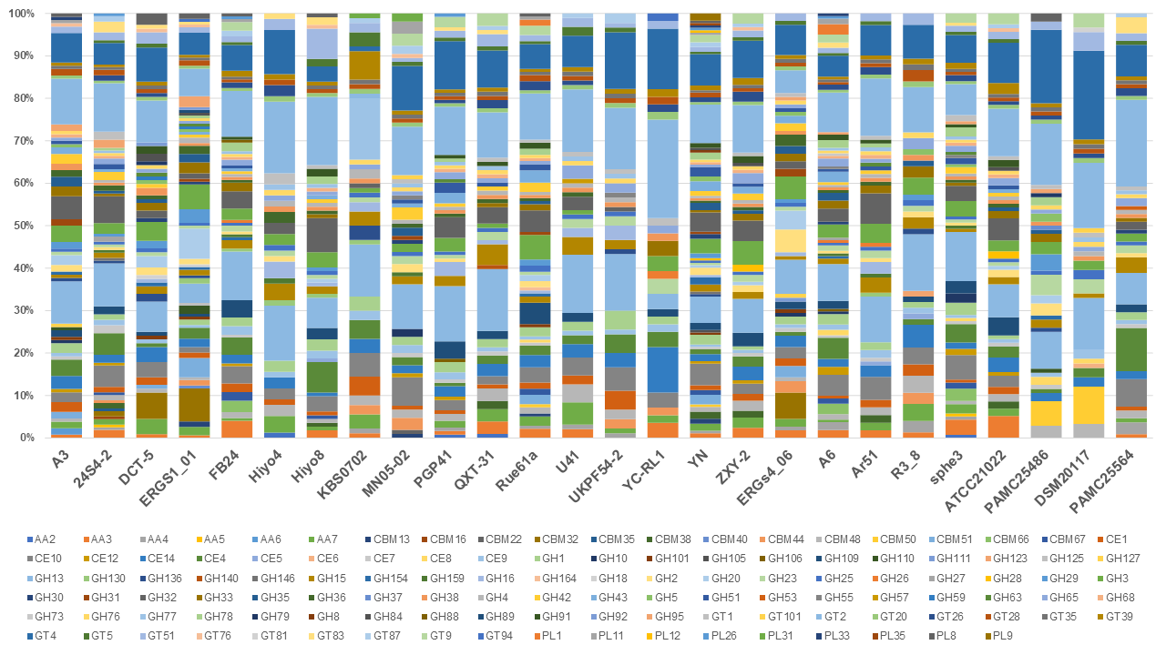
Figure S1. Comparative CAZyme-encoding genes found in the genome of Arthrobacter species. GT, glycosyl transferase; GH, glycoside hydrolase; CE, carbohydrate esterase; CBM, carbohydrate binding; and AA, auxiliary activities. CAZyme-encoding genes are colored as indicated below the figure. Arthrobacter sp.: PAMC25564, 24S4-2, YN, QXT-31, Rue61a, FB24, PAMC25486, ZXY-2, U41, DCT-5, PGP41, ERGS1:01, YC-RL1, Hiyo4, KBS0702, UKPF54-2, MN05-02, Hiyo8, and ATCC21022; Arthrobacter crystallopoietes: DSM 20117; Arthrobacter alpinus: R3.8, ERGS4:06, and A3; Pseudarthrobacter phenanthrenivorans: Sphe3; Pseudarthrobacter chlorophenolicus: A6; and Pseudarthrobacter sulfonivorans: Ar51.

