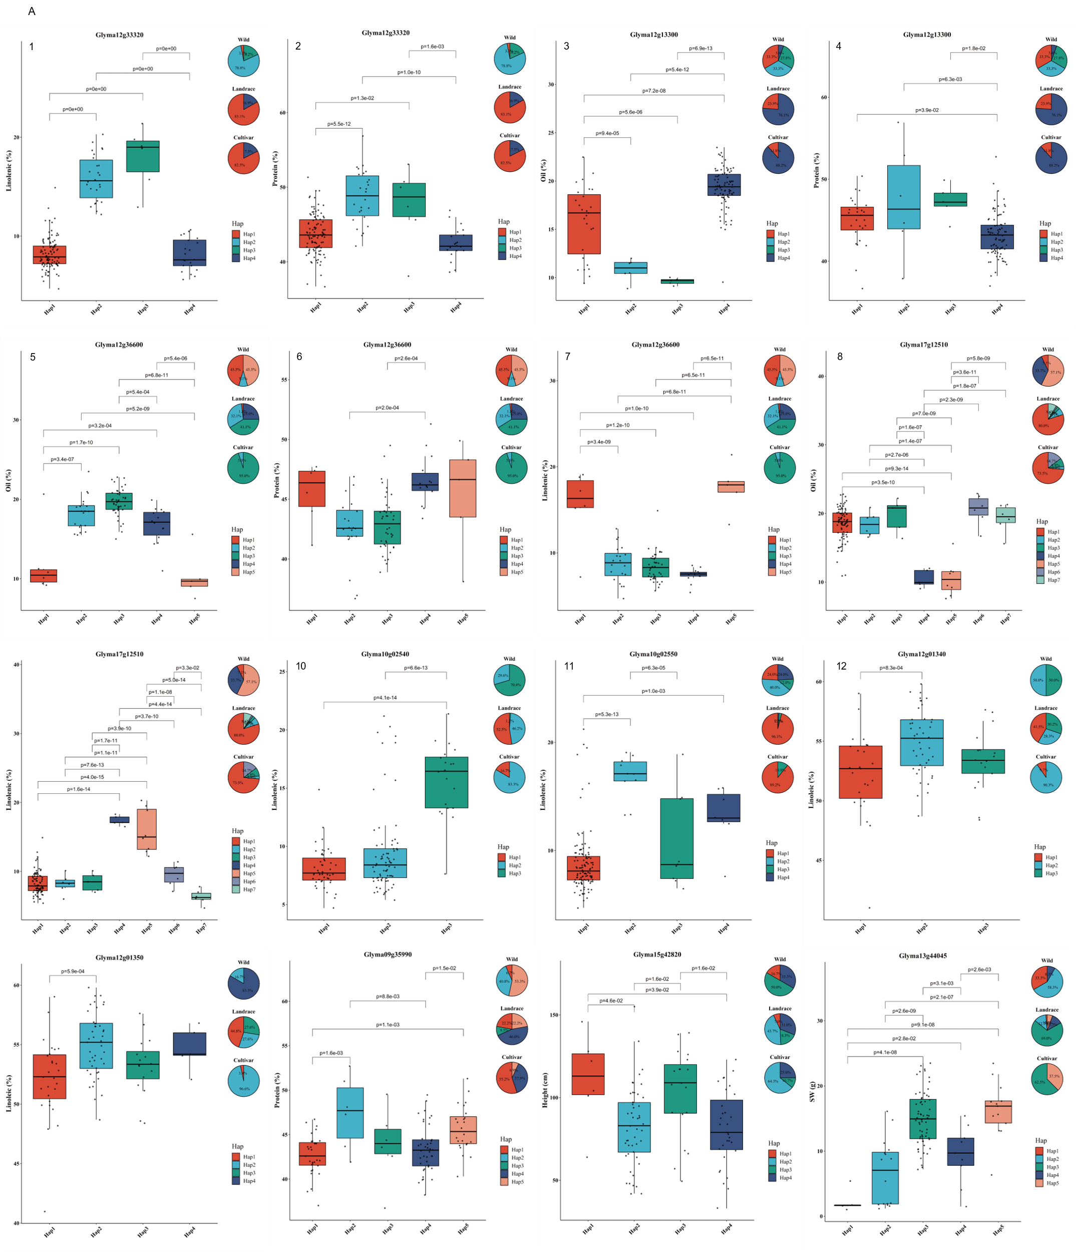

Figure S1 A

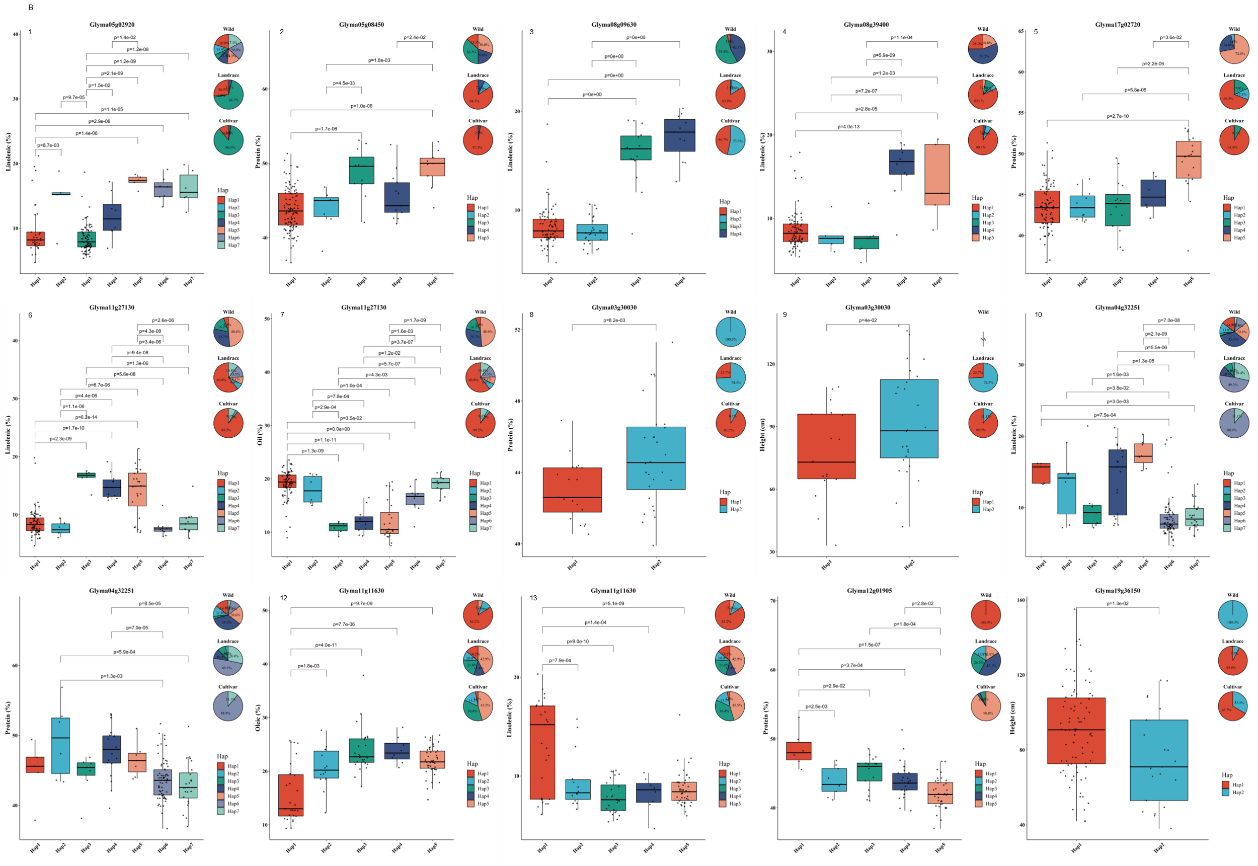
Figure S1 B
Figure S1: The haplotype, the frequency and the corresponding phenotype of haplotype for 22 Gmzf_CCCHs in 164 of 302 soybean accessions. (A), haplotype analysis for 11 Gmzf_CCCHs domestication gene; (B), haplotype analysis for 11 Gmz_CCCH genes in domestication regions.

