Epidemiological and genomic characteristics of Acinetobacter baumannii from different infection sites using comparative genomics
Xingchen Bian^{1,2,3,4}, Xiaofen Liu^{2,3,4}, Xuefei Zhang², Xin Li^{2,3,4}, Jing Zhang^{2,3,4,5}, Huajun Zheng⁶, Sichao Song⁶, Xiang Li^{1*}, Meiqing Feng^{1*}
¹ School of Pharmacy & Minhang Hospital, Fudan University, Shanghai, 201203, China;
² Institute of Antibiotics, Huashan Hospital, Fudan University, Shanghai, 200040, China;
³ Key Laboratory of Clinical Pharmacology of Antibiotics, Shanghai, 200040, China;
⁴ National Health Commission & National Clinical Research Center for Aging and Medicine, Huashan Hospital, Fudan University, Shanghai, 200040, China;
⁵ Phase I Unit, Huashan Hospital, Fudan University, Shanghai, 200040, China;
⁶ Chinese National Human Genome Center, Shanghai, 201203, China;

*Corresponding author: Meiqing Feng, 826 Zhang Heng Rd, Shanghai, 201203, China; Email: fmq@fudan.edu.cn ; Xiang Li, 170 Xinsong Rd, 201100, China; Email: xiangli_mh@fudan.edu.cn
Running title: genomic characteristics of Acinetobacter baumannii
Key words: Acinetobacter baumannii, whole genome sequencing, epidemiological characteristics, multi-drug resistance, comparative genomics

Figure S1. Virulence factors in 64 A. baumannii isolates. htp8, Hsp60, 60K heat shock protein HtpB; orf18, Unknown; orf48, orf66, hypothetical protein; pilT, pilU, pilG, twitching motility protein; bplB, probable acetyltransferase; tetA(B), tetracycline resistance protein TetA(B); tetR, tet repressor; tviB, Vi polysaccharide biosynthesis protein, UDP-glucose/GDP-mannose dehydrogenase; aadA1, streptomycin adenyltransferase AadA1; intl1, Tn21 integrase IntI1; tnpR, resolvase TnpR; cap8E, capsular polysaccharide synthesis enzyme Cap8E; VC0817, transposase, putative

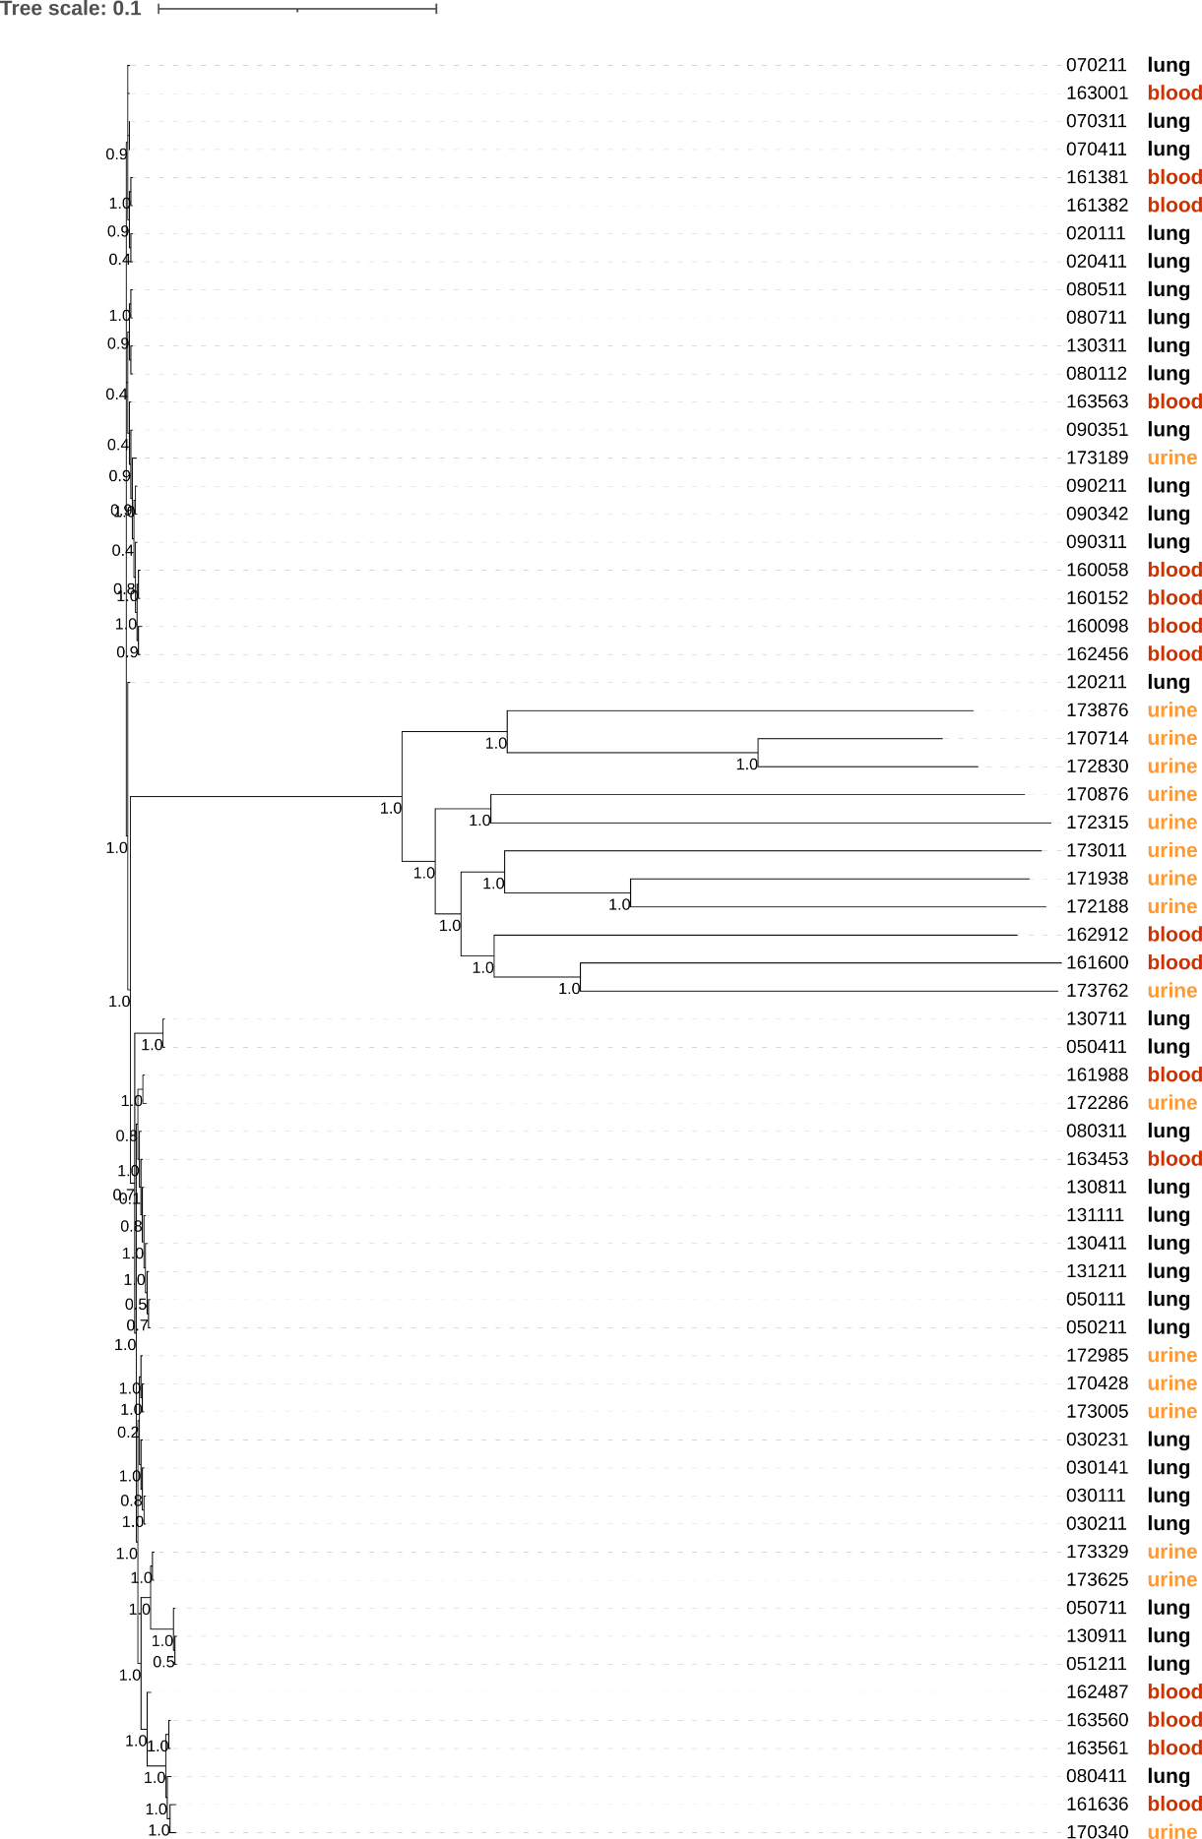
Figure S2. SNP-based phylogenetic tree of 64 A. baumannii isolates with infection sites.
Table S2. The full length and GC contents of intact AbGRI1 islands
Infection type | Strain | Total base (bp) | GC (%) | Infection type | Strain | Total base (bp) | GC (%)
HAP | 030111 | 30193 | 38.3 | HAP | 131211 | 17595 | 40.9
HAP | 030231 | 28537 | 39.4 | BSI | 160058 | 20701 | 39.0
HAP | 050111 | 17595 | 40.9 | BSI | 161381 | 16930 | 43.1
HAP | 050211 | 17595 | 40.9 | BSI | 161600 | 11963 | 36.1
HAP | 050411 | 20648 | 40.3 | BSI | 161636 | 16441 | 36.0
HAP | 050711 | 17595 | 40.9 | BSI | 162456 | 14527 | 43.3
HAP | 051211 | 17595 | 40.9 | BSI | 162487 | 12060 | 36.0
HAP | 080311 | 20445 | 40.3 | BSI | 163001 | 17389 | 42.3
HAP | 080411 | 9113 | 35.7 | BSI | 163561 | 18527 | 36.2
HAP | 090311 | 18496 | 41.1 | UTI | 170340 | 21930 | 36.0
HAP | 090342 | 22007 | 41.3 | UTI | 170428 | 17595 | 40.9
HAP | 090351 | 18614 | 41.1 | UTI | 170876 | 37800 | 37.0
HAP | 120211 | 17790 | 40.8 | UTI | 172286 | 20445 | 40.3
HAP | 130411 | 17595 | 40.9 | UTI | 172985 | 28616 | 39.4
HAP | 130711 | 31488 | 39.0 | UTI | 173329 | 17595 | 40.9
HAP | 130811 | 10544 | 46.8 | UTI | 173625 | 17595 | 40.9
HAP | 130911 | 17595 | 40.9 | UTI | 173762 | 19781 | 33.7
HAP | 131111 | 17595 | 40.9 |  | median | 17595 | 40.9

Table S5. The information of A. baumannii and A. pitti isolates from public database
Strain | Country | Year | Source | MLST (Oxford) | MLST  (Pasteur)
ATCC17978 | France | 1951 | Meninges | 959 | 437
AYE | France | 2001 | Urine | 231 | 1
ACICU | Italy | 2005 | CSF | 437 | 2
AB5075-UW | USA | 2008 | Tibia/  Osteomyelitis | 945 | 1
XJ88(A. pitti) | China | 2016 | Sputum | 2256 | 485

