Supplementary information

Global Analysis of Protein Lysine 2-Hydroxyisobutyrylation (K_{hib}) Profiles in Chinese Herb Rhubarb (Dahuang)

Tong Qi ^{#, 1}, Jinping Li ^{#, 2}, Huifang Wang ¹, Xiaofan Han ¹, Junrong Li ³, Jinzhe Du*^{, 1}

¹ Shandong Provincial Key Laboratory of Dryland Farming Technology/College of Agronomy, Qingdao AgriculturalUniversity, Qingdao Shandong 266109, China
² International Cooperation Department of Qilu University of Technology (Shandong Academy of Sciences)
³ Bathurst Future Agri-Tech Institute of Qingdao Agricultural University

*Corresponding author:
Jinzhe Du, Shandong Provincial Key Laboratory of Dryland Farming Technology/College of Agronomy, Qingdao Agricultural University, Qingdao Shandong 266109, China. wangxx0532@163.com

# These authors contribute equally to this work.

Supplemental Tables
Table S1. All identified K_{hib}-modified peptides and proteins in rhubarb.
Table S2. GO functional classification of K_{hib}-modified proteins.
Table S3. Classification of subcellular localizations of K_{hib}-modified proteins.
Table S4. GO enrichment analysis of K_{hib}-modified proteins.
Table S5. KEGG pathway enrichment analysis of K_{hib}-modified proteins.
Table S6. Protein domain enrichment analysis of K_{hib}-modified proteins.
Table S7. Motif analysis of K_{hib} modified peptides.
(Note: all supplemental tables are showed in Excel files (.xlsx))

Supplemental Figure Legends
Fig. S1. Mass accuracy of MS.
Fig. S2. The bubble chart shows the fold enrichment for GO analyses of K_{hib}-modified proteins in terms of biological process, cellular component and molecular function.
Fig. S3. The bubble chart shows the fold enrichment of KEGG pathways of K_{hib}-modified proteins.
Fig. S4. The bubble chart shows the fold enrichment of the protein domains of K_{hib}-modified proteins.
Fig. S5. Pathway map of the K_{hib}-modified enzymes in central carbon metabolism in rhubarb. Central carbon metabolism includes glycolysis/gluconeogenesis, the pentose phosphate pathway, the TCA cycle and oxidative phosphorylation. The identified K_{hib}-modified enzymes are indicated in red boxes. The K_{hib}-modified enzymes in the TCA cycle are shown in Figure 6.
Fig. S6. Schematic diagram showing the association of K_{hib}-modified proteins with the ribosome in rhubarb. The identified K_{hib}-modified proteins are indicated in red boxes.
Fig. S7. Sequence pattern surrounding the K_{hib} sites that include the significantly enriched and depleted residues based on K_{hib} peptides and non-modification peptides from P. patens, O. sativa and R. palmatum (The K_{hib} sequence pattern of P. patens and O. sativa were from [7]).

Supplemental Figures
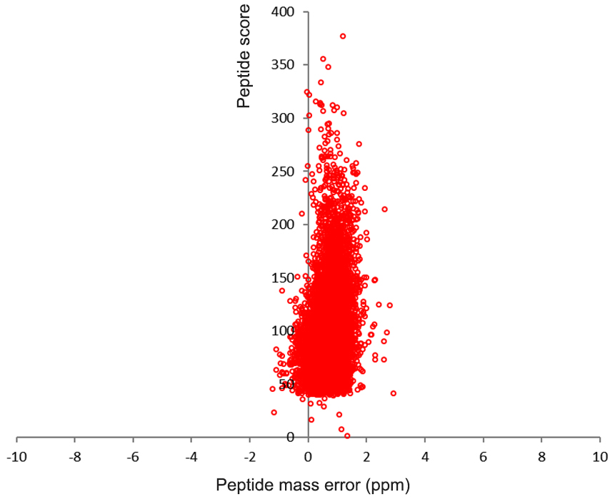
Fig. S1

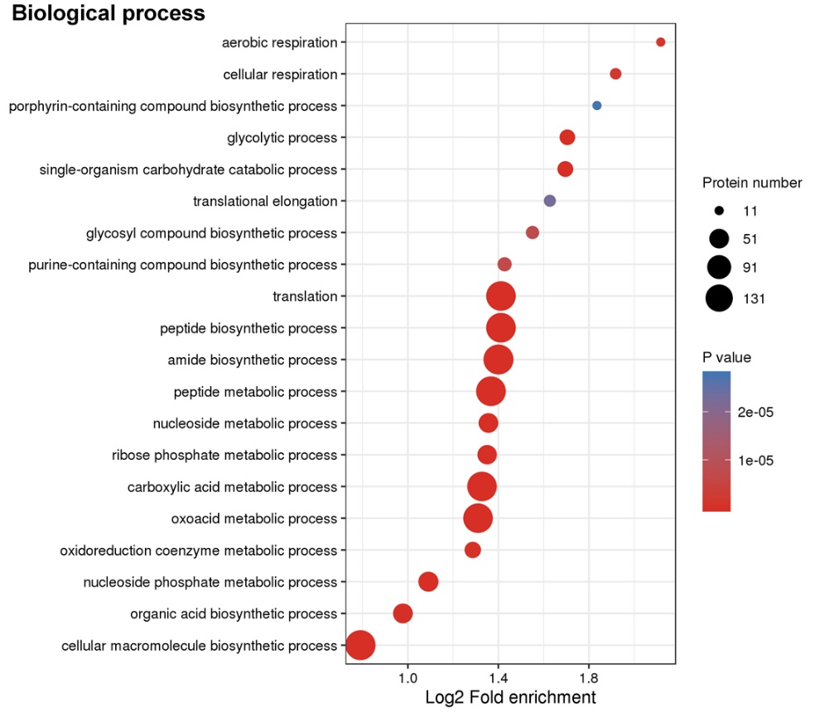
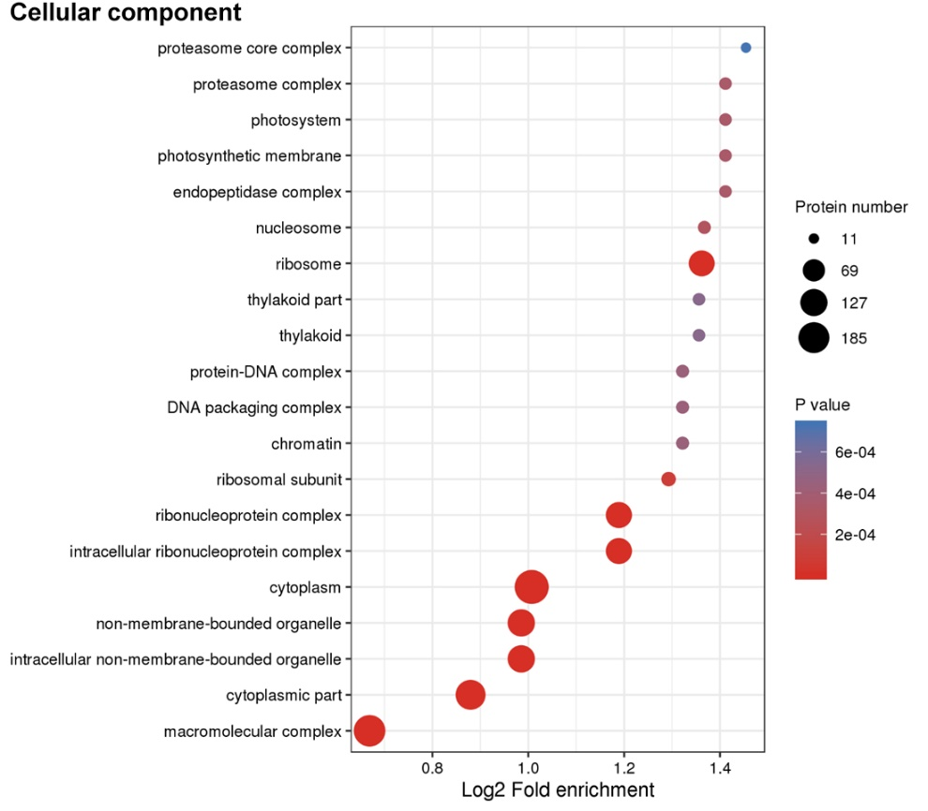
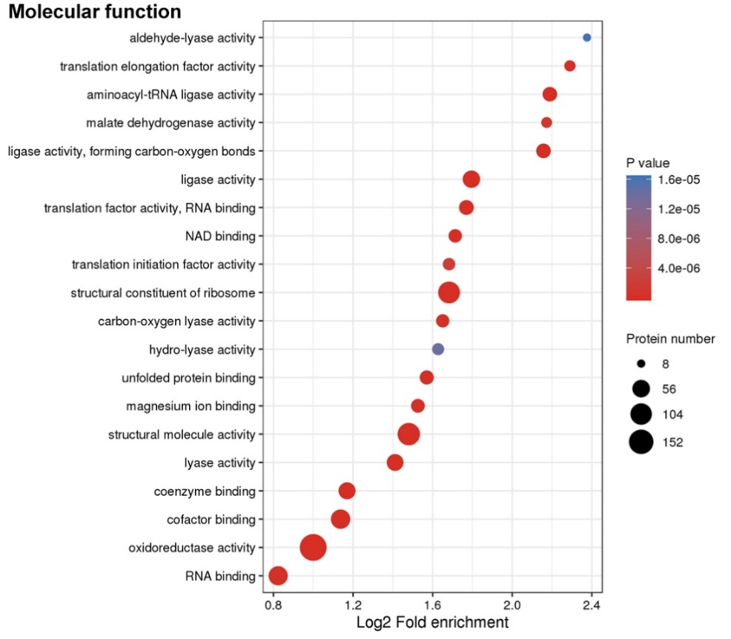

Fig. S2

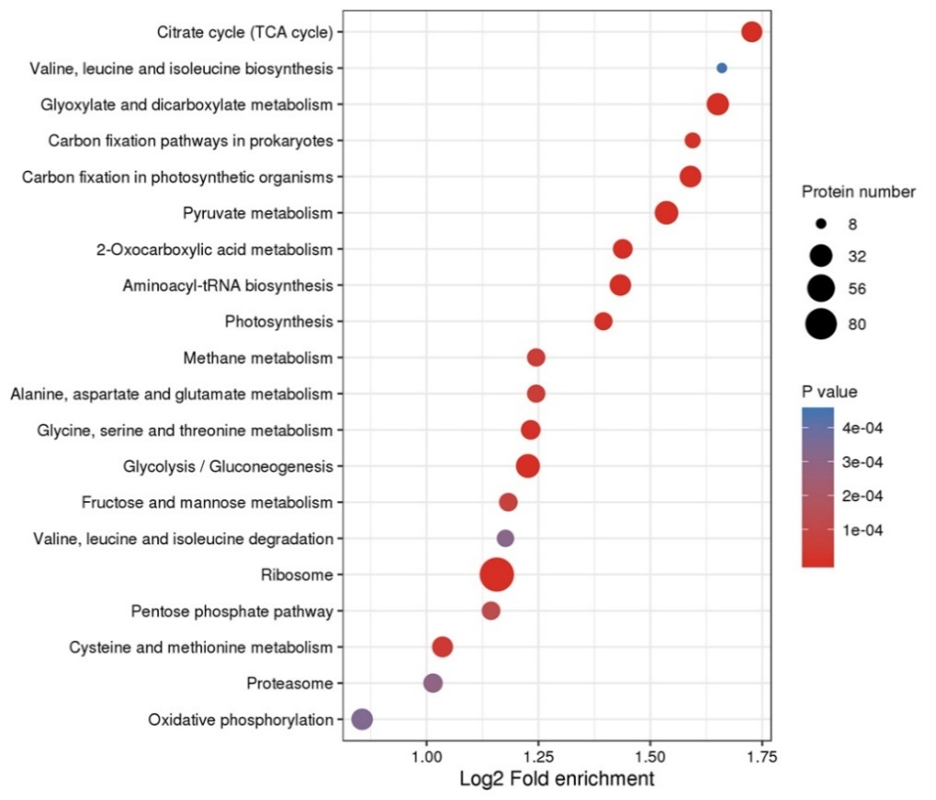
Fig. S3

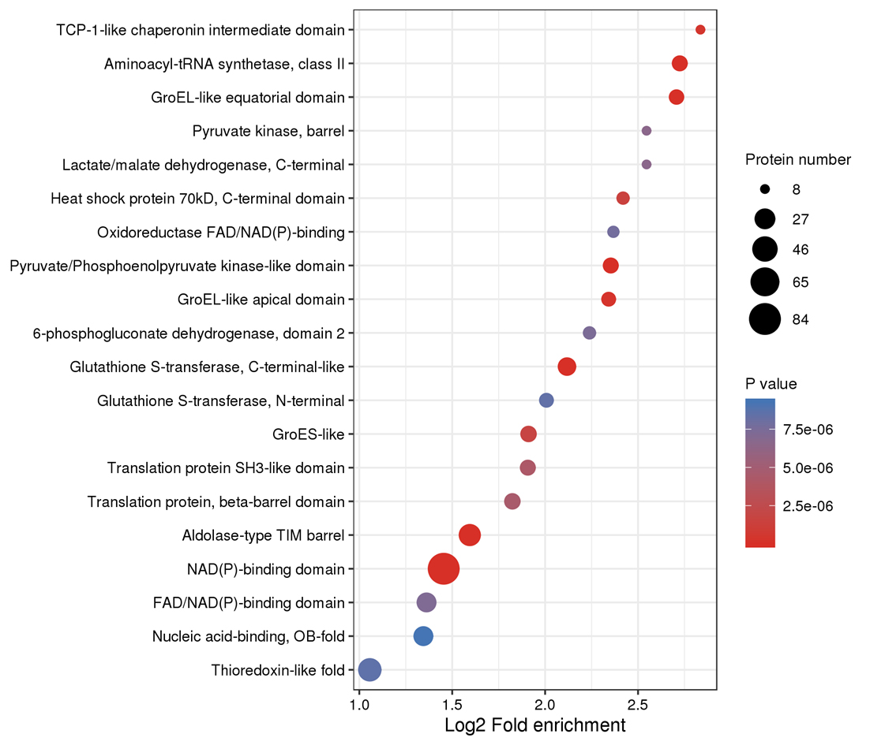
Fig. S4
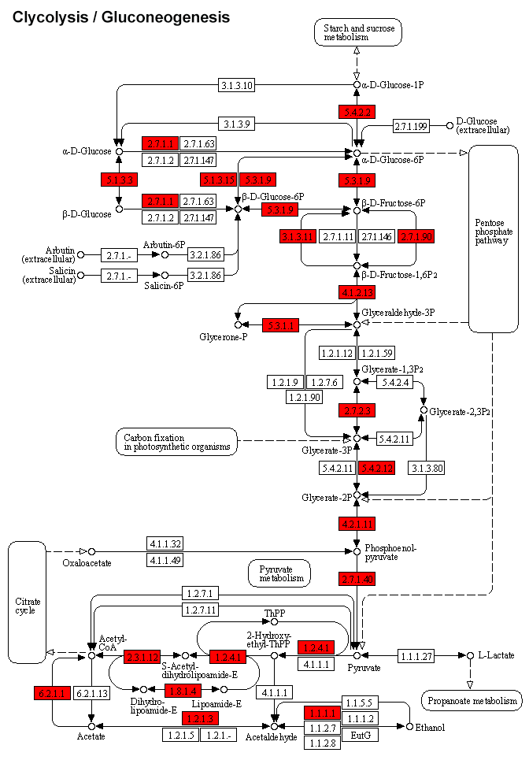
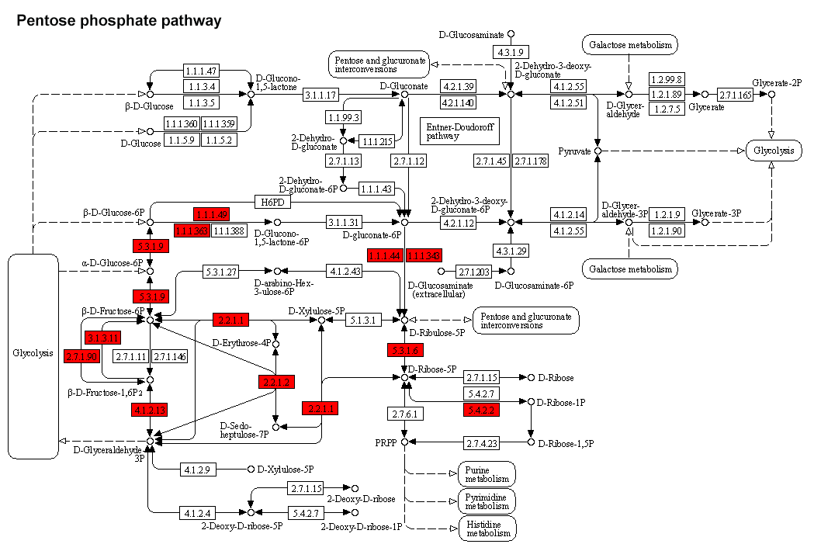
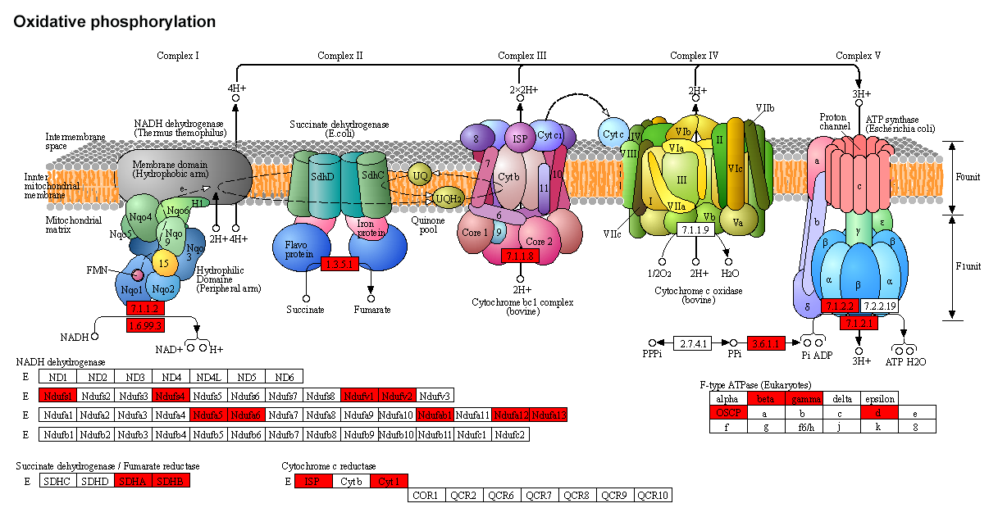
Fig. S5

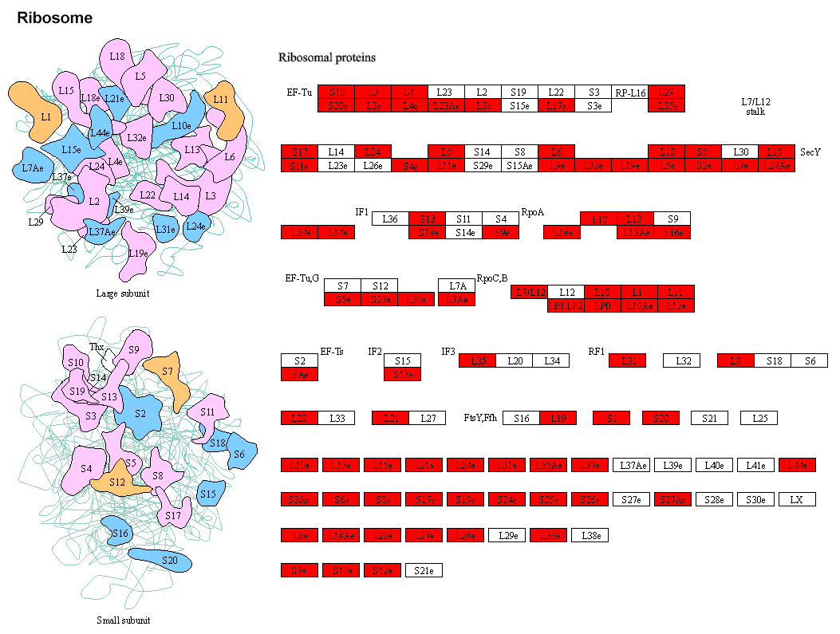
Fig. S6

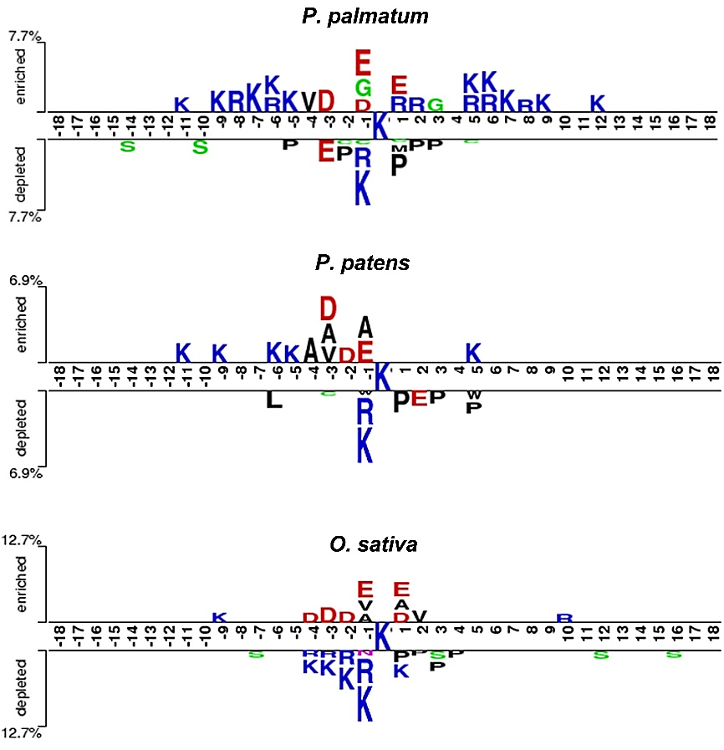
Fig. S7

