Supplementary 1
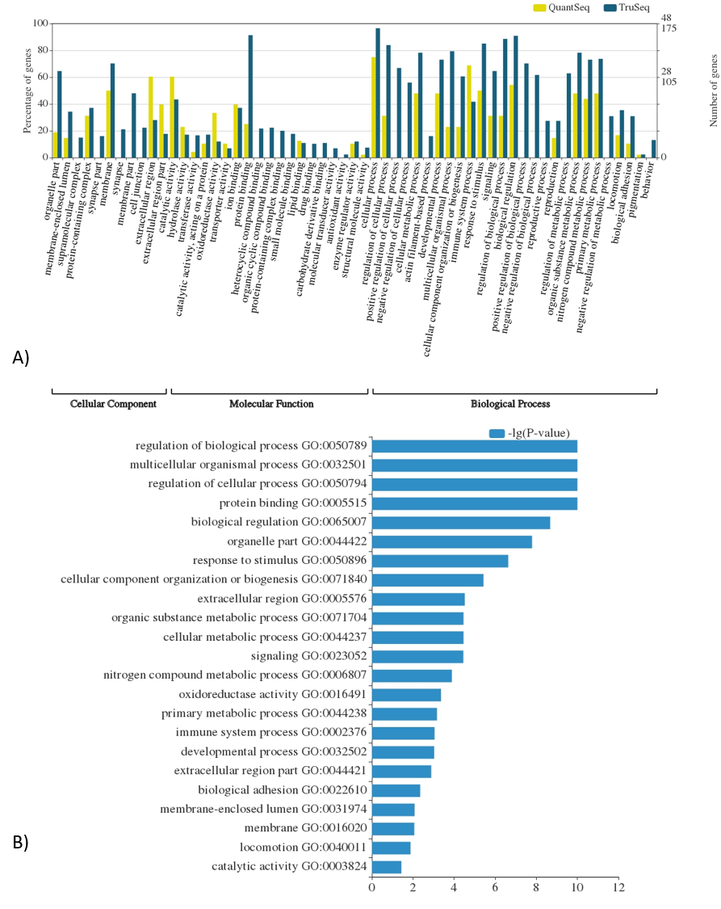
Distribution of GO terms (A) and the most significant GO terms in comparison of TruSeq and QuantSeq library (B).

