SUPPLEMENTARY INFORMATION
Additional file 1. Figure S1. IGV viewer alignment on the CBFB and MYH11 genes of the reads obtained with a nanopore flow cell sequence for the cell line ME1 (panel A) and on KMT2A and AFF1 for MV4;11 (panel B). ME1 carries the inv(16) resulting in CBFB-MYH11 fusion and MV4;11 carries t(4;11) with KMT2A-AFF1 fusion. Libraries were generated from DNA with a PCR-free enrichment protocol using CRISPR guides targeting CBFB and MYH11 in the first experiment and KMT2A and AFF1 in the second one. Reads that span two genes are colored.

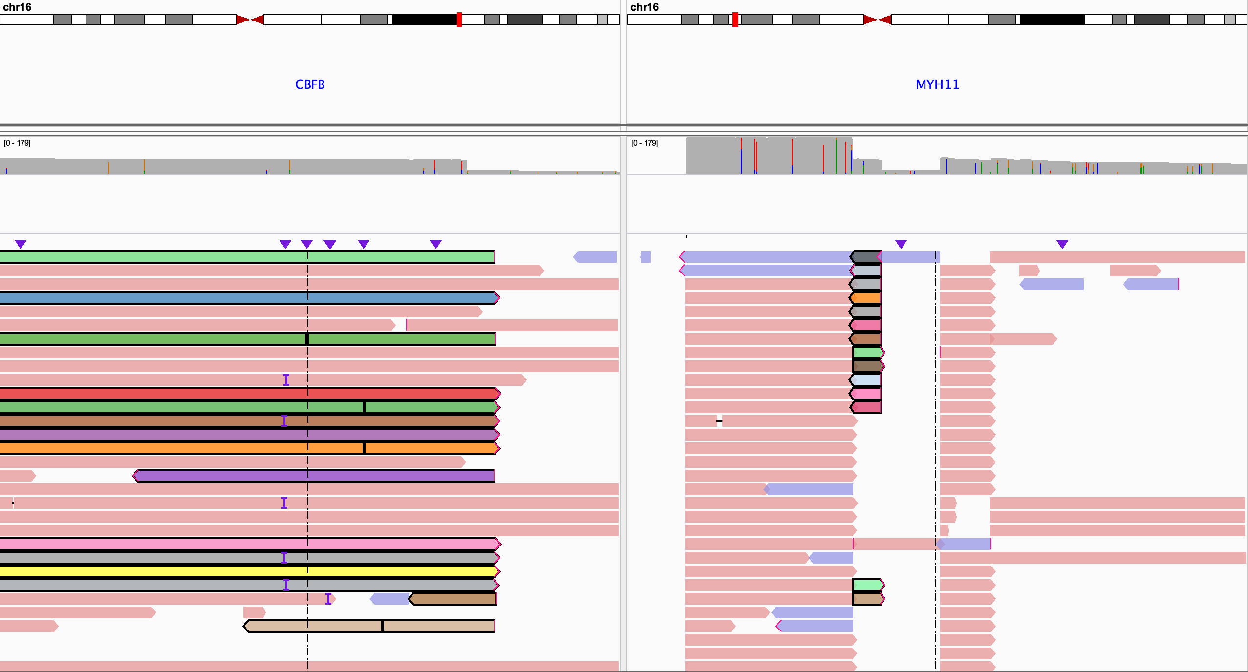
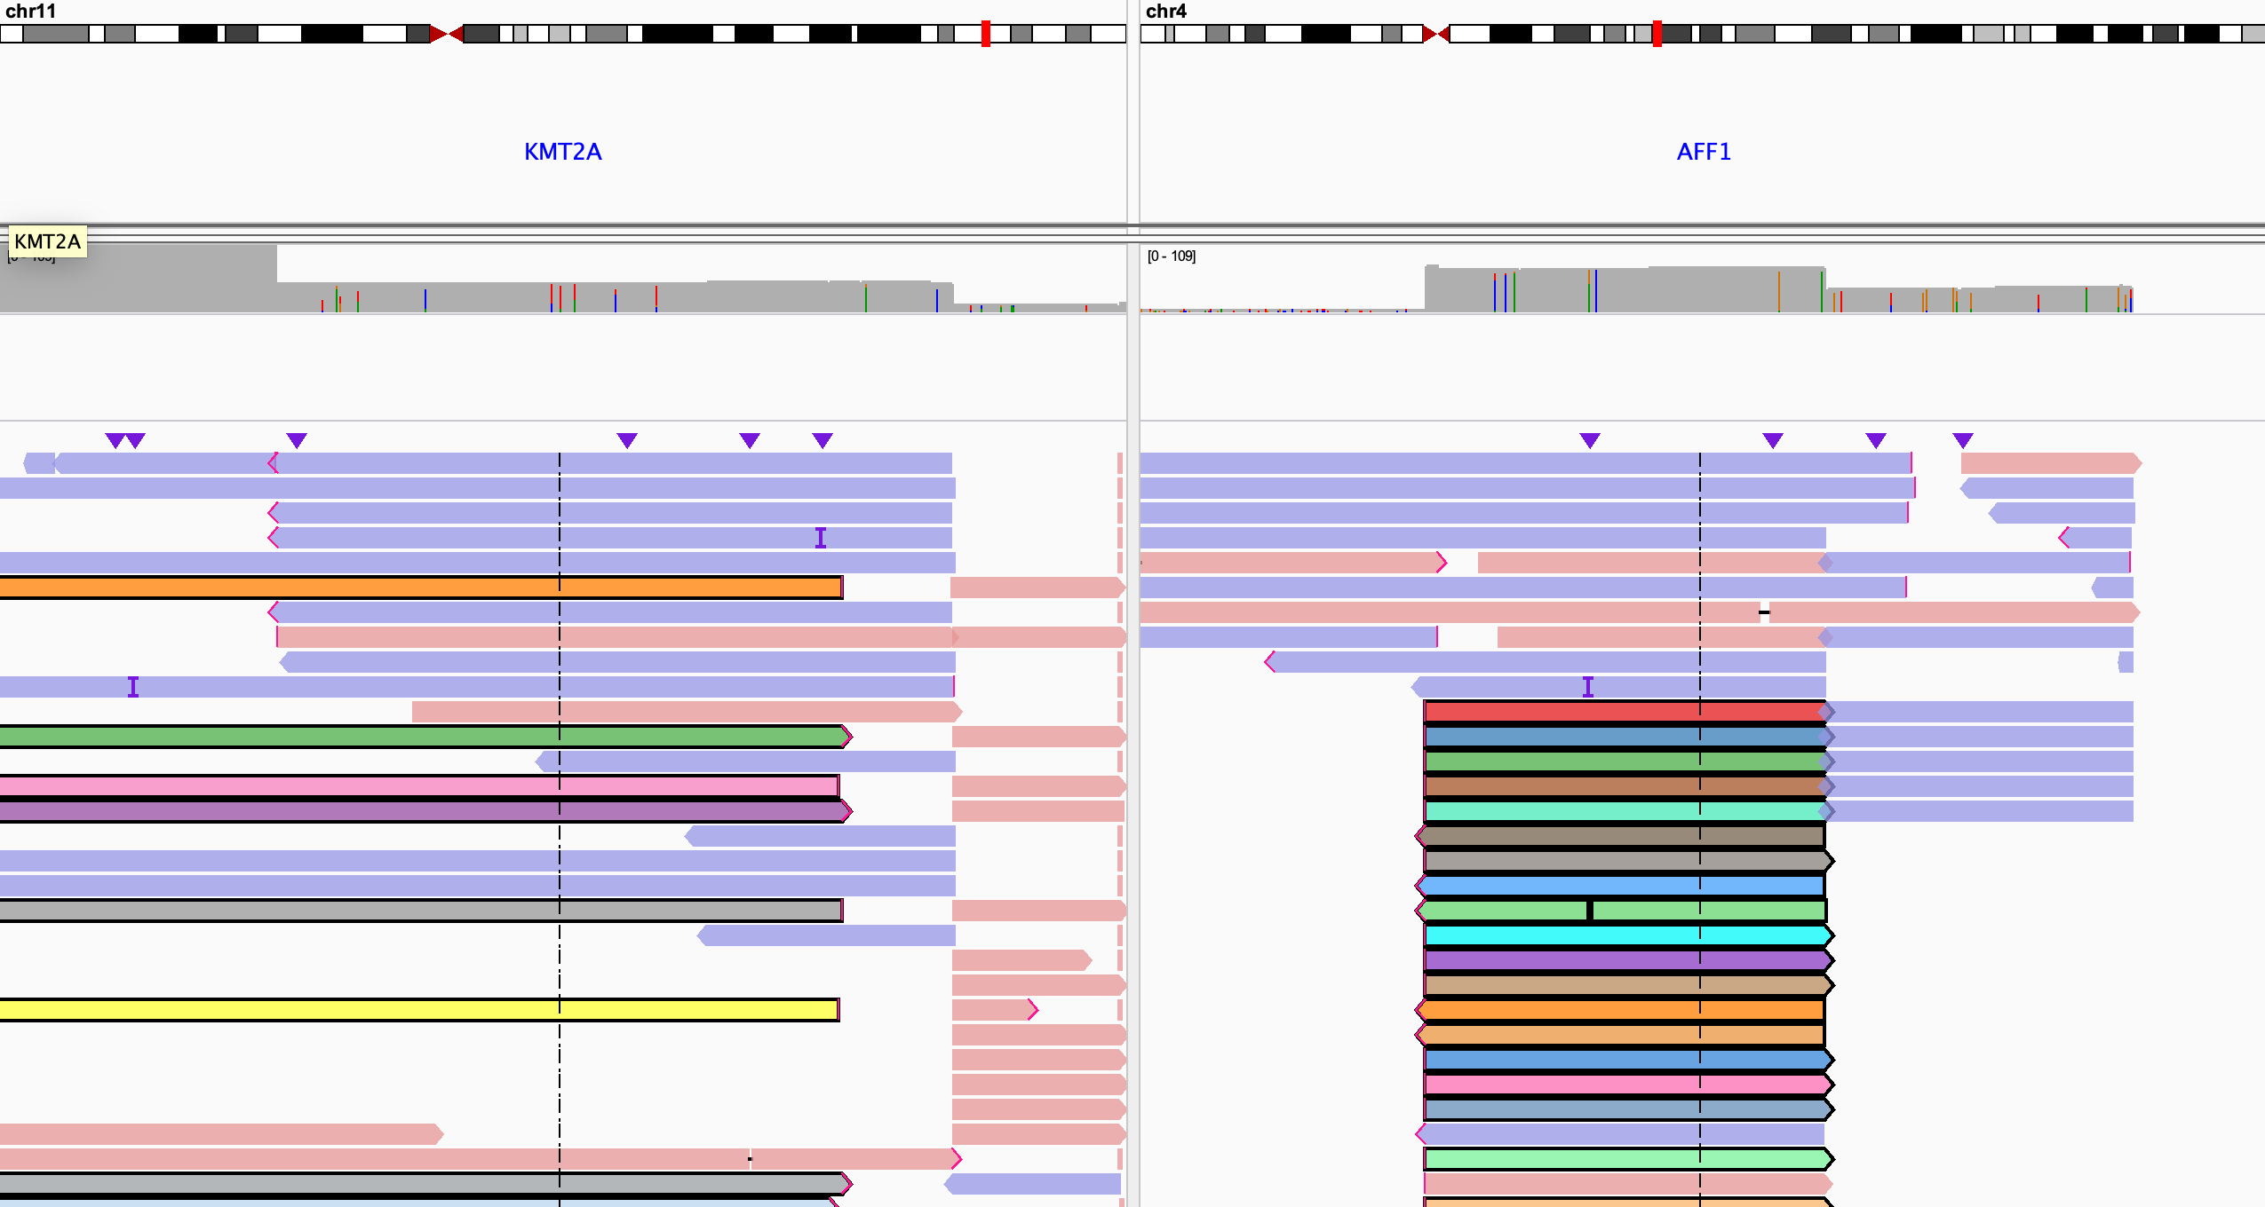
A
B

