Gene Co-expression Network Analysis in Zebrafish Reveals Chemical Class Specific Modules

Prarthana Shankar^{‡1}, Ryan S. McClure^{‡2}, Katrina M. Waters², Robyn L. Tanguay^{1*}
¹ Department of Environmental and Molecular Toxicology, Oregon State University, Corvallis, OR 97331 USA
² Biological Sciences Division, Pacific Northwest Laboratory, 902 Battelle Boulevard, P.O. Box 999, Richland, WA 99352 USA

‡ These co-authors contributed equally to this manuscript.

* Correspondence to:
Robyn Tanguay, Ph.D. Department of Environmental and Molecular Toxicology, the Sinnhuber Aquatic Research Laboratory 28645 East Highway 34, Oregon State University, Corvallis, OR 97333. Email: Robyn.Tanguay@oregonstate.edu, Telephone: 1-541-737-6514, Fax: 1-541-737-6074

Supplementary figures

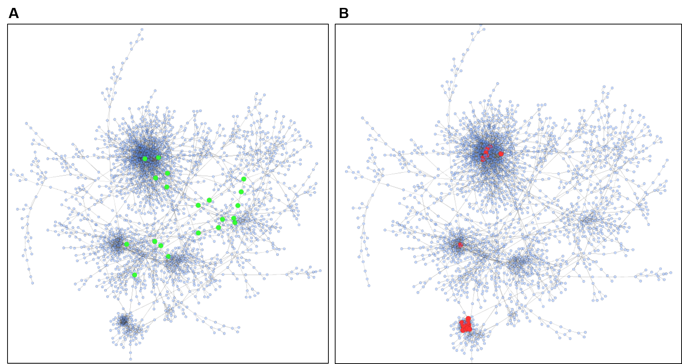

Figure S1. High Centrality Network Genes. (A) Genes of high betweenness (top 20 ranked by betweenness) are indicated as larger green nodes in the network. (B) Genes of high degree (top 20 ranked by degree) are indicated as larger red nodes in the network.

