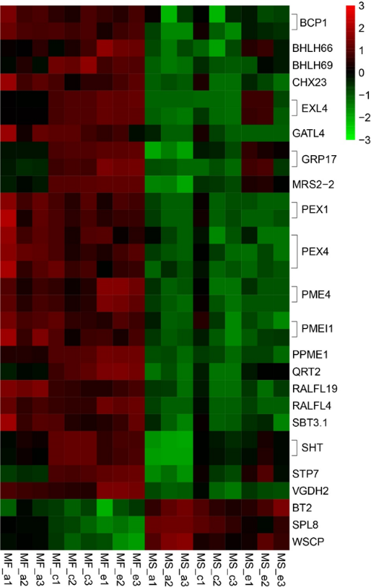
Fig. S1 Heatmap analysis of anther- and pollen development-related genes. The expression levels shown are based on the FPKM data. The color key represents the value of log2(FPKM). Red represents high expression, and green represents low expression. Each row represents a DEG.

