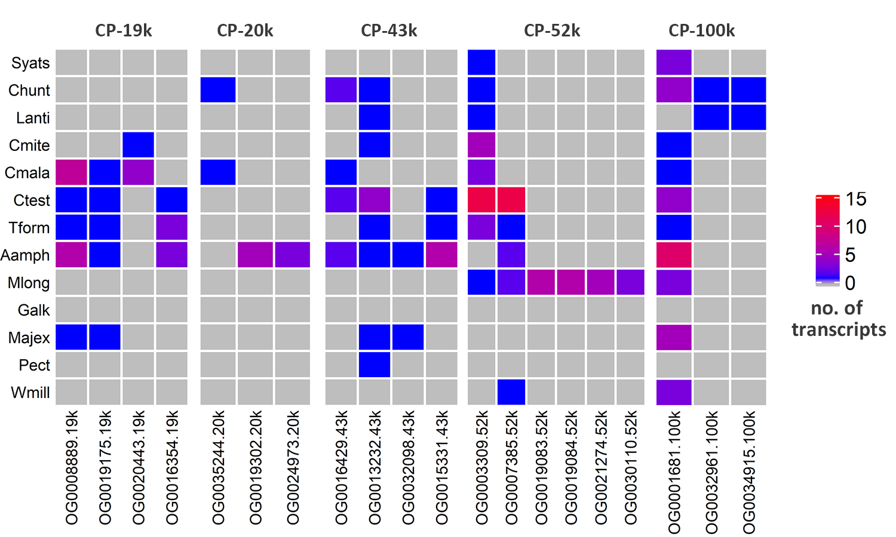
Additional file 5. Summary of orthogroup assignments for CP homologs. Heatmap summarizing the number of CP homologs assigned to different orthogroups.

