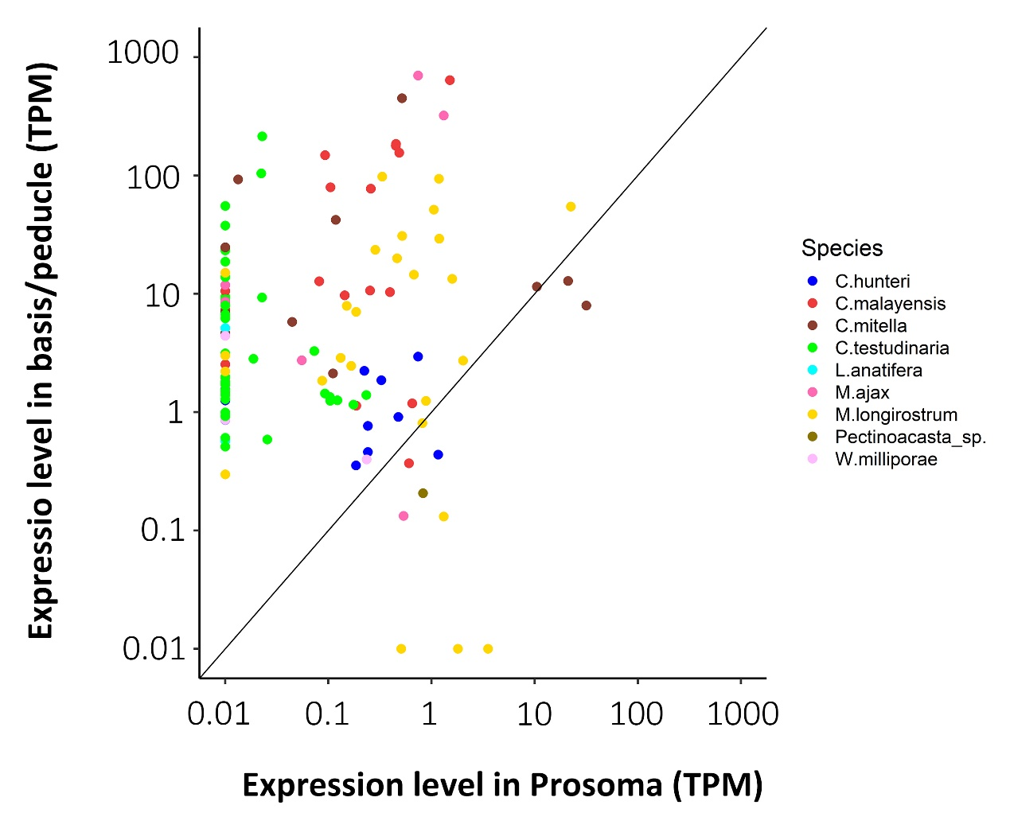
Additional file 6. mRNA expression level of CP homologs in the prosoma against the base or the peduncle. mRNA expression level is presented as log10-transformed transcripts per million read (TPM) value.

