Supplementary Figures:
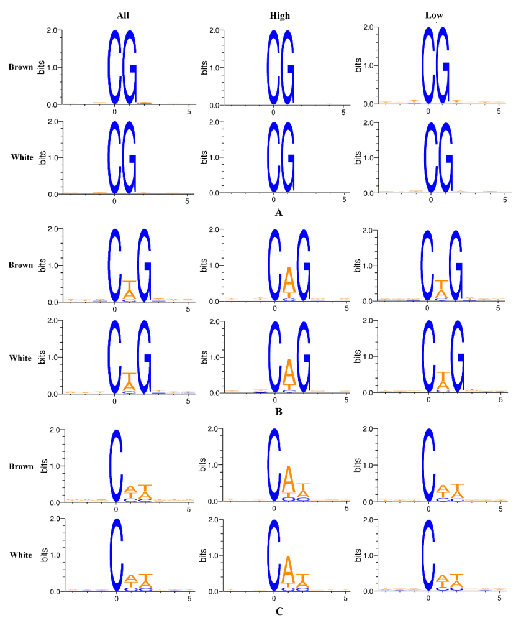
Figure S1. Sequence preferences for DNA methylation in different sequence contexts in two shell color Yesso scallops. A. Sequence preference analysis in CG context. For this type, sites with methylation level >75% were defined as high methylation level sites and others were low methylation level sites. B. Sequence preference analysis in CHG context. C. Sequence preferences in CHH context. For CHG and CHH context, sites with methylation level >25% were defined as high methylation level sites and others were low methylation level sites.

Supplementary Tables:
Table S1. Statistical results of methylated cytosines in different sequence contests.
Sample | Context | Covered C | ^{m}C | ^{m}C Percent (%) | Covered C Methyl Level (%) | ^{m}C Methyl Level (%)
Brown | CG | 19,955,059 | 4,859,256 | 24.35 | 17.96 | 72.24
Brown | CHG | 28,971,528 | 36,643 | 0.13 | 0.18 | 40.61
Brown | CHH | 113,725,596 | 105,234 | 0.09 | 0.15 | 39.98
Brown | C | 162,652,183 | 5,001,133 | 3.07 | 2.34 | 71.33
White | CG | 25,847,550 | 5,868,813 | 22.71 | 16.39 | 70.86
White | CHG | 36,973,922 | 45,563 | 0.12 | 0.15 | 39.49
White | CHH | 142,992,091 | 129,658 | 0.09 | 0.12 | 39.12
White | C | 205,813,563 | 6,044,034 | 2.94 | 2.17 | 69.94

Table S5. Primers for quantitative real-time PCR used in this study.
Name | Primer sequences (5’-3’) | Note
ALAS-F | TCAAGACTGGCTCGCTAT | qRT-PCR
ALAS-R | CGACTCAGGAACGGACAT | qRT-PCR
ALAD-F | AAGTTCCCTTATGTAGACC | qRT-PCR
ALAD-R | CCAGTGACAAGTAGTGCC | qRT-PCR
UROS-F | AGGCATTGTGATGAAGTT | qRT-PCR
UROS-R | TCCCGTTATGTCTCCTAT | qRT-PCR
UROD-F | AAAGGTTGAGCCTGTCCC | qRT-PCR
UROD-R | GCACCCAATAACCGTCTT | qRT-PCR
CPOX-F | ATCCCAACATTCCAACAA | qRT-PCR
CPOX-R | ATCCAGGTAAGAAGGTGT | qRT-PCR
PPOX-F | TGGGTGACGCATTTGTTA | qRT-PCR
PPOX-R | GAAGGATTGGGTGGCTCT | qRT-PCR
FECH-F | TTATGTCGCCATTCCAGC | qRT-PCR
FECH-R | CATCAGGTCACGGTCAAG | qRT-PCR
β-actin-F | CCAAAGCCAACAGGGAAAAG | qRT-PCR
β-actin-R | TAGATGGGGACGGTGTGAGTG | qRT-PCR

