For WB validation:
CAPN1, MMP2, MMP9, MMP14, GAPDH were detected in one NC membrane, then, CTSS was detected with the regenerated NC membrane.
(One NC membrane was cut into 2 pieces: 1.CAPN1, MMP2, MMP9, MMP14; 2.CTSS)

Image Multiple exposures of WB: MMP9, CAPN1, MMP2, MMP14. (5 times)
No 1.
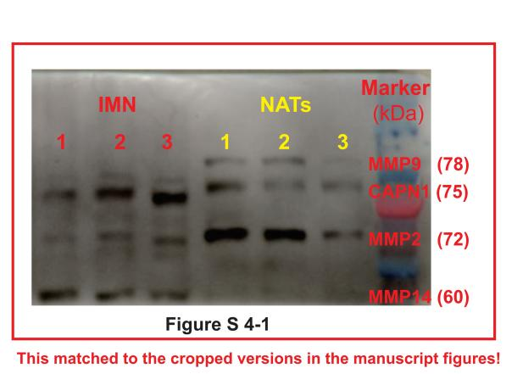

Figure S 4-1. The first time exposure of gel for MMP9, CAPN1, MMP2, MMP14.
No 2.
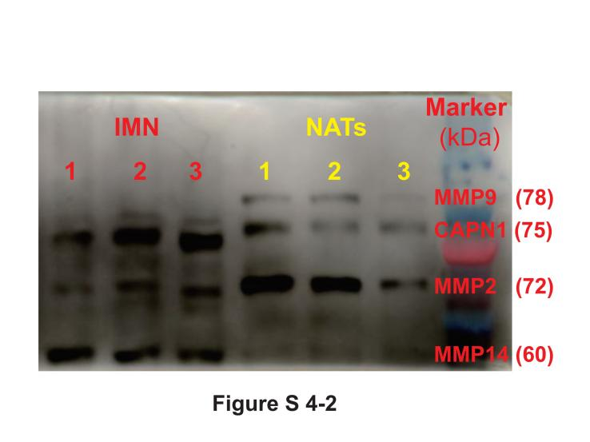
Figure S 4-2. The second time exposure of gel for MMP9, CAPN1, MMP2, MMP14.

No 3.
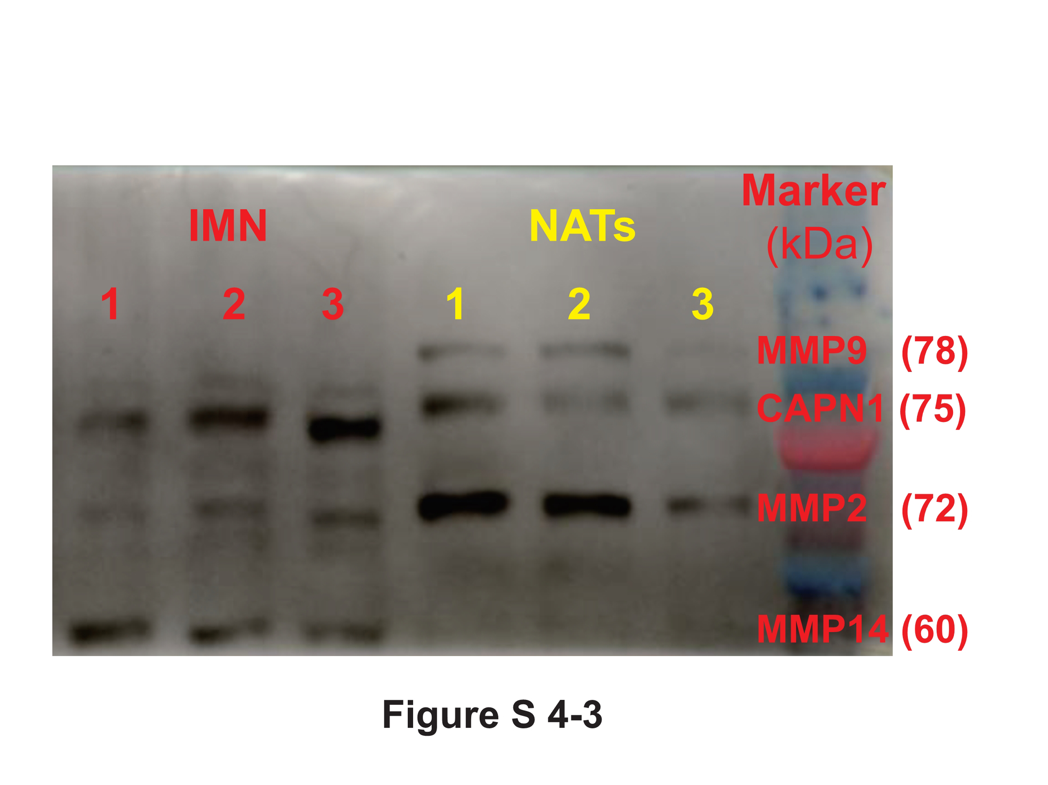

Figure S 4-3. The third time exposure of gel for MMP9, CAPN1, MMP2, MMP14.

No 4.
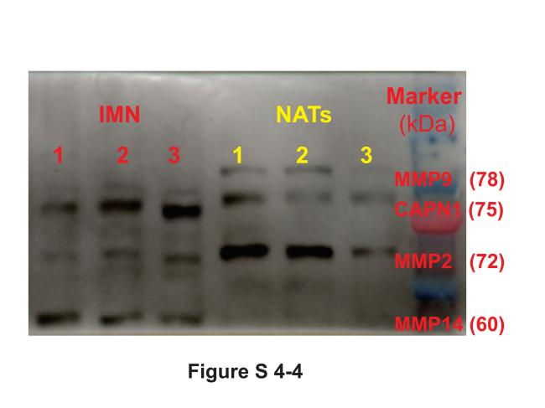
Figure S 4-4. The second time exposure of gel for MMP9, CAPN1, MMP2, MMP14.

No 5.
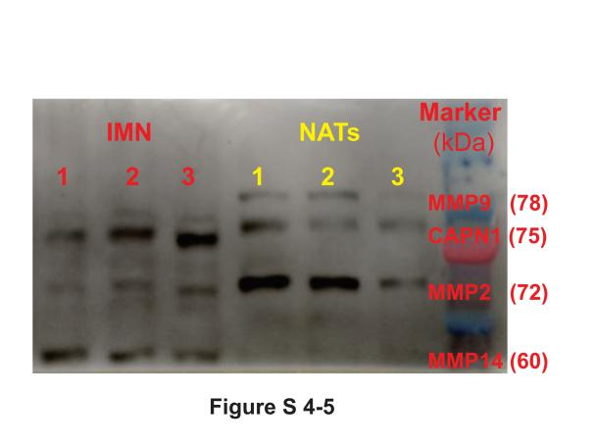
Figure S 4-5. The fifth time exposure of gel for MMP9, CAPN1, MMP2, MMP14.

Image Multiple exposures of WB: CTSS. (4 times)
No 1.
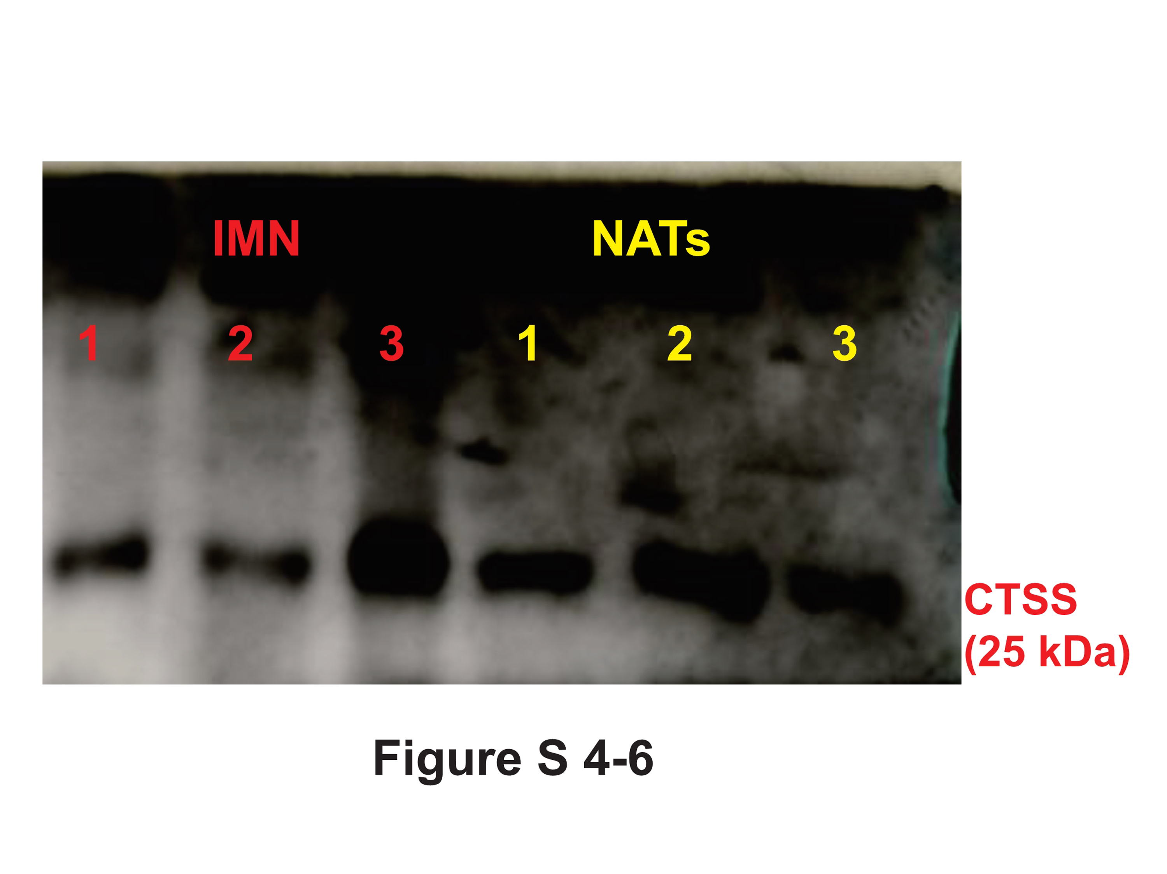
Figure S 4-6. The first time exposure of gel for CTSS.

No 2.
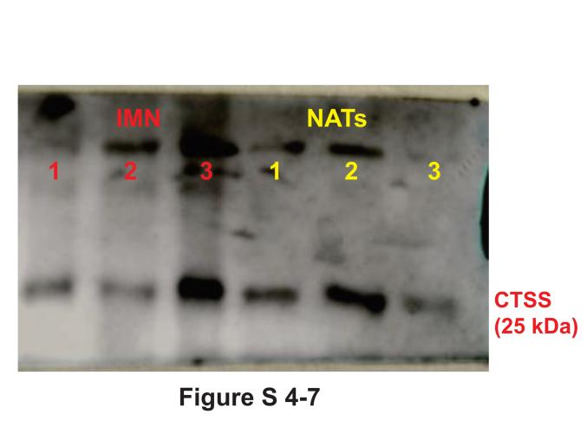

Figure S 4-7. The second time exposure of gel for CTSS.

No 3.

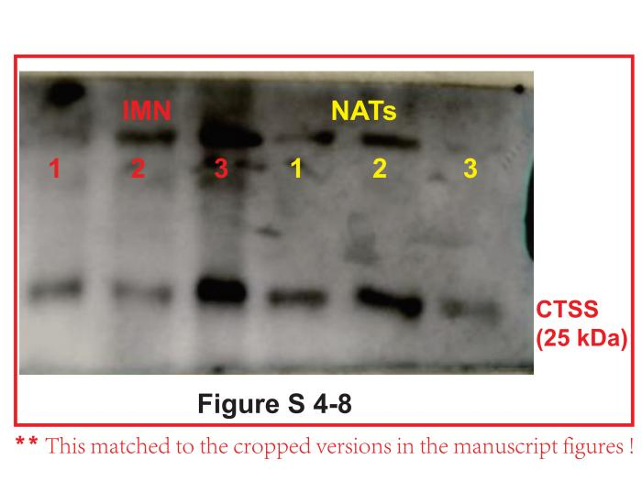
Figure S 4-8. The third time exposure of gel for CTSS.

No 4.
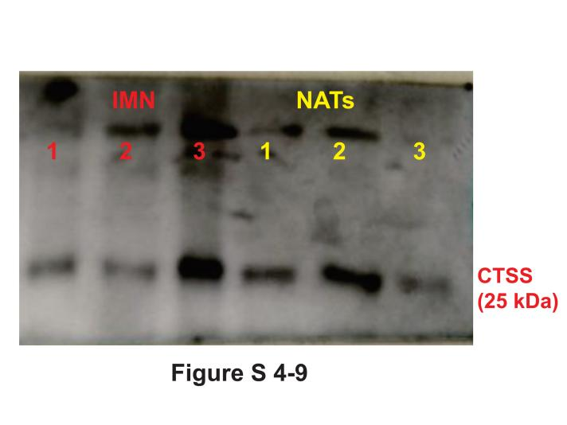
Figure S 4-9. The forth time exposure of gel for CTSS.

Image Multiple exposures of WB: GAPDH. (2 times)
No 1.
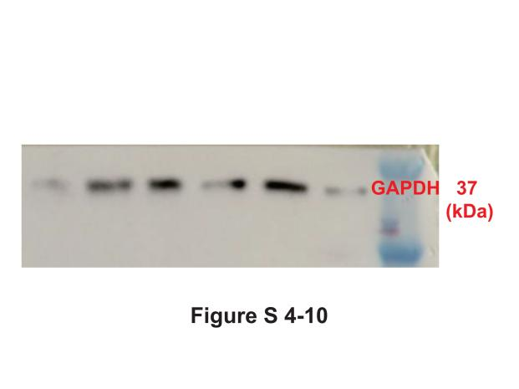
Figure S 4-10. The first time exposure of gel for GAPDH.
No 2.
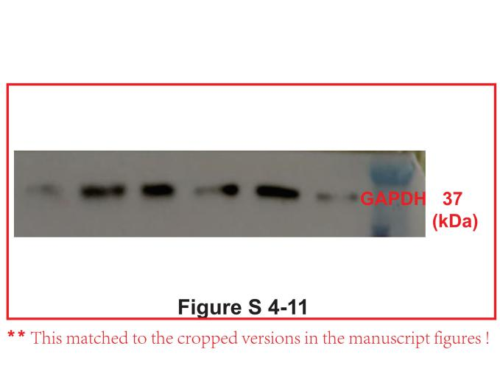
Figure S 4-11. The second time exposure of gel for GAPDH.

