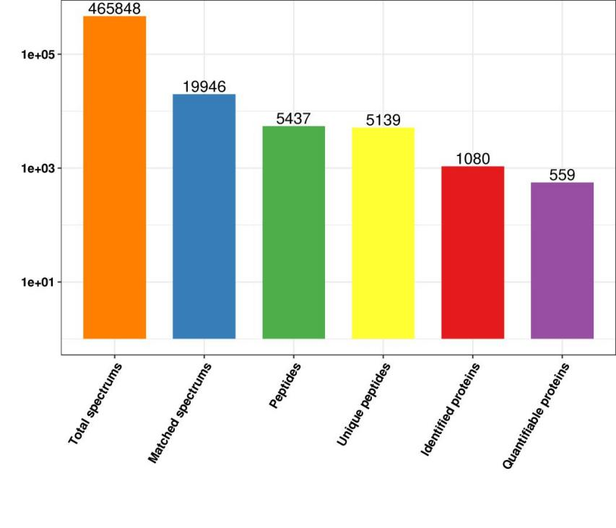

Figure S1.Overview of protein identified. 559 quantifiable proteins were identified by DIA-MS.

