Supplementary Information
- Supplementary Tables:
Table S1 Genomes included in this study

Table S2 Pathogen-host infection biology

Species | Strain | Host | Disease | References
Aspergillus fumigatus | Af293 | Human | Human lung infection | Nierman, et al. [1]
Botrytis cinerea | B05.10 | Nonspecific | Gray mold rot | Van Kan, et al. [2]
Blumeria graminis f. sp. hordei | DH14 | Barley | Powdery mildew | Wu, et al. [3]
Ceratocystis fimbriata | CBS 114723 | Sweet potato | Sweet potato black rot | Simpson, et al. [4]
Colletotrichum gloeosporioides | SMCG1#C | Nonspecific | Anthracnose disease | Huang, et al. [5]
Fusarium graminearum | PH-1 | Wheat and barley | Fusarium head blight (FHB) | Cuomo, et al. [6]
Fusarium oxysporum f. sp. Lycopersici | 4287 | Tomato | Fusarium wilt of Tomato | Ma, et al. [7]
Golovinomyces cichoracearum | UMSG1 | Sow thistle | Powdery mildew | Wu, et al. [3]
Gaeumannomyces tritici | R3-111a-1 | Wheat | Take-all disease | Okagaki, et al. [8]
Histoplasma capsulatum | NAm1 | Mamalian | Mamalian infection | Kasuga, et al. [9]
Leptosphaeria maculans | JN3 | Oilseed rape | Blackleg of oilseed rape | Rouxel, et al. [10]
Magnaporthe oryzae | 70-15 | Rice | Rice blast | Dean, et al. [11]
Parastagonospora nodorum | SN15 | Wheat | Stagonospora nodorum blotch (SNB) | Hane, et al. [12]
Pyrenophora seminiperda | CCB06 | Grass | Seed pathogen | Soliai, et al. [13]
Pyrenophora teres f. teres | W1-1 | Barley | Barley net blotch | Syme, et al. [14]
Sclerotinia sclerotiorum | 1980 | Nonspecific | Sclerotinia rot | Amselem, et al. [15]
Verticillium dahliae | VdLs.17 | Nonspecific | Verticillium wilt | Klosterman, et al. [16]
Venturia inaequalis | EU-B04 | Apple | Apple scab | Le Cam, et al. [17]
Zymoseptoria tritici | IPO323 | Wheat | Septoria tritici blotch (STB) | Goodwin, et al. [18]
Puccinia graminis f. sp. tritici | CRL 75-36-700-3 | Wheat | Wheat stem rust | Duplessis, et al. [19]
Melampsora larici-populina | 98AG31 | Poplar | Poplar leaf rust | Duplessis, et al. [19]
Ustilago maydis | 521 | Maize | Maize Smut | Kämper, et al. [20]

Table S3 Gene family size changes of species

Species | Abbreviation | Expanded families | Rapidly expanded families | Genes gain | Contracted families | Rapidly contracted families | Genes loss
Ustilago maydis | Um | 188 | 10 | 289 | 1781 | 8 | 1866
Puccinia graminis f. sp. tritici | Pg | 995 | 88 | 2533 | 609 | 56 | 703
Melampsora larici-populina | Mlp | 737 | 83 | 2176 | 426 | 45 | 511
Histoplasma capsulatum | Hc | 305 | 64 | 1201 | 1765 | 79 | 1918
Aspergillus fumigatus | Af | 694 | 137 | 1081 | 515 | 22 | 562
Zymoseptoria tritici | Zt | 641 | 84 | 1025 | 3640 | 5 | 3676
Venturia inaequalis | Vi | 707 | 129 | 1337 | 2765 | 18 | 2805
Parastagonospora nodorum | Pn | 858 | 224 | 1556 | 980 | 4 | 987
Leptosphaeria maculans | Lm | 308 | 21 | 346 | 1649 | 63 | 1745
Pyrenophora seminiperda | Ps | 206 | 100 | 247 | 2259 | 84 | 2387
Pyrenophora teres f. teres | Pt | 444 | 276 | 1499 | 404 | 10 | 418
Blumeria graminis f. sp. hordei | Bg | 200 | 36 | 690 | 515 | 6 | 522
Golovinomyces cichoracearum | Gc | 119 | 27 | 361 | 406 | 10 | 429
Sclerotinia sclerotiorum | Ss | 249 | 97 | 655 | 680 | 8 | 692
Botrytis cinerea | Bc | 1522 | 513 | 2449 | 240 | 10 | 270
Gaeumannomyces tritici | Gt | 729 | 156 | 1282 | 568 | 11 | 585
Magnaporthe oryzae | Mo | 500 | 86 | 812 | 708 | 12 | 738
Ceratocystis fimbriata | Cf | 97 | 21 | 328 | 5072 | 243 | 5632
Colletotrichum gloeosporioides | Cg | 1289 | 473 | 3010 | 627 | 10 | 641
Verticillium dahliae | Vd | 379 | 40 | 484 | 1740 | 67 | 1896
Fusarium oxysporum f. sp. Lycopersici | Fo | 3485 | 1222 | 9699 | 286 | 1 | 287
Fusarium graminearum | Fg | 237 | 67 | 303 | 1279 | 60 | 1380
Table S4 Distribution of CAZyme-coding gene homologs in selected pathogenic fungi

Species | Abbreviation | GH | GT | PL | CE | AA | CBM
Ustilago maydis | Um | 117 | 96 | 4 | 67 | 46 | 4
Puccinia graminis f. sp. tritici | Pg | 185 | 128 | 7 | 70 | 52 | 9
Melampsora larici-populina | Mlp | 200 | 126 | 7 | 111 | 69 | 13
Histoplasma capsulatum | Hc | 87 | 91 | 2 | 41 | 45 | 3
Aspergillus fumigatus | Af | 282 | 138 | 21 | 107 | 80 | 13
Zymoseptoria tritici | Zt | 206 | 135 | 4 | 98 | 82 | 12
Venturia inaequalis | Vi | 239 | 123 | 17 | 151 | 124 | 12
Parastagonospora nodorum | Pn | 291 | 135 | 13 | 167 | 191 | 26
Leptosphaeria maculans | Lm | 231 | 126 | 20 | 119 | 113 | 10
Pyrenophora seminiperda | Ps | 221 | 95 | 10 | 101 | 109 | 15
Pyrenophora teres f. teres | Pt | 251 | 133 | 11 | 129 | 139 | 15
Blumeria graminis f. sp. hordei | Bg | 75 | 85 | 1 | 35 | 20 | 1
Golovinomyces cichoracearum | Gc | 65 | 85 | 2 | 30 | 20 | 1
Sclerotinia sclerotiorum | Ss | 238 | 125 | 10 | 101 | 114 | 17
Botrytis cinerea | Bc | 298 | 164 | 13 | 156 | 150 | 15
Gaeumannomyces tritici | Gt | 276 | 135 | 9 | 121 | 162 | 28
Magnaporthe oryzae | Mo | 277 | 137 | 8 | 139 | 171 | 31
Ceratocystis fimbriata | Cf | 104 | 94 | 6 | 39 | 43 | 4
Colletotrichum gloeosporioides | Cg | 457 | 160 | 47 | 251 | 274 | 32
Verticillium dahliae | Vd | 290 | 123 | 39 | 125 | 138 | 12
Fusarium oxysporum f. sp. Lycopersici | Fo | 484 | 275 | 29 | 271 | 260 | 82
Fusarium graminearum | Fg | 269 | 148 | 24 | 152 | 146 | 25

Table S5 Distribution of biosynthetic gene cluster in pathogenic fungi

Species | Abbreviation | NRPs | Polyketides | Terpenes
Ustilago maydis | Um | 3 | 1 | 2
Puccinia graminis f. sp. tritici | Pg | 1 | 0 | 4
Melampsora larici-populina | Mlp | 1 | 0 | 3
Histoplasma capsulatum | Hc | 4 | 1 | 4
Aspergillus fumigatus | Af | 8 | 10 | 6
Zymoseptoria tritici | Zt | 10 | 6 | 4
Venturia inaequalis | Vi | 4 | 2 | 3
Parastagonospora nodorum | Pn | 5 | 15 | 5
Leptosphaeria maculans | Lm | 4 | 11 | 5
Pyrenophora seminiperda | Ps | 7 | 8 | 5
Pyrenophora teres f. teres | Pt | 72 | 11 | 4
Blumeria graminis f. sp. hordei | Bg | 1 | 1 | 1
Golovinomyces cichoracearum | Gc | 1 | 3 | 3
Sclerotinia sclerotiorum | Ss | 6 | 15 | 3
Botrytis cinerea | Bc | 6 | 15 | 9
Gaeumannomyces tritici | Gt | 5 | 14 | 5
Magnaporthe oryzae | Mo | 9 | 19 | 11
Ceratocystis fimbriata | Cf | 2 | 3 | 2
Colletotrichum gloeosporioides | Cg | 9 | 20 | 8
Verticillium dahliae | Vd | 3 | 9 | 5
Fusarium oxysporum f. sp. Lycopersici | Fo | 10 | 11 | 11
Fusarium graminearum | Fg | 7 | 8 | 11

Table S6 The biotrophs-specific effector families

Table S7 Pfam domains annotations of biotrophs-specific effector families

Target name | Sequence number | Domain accession | Descriptions
Hce2 | 5 | PF14856.6 | Pathogen effector; putative necrosis-inducing factor
Egh16-like | 3 | PF11327.8 | Egh16-like virulence factor
CFEM | 2 | PF05730.11 | CFEM domain
CM_2 | 2 | PF01817.21 | Chorismate mutase type
GILT | 2 | PF03227.16 | Gamma interferon inducible lysosomal thiol reductase
LOR | 2 | PF04525.12 | Family of unknow function (DUF5333)
SRP19 | 2 | PF01922.17 | SRP19 protein
Collagen_bind_2 | 1 | PF12904.7 | Putative collagen-binding domain of a collagenase
DUF1431 | 1 | PF07248.12 | Protein of unknown function(DUF1431)
DUF1856 | 1 | PF08983.10 | Domain of unknown function (DUF1856)
DUF333 | 1 | PF03891.15 | Domain of unknown function (DUF333)
DUF3724 | 1 | PF12521.8 | Protein of unknown function (DUF3724)
DUF4232 | 1 | PF14016.6 | Protein of unknown function (DUF4232)
DUF5333 | 1 | PF17267.2 | Family of unknow function (DUF5333)
GPI-anchored | 1 | PF10342.9 | Ser-Thr-rich glycosyl-phosphatidyl-inositol-anchored membrane family
Muted | 1 | PF14942.6 | Organelle biogenesis, Muted-like protein
PADR1 | 1 | PF08063.12 | PADR1 (NUC008) domain
Stig1 | 1 | PF04885.13 | Stigma-specific protein, Stig1
Sugarporin_N | 1 | PF11471.8 | Maltoporin periplasmic N-terminal extension
TarH | 1 | PF02203.15 | Tar ligand binding domain homologue
YlbE | 1 | PF14003.6 | YlbE-like protein
Others | 62 |  | No annotation information

Table S8 The core effector families of phytopathogens with distinct lifestyles

- Supplementary Figures :
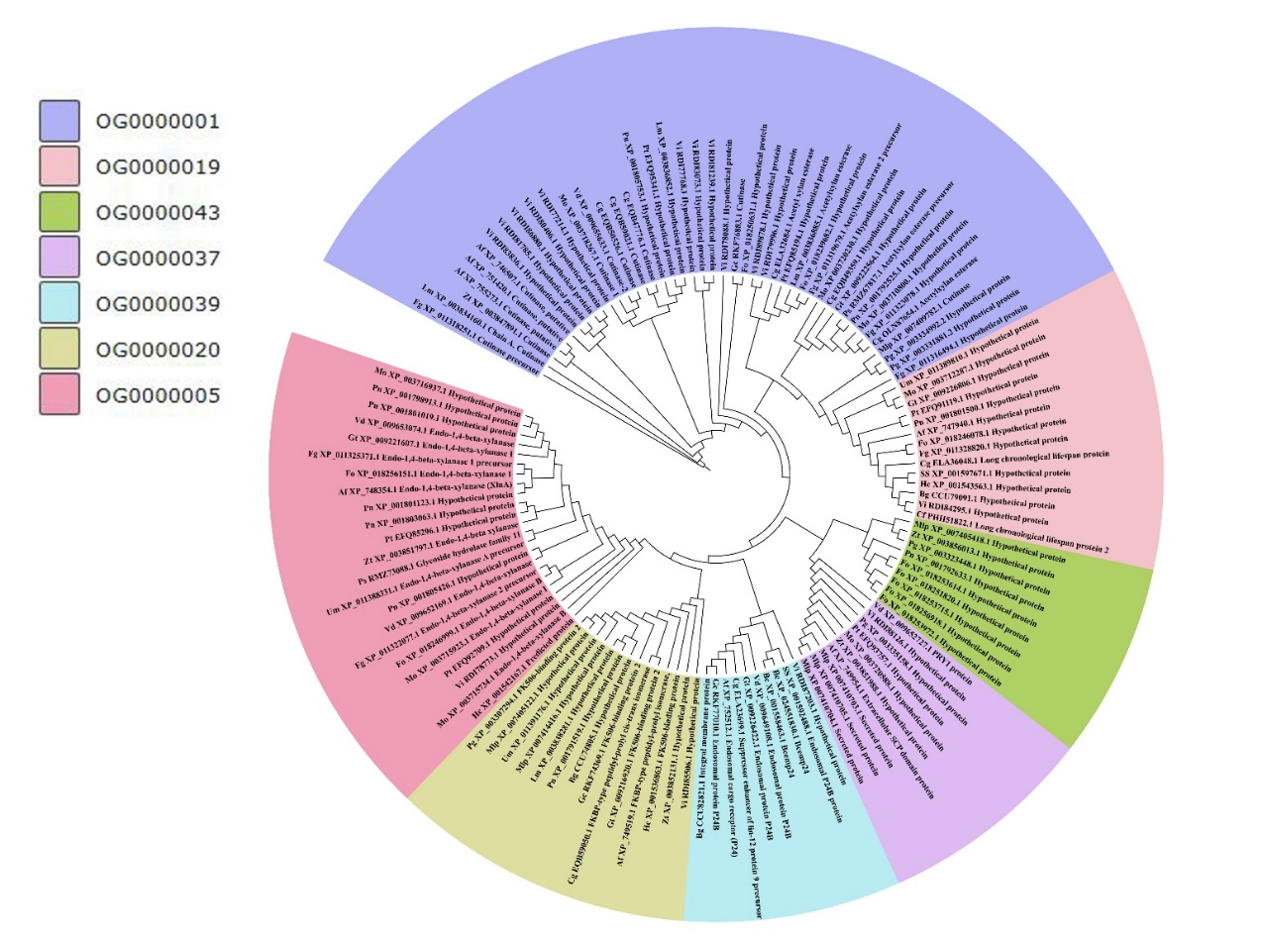
Fig.S1 Phylogenetic analysis of core effector gene families
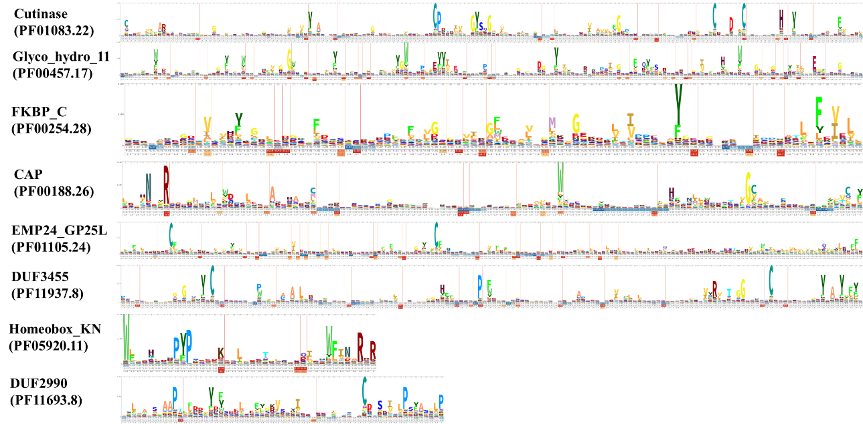
Fig.S2 Domain visualization of core effector gene families

Reference
1. Nierman WC, Pain A, Anderson MJ, Wortman JR, Kim HS, Arroyo J et al: Genomic sequence of the pathogenic and allergenic filamentous fungus Aspergillus fumigatus. Nature 2005, 438(7071):1151.
2. Van Kan JA, Stassen JH, Mosbach A, Van Der Lee TA, Faino L, Farmer AD et al: A gapless genome sequence of the fungus Botrytis cinerea. Molecular plant pathology 2017, 18(1):75-89.
3. Wu Y, Ma X, Pan Z, Kale SD, Song Y, King H et al: Comparative genome analyses reveal sequence features reflecting distinct modes of host-adaptation between dicot and monocot powdery mildew. BMC Genomics 2018, 19(1):705.
4. Simpson MC, Wilken PM, Coetzee MP, Wingfield MJ, Wingfield BD: Analysis of microsatellite markers in the genome of the plant pathogen Ceratocystis fimbriata. Fungal biology 2013, 117(7-8):545-555.
5. Huang L, Kim K-T, Yang J-Y, Song H, Choi G, Jeon J et al: A high-quality draft genome sequence of Colletotrichum gloeosporioides sensu stricto SMCG1# C, a causal agent of anthracnose on Cunninghamia lanceolata in China. Molecular plant-microbe interactions 2019, 32(2):139-141.
6. Cuomo CA, Güldener U, Xu J-R, Trail F, Turgeon BG, Di Pietro A et al: The Fusarium graminearum genome reveals a link between localized polymorphism and pathogen specialization. Science 2007, 317(5843):1400-1402.
7. Ma L-J, Van Der Does HC, Borkovich KA, Coleman JJ, Daboussi M-J, Di Pietro A et al: Comparative genomics reveals mobile pathogenicity chromosomes in Fusarium. Nature 2010, 464(7287):367-373.
8. Okagaki LH, Nunes CC, Sailsbery J, Clay B, Brown D, John T et al: Genome sequences of three phytopathogenic species of the Magnaporthaceae family of fungi. G3: Genes, Genomes, Genetics 2015, 5(12):2539-2545.
9. Kasuga T, White TJ, Koenig G, Mcewen J, Restrepo A, Castañeda E et al: Phylogeography of the fungal pathogen Histoplasma capsulatum. Molecular ecology 2003, 12(12):3383-3401.
10. Rouxel T, Grandaubert J, Hane JK, Hoede C, Van de Wouw AP, Couloux A et al: Effector diversification within compartments of the Leptosphaeria maculans genome affected by repeat-induced point mutations. Nature communications 2011, 2(1):1-10.
11. Dean RA, Talbot NJ, Ebbole DJ, Farman ML, Mitchell TK, Orbach MJ et al: The genome sequence of the rice blast fungus Magnaporthe grisea. Nature 2005, 434(7036):980-986.
12. Hane JK, Lowe RG, Solomon PS, Tan K-C, Schoch CL, Spatafora JW et al: Dothideomycete–plant interactions illuminated by genome sequencing and EST analysis of the wheat pathogen Stagonospora nodorum. Plant Cell 2007, 19(11):3347-3368.
13. Soliai MM, Meyer SE, Udall JA, Elzinga DE, Hermansen RA, Bodily PM, Hart AA, Coleman CE: De novo genome assembly of the fungal plant pathogen Pyrenophora semeniperda. PLoS One 2014, 9(1).
14. Syme RA, Martin A, Wyatt NA, Lawrence JA, Muria-Gonzalez MJ, Friesen TL, Ellwood SR: Transposable element genomic fissuring in Pyrenophora teres is associated with genome expansion and dynamics of host–pathogen genetic interactions. Frontiers in Genetics 2018, 9:130.
15. Amselem J, Cuomo CA, van Kan JA, Viaud M, Benito EP, Couloux A et al: Genomic analysis of the necrotrophic fungal pathogens Sclerotinia sclerotiorum and Botrytis cinerea. PLoS genetics 2011, 7(8):e1002230.
16. Klosterman SJ, Subbarao KV, Kang S, Veronese P, Gold SE, Thomma BP et al: Comparative genomics yields insights into niche adaptation of plant vascular wilt pathogens. PLoS pathogens 2011, 7(7).
17. Le Cam B, Sargent D, Gouzy J, Amselem J, Bellanger M-N, Bouchez O et al: Population genome sequencing of the scab fungal species Venturia inaequalis, Venturia pirina, Venturia aucupariae and Venturia asperata. G3: Genes, Genomes, Genetics 2019, 9(8):2405-2414.
18. Goodwin SB, M'Barek SB, Dhillon B, Wittenberg AH, Crane CF, Hane JK et al: Finished genome of the fungal wheat pathogen Mycosphaerella graminicola reveals dispensome structure, chromosome plasticity, and stealth pathogenesis. PLoS genetics 2011, 7(6).
19. Duplessis S, Cuomo CA, Lin Y-C, Aerts A, Tisserant E, Veneault-Fourrey C et al: Obligate biotrophy features unraveled by the genomic analysis of rust fungi. Proceedings of the National Academy of Sciences 2011, 108(22):9166-9171.
20. Kämper J, Kahmann R, Bölker M, Ma L-J, Brefort T, Saville BJ et al: Insights from the genome of the biotrophic fungal plant pathogen Ustilago maydis. Nature 2006, 444(7115):97-101.

