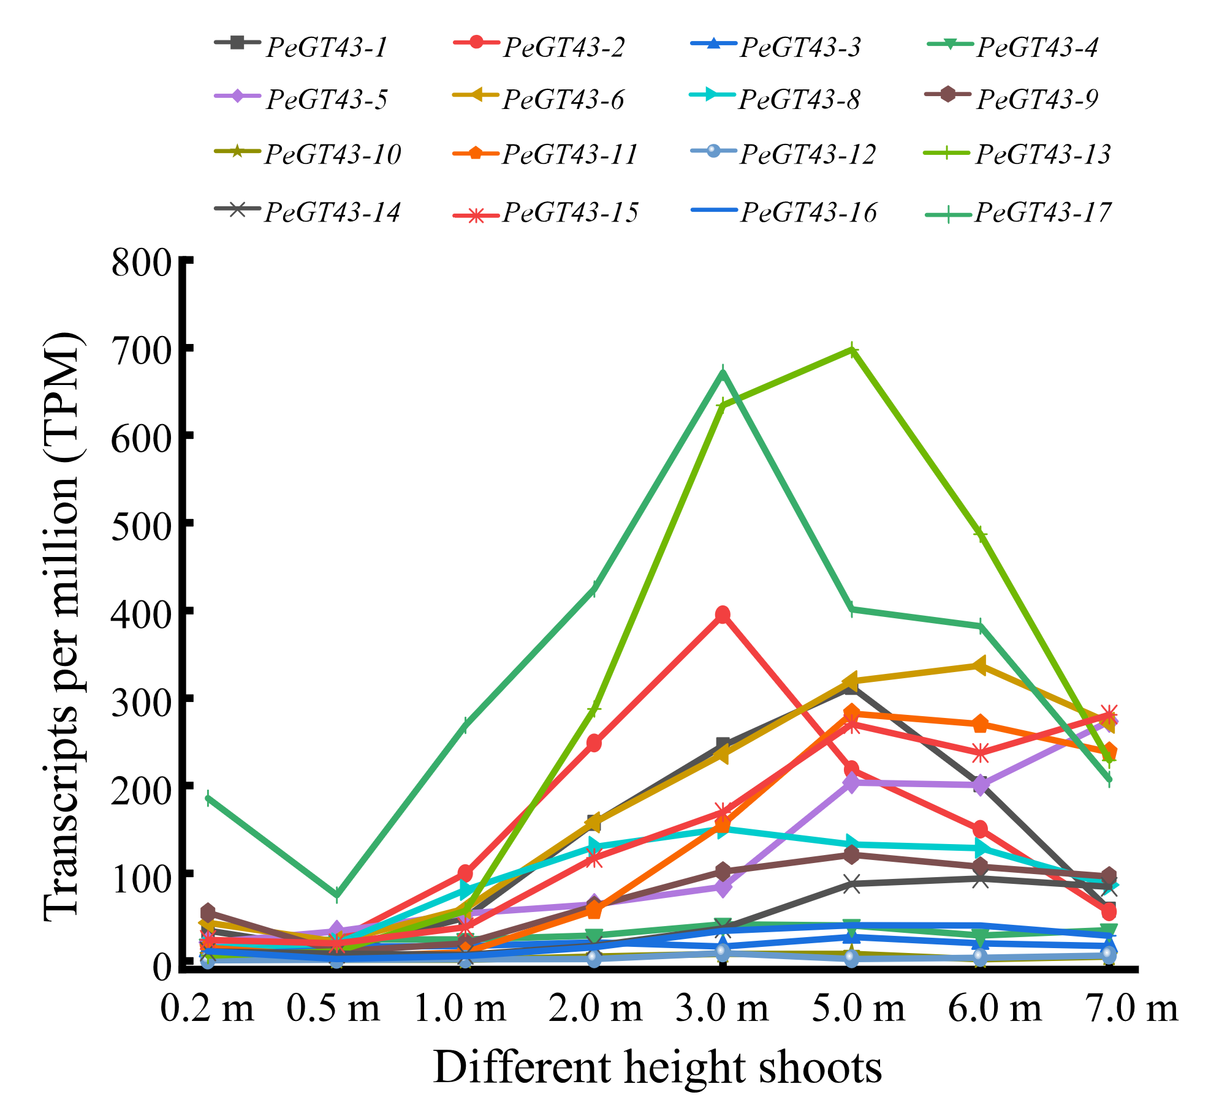

Figure S1. Expression profiles of PeGT43s in different height shoots of moso bamboo. Expression patterns of PeGT43s with significant transcriptional changes were showed in folding line chart, using the transcripts per million (TPM) as the value of the vertical coordinate. The TPM value was listed in Table S5.

