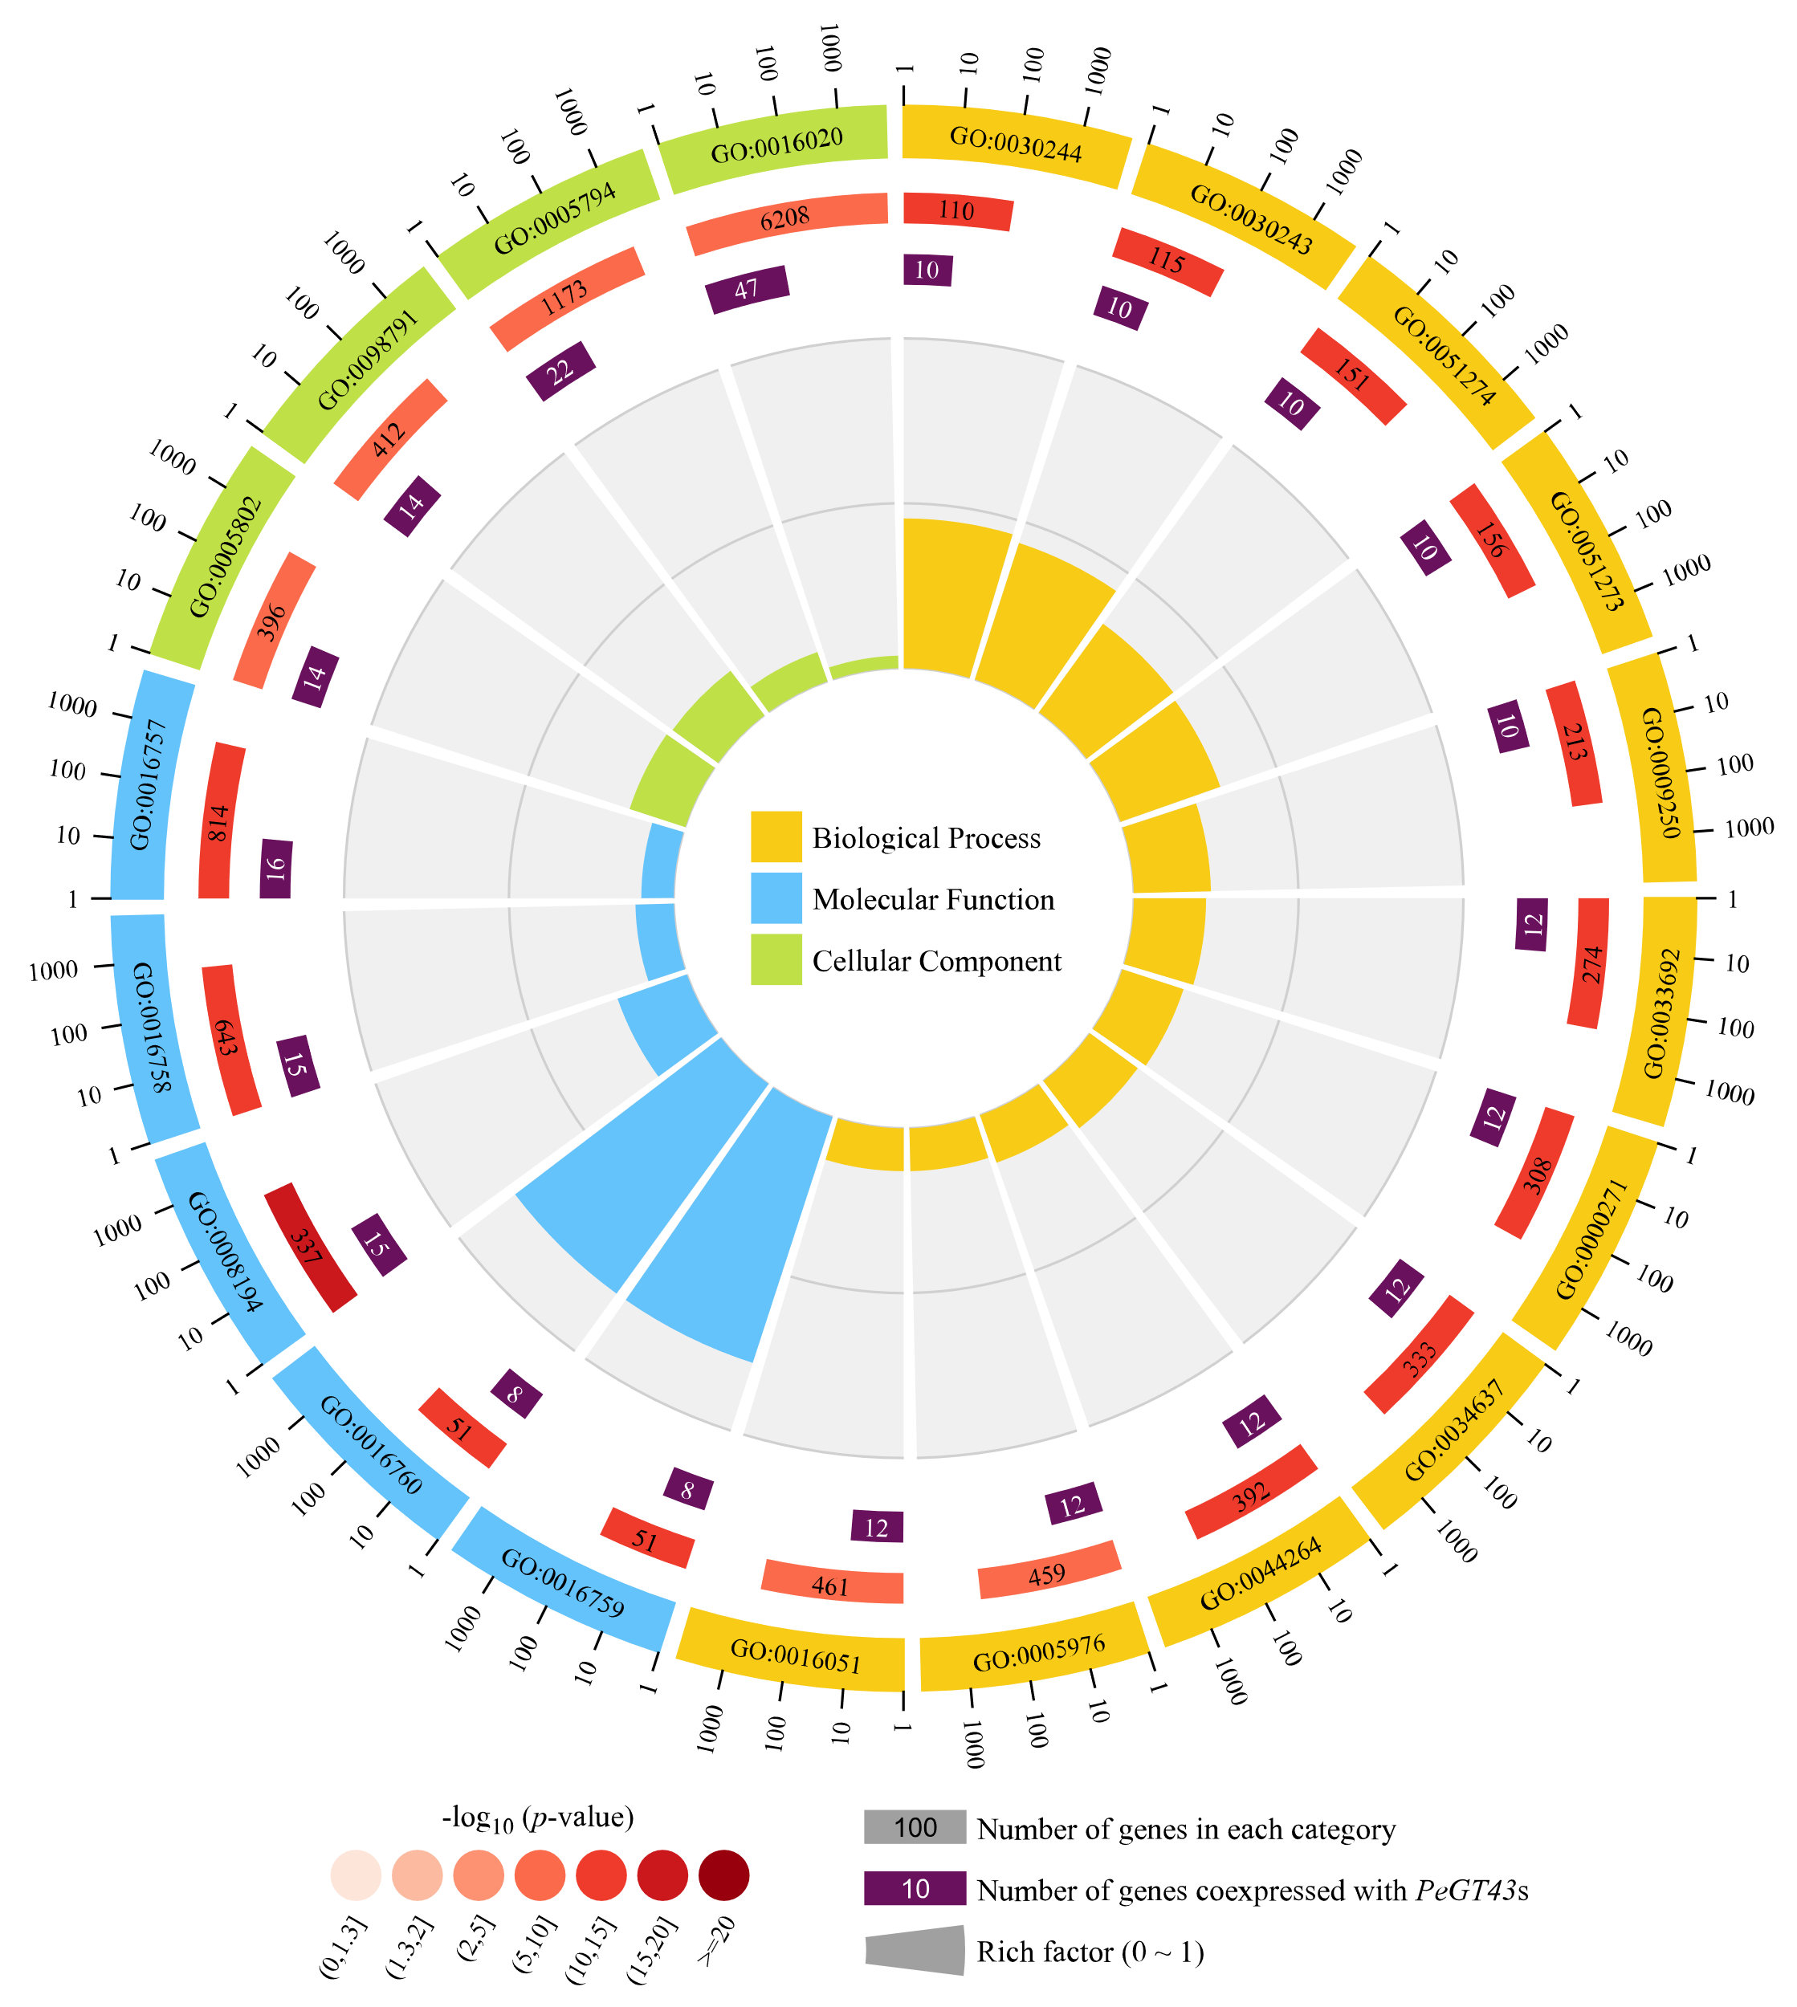
Figure S2. Gene Ontology classification of genes co-expressed with PeGT43s. Outside the circle indicates the scale of the gene numbers.

