Genome insights into the pharmaceutical and the plant growth promoting features of the novel species Nocardia alni sp. nov.

Imen Nouioui^{1*}, Sung-min Ha², Inwoo Baek³, Jongsik Chun^{3,4}, Michael Goodfellow⁵

¹Department of Microorganisms, Leibniz Institute DSMZ–German Collection of Microorganisms and Cell Cultures, 38124 Braunschweig, Germany
²Department of Integrative Biology and Physiology, University of California, Los Angeles, 610 Charles E. Young Drive East, Los Angeles, CA 90095, USA
³School of Biological Sciences & Institute of Molecular Biology and Genetics, Seoul National University, Seoul, Korea
⁴ChunLab, Inc., Seoul, Korea
⁵School of Natural and Environmental Sciences, Newcastle University, Ridley Building 2, Newcastle upon Tyne, NE1 7RU, United Kingdom

Corresponding author: Imen Nouioui, email: imen.nouioui@dsmz.de, Tel. ++49531-2616-369, Fax. ++49531-2616-418

Supplementary table and figure legends

Table S1. Fatty acids profiles of strain ncl2^{T} and the type strain of N. vaccinii, its closest phylogenomic neighbour.
Table S2. Putative natural product biosynthetic gene clusters detected in the draft genome of strain ncl2^{T} and N. vaccinii NBRC 15922^{T} using Antismash 5.0.0 webserver.
Table S3. Pairwise ortholog matrix between the genome sequences of isolate ncl2^{T} (1) and N. vaccinii NBRC 15922^{T} (2), N. casuarinae BMG51109^{T} (3), N. jiangxiensis NBRC 101359^{T} (4), N. miyunensis NBRC 108239^{T} (5) and N. pseudobrasiliensis DSM 44290 ^{T} (6)
Figure S1. Culture of isolate ncl2^{T} grown on medium DSMZ 65 after 10 days incubation at 28°C
Figure S2. Statistical comparisons of genomic properties of: 1, strain ncl2^{T}, 2, N. vaccinii NBRC 15922^{T}, 3, N. casuarinae BMG51109^{T}, 4, N. jiangxiensis NBRC 101359^{T}, 5, N. miyunensis NBRC 108239^{T} and 6, N. pseudobrasiliensis DSM 44290 ^{T}
Figure S3. Frequency plot of POGs showing major COG categories
Figure S4. Functional categories found in the (a) COG/EggNog and (b) SEED analyses
Figure S5. Two-dimensional TLC plates of polar lipids extracted from isolate ncl2^{T} (a) and N. vaccinii (b) stained with molybdatophosphoric acid (SigmaP1518). Key: DPG, diphosphatidylglycerol; PE, phosphatidylethanolamine; PG, phosphatidylglycerol;PI, phosphatidylinositol; GPL, glycophospholipid; AL1‐2, aminoplipids, GL1‐5, glycolipids and L1‐3, lipid. Solvent1: chloroform: methanol: distilled water (65:25:4); solvent 2: chloroform: glacial acetic acid: methanol: distilled water (80:12:15:4).

Table S1. Fatty acids profiles of strain ncl2 and the type strain of N. vaccinii, its closest phylogenomic neighbour
Fatty acids | Strain ncl2^{T} | N. vaccinii DSM 43285^{T} | Nocardia jiangxiensis 43401^{T*} | Nocardia miyunensis 117^{T*}
C_{16 :0} | 39.2 | 37.3 | 24.8 | 27.2
C_{16 : 1} ω7c | - | - | 12.4 | 16.4
C_{17 :1} ω9c | 6.0 | - | - | -
C_{17 :1} ω5c | 4.3 | 4.0 | - | -
C_{18 :0} | - | - | 11.0 | 6.4
C_{18 :1}ω9c | 21.4 | 9.6 | 12.3 | 7.7
C_{18 :0} 10-methyl | 9 .8 | 21.9 | 27.3 | 33.0
Summed feature 3 C_{16 :1}ω7c/C_{16 :1}ω6c | 5 .4 | 8.1 | - | -
Only fatty acids > 4 % are considered. -, fatty acid is absent; * fatty acid data taken from Cui et al. 2005

Table S2. Putative natural product biosynthetic gene clusters detected in the draft genome of strain ncl2^{T} and N. vaccinii NBRC 15922^{T} using Antismash 5.0.0 webserver

Isolate ncl2^{T}
Type | From | To | Most similar known cluster |  | Similarity
NRPS,RiPP-like | 102,337 | 129,534 | himastatin | NRP | 8%
T1PKS | 1 | 27,953 | tylactone | Polyketide | 15%
NRPS | 1 | 39,752 | A54145 | NRP | 5%
T1PKS | 80,213 | 109,041 | amycolamycin A / amycolamycin B | Polyketide | 2%
T1PKS | 50,577 | 90,968 | tiacumicin B | Polyketide:Modular type I | 6%
NRPS | 42,582 | 87,073
T1PKS | 43,009 | 86,311 | teicoplanin | NRP:Glycopeptide | 3%
NRPS | 12,703 | 75,131 | fengycin | NRP | 13%
NRPS,redox-cofactor | 3,792 | 70,004 | JBIR-06 | NRP + Polyketide | 22%
NRPS,T1PKS | 1 | 42,636 | echoside A / echoside B / echoside C / echoside D / echoside E | NRP | 11%
terpene | 50,627 | 64,994
NAPAA | 29,17 | 61,195 | steffimycin D | Polyketide:Type II + Saccharide:Hybrid/tailoring | 8%
T1PKS | 19,086 | 60,181
NRPS | 1 | 59,712
betalactone | 51 | 31,832 | lasalocid | Polyketide | 3%
T1PKS | 25,255 | 56,309
terpene | 39,132 | 56,213 | 2-methylisoborneol | Terpene | 75%
NRPS | 1 | 48,334 | atratumycin | NRP | 7%
terpene | 13,256 | 34,311 | carotenoid | Terpene | 18%
T1PKS | 1 | 53,857 | nystatin | Polyketide | 31%
terpene | 29,28 | 48,28
other | 1 | 29,939 | capreomycin IA / capreomycin IB / capreomycin IIA / capreomycin IIB | NRP | 6%
arylpolyene | 1,68 | 42,858
indole | 1 | 17,652
terpene | 1,656 | 23,659
linaridin | 3,174 | 23,707
NRPS,T1PKS | 1 | 35,298
ectoine | 10,575 | 20,964 | ectoine | Other | 100%
NRPS | 1 | 23,103 | lasalocid | Polyketide | 3%
terpene | 16,554 | 27,793
NRPS,terpene | 1 | 24,845
NRPS | 1 | 24,782
terpene | 1 | 19,541 | prejadomycin / rabelomycin / gaudimycin C / gaudimycin D / UWM6 / gaudimycin A | Polyketide:Type II + Saccharide:Hybrid/tailoring | 4%
NRPS | 1 | 21,043 | pepticinnamin E | NRP + Polyketide | 6%
T1PKS | 1 | 17,15 | stambomycin A / stambomycin B / stambomycin C / stambomycin D | Polyketide:Modular type I + Saccharide:Hybrid/tailoring | 36%
lassopeptide | 1 | 5,329 | anantin B1 / anantin B2 | RiPP | 40%

N. vaccinii NBRC 15922^{T}
Type | From | To | Most similar known cluster |  | Similarity
T1PKS | 91,036 | 137,032
T1PKS | 9,243 | 45,775
NRPS,RiPP-like | 334,57 | 434,306 | himastatin | NRP | 8%
terpene | 258,811 | 279,782 | isorenieratene | Terpene | 28%
lanthipeptide-class-i | 356,921 | 381,5
ectoine | 403,687 | 414,082 | ectoine | Other | 100%
NAPAA | 39,654 | 73,577 | steffimycin D | Polyketide:Type II + Saccharide:Hybrid/tailoring | 8%
NRPS | 147,202 | 205,255
betalactone | 304,683 | 332,993
NRPS | 2,512 | 56,659 | tetarimycin A / tetarimycin B | Polyketide:Type II | 8%
terpene | 104,024 | 124,968 | carotenoid | Terpene | 18%
arylpolyene | 1 | 26,582
terpene,betalactone | 48,68 | 81,44 | leinamycin | NRP + Polyketide:Modular type I + Polyketide:Trans-AT type I | 2%
lanthipeptide-class-i | 4,122 | 28,373 | nisin O | RiPP | 26%
terpene | 35,54 | 56,631 | A54145 | NRP | 5%
T3PKS | 44,495 | 85,607 | teicoplanin | NRP:Glycopeptide | 3%
lanthipeptide-class-v,NRPS,T1PKS,terpene | 134,618 | 305,416 | cremimycin | Polyketide | 5%
NRPS,T1PKS | 5,205 | 73,19 | cyphomycin | Polyketide | 2%
NRPS | 78,757 | 132,454 | retimycin A | NRP:Cyclic depsipeptide | 13%
betalactone | 12,164 | 34,959
NRPS | 8,925 | 44,376
T1PKS | 1 | 23,973
terpene | 6,748 | 27,731 | isorenieratene | Terpene | 57%
T1PKS | 1 | 37,162 | caniferolide A / caniferolide B / caniferolide C / caniferolide D | Polyketide:Modular type I | 6%
redox-cofactor | 29,467 | 52,179
NRPS | 54,633 | 90,449
terpene | 67,989 | 81,644
NRPS | 1 | 39,616
NRPS | 1 | 48,508 | rustmicin | Polyketide:Iterative type I | 6%

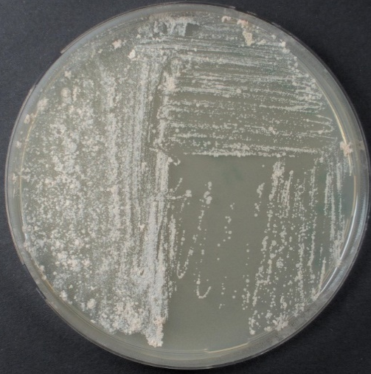
Figure S1. Culture of isolate ncl2^{T} grown on medium DSMZ 65 after 10 days of incubation at 28°C.

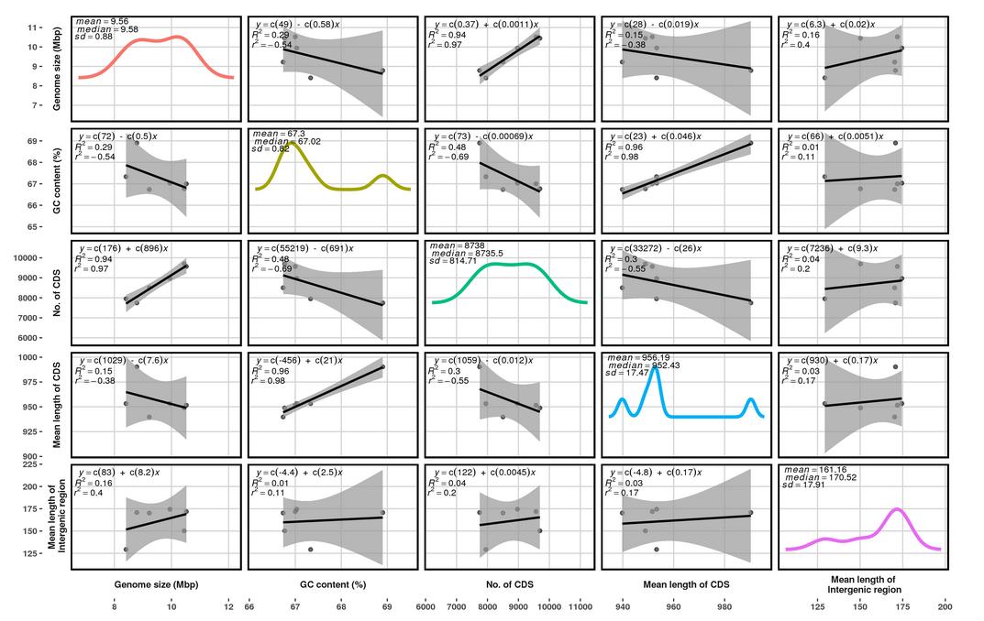
Figure S2. Statistical comparisons of genomic properties of: 1, strain ncl2^{T}, 2, N. vaccinii NBRC 15922^{T}, 3, N. casuarinae BMG51109^{T}, 4, N. jiangxiensis NBRC 101359^{T}, 5, N. miyunensis NBRC 108239^{T} and 6, N. pseudobrasiliensis DSM 44290 ^{T}.

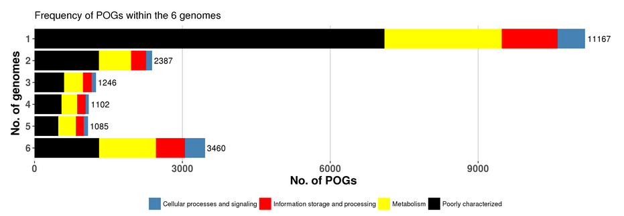
Figure S3. Frequency plot of POGs showing major COG categories. 1, strain ncl2^{T}, 2, N. vaccinii NBRC 15922^{T}, 3, N. casuarinae BMG51109^{T}, 4, N. jiangxiensis NBRC 101359^{T}, 5, N. miyunensis NBRC 108239^{T} and 6, N. pseudobrasiliensis DSM 44290 ^{T}.

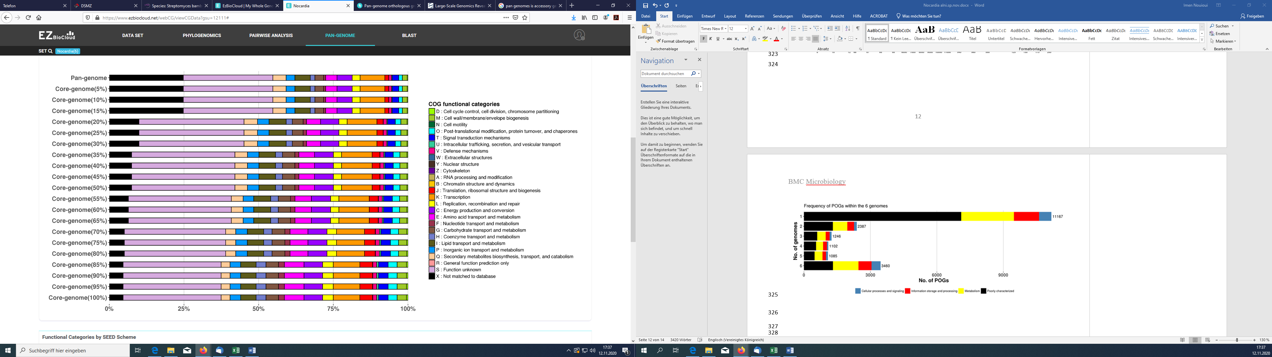
a

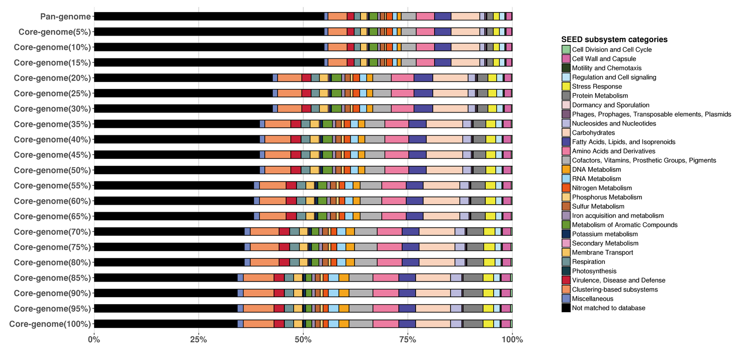
b

Figure S4. Functional categories found in the (a) COG/EggNog and (b) SEED analyses

Figure S5. Two-dimensional TLC plates of polar lipids extracted from isolate ncl2^{T} (a) and N. vaccinii DSM 43285^{T}(b) stained with molybdatophosphoric acid (SigmaP1518). Key: DPG, diphosphatidylglycerol; PE, phosphatidylethanolamine; PI, phosphatidylinositol; PGL, phosphoglycolipid; AL, aminoplipid, GL, glycolipid, L1‐2, lipids and PL1-2, phospholipids. Solvent1: chloroform: methanol: distilled water (65:25:4 v/v/v/); solvent 2: chloroform: glacial acetic acid: methanol: distilled water (80:12:15:4 v/v/v).

