Supplementary Materials

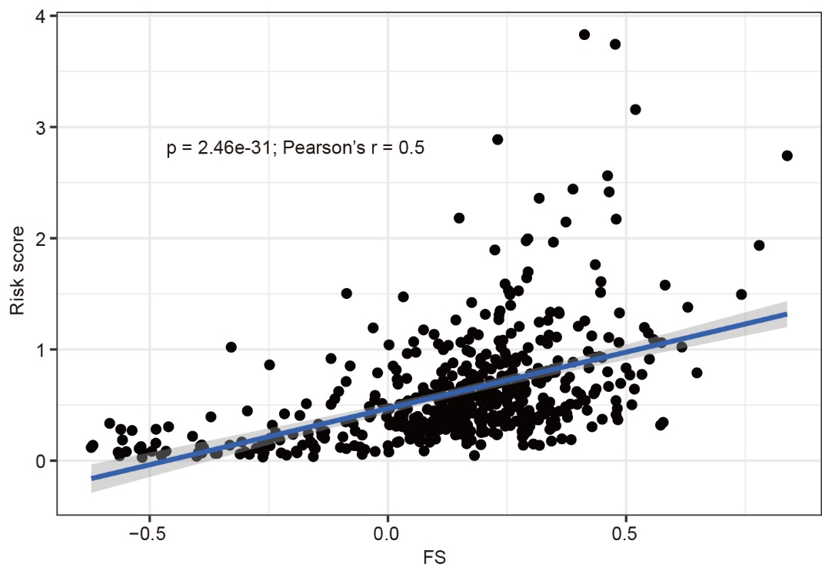
Supplementary Figure 1. The association between risk score and FS in HNSCC patients.
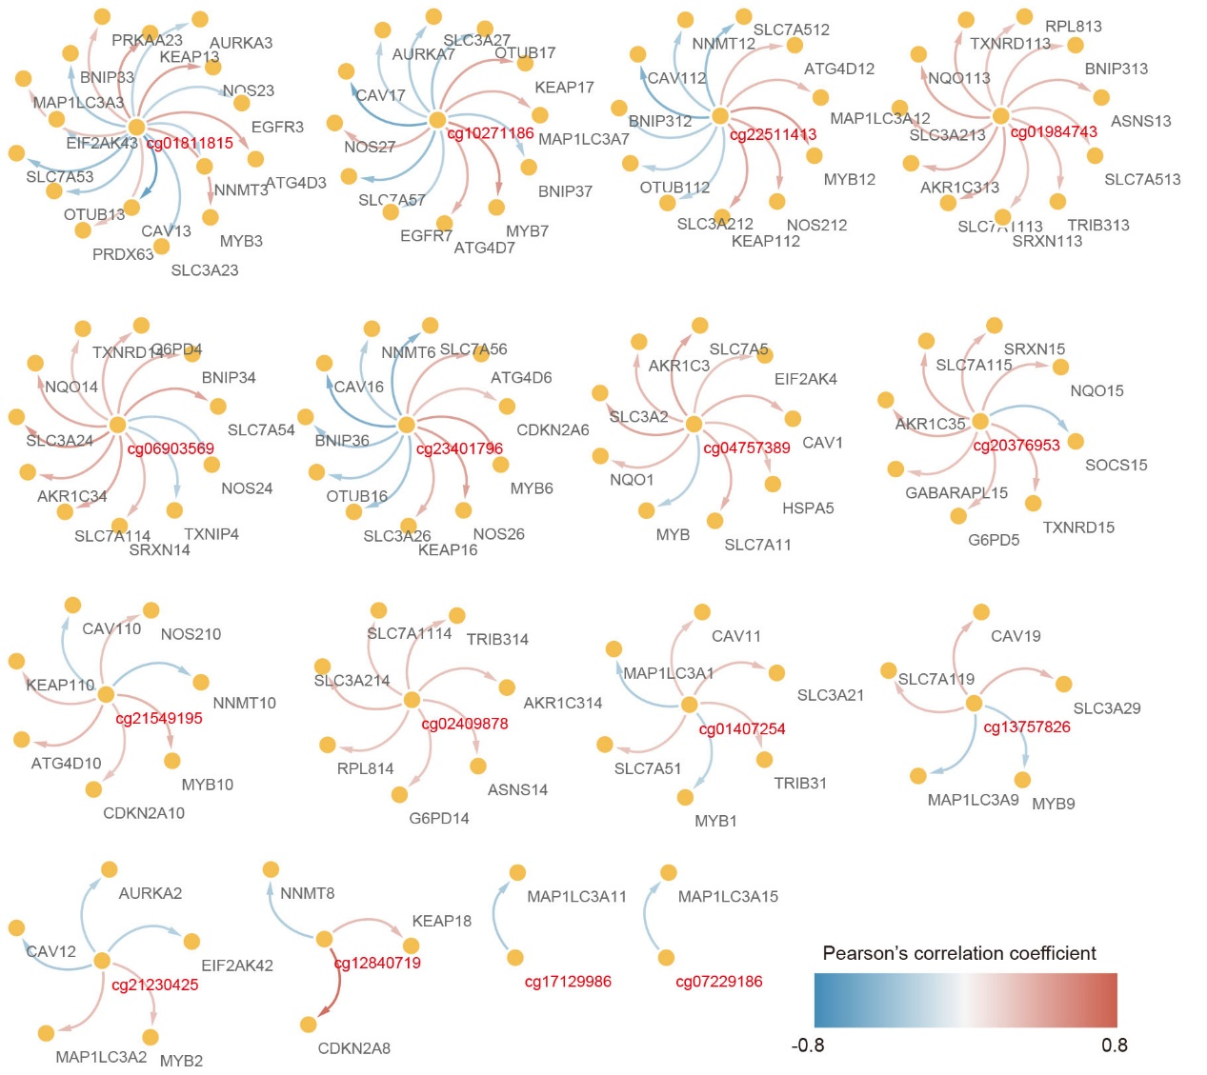
Supplementary Figure 2. Correlation between methylation level of each site from 16-DNAm signature and expression of ferroptosis-related genes involving HNSCC survival.

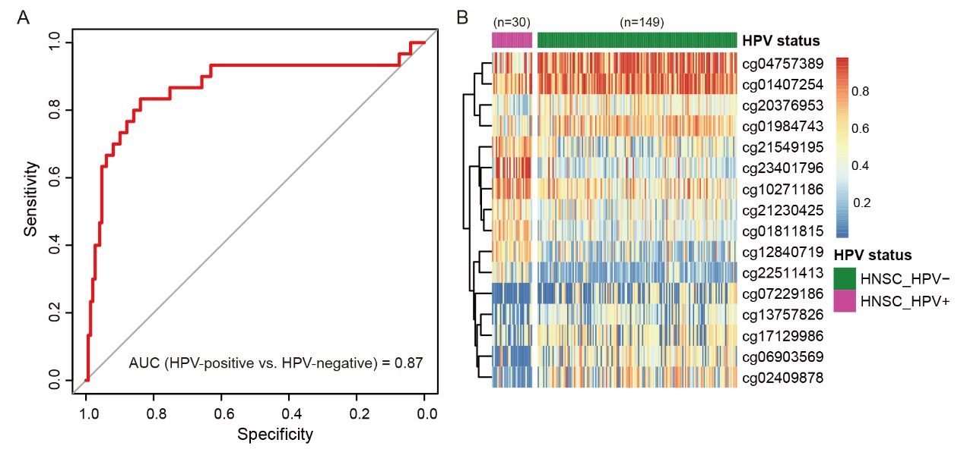
Supplementary Figure 3. Performance of the 16-DNA methylation signature in classifying HPV-positive and HPV-negative HNSCC patients. (A) ROC curve of the methylation signature in the classification of HPV-positive and HPV-negative HNSCC patients. (B) Heatmap for the methylation difference of the selected CpG sites between HPV-positive and HPV-negative patients.

Supplementary Table 1. The ferroptosis-related genes associated with HNSCC survival.
Genes | HR (95% CI for HR) | P-value
Negative components
ENSG00000151012.12 | 1.1 (1-1.2) | 0.041
ENSG00000196139.10 | 1.1 (1-1.1) | 0.031
ENSG00000181019.11 | 1.2 (1.1-1.3) | 0.00054
ENSG00000167996.14 | 1.3 (1.1-1.5) | 0.0027
ENSG00000168003.15 | 1.2 (1-1.4) | 0.033
ENSG00000044574.7 | 1.4 (1.1-1.7) | 0.01
ENSG00000165637.12 | 1.4 (1-1.9) | 0.034
ENSG00000123983.12 | 1.3 (1-1.8) | 0.047
ENSG00000167770.10 | 1.4 (1-1.9) | 0.032
ENSG00000117592.8 | 1.4 (1.1-1.8) | 0.0089
ENSG00000042286.13 | 1.3 (1.1-1.6) | 0.015
ENSG00000105974.10 | 1.1 (1-1.2) | 0.032
ENSG00000161016.14 | 1.2 (1-1.5) | 0.045
ENSG00000160211.14 | 1.1 (1-1.3) | 0.033
ENSG00000057663.11 | 1.8 (1.2-2.5) | 0.0019
ENSG00000126581.11 | 1.5 (1-2.2) | 0.026
ENSG00000034713.6 | 1.5 (1.1-2.1) | 0.019
ENSG00000139112.9 | 1.2 (1-1.4) | 0.025
ENSG00000146648.14 | 1.1 (1-1.2) | 0.044
ENSG00000050748.16 | 1.9 (1.3-2.8) | 0.0024
ENSG00000162409.9 | 1.3 (1.1-1.6) | 0.018
ENSG00000163631.15 | 1.3 (1.1-1.6) | 0.035
ENSG00000198431.14 | 1.1 (1-1.3) | 0.0087
ENSG00000271303.1 | 1.2 (1-1.4) | 0.032
ENSG00000176171.10 | 1.2 (1-1.4) | 0.012
ENSG00000070669.15 | 1.3 (1.1-1.5) | 0.0016
ENSG00000103257.7 | 1.1 (1-1.3) | 0.021
ENSG00000101255.9 | 1.4 (1.2-1.6) | 0.00022
ENSG00000074935.12 | 1.7 (1.1-2.8) | 0.033
ENSG00000136244.10 | 1.1 (1-1.2) | 0.011
ENSG00000059804.14 | 1.3 (1.1-1.5) | 0.00029
ENSG00000128829.10 | 1.4 (1-2) | 0.046
ENSG00000166741.6 | 1.1 (1-1.2) | 0.03
ENSG00000087586.16 | 1.3 (1-1.6) | 0.019
Positive components
ENSG00000168610.13 | 0.79 (0.63-0.99) | 0.041
ENSG00000079999.12 | 0.7 (0.53-0.92) | 0.01
ENSG00000130734.8 | 0.77 (0.6-0.98) | 0.035
ENSG00000101460.11 | 0.85 (0.73-0.99) | 0.029
ENSG00000147889.15 | 0.91 (0.84-0.97) | 0.0046
ENSG00000185338.4 | 0.84 (0.72-0.97) | 0.019
ENSG00000118513.17 | 0.79 (0.64-0.99) | 0.03
ENSG00000163930.8 | 0.58 (0.41-0.83) | 0.003
ENSG00000007171.15 | 0.82 (0.69-0.98) | 0.014
ENSG00000265972.4 | 0.89 (0.81-0.99) | 0.031
ENSG00000139718.9 | 0.69 (0.51-0.95) | 0.024
ENSG00000197442.9 | 0.72 (0.58-0.9) | 0.0032
ENSG00000137275.12 | 0.69 (0.5-0.96) | 0.032

Supplementary Table 2. Univariate cox survival analysis for each site from the 16-DNA methylation signature in HNSCC patients.
CpG sites | HR (95% CI for HR) | P-value
cg21230425 | 0.094 (0.042-0.21) | 4.00E-09
cg20376953 | 4.8 (2.3-10) | 4.60E-05
cg02409878 | 2.8 (1.7-4.7) | 5.40E-05
cg01407254 | 6 (2.3-15) | 9.60E-05
cg01984743 | 3.9 (1.9-8.1) | 9.80E-05
cg13757826 | 3.6 (1.9-7.1) | 0.00011
cg07229186 | 2.5 (1.5-4) | 0.00022
cg10271186 | 0.26 (0.13-0.54) | 0.00025
cg22511413 | 0.26 (0.12-0.56) | 3.00E-04
cg01811815 | 0.24 (0.11-0.53) | 0.00031
cg23401796 | 0.34 (0.18-0.65) | 0.00055
cg06903569 | 2.3 (1.3-3.9) | 0.0025
cg21549195 | 0.42 (0.24-0.76) | 0.0041
cg12840719 | 0.5 (0.28-0.9) | 0.019
cg17129986 | 1.2 (0.73-2.1) | 0.42
cg04757389 | 1 (0.54-2) | 0.88

