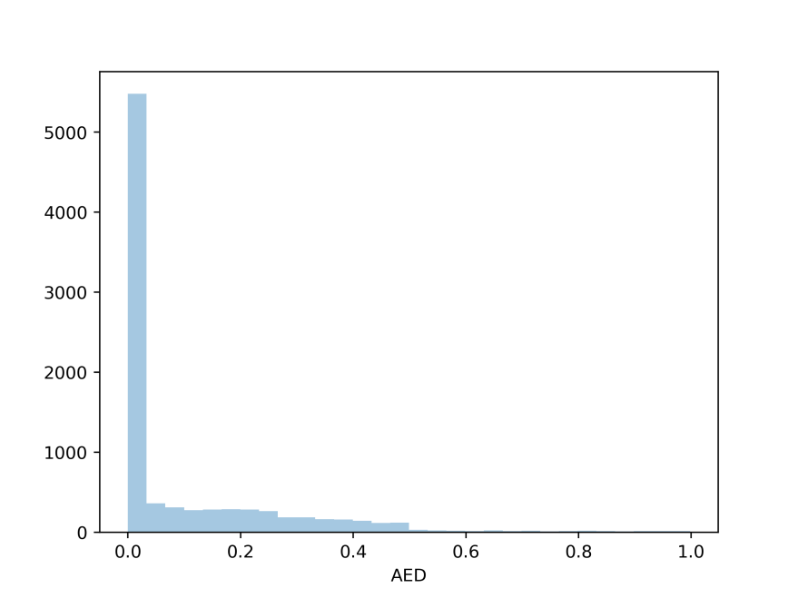
Fig. S1 The distribution of AED index by comparing gene annotation and RNA-seq data alignment.

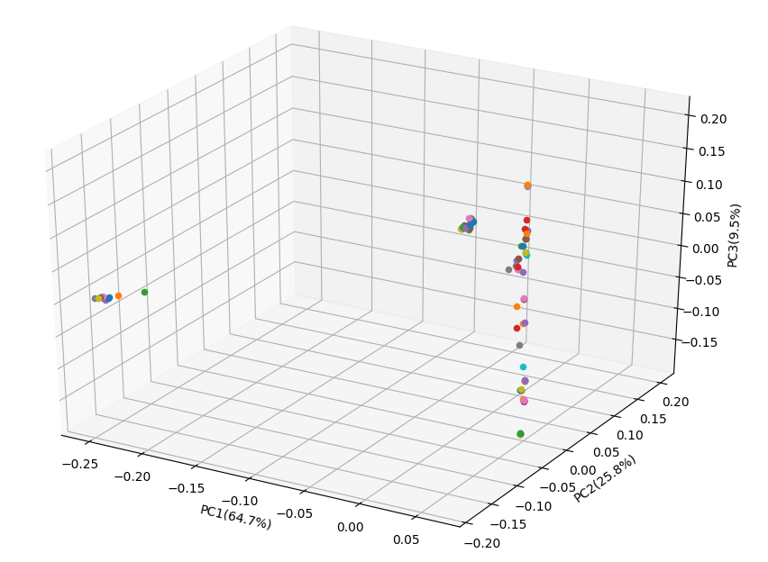
Fig. S2 Top three components in the PCA analysis for population analysis.

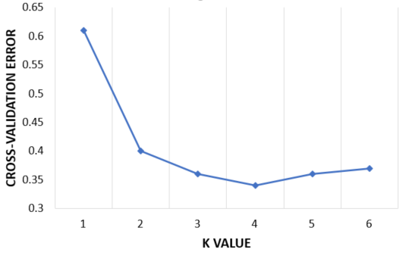
Fig. S3 Cross-validation error for population structure analysis using Admixture for different K values.

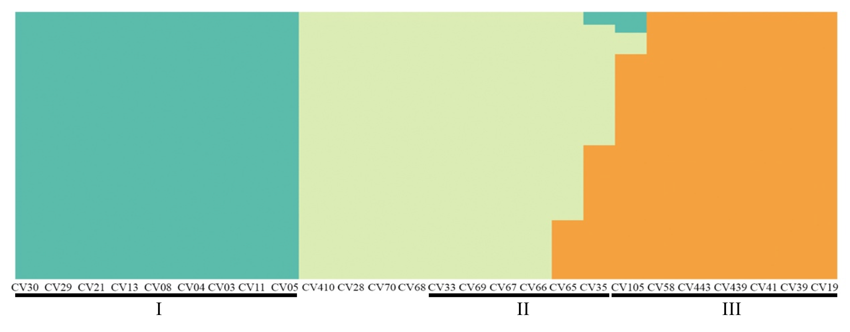
Fig. S4 Population structure analysis of 26 L. edodes cultivars.

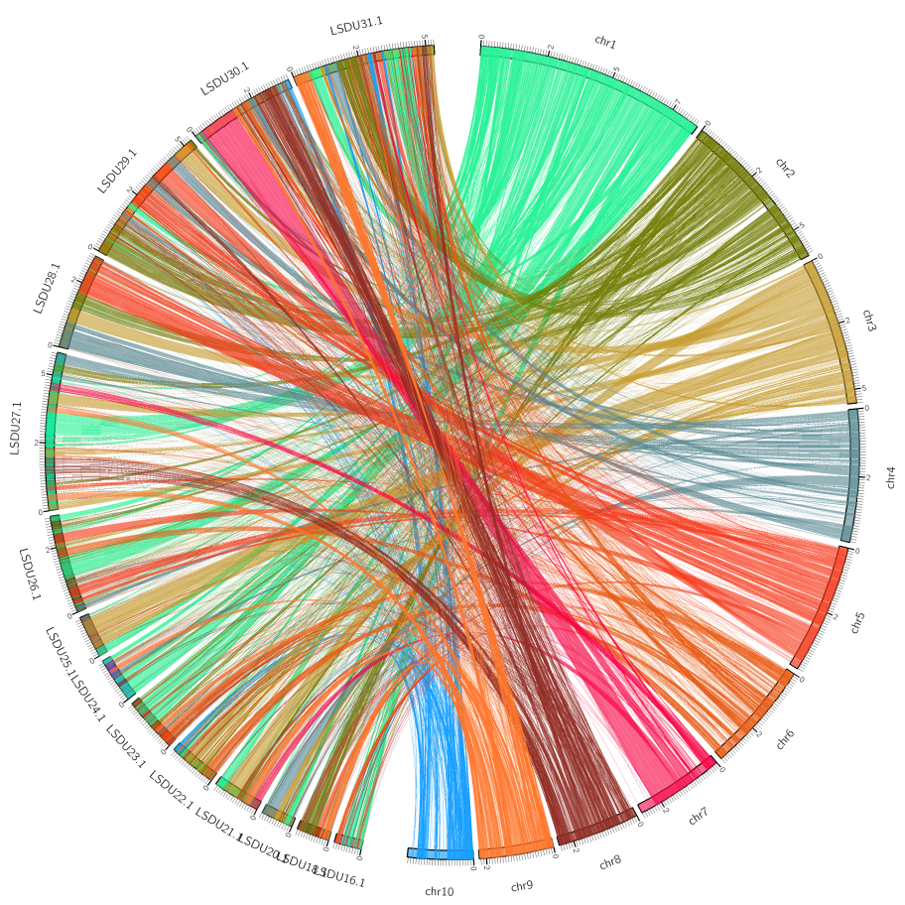
Fig. S5 Collinearity plot of B17 and L808-1 genome. Scoffold length above 1Mb.

