Supplementary Table S1
Overview of TaqMan assays for miRNA qRT-PCR experiments
miRNA | AssayID | Mature sequence
miR-486-5p | 1278 | UCCUGUACUGAGCUGCCCCGAG
pri-miRNA | AssayID | Stem-loop sequence
hsa-miR-486-1 | Hs03303815_pri | GCAUCCUGUACUGAGCUGCCCCGAGGCCCUUCAUGCUGCCCAGCUCGGGGCAGCUCAGUACAGGAUAC
Endogenous control
Assay | AssayID | Control sequence
RNU44 | 1094 | CCTGGATGATGATAGCAAATGCTGACTGAACATGAAGGTCTTAATTAGCTCTAACTGACT
Overview of TaqMan assays for mRNA qRT-PCR experiments
mRNA | AssayID | Transcript variant
ANK1 | Hs00986630_m1 | Variant 1-4
ANK1 | Hs00986660_m1 | Variant 9
ANK1 | Hs00252830_m1 | Variant 5,7,10 (sANK1).
GAPDH | Hs99999905_m1

Supplementary Table S2
Primers used for qualitative Methylation-Specific Polymerase Chain Reaction (MSP) and bisulfite sequencing (BS).

Primer Set | Forward Primer | Reverse Primer | Fragment size | Fragment Location
mir-486 MSP-M | GTAATTTGAGGTTTTTAGGC | ACTAACGAACTCACCGCA | 152 | -128 to +24
mir-486 MSP-U | TTTGTAATTTGTGGTTTTTAGGT | AACTAACAAACTCACCACAAC | 156 | -131 to +25
mir-486 BS | GTGGTTTGATGTTTAATTTTGG | TAACCCCCTCCTAACATCTC | 424 | -261 to +163
Abbreviations: MSP, methylation-specific polymerase chain reaction; BS, bisulfite sequencing; M, methylated-specific primers; U, unmethylated-specific primers; Frg. Size, fragment size (in bases); Fragment location indicates the start and end point (in bases, provided by the USCS Genome Browser) of each fragment relative to the transcription start site of ANK1 variant 1-4 for mir-486.

Primers and probe used for quantitative Methylation-Specific Polymerase Chain Reaction (qMSP).

Assay | Forward Primer | Reverse Primer | Probe | Fragment size
mir-486 | TTAGGCGGGCGTTATTTTTTC | GTACGAACCAAACCCCCGA | TTCGGTTCGATAGTAAGC | 100

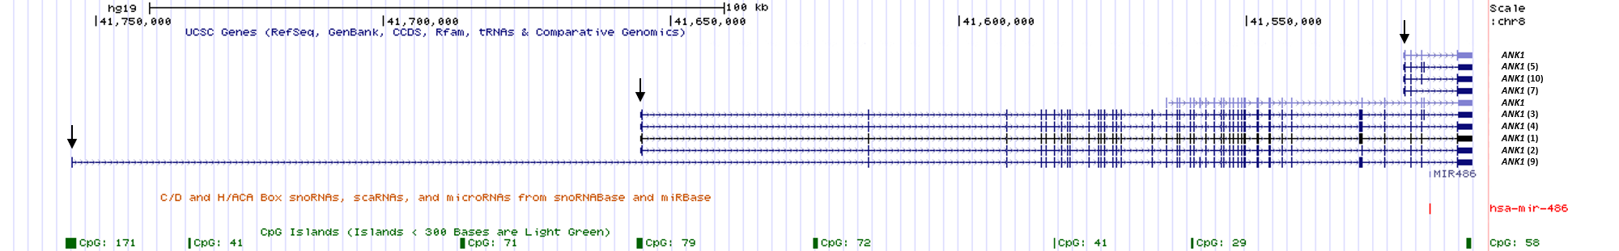
Supplementary Figure S1. Genomic overview of the mir-486/ANK1 locus. Shown is different ANK1 isoforms with TSS (vertical arrow), hsa-miR-486 and the CpG islands in the region. Modified from UCSC Genome Browser NCBI, GRCh37/hg19 assembly.

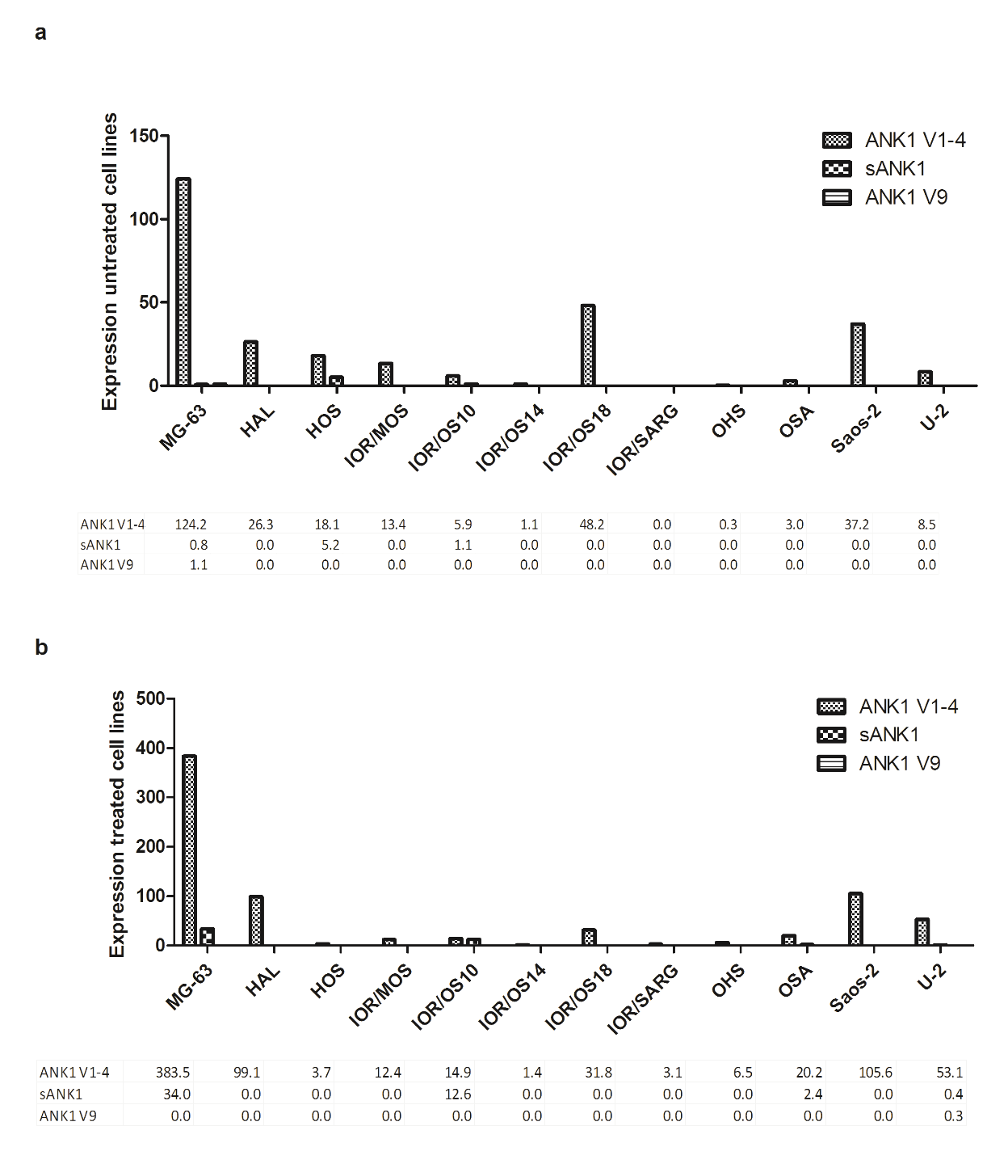
Supplementary Figure S2. Expression of ANK1 transcript variants in untreated and 5-Aza treated osteosarcoma cell lines. Quantification of ANK1 using qRT-PCR in cell lines. a. Expression of untreated cells. b. Expression of 5-Aza treated cells. Expression normalized against GAPDH. Cell lines with undetected expression is set to 0.

 | CGI CpG79  variant 1-4 | CGI CpG171  variant 9
143B | M | U/M
Cal72 | M | U
G-292 | U/M | U
GCT | U/M | U
HAL | M | U
HOS | M | U
IOR/OS9 | U/M | U
IOR/OS10 | M | U
IOR/OS14 | U | U
IOR/OS15 | U/M | U
IOR/OS18 | M | U
IOR/MOS | M | U
IOR/SARG | M | U
KPD | M | U
MG-63 | M | U
MHM | U/M | U
MNNG/HOS | U/M | U
OHS | U/M | U
OSA | M | U
Saos-2 | U/M | U
U2- OS | M | U
ZK58 | U/M | U
 | 21/22 | 1/22

Supplementary Figure S3. Methylation level of miR-486 as assessed by methylation specific PCR (MSP). MSP analyses of the CGI upstream of miR-486, covering the TSS of ANK1 variant 1-4 and ANK1 variant 9. MSP was performed on 21 osteosarcoma cell lines. M, methylated; U/M,: presence of both methylated and unmethylated band; U, unmethylated.

