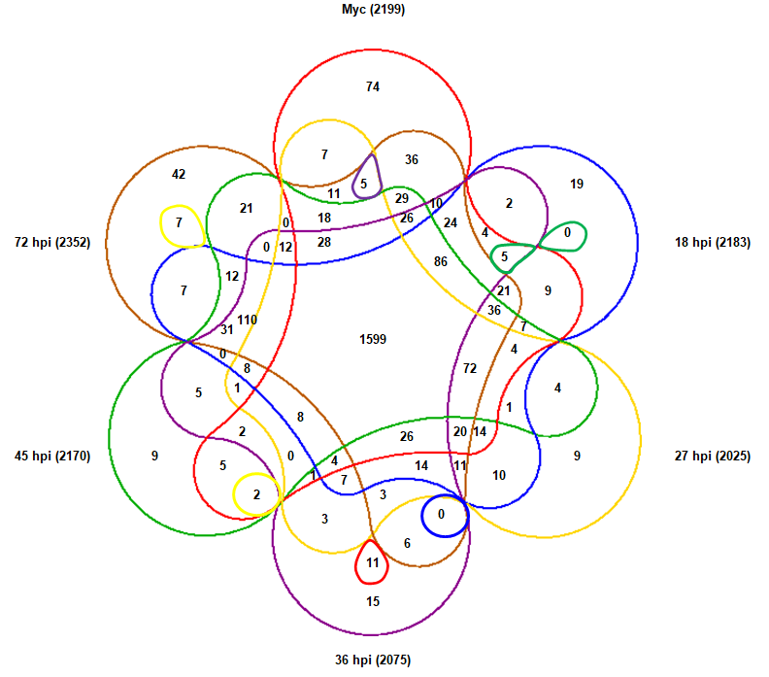

Figure S1. Venn diagram showing the number of lncRNAs expressed among stages.

