Table S1 Primer information of DEGs
Genes | Gene accession number | Sequence of Primers (5’->3’) | Production length (bp) | Annealing Temperature (˚C)
β-actin | L08165.1 | F: GTGTGATGGTTGGTATGGGC | 58 | 225
β-actin | L08165.1 | R: CTCTGTTGGCTTTGGGGTTC | 58 | 225
PDZK1 | XM_416669.6 | F: CCTGCAAAGGCTGCTTCACA | 59 | 193
PDZK1 | XM_416669.6 | R: TGTCTCCATCCTTCAAGCCAG | 59 | 193
PDZK1 | XM_416669.6 | R: GACATGTTGAAGGAGCCGGA | 59 | 193
TFAP2B | NM_204895.1 | F: ATCTATGAGGACCGGCATGA | 58 | 181
TFAP2B | NM_204895.1 | R: GGTCCTGGCTTTGGTGGTAA | 58 | 181
TFAP2A | NM_205094.1 | F: TCAAGTACGAGGAGTGCGAG | 59 | 198
TFAP2A | NM_205094.1 | R: GGGAGTAGGGGTCCTGAGAC | 59 | 198
TFAP2A | NM_205094.1 | R: GAGGCCGGAACGACTCATAG | 59 | 198
MITF | NM_205029 | F: TTTGCTCCCCTGATATGGTC | 60 | 199
MITF | NM_205029 | R: CCCATTTTTGCAGGAACACT | 60 | 199

Table S2. Sequencing data statistics
Sample | Raw data |  | Clean data |  | Clean data Ratio(%) |  | Mapped Ratio(%)
Sample | Sequences | Bases(bp) | Sequences | Bases(bp) | Sequences | Bases | Mapped Ratio(%)
CB1 | 102194018 | 15180818120 | 101788762 | 14926988949 | 99.60 | 98.33 | 78.20
CB2 | 88315022 | 13109664236 | 87980470 | 12890056081 | 99.62 | 98.32 | 75.26
CB3 | 96747288 | 14260647352 | 96424166 | 14045951820 | 99.67 | 98.49 | 75.87
CB4 | 99853030 | 14815112908 | 99456974 | 14565096566 | 99.60 | 98.31 | 77.11
CB5 | 100835344 | 14910265942 | 100720876 | 14815081521 | 99.89 | 99.36 | 78.24
CB6 | 100687630 | 14897999484 | 100521788 | 14768705358 | 99.84 | 99.13 | 74.63
CH1 | 97230718 | 14555042964 | 95176732 | 14492754994 | 97.89 | 99.57 | 76.19
CH2 | 97802812 | 14632196524 | 95747656 | 14569768481 | 97.90 | 99.57 | 76.19
CH3 | 84452768 | 12631301126 | 82828586 | 12584688554 | 98.08 | 99.63 | 75.04
CH4 | 58218954 | 8732843100 | 57383266 | 8677159321 | 98.56 | 99.36 | 89.98
CH5 | 94390790 | 14122530710 | 92476312 | 14066837110 | 97.97 | 99.61 | 73.66
CH6 | 91319058 | 13654637556 | 89706706 | 13608724210 | 98.23 | 98.50 | 76.44
WL1 | 97856240 | 14525908012 | 97684250 | 14410626016 | 99.82 | 99.21 | 74.21
WL2 | 95151322 | 14107366882 | 94965242 | 13975225529 | 99.80 | 99.06 | 73.40
WL3 | 96142946 | 14253678986 | 95779562 | 14027595665 | 99.62 | 98.41 | 73.58
WL4 | 100848914 | 14921316924 | 100455328 | 14672765081 | 99.61 | 98.33 | 73.27
WL5 | 99128668 | 14753507410 | 98684114 | 14497914730 | 99.55 | 98.27 | 74.27
WL6 | 99996776 | 14876479492 | 99546746 | 14609125199 | 99.55 | 98.20 | 74.26
Total | 1701172298  (1701.17 million) | 252941317728  (235.57 Gb) | 1687327536  (1687.33 million) | 250205065185  (233.02 Gb)

Table S3. Composition of the Period I and Period II (g/kg, air dry) diets used in the experiment
Dietary Component | Period I¹ | Period II¹
Maize | 545.0 | 580.0
Soy protein | 190.0 | 167.0
Toasted soybean | 140.0 | 80.0
Fish meal | 35.0 | 20.0
Wheat bran | 30.0 | 100.0
Soya oil | 25.0 | 18.0
CaHPO₄·2H₂O | 12.4 | 12.4
Stone meal | 11.7 | 11.5
Lysine | 2.2 | 2.2
Methionine | 1.6 | 1.6
Salt | 2.1 | 2.3
Minerals and vitamins mix² | 5.0 | 5.0
Metabolism Energy（MJ/Kg） | 12.8 | 12.6
Crude protein (CP) | 205.5 | 183.5
Crude fat | 54.1 | 56.5
Calcium | 10.5 | 9.8
Available phosphorus | 6.8 | 6.5
Lysine | 13.5 | 12.1
Methionine + Cysteine | 8.8 | 7.8
1: Period I is age 1-30 days; Period II is older than 30 days of age; 2: Supplied per kilogram of diet: antioxidant, 100 mg; biotin, 0.3 mg; vitamin A, 12,000 IU; vitamin D3, 3000 IU; vitamin E, 18.75 mg; vitamin K3, 2.65 mg; vitamin C, 12.6 mg; cyanocobalamin, 0.025 mg; folic acid, 2.2 mg; niacin, 35 mg; pyridoxine, 6 mg; riboflavin, 9 mg; thiamine, 3.0 mg; choline chloride, 600 mg; Co, 0.3 mg; Cu, 12 mg; Fe, 50 mg; I, 1 mg; Mn, 125 mg; Mo, 0.5 mg; Se, 200 μg; Zn, 60 mg.

Normalization of the gene count matrix

The code is (for CH vs CB):
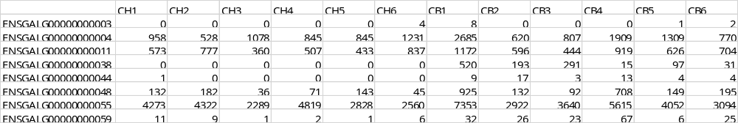

Specific values: Sample: factor(c(rep("CH1",1), rep("CH2",1), rep("CH3",1), rep("CH4",1), rep("CH5",1), rep("CH6",1), rep("CB1",1), rep("CB2",1), rep("CB3",1), rep("CB4",1), rep("CB5",1), rep("CB6",1))); Condition: factor(c(rep("CH", 6), rep("CB", 6))); Sample Table: data.frame(Sample = as.factor(Sample), Condition = as.factor(Condition)); Row names: (sampleTable) = colnames(raw.deseq.data); deseq: DESeqDataSetFromMatrix(countData = raw.deseq.data, colData = sampleTable, design = ~Condition); deseq: deseq[ rowSums (counts(deseq)) > 1, ]; d.deseq: DESeq(deseq); dds.sizefactor: estimateSizeFactors(d.deseq);
sizeFactors(dds.sizefactor)

Metabolomics analysis

PLS-DA model
Table 1. Evaluation parameters of PLS-DA model for positive ion mode
Group | R2X(cum) | R2Y(cum) | Q2(cum)
WL_vs_CB | 0.313 | 0.961 | 0.126
WL_vs_CH | 0.481 | 0.991 | 0.815
CH_vs_CB | 0.393 | 0.95 | 0.663

Note: R2X represents the interpretation rate of X variable by the model, R2Y represents the explanatory rate of the model for Y variable, and Q2 represents the predictive power of the model; cum = cumulative.

Table 2. Evaluation parameters of PLS-DA model for negative ion mode
Group | R2X(cum) | R2Y(cum) | Q2(cum)
WL_vs_CB | 0.385 | 0.932 | 0.547
WL_vs_CH | 0.548 | 0.999 | 0.743
CH_vs_CB | 0.337 | 0.972 | 0.276

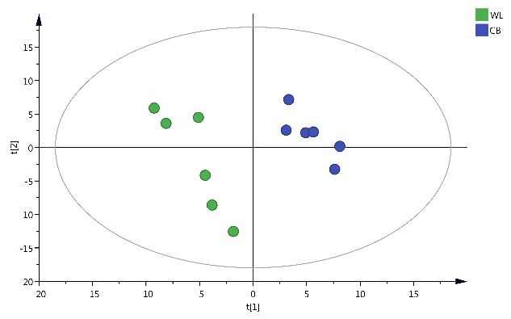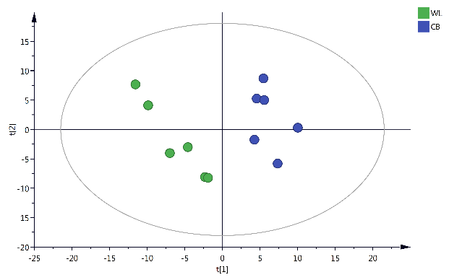
A1. PLS-DA score plots of positive ion mode in WL vs CB A2. PLS-DA score plots of NEG mode in WL vs CB

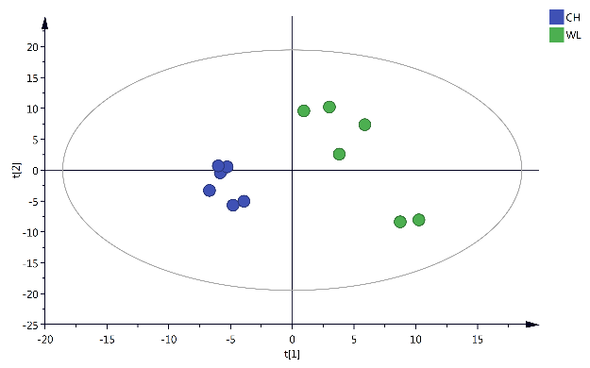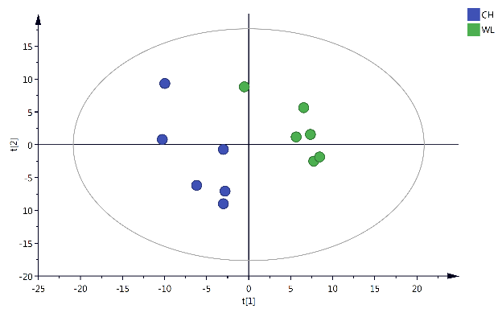
B1. PLS-DA score plots of POS mode in WL vs CH B2. PLS-DA score plots of NEG mode in WL vs CH

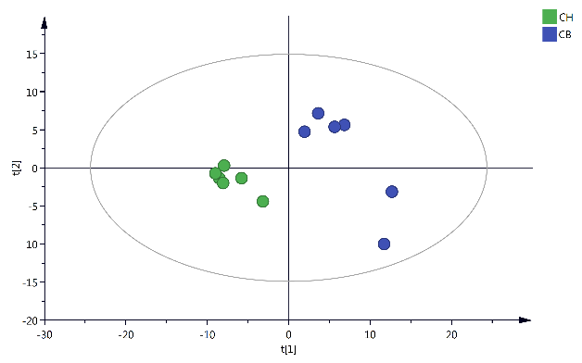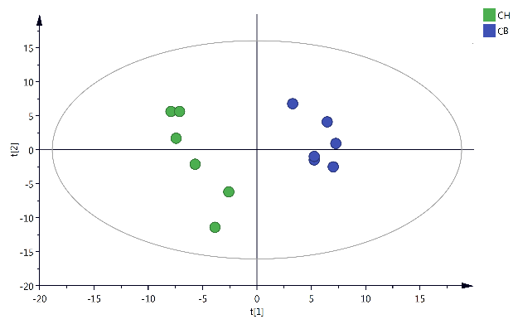
C1. PLS-DA score plots of POS mode in CH vs CB C2. PLS-DA score plots of NEG mode in CH vs CB

Figure 1. PLS-DA score plots of positive ion mode (POS mode) and negative ion mode (NEG mode) in different groups and comparisons.

OPLS-DA model
Table 3. Evaluation parameters of OPLS-DA model for positive ion mode
Group | R2X(cum) | R2Y(cum) | Q2(cum) | R2_{intercept} | Q2_{intercept}
WL_vs_CB | 0.313 | 0.961 | 0.329 | 0.934 | -0.114
WL_vs_CH | 0.799 | 1 | 0.728 | 1 | 0.279
CH_vs_CB | 0.393 | 0.95 | 0.673 | 0.906 | -0.221

Note: R2X represents the interpretation rate of the X variable by the model, R2Y represents the explanatory rate of the model for the Y variable, and Q2 represents the predictive power of the model. R2_{Intercept} and Q2_{Intercept} represents the intercepts of R2 and Q2 regression lines to the Y-axis.

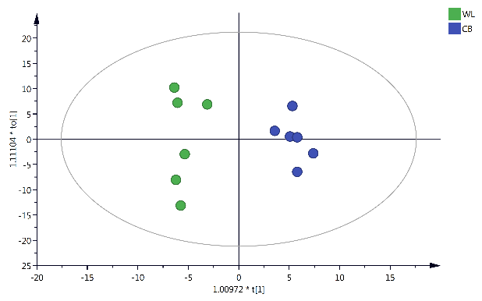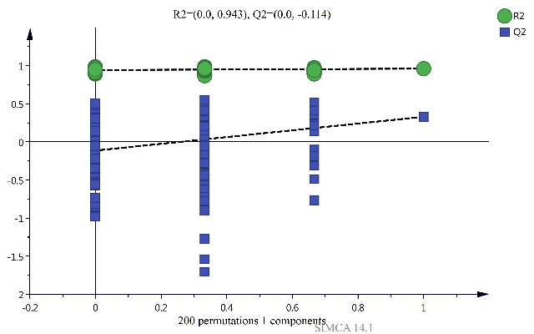 A1. OPLS-DA score plots of POS mode in WL vs CB A2. OPLS-DA permutation test for POS mode in WL vs CB

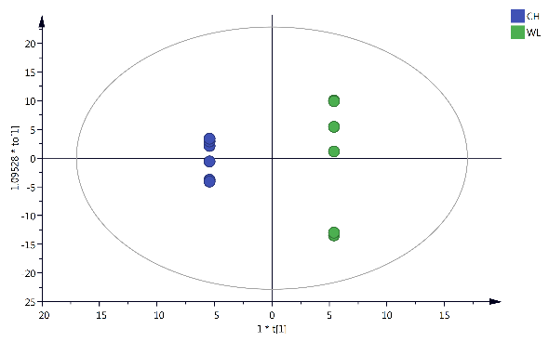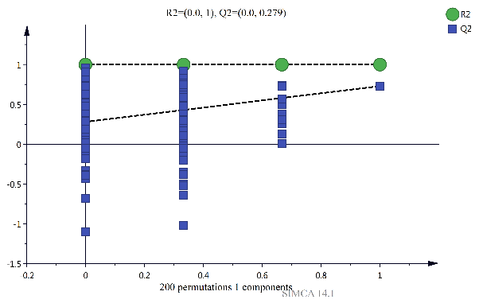
B1. OPLS-DA score plots of POS mode in WL vs CH B2. OPLS-DA permutation test for POS mode in WL vs CH

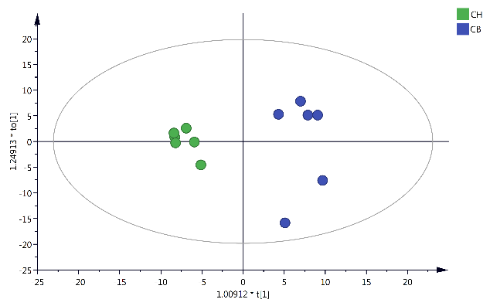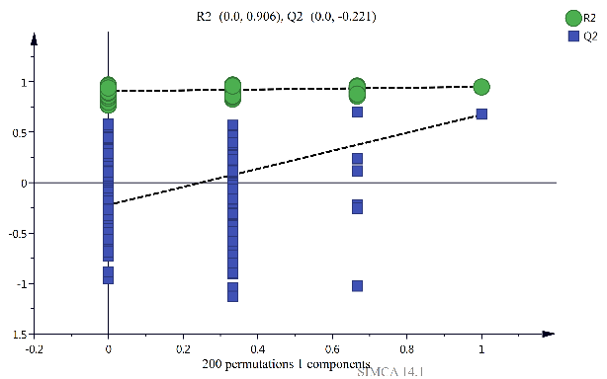
C1. OPLS-DA score plots of POS mode in CH vs CB C2. OPLS-DA permutation test for POS mode in CH vs CB

Figure 2. OPLS-DA score plots and permutation tests for the positive ion mode (POS mode) in different groups and comparisons

Table 4. Evaluation parameters of OPLS-DA model for negative ion mode
Group | R2X(cum) | R2Y(cum) | Q2(cum) | R2_{intercept} | Q2_{intercept}
WL_vs_CB | 0.773 | 1 | 0.655 | 1 | 0.255
WL_vs_CH | 0.366 | 0.924 | 0.422 | 0.935 | -0.121
CH_vs_CB | 0.337 | 0.972 | 0.584 | 0.915 | -0.234

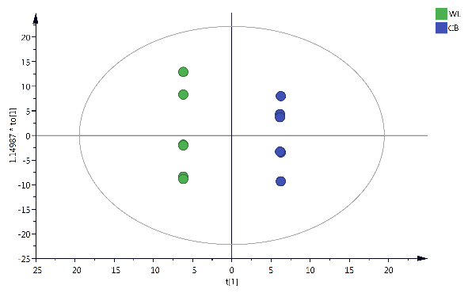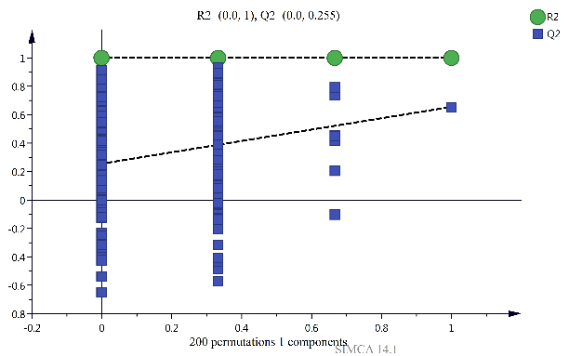
A1. OPLS-DA score plots of NEG mode in WL vs CB A2. OPLS-DA permutation test for NEG mode in WL vs CB

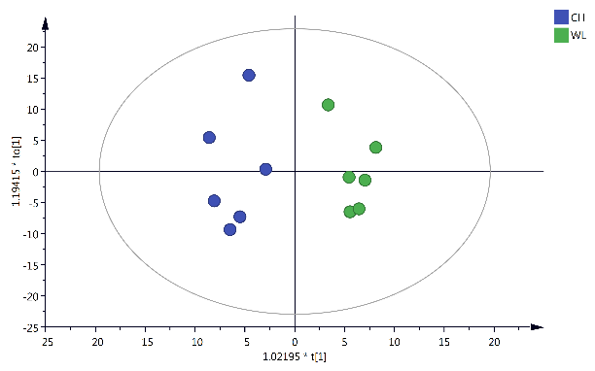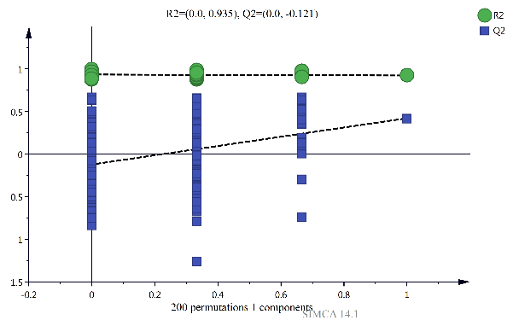
B1. OPLS-DA score plots of NEG mode in WL vs CH B2. OPLS-DA permutation test for NEG mode in WL vs CH

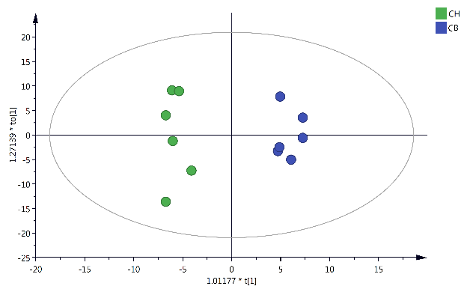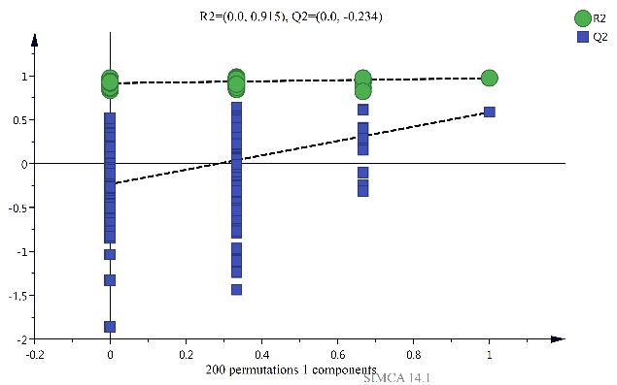
C1. OPLS-DA score plots of NEG mode in CH vs CB C2. OPLS-DA permutation test for NEG mode in CH vs CB

Figure 3. OPLS-DA score plots and permutation tests for negative ion mode (NEG mode) in different group

