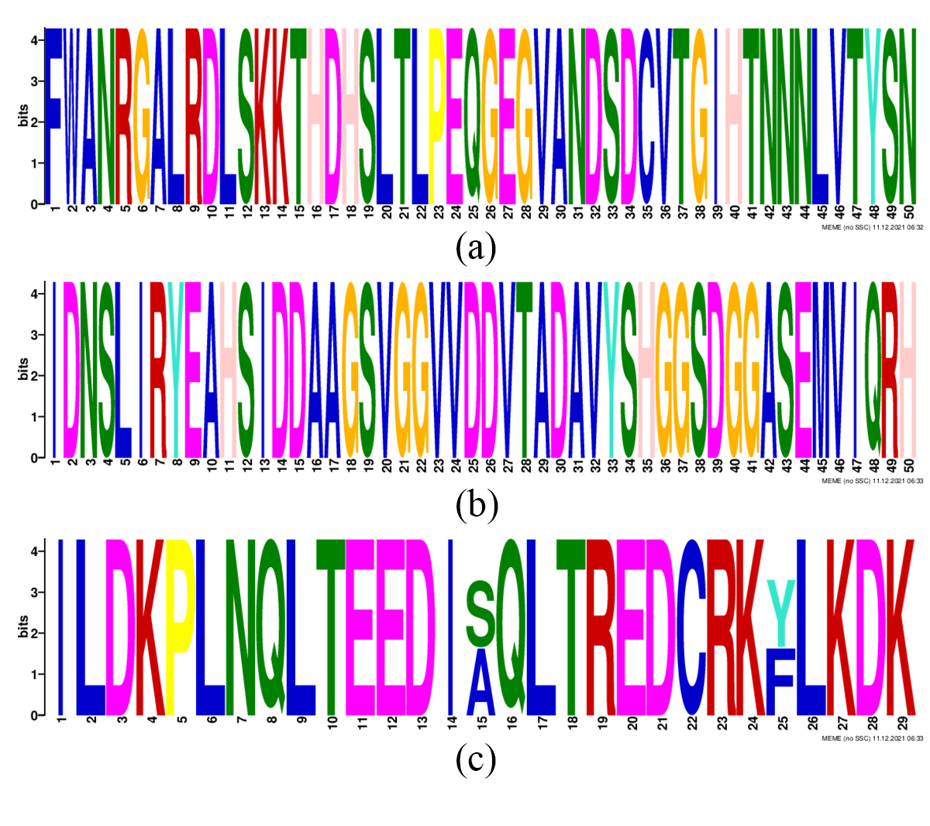
Supplemental Figure 1. Highly conserved motifs of JrTIFYs. (a) The Weblogo of motif7. (b) The Weblogo of motif9. (c) The Weblogo of motif15.

