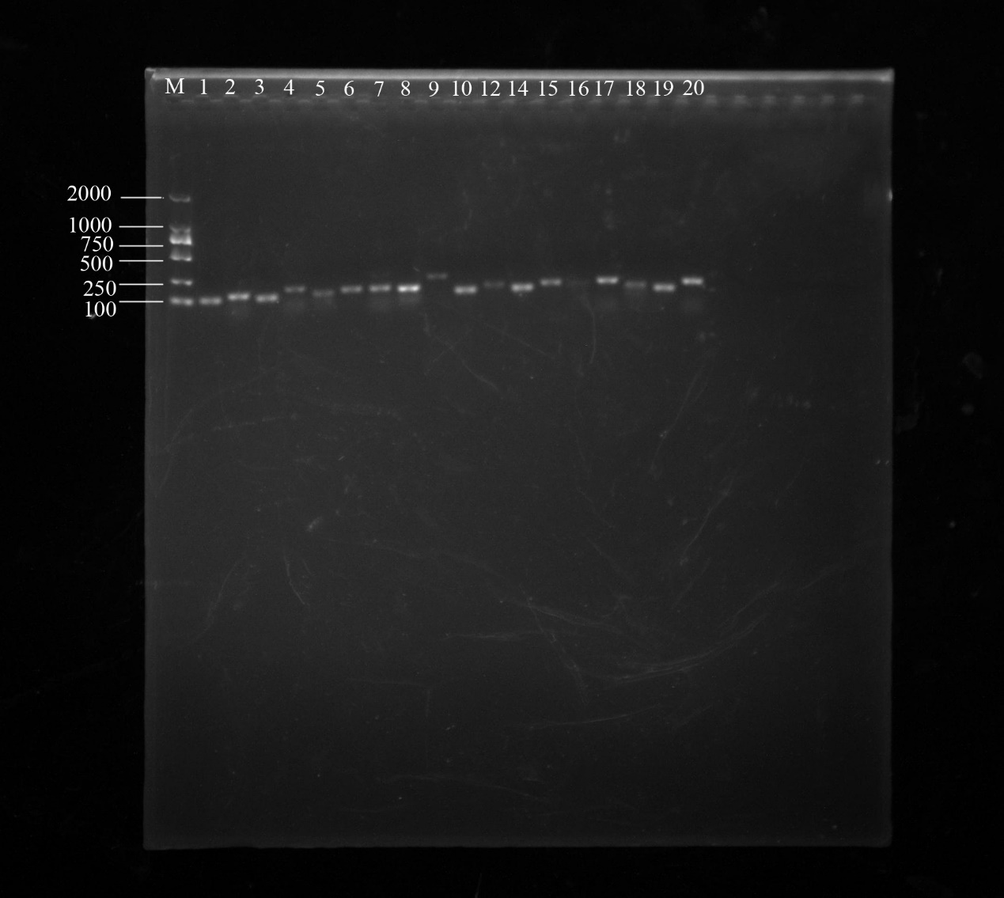
(A)
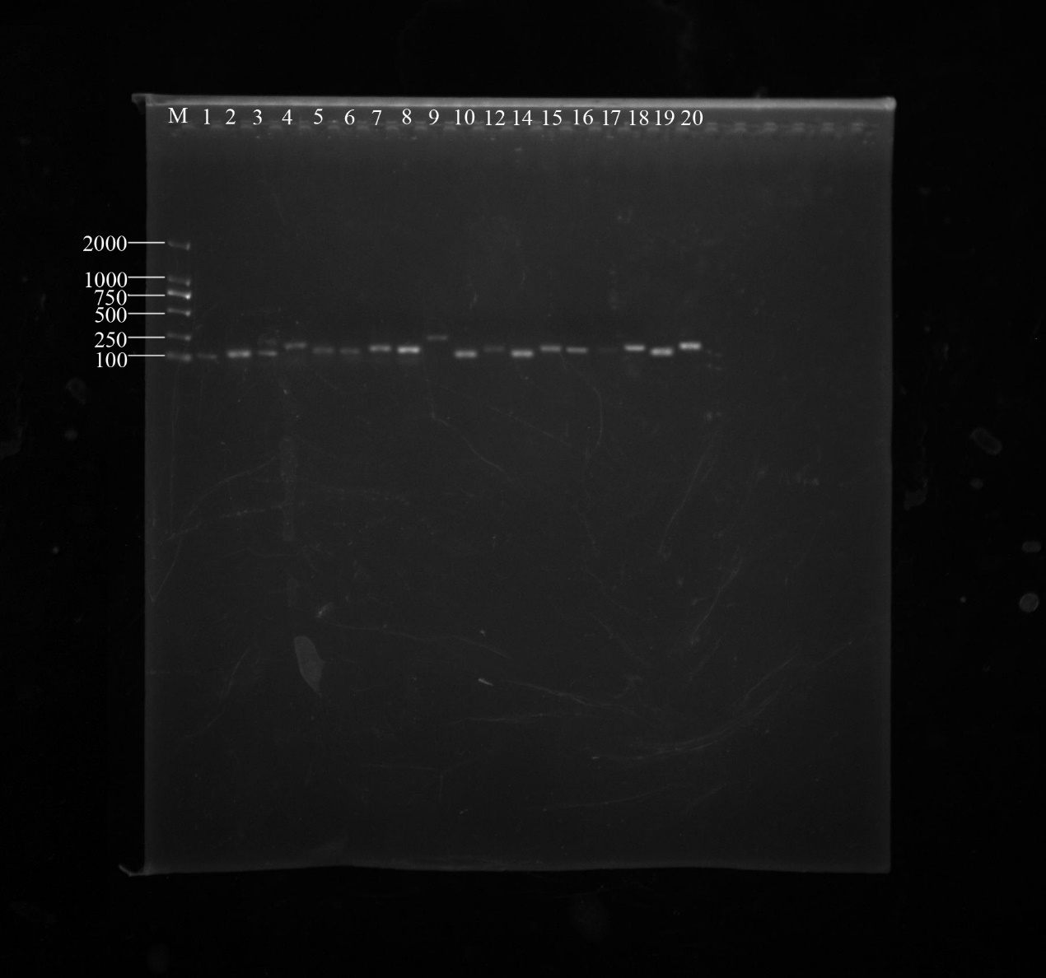
(B)
Supplemental Figure 2. PCR analysis of JrTIFY in ‘Qingxiang’ and ‘Xianging’. M: DL Marker2000. (A) 01-20: JrTIFY01-JrTIFY20 in ‘Qingxiang’. (B) 01-20: JrTIFY01-JrTIFY20 in ‘Xiangling’.

