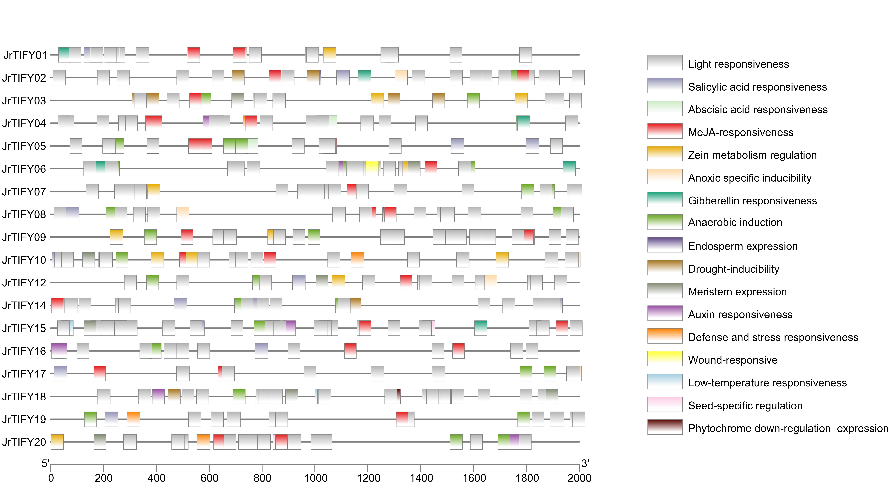
Supplemental Figure 3. Promoter element of JrTIFYs genes about Fig. 6. All promoter elements are shown in the diagram.

