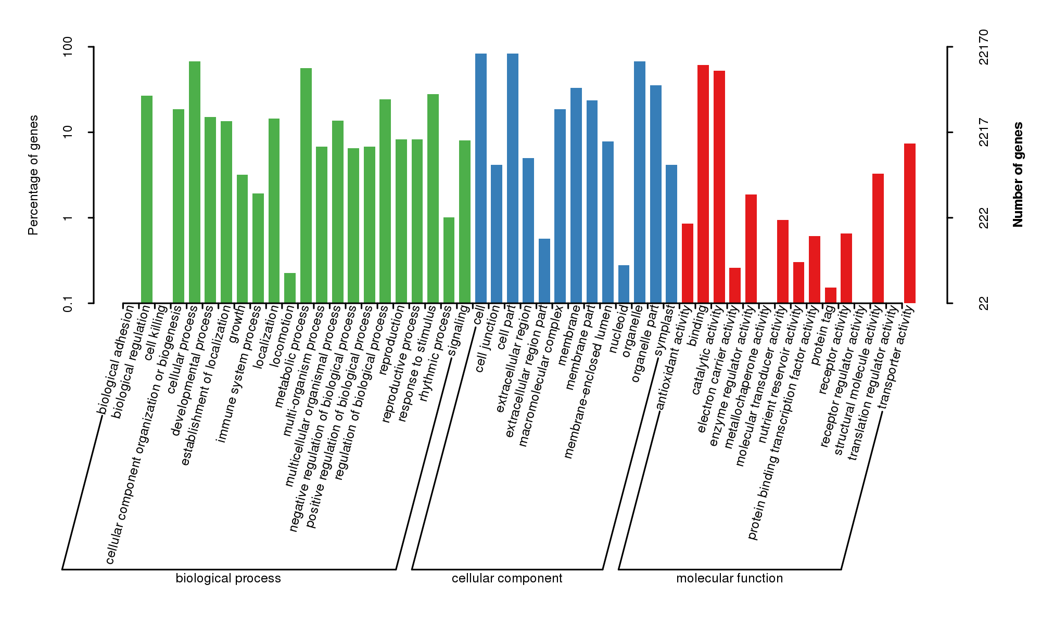
Figure S5 GO function annotation of P. cyrtonema transcriptome.

