Supplementary figures and tables

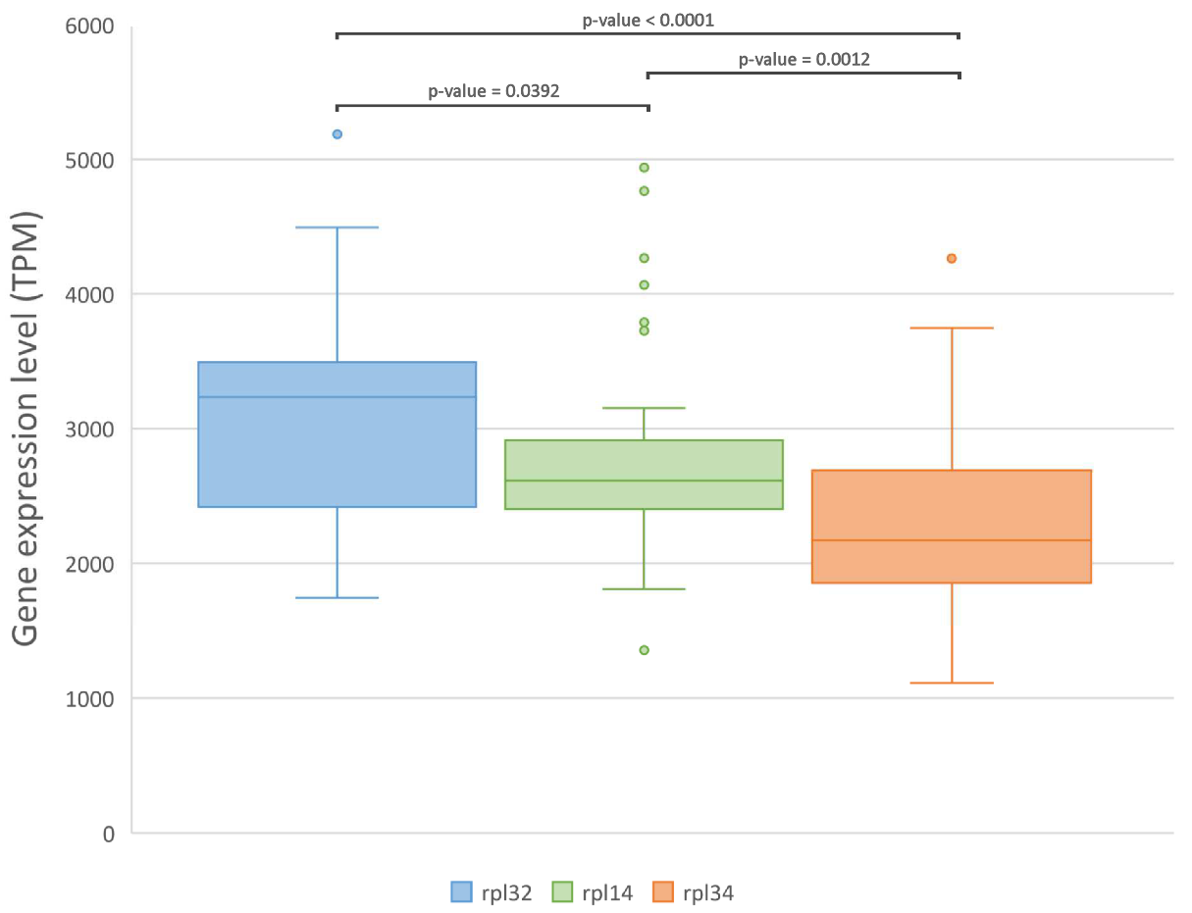
Figure S1 Expression levels of rpl32, rpl14 and rpl34 genes across 51 RNA-seq datasets. Gene expression levels are shown as Transcripts Per Million (TPM). The graphs indicate the median and interquartile ranges. The p-values resulting from pairwise comparisons of gene expression levels among the three genes (based on an unpaired T-test) are indicated.

Figure S2 RT-qPCR cycle threshold (Ct) values of candidate reference genes among different tissues. Ct distribution values of rpl14, rpl32, rpl34, 18S, 28S, act, cyp, ef1α, gapdh and rps4 from Gilles, Digestive Gland, Gonads, Mantle, Foot of M. galloprovincialis. The distribution is shown by vertical box plot as medians (lines), interquartile range (boxes) and ranges (whiskers).
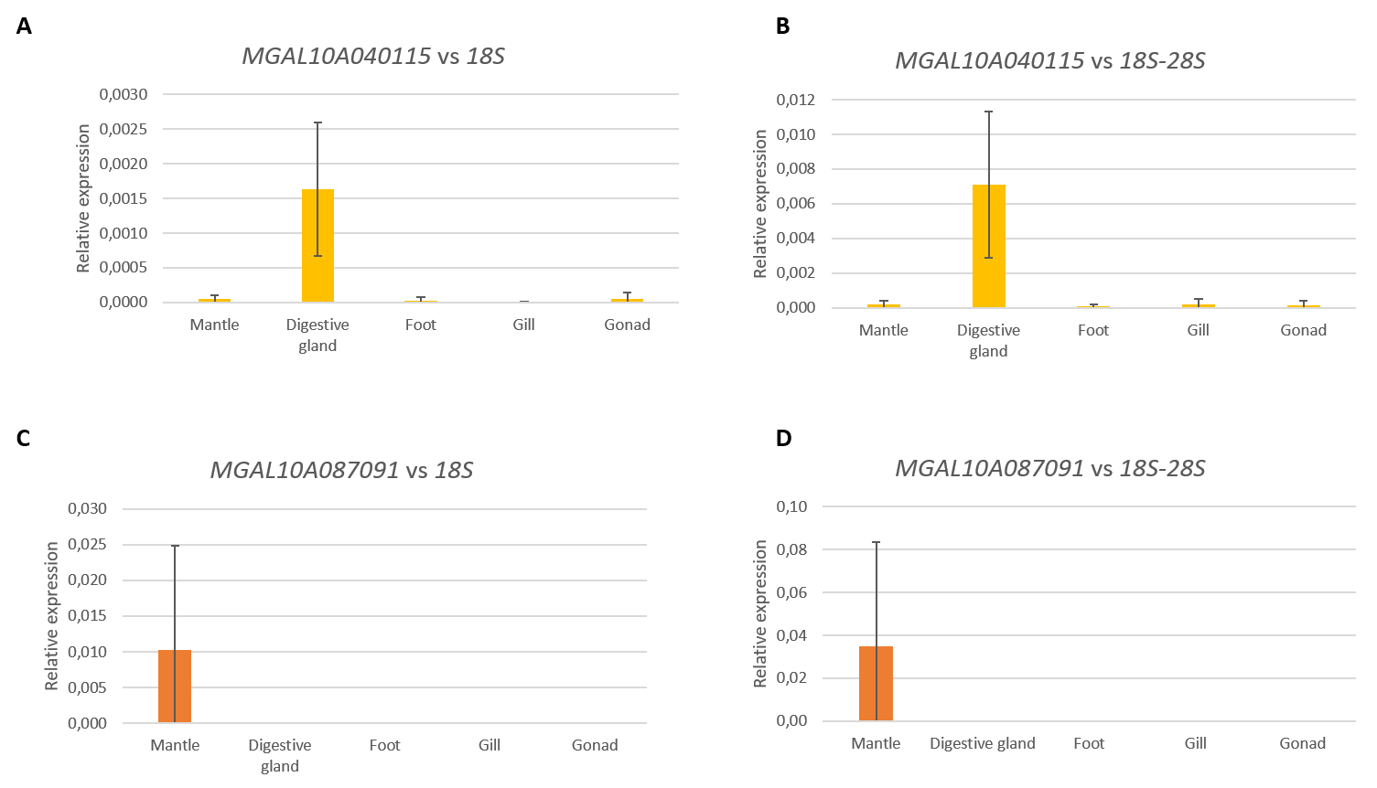
Figure S3 Relative expression of GOI using not the worst ranked candidate reference genes. Relative expression was calculate according to the ΔCt methods using 18S (A,C) or the Geometric mean of 18S-28S (B,D) as reference. N=3.

Table S1 Summary of results for the most stable candidate reference genes in the gill.
Rank | geNorm: mean M value |  | NormFinder: stability value |  | BestKeeper: SD
GL
1 | Rps4 | 0.071 | Act | 0.006 | Rpl34 | 0.52
2 | Act | 0.072 | Cyp-A | 0.006 | Rpl14 | 0.53
3 | Cyp-A | 0.072 | Ef1a | 0.021 | Gapdh | 0.60
4 | Rpl14 | 0.073 | Rps4 | 0.031 | Rpl32 | 0.68
5 | Rpl32 | 0.074 | Rpl14 | 0.035 | Rps4 | 0.74
6 | Gapdh | 0.078 | Rpl32 | 0.038 | Cyp-A | 0.99
7 | Rpl34 | 0.082 | Gapdh | 0.045 | Act | 1.02
8 | Ef1a | 0.097 | Rpl34 | 0.050 | 28S | 1.51
9 | 28S | 0.132 | 28S | 0.067 | Ef1a | 1.60
10 | 18S | 0.255 | 18S | 0.175 | 18S | 2.69
Candidate reference genes for normalization were identified according to BestKeeper (Pfaffl et al., 2004), geNorm (Vandesompele et al., 2002) and NormFinder (Andersen et al., 2004). Values within the recommended thresholds are in bold. Black rectangles highlight the best combination of genes for each tissue according to geNorm (Vandesompele et al., 2002).

Table S2 Summary of results for the most stable candidate reference genes in the digestive gland.
Rank | geNorm: mean M value |  | NormFinder: stability value |  | BestKeeper: SD
DG
1 | Gapdh | 0.054 | Gapdh | 0.006 | Cyp-A | 0.79
2 | Rps4 | 0.054 | Cyp-A | 0.007 | Rpl34 | 0.80
3 | Rpl14 | 0.056 | Rps4 | 0.013 | 18S | 0.92
4 | Cyp-A | 0.057 | Rpl34 | 0.014 | Rps4 | 1.00
5 | Rpl34 | 0.059 | Rpl14 | 0.019 | Gapdh | 1.03
6 | Act | 0.077 | Act | 0.038 | Rpl32 | 1.03
7 | Rpl32 | 0.078 | Rpl32 | 0.043 | Rpl14 | 1.08
8 | Ef1a | 0.084 | Ef1a | 0.049 | 28S | 1.28
9 | 28S | 0.127 | 28S | 0.082 | Act | 1.45
10 | 18S | 0.134 | 18S | 0.089 | Ef1a | 1.54
Candidate reference genes for normalization were identified according to BestKeeper (Pfaffl et al., 2004), geNorm (Vandesompele et al., 2002) and NormFinder (Andersen et al., 2004). Values within the recommended thresholds are in bold. Black rectangles highlight the best combination of genes for each tissue according to geNorm (Vandesompele et al., 2002).

Table S3 Summary of results for the most stable candidate reference genes in the mantle.
Rank | geNorm: mean M value |  | NormFinder: stability value |  | BestKeeper: SD
M
1 | Cyp-A | 0.095 | Act | 0.018 | Cyp-A | 0.28
2 | Rps4 | 0.099 | Rpl34 | 0.036 | Rps4 | 0.29
3 | Rpl14 | 0.103 | Cyp-A | 0.041 | Rpl32 | 0.34
4 | Rpl32 | 0.104 | Ef1a | 0.044 | Rpl14 | 0.50
5 | Act | 0.105 | Gapdh | 0.045 | Rpl34 | 0.50
6 | Ef1a | 0.11 | Rps4 | 0.047 | Ef1a | 0.60
7 | Rpl34 | 0.111 | Rpl32 | 0.050 | Act | 0.82
8 | Gapdh | 0.114 | Rpl14 | 0.055 | Gapdh | 1.20
9 | 18S | 0.193 | 18S | 0.113 | 18S | 1.67
10 | 28S | 0.278 | 28S | 0.189 | 28S | 3.28
Candidate reference genes for normalization were identified according to BestKeeper (Pfaffl et al., 2004), geNorm (Vandesompele et al., 2002) and NormFinder (Andersen et al., 2004). Values within the recommended thresholds are in bold. Black rectangles highlight the best combination of genes for each tissue according to geNorm (Vandesompele et al., 2002).

Table S4 Summary of results for the most stable candidate reference genes in the gonad.
Rank | geNorm: mean M value |  | NormFinder: stability value |  | BestKeeper: SD
GO
1 | Gapdh | 0.119 | Rps4 | 0.007 | Rpl34 | 0.19
2 | Cyp-A | 0.122 | Act | 0.017 | Rpl14 | 0.53
3 | Rpl14 | 0.128 | Cyp-A | 0.028 | Gapdh | 0.89
4 | Rps4 | 0.129 | Gapdh | 0.035 | Cyp-A | 1.02
5 | Rpl34 | 0.140 | Rpl14 | 0.058 | Rpl32 | 1.06
6 | Act | 0.143 | Rpl34 | 0.065 | Ef1a | 1.10
7 | Ef1a | 0.157 | Ef1a | 0.085 | Rps4 | 1.25
8 | Rpl32 | 0.158 | Rpl32 | 0.093 | Act | 1.49
9 | 18S | 0.289 | 18S | 0.191 | 18S | 2.93
10 | 28S | 0.296 | 28S | 0.198 | 28S | 3.24
Candidate reference genes for normalization were identified according to BestKeeper (Pfaffl et al., 2004), geNorm (Vandesompele et al., 2002) and NormFinder (Andersen et al., 2004). Values within the recommended thresholds are in bold. Black rectangles highlight the best combination of genes for each tissue according to geNorm (Vandesompele et al., 2002).

Table S5 Summary of results for the most stable candidate reference genes in the foot.
Rank | geNorm: mean M value |  | NormFinder: stability value |  | BestKeeper: SD
F
1 | Gapdh | 0.097 | Act | 0.025 | Cyp-A | 0.10
2 | Rpl14 | 0.098 | Cyp-A | 0.026 | Rpl14 | 0.25
3 | Rpl32 | 0.098 | Gapdh | 0.031 | Rpl32 | 0.29
4 | Cyp-A | 0.101 | Rpl32 | 0.040 | Rpl34 | 0.37
5 | Rps4 | 0.102 | Rpl14 | 0.045 | Gapdh | 0.42
6 | Rpl34 | 0.111 | Rps4 | 0.050 | Rps4 | 0.48
7 | Ef1a | 0.115 | Ef1a | 0.058 | Ef1a | 0.70
8 | Act | 0.127 | Rpl34 | 0.059 | Act | 1.29
9 | 28S | 0.255 | 28S | 0.157 | 28S | 2.78
10 | 18S | 0.336 | 18S | 0.227 | 18S | 3.00
Candidate reference genes for normalization were identified according to BestKeeper (Pfaffl et al., 2004), geNorm (Vandesompele et al., 2002) and NormFinder (Andersen et al., 2004). Values within the recommended thresholds are in bold. Black rectangles highlight the best combination of genes for each tissue according to geNorm (Vandesompele et al., 2002).

Table S6 List of SRA accession IDs of the RNA-seq experiments analyzed in this study.
SRA Accession | Tissue
SRX126945 | digestive gland
SRX126946 | digestive gland
SRX126947 | digestive gland
SRX126948 | digestive gland
SRX126949 | digestive gland
SRX126950 | digestive gland
SRX3198556 | whole body
SRX565225 | whole body
SRX565226 | whole body
SRX565227 | whole body
SRX565228 | whole body
SRX565229 | whole body
SRX565230 | whole body
SRX386628 | hemocytes
SRX389338 | hemocytes
SRX389462 | mantle
SRX389463 | mantle
SRX389464 | posterior adductor muscle
SRX389465 | posterior adductor muscle
SRX389466 | gills
SRR2392495 | anterior mantle
SRR2392762 | mid mantle
SRR2409049 | posterior mantle
ERR4296980 | digestive gland
ERR4296979 | gills
SRX4059480 | hemocytes
SRX4059481 | hemocytes
SRX4059482 | hemocytes
SRX4059483 | hemocytes
SRX4059484 | hemocytes
SRX4059485 | hemocytes
SRX4059486 | hemocytes
SRX4059487 | hemocytes
SRX4059488 | hemocytes
SRX4059489 | hemocytes
SRX4059490 | hemocytes
SRX4059491 | hemocytes
SRX4059492 | hemocytes
SRX4059493 | hemocytes
SRX4059494 | hemocytes
SRX4059495 | hemocytes
SRX4059496 | hemocytes
SRX4059497 | hemocytes
SRX4059498 | hemocytes
SRX4059499 | hemocytes
SRX4059500 | hemocytes
SRX4059501 | hemocytes
SRX4059502 | hemocytes
SRX4059503 | hemocytes

