Supplementary Figures
Identification of condition-specific regulatory mechanisms in normal and cancerous human lung tissue

Yuqing Hang¹, Josh Burns², Benjamin T. Shealy³, Stephen P. Ficklin², and Frank A. Feltus^{1,4,5}

¹Clemson University Department of Genetics & Biochemistry 29634 USA
²Washington State University, Department of Horticulture 99164 USA
³Clemson University Department of Electrical and Computer Engineering 29634 USA
⁴Clemson University Biomedical Data Science and Informatics Program 29634 USA
⁵Clemson University Center for Human Genetics 29634 USA

*Corresponding Author. Email: ffeltus@clemson.edu

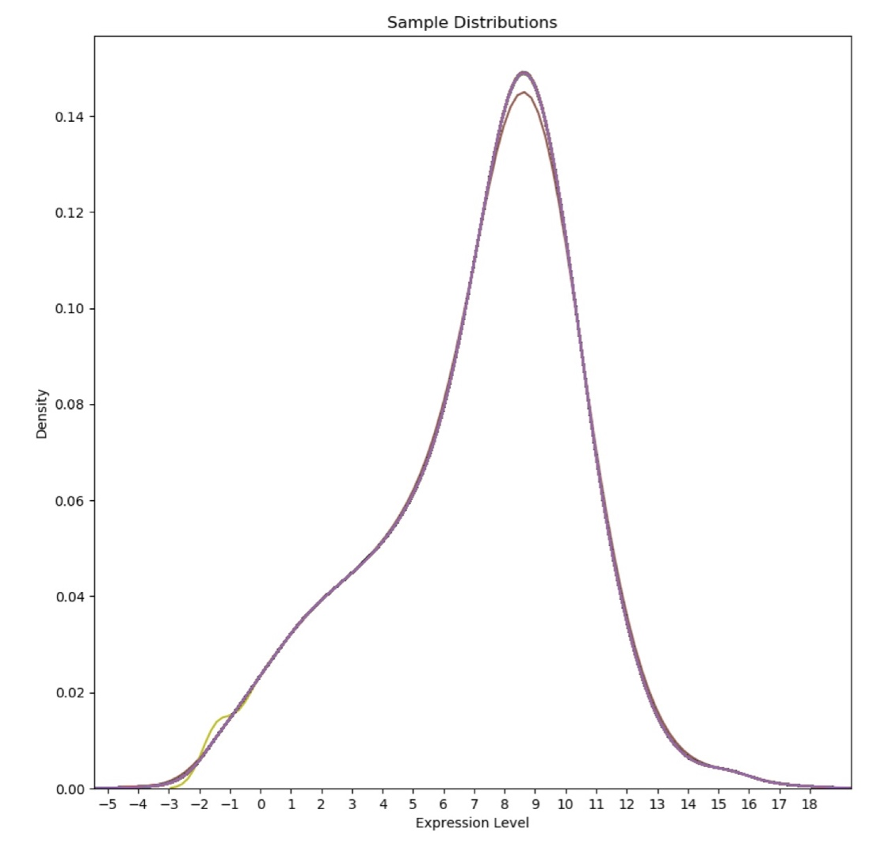
Supplemental Figure 1. Unified Lung Matrix Sample Distribution Plot. The combined lung GEM was log base 2 transformed and quantile normalized. Different color lines represent samples that have slightly different distribution. X-axis represents log base 2 transformed gene expression values, and y-axis represents the corresponding density.

Supplemental Figure 2. Unified Lung Sample Stage Distribution. Dark blue indicates not reported samples; Orange indicates lung cancer Stage I condition; Gray indicates lung cancer Stage II condition; Yellow indicates lung cancer Stage III condition; light blue indicates lung cancer Stage IV condition; and green indicates GTEx normal samples.

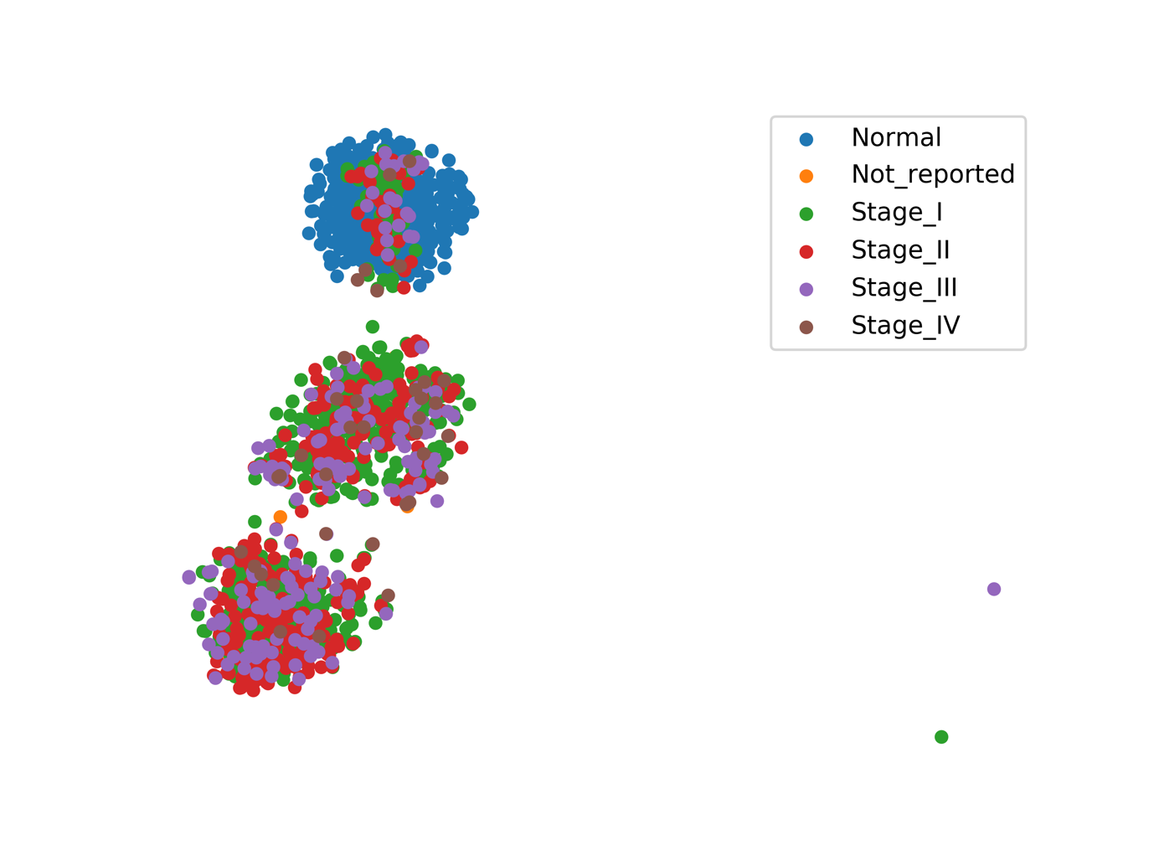
Supplemental Figure 3. t-SNE Visualization of Gene Expression Patterns for Unified Lung Samples Stage Information. This unified lung data contains GTEx normal, TCGA solid normal, LUAD, and LUSC samples. Stage information was added to those samples. Each color represents a different stage. GTEx normal samples are labeled as blue; Not reported samples are labeled as orange; TCGA tumor stage I, II, III, and IV samples are labeled as green, red, purple and brown respectively.

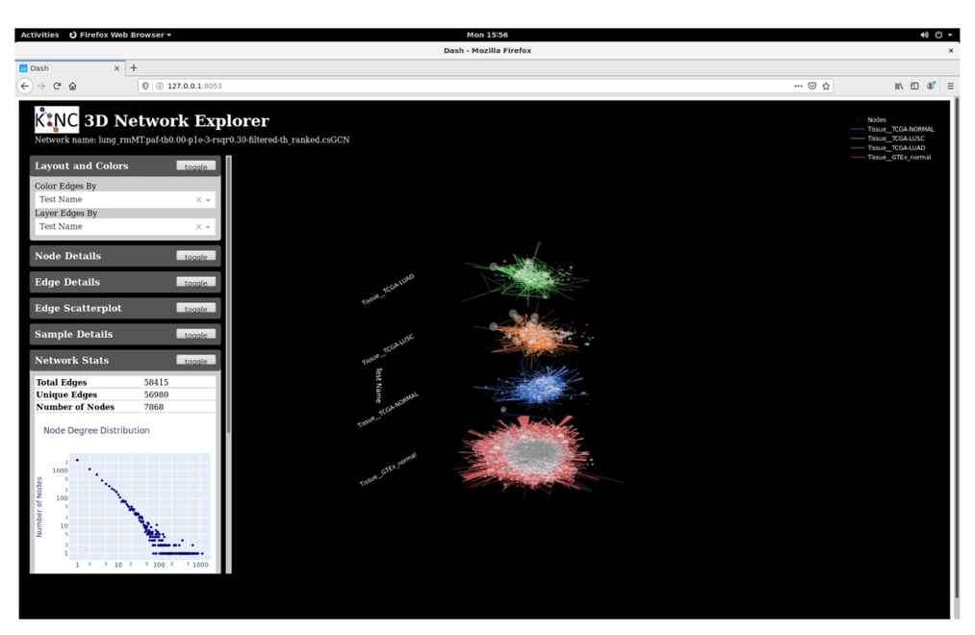
Supplemental Figure 4. Lung GCN 3D Network Visualization. Red represents GTEx normal specific edges; Blue represents TCGA normal specific edges; Green represents TCGA LUAD specific edges; and orange represents TCGA LUSC specific edges. The grey circle represents connectivity. Larger circles represent higher connectivity. The left part is the basic information of this network, including number of total edges, number of unique edges, number of nodes, and node degree distribution.

