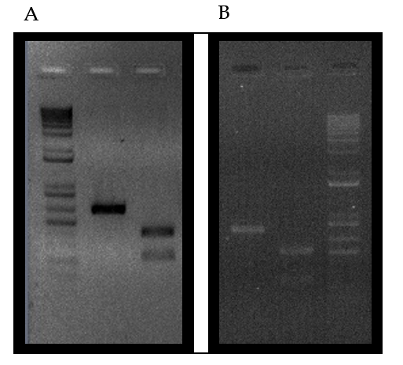
Additional Figure 1: Gel electrophoretic separation of digested PCR products (left 381e, right TF); panel A: LG01SNP1; panel B: LG08SNP4. Relevant fragment sizes (bp) are denoted on the right side (1Kb plus).

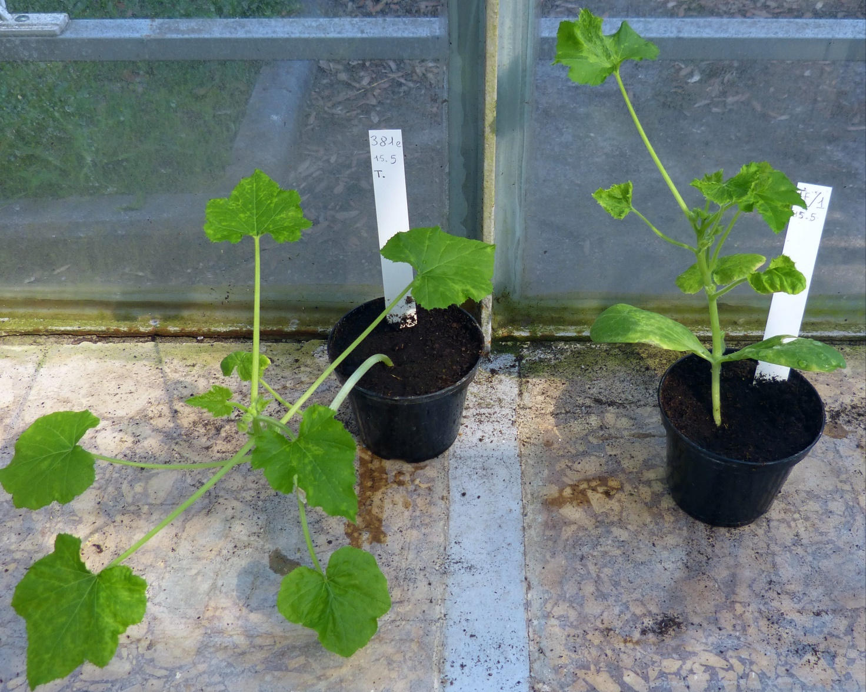
Additional Figure 2: Comparison of the ZYMV tolerant line 381e (left) and the susceptible True French (right) 12 days after ZYMV inoculation.

