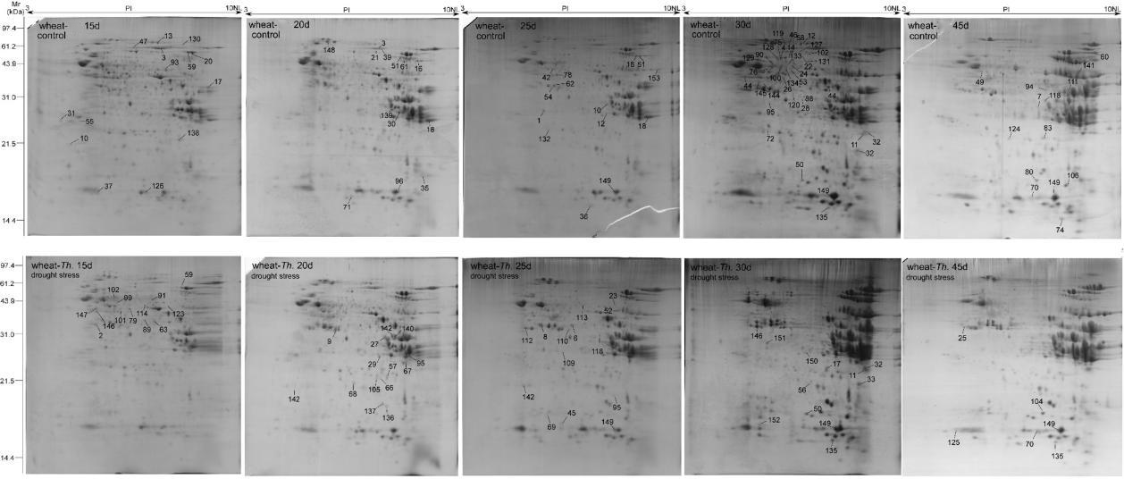
Fig. S1. Dynamic proteomic expression profiling of five grain development periods at 15, 20, 25, 30 and 45 DPA by 2-DE.
The first row in the picture is the Zhongmai 8601 under drought stress and the second row is drought stress of wheat-Thinopyrum intermedium 7XL/7DS translocation line.

